### **SQL SERVER**

**Creating, altering and dropping a database - Part 2**

SQL Server database can be created, altered and dropped

1. Graphically using SQL Server Management Studio (SSMS) or

2. Using a Query

To create the database graphically

1. Right Click on Databases folder in the Object explorer

2. Select New Database

3. In the New Database dialog box, enter the Database name and click OK.

**To Create the database using a query**

Create database DatabaseName

Whether, you create a database graphically using the designer or, using a query, the following 2 files gets generated.

.MDF file - Data File (Contains actual data)

.LDF file - Transaction Log file (Used to recover the database)

**To alter a database, once it's created**

Alter database DatabaseName Modify Name = NewDatabaseName

**Alternatively, you can also use system stored procedure**

Execute sp\_renameDB 'OldDatabaseName','NewDatabaseName'

**To Delete or Drop a database**

Drop Database DatabaseThatYouWantToDrop

**Dropping a database, deletes the LDF and MDF files.**

You cannot drop a database, if it is currently in use. You get an error stating - Cannot drop database "NewDatabaseName" because it is currently in use. So, if other users are connected, you need to put the database in single user mode and then drop the database.

Alter Database DatabaseName Set SINGLE\_USER With Rollback Immediate

With Rollback Immediate option, will rollback all incomplete transactions and closes the connection to the database.

Note: **System databases cannot be dropped.**

**Link :<https://csharp-video-tutorials.blogspot.com/2012/08/creating-altering-and-dropping-database.html>**

[**https://youtu.be/TuxuHHacIWU**](https://youtu.be/TuxuHHacIWU)

### **Creating and Working with tables - Part 3**

The aim of this article is to create tblPerson and tblGender tables and establish primary key and foreign key constraints. In SQL Server, tables can be created graphically using SQL Server Management Studio (SSMS) or using a query.

### <https://youtu.be/JLeaM8pK8dE>

To create tblPerson table, graphically, using SQL Server Management Studio  
1. Right click on Tables folder in Object explorer window  
2. Select New Table  
3. Fill Column Name, Data Type and Allow Nulls, as shown below and save the table as tblPerson.

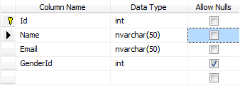

The following statement creates tblGender table, with ID and Gender columns. The following statement creates tblGender table, with ID and Gender columns. ID column, is the primary key column. The primary key is used to uniquely identify each row in a table. Primary key does not allow nulls.

Create Table tblGender  
(ID int Not Null Primary Key,  
Gender nvarchar(50))  
  
In tblPerson table, GenderID is the foreign key referencing ID column in tblGender table. Foreign key references can be added graphically using SSMS or using a query.  
  
To graphically add a foreign key reference  
1. Right click tblPerson table and select Design  
2. In the table design window, right click on GenderId column and select Relationships

3. In the Foreign Key Relationships window, click Add button

4. Now expand, in Tables and Column Specification row, by clicking the, + sign

5. Click on the elipses button, that is present in Tables and Column Specification row  
6. From the Primary Key Table, dropdownlist, select tblGender  
7. Click on the row below, and select ID column  
8. From the column on the right hand side, select GenderId  
9. Click OK and then click close.  
10. Finally save the table.  
  
  
To add a foreign key reference using a query  
Alter table tblPerson   
add constraint tblPerson\_GenderId\_FK FOREIGN KEY (GenderId) references tblGender(ID)  
  
  
The general formula is here  
Alter table ForeignKeyTable add constraint ForeignKeyTable\_ForiegnKeyColumn\_FK   
FOREIGN KEY (ForiegnKeyColumn) references PrimaryKeyTable (PrimaryKeyColumn)  
  
  
Foreign keys are used to enforce database integrity. In layman's terms, A foreign key in one table points to a primary key in another table. The foreign key constraint prevents invalid data form being inserted into the foreign key column. The values that you enter into the foreign key column, has to be one of the values contained in the table it points to.

<https://youtu.be/JLeaM8pK8dE>**Default constraint in SQL server - Part 4**

### In this video, we will learn adding a Default Constraint. A column default can be specified using Default constraint. The default constraint is used to insert a default value into a column. The default value will be added to all new records, if no other value is specified, including NULL.

### Altering an existing column to add a default constraint: ALTER TABLE { TABLE\_NAME } ADD CONSTRAINT { CONSTRAINT\_NAME } DEFAULT { DEFAULT\_VALUE } FOR { EXISTING\_COLUMN\_NAME } Adding a new column, with default value, to an existing table: ALTER TABLE { TABLE\_NAME }  ADD { COLUMN\_NAME } { DATA\_TYPE } { NULL | NOT NULL }  CONSTRAINT { CONSTRAINT\_NAME } DEFAULT { DEFAULT\_VALUE }

### The following command will add a default constraint, DF\_tblPerson\_GenderId. ALTER TABLE tblPerson ADD CONSTRAINT DF\_tblPerson\_GenderId DEFAULT 1 FOR GenderId The insert statement below does not provide a value for GenderId column, so the default of 1 will be inserted for this record. Insert into tblPerson(ID,Name,Email) values(5,'Sam','s@s.com') On the other hand, the following insert statement will insert NULL, instead of using the default.

### Insert into tblPerson(ID,Name,Email,GenderId) values (6,'Dan','d@d.com',NULL) To drop a constraint ALTER TABLE { TABLE\_NAME }  DROP CONSTRAINT { CONSTRAINT\_NAME }

Is it possible to change the default value for existing default constraint if yes please explain..

Altering constraint.

Ex: ALTER TABLE tblPerson ADD CNSTRAINT DF\_tblPerson\_GenderId DEFAULT 3 FOR GenderId

[**https://youtu.be/dwSqHhMl32Y**](https://youtu.be/dwSqHhMl32Y)

### **Cascading referential integrity constraint - Part 5**

In [Part 3 of this video series, we have seen how to create tables (tblPerson and tblGender) and enforce primary and foreign key constraints](http://csharp-video-tutorials.blogspot.com/2012/08/creating-and-working-with-tables-part-3.html). In [Part 4, we have learnt adding a default constraint.](http://csharp-video-tutorials.blogspot.com/2012/08/default-constraint-in-sql-server-part-4.html) Please watch Parts 3 and 4, before continuing with this session.

In this video, we will learn about **Cascading referential integrity constraint**  
Cascading referential integrity constraint allows to define the actions Microsoft SQL Server should take when a user attempts to delete or update a key to which an existing foreign keys points.  
**For example**, consider the 2 tables shown below. If you delete row with **ID = 1** from **tblGender**table, then row with **ID = 3** from **tblPerson**table becomes an **orphan record**. You will not be able to tell the Gender for this row. So, Cascading referential integrity constraint can be used to define actions Microsoft SQL Server should take when this happens. By default, we get an error and the DELETE or UPDATE statement is rolled back.

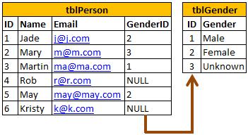

However, you have the following options when setting up Cascading referential integrity constraint

**1. No Action**: This is the default behaviour. No Action specifies that if an attempt is made to delete or update a row with a key referenced by foreign keys in existing rows in other tables, an error is raised, and the DELETE or UPDATE is rolled back.  
  
  
**2. Cascade**: Specifies that if an attempt is made to delete or update a row with a key referenced by foreign keys in existing rows in other tables, all rows containing those foreign keys are also deleted or updated.  
  
  
**3. Set NULL**: Specifies that if an attempt is made to delete or update a row with a key referenced by foreign keys in existing rows in other tables, all rows containing those foreign keys are set to NULL.

**4. Set Default**: Specifies that if an attempt is made to delete or update a row with a key referenced by foreign keys in existing rows in other tables, all rows containing those foreign keys are set to default values.

<https://www.youtube.com/watch?v=ETepOVi7Xk8>

**Check constraint in SQL Server - Part 6**

**CHECK constraint** is used to **limit the range of the values**, that can be entered for a column.Let's say, we have an integer AGE column, in a table. The AGE in general cannot be less than ZERO and at the same time cannot be greater than 150. But, since AGE is an integer column it can accept negative values and values much greater than 150.

So, to limit the values, that can be added, we can use CHECK constraint. In SQL Server, CHECK constraint can be created graphically, or using a query.

**The following check constraint limits the age between ZERO and 150.**

ALTER TABLE tblPerson ADD CONSTRAINT

CK\_tblPerson\_Age CHECK (Age > 0 AND Age < 150)

**The general formula for adding check constraint in SQL Server:**

ALTER TABLE { TABLE\_NAME } ADD CONSTRAINT { CONSTRAINT\_NAME } CHECK ( BOOLEAN\_EXPRESSION **)**

If the BOOLEAN\_EXPRESSION returns true, then the CHECK constraint allows the value, otherwise it doesn't. Since, AGE is a nullable column, it's possible to pass null for this column, when inserting a row. When you pass NULL for the AGE column, the boolean expression evaluates to **UNKNOWN**, and allows the value.  
  
  
**To drop the CHECK constraint:**

ALTER TABLE tblPerson

DROP CONSTRAINT CK\_tblPerson\_Age

<https://youtu.be/9Zj5ODhv0b0>

### **Identity column in SQL Server - Part 7**

If a column is marked as an identity column, then the values for this column are automatically generated, when you insert a new row into the table. The following, create table statement marks PersonId as an identity column with seed = 1 and Identity Increment = 1. Seed and Increment values are optional. If you don't specify the identity and seed they both default to 1.

Create Table tblPerson

(

PersonId int Identity(1,1) Primary Key,

Name nvarchar(20)

)

In the following 2 insert statements, we only supply values for Name column and not for PersonId column.

Insert into tblPerson values ('Sam')

Insert into tblPerson values ('Sara')

If you select all the rows from tblPerson table, you will see that, 'Sam' and 'Sara' rows have got 1 and 2 as PersonId.

Now, if I try to execute the following query, I get an error stating - An explicit value for the identity column in table 'tblPerson'

can only be specified when a column list is used and IDENTITY\_INSERT is ON.

Insert into tblPerson values (1,'Todd')

So if you mark a column as an Identity column, you dont have to explicitly supply a value for that column when you insert a new row.

The value is automatically calculated and provided by SQL server. So, to insert a row into tblPerson table, just provide value for Name column.

Insert into tblPerson values ('Todd')

Delete the row, that you have just inserted and insert another row. You see that the value for PersonId is 2.

Now if you insert another row, PersonId is 3. A record with PersonId = 1, does not exist, and I want to fill this gap. To do this,

we should be able to explicitly supply the value for identity column. To explicitly supply a value for identity column

1. First turn on identity insert - SET Identity\_Insert tblPerson ON

2. In the insert query specify the column list

Insert into tblPerson(PersonId, Name) values(2, 'John')

As long as the Identity\_Insert is turned on for a table, you need to explicitly provide the value for that column.

If you don't provide the value, you get an error - Explicit value must be specified for identity column in table 'tblPerson1' either when IDENTITY\_INSERT is set to ON or when a replication user is inserting into a NOT FOR REPLICATION identity column.

After, you have the gaps in the identity column filled, and if you wish SQL server to calculate the value, turn off Identity\_Insert.

SET Identity\_Insert tblPerson OFF

If you have deleted all the rows in a table, and you want to reset the identity column value, use DBCC CHECKIDENT command.

This command will reset PersonId identity column.

DBCC CHECKIDENT(tblPerson, RESEED, 0)

### **How to get the last generated identity column value in SQL Server - Part 8**

From the previous session, we understood that identity column values are auto generated.

There are several ways in sql server, to retrieve the last identity value that is generated.

The most common way is to use SCOPE\_IDENTITY() built in function.

Apart, from using SCOPE\_IDENTITY(), you also have @@IDENTITY and IDENT\_CURRENT('TableName') function.

Example queries for getting the last generated identity value

Select SCOPE\_IDENTITY()

Select @@IDENTITY

Select IDENT\_CURRENT('tblPerson')

Let's now understand the difference between, these 3 approaches.

SCOPE\_IDENTITY() returns the last identity value that is created in the same session (Connection) and in the same scope (in the same Stored procedure, function, trigger).

Let's say, I have 2 tables tblPerson1 and tblPerson2, and I have a trigger on tblPerson1 table, which will insert a record into tblPerson2 table.

Now, when you insert a record into tblPerson1 table, SCOPE\_IDENTITY() returns the idetentity value that is generated in tblPerson1 table,

where as @@IDENTITY returns,the value that is generated in tblPerson2 table.

So, @@IDENTITY returns the last identity value that is created in the same session without any consideration to the scope.

**IDENT\_CURRENT('tblPerson')** returns the last identity value created for a specific table across any session and any scope.

In brief:

**SCOPE\_IDENTITY()** - returns the last identity value that is created in the same session and in the same scope.

**@@IDENTITY** - returns the last identity value that is created in the same session and across any scope.

**IDENT\_CURRENT('TableName')** - returns the last identity value that is created for a specific table across any session and any scope.

If you execute **SCOPE\_IDENTITY() or @@IDENTITY** for the first time in the current session before insert statement then you will get NULL.

When it comes to **IDENT\_CURRENT('TABLENAME')**, the result is same if no data is inserted by any of the sessions.

When I insert record in table and get identity column that work fine.  
But problem is that when exception in program like(Primary Key)  
occurs then data not save in table but Identity column increment ?  
(in my program Identity column is not primary key )

Ans :

Begin Transaction

insert into tblPerson values('bobayya','hbc',2)

if(@@Error = 2627)

Begin

Declare @Id int

Set @Id = @@IDENTITY

DBCC CheckIdent('tblPerson',reseed, @Id)

end

Else

Begin

Commit Transaction

End

What **SCOPE\_IDENTITY is**

SCOPE\_IDENTITY returns the last IDENTITY value inserted into an IDENTITY column in the same scope. SCOPE\_IDENTITY returns the last identity value generated for any table in the current session and the current scope.

A scope is a module; a Stored Procedure, trigger, function, or batch.

Thus, two statements are in the same scope if they are in the same Stored Procedure, function, or batch. The SCOPE\_IDENTITY() function will return the NULL value if the function is invoked before any insert statements into an identity column occur in the scope.

**What IDENT\_CURRENT is**

IDENT\_CURRENT returns the last identity value generated for a specific table in any session and any scope.

IDENT\_CURRENT is not limited by scope and session; it is limited to a specified table.

**What @@IDENTITY is**

@@IDENTITY returns the last identity value generated for any table in the current session, across all scopes.

After an INSERT, SELECT INTO, or bulk copy statement completes, @@IDENTITY contains the last identity value generated by the statement.

If the statement did not affect any tables with identity columns, @@IDENTITY returns NULL.

If multiple rows are inserted, generating multiple identity values, @@IDENTITY returns the last identity value generated.

The @@IDENTITY value does not revert to a previous setting if the INSERT or SELECT INTO statement or bulk copy fails, or if the transaction is rolled back.

Differences

The differences between them are:

SCOPE\_IDENTITY, IDENT\_CURRENT, and @@IDENTITY are similar functions in that they return values inserted into IDENTITY columns.

SCOPE\_IDENTITY and @@IDENTITY will return the last identity values generated in any table in the current session. However, SCOPE\_IDENTITY returns values inserted only within the current scope; @@IDENTITY is not limited to a specific scope. A scope is a module; a Stored Procedure, trigger, function, or batch.

**Unique key constraint - Part 9**

We use UNIQUE constraint to enforce uniqueness of a column i.e the column shouldn't allow any duplicate values. We can add a Unique constraint thru the designer or using a query.To add a unique constraint using SQL server management studio designer:

1. Right-click on the table and select Design

2. Right-click on the column, and select Indexes/Keys...

3. Click Add

4. For Columns, select the column name you want to be unique.

5. For Type, choose Unique Key.

6. Click Close, Save the table.

To create the unique key using a query:

Alter Table Table\_Name

Add Constraint Constraint\_Name Unique(Column\_Name)

Both primary key and unique key are used to enforce, the uniqueness of a column. So, when do you choose one over the other?

A table can have, only one primary key. If you want to enforce uniqueness on 2 or more columns, then we use unique key constraint.

What is the difference between Primary key constraint and Unique key constraint? This question is asked very frequently in interviews.

1. A table can have only one primary key, but more than one unique key

2. Primary key does not allow nulls, where as unique key allows one null

To drop the constraint

1. Right click the constraint and delete.

Or

2. Using a query

Alter Table tblPerson

Drop COnstraint UQ\_tblPerson\_Email

Yes, You can create foreign key on Unique key with the below conditions

-- We should forget the definition "Foreign key allows duplicate values and OK them to contain multiple null values "

Since foreign key on unique column will allow only Unique values including only one null.

We cannot insert multiple null values in unique key column,

Unique key allows only one null value.

Because,two null values are same like duplicate..Unique key will not allow duplicate values.you enter two null values it must be duplicate..that's why unique key does not allow duplicate values..

But, How to NULL values will be same. They are unknown values. SO, how we can say that they are same.Null has its specific value, that's why database can determine duplicate.

**Select statement - Part 10**

Basic select statement syntax

SELECT Column\_List FROM Table\_Name

If you want to select all the columns, you can also use \*. For better performance use the column list, instead of using \*.

SELECT \* FROM Table\_Name

To Select distinct rows use DISTINCT keyword

SELECT DISTINCT Column\_List FROM Table\_Name

Example: Select distinct city from tblPerson

Filtering rows with WHERE clause

SELECT Column\_List FROM Table\_Name WHERE Filter\_Condition

Example: Select Name, Email from tblPerson where City = 'London'

Note: Text values, should be present in single quotes, but not required for numeric values.

Different operators that can be used in a where clause

1.\* reteives all columns even though some of the columns are not requred,it causes performance degadation,time consuming.

2. In future if we want to change any column alias names while retriving, it is difficult. in that time we must specify thespecified columns.

**Group By - Part 11**

In SQL Server we have got lot of aggregate functions. Examples

1. Count()

2. Sum()

3. avg()

4. Min()

5. Max()

Group by clause is used to group a selected set of rows into a set of summary rows by the values of one or more columns or expressions.

It is always used in conjunction with one or more aggregate functions.

I want an sql query, which gives total salaries paid by City. The output should be as shown below.

Query for retrieving total salaries by city:

We are applying SUM() aggregate function on Salary column, and grouping by city column.

This effectively adds, all salaries of employees with in the same city.

Select City, SUM(Salary) as TotalSalary from tblEmployee Group by City

Note: If you omit, the group by clause and try to execute the query, you get an error - Column 'tblEmployee.City' is invalid

in the select list because it is not contained in either an aggregate function or the GROUP BY clause.

Now, I want an sql query, which gives total salaries by City, by gender. The output should be as shown below.

Query for retrieving total salaries by city and by gender: It's possible to group by multiple columns.

In this query, we are grouping first by city and then by gender.

Select City, Gender, SUM(Salary) as TotalSalary from tblEmployee group by City, Gender

Now, I want an sql query, which gives total salaries and total number of employees by City, and by gender. The output should be as shown below.

Query for retrieving total salaries and total number of employees by City, and by gender: The only difference here is that, we are using Count() aggregate function.

Select City, Gender, SUM(Salary) as TotalSalary, COUNT(ID) as TotalEmployees from tblEmployee group by City, Gender

Filtering Groups:

WHERE clause is used to filter rows before aggregation, where as HAVING clause is used to filter groups after aggregations.

The following 2 queries produce the same result.

Filtering rows using WHERE clause, before aggrgations take place:

Select City, SUM(Salary) as TotalSalary

from tblEmployee

Where City = 'London'

group by City

Filtering groups using HAVING clause, after all aggrgations take place:

Select City, SUM(Salary) as TotalSalary

from tblEmployee

group by City

Having City = 'London'

From a performance standpoint, you cannot say that one method is less efficient than the other Sql server optimizer analyzes each statement and selects an efficient way of executing it. As a best practice, use the syntax that clearly describes the desired result. Try to eliminate rows that you wouldn't need, as early as possible.

It is also possible to combine WHERE and HAVING

Select City, SUM(Salary) as TotalSalary

from tblEmployee

Where Gender = 'Male'

group by City

Having City = 'London'

Difference between WHERE and HAVING clause:

1. WHERE clause can be used with - Select, Insert, and Update statements, where as HAVING clause can only be used with the Select statement.

2. WHERE filters rows before aggregation (GROUPING), where as, HAVING filters groups, after the aggregations are performed.

3. Aggregate functions cannot be used in the WHERE clause, unless it is in a sub query contained in a HAVING clause, whereas, aggregate functions can be used in Having clause.

**Joins in sql server - Part 12**

Joins in SQL server are used to query (retrieve) data from 2 or more related tables. In general tables are related to each other using foreign key constraints.

In SQL server, there are different types of JOINS.

1. CROSS JOIN

2. INNER JOIN

3. OUTER JOIN

Outer Joins are again divided into 3 types

1. Left Join or Left Outer Join

2. Right Join or Right Outer Join

3. Full Join or Full Outer Join

Now let's understand all the JOIN types, with examples and the differences between them.

Employee Table (tblEmployee)

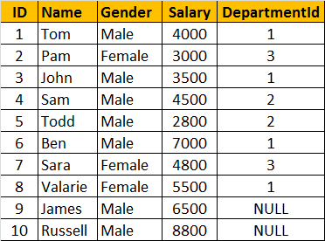

**Departments Table (tblDepartment)**

**SQL Script to create tblEmployee and tblDepartment tables**

Create table tblDepartment

(

     ID int primary key,

     DepartmentName nvarchar(50),

     Location nvarchar(50),

     DepartmentHead nvarchar(50)

)

Go

Insert into tblDepartment values (1, 'IT', 'London', 'Rick')

Insert into tblDepartment values (2, 'Payroll', 'Delhi', 'Ron')

Insert into tblDepartment values (4, 'Other Department', 'Sydney', 'Cindrella')

Go

Create table tblEmployee

(

ID int primary key,

Name nvarchar(50),

Gender nvarchar(50),

Salary int,

DepartmentId int foreign key references tblDepartment(Id)

)

Go

Insert into tblEmployee values (1, 'Tom', 'Male', 4000, 1)

Insert into tblEmployee values (2, 'Pam', 'Female', 3000, 3)

Insert into tblEmployee values (3, 'John', 'Male', 3500, 1)

Insert into tblEmployee values (4, 'Sam', 'Male', 4500, 2)

Insert into tblEmployee values (5, 'Todd', 'Male', 2800, 2)

Insert into tblEmployee values (6, 'Ben', 'Male', 7000, 1)

Insert into tblEmployee values (7, 'Sara', 'Female', 4800, 3)

Insert into tblEmployee values (8, 'Valarie', 'Female', 5500, 1)

Insert into tblEmployee values (9, 'James', 'Male', 6500, NULL)

Insert into tblEmployee values (10, 'Russell', 'Male', 8800, NULL)

Go

General Formula for Joins

SELECT ColumnList FROM LeftTableName

JOIN\_TYPE RightTableName ON JoinCondition

CROSS JOIN

CROSS JOIN, produces the cartesian product of the 2 tables involved in the join. For example,

in the Employees table we have 10 rows and in the Departments table we have 4 rows.

So, a cross join between these 2 tables produces 40 rows. Cross Join shouldn't have ON clause.

CROSS JOIN Query:

SELECT Name, Gender, Salary, DepartmentName

FROM tblEmployee CROSS JOIN tblDepartment

JOIN or INNER JOIN : Write a query, to retrieve Name, Gender, Salary and DepartmentName from Employees and Departments table. The output of the query should be as shown below.

SELECT Name, Gender, Salary, DepartmentName

FROM tblEmployee

INNER JOIN tblDepartment

ON tblEmployee.DepartmentId = tblDepartment.Id

OR

SELECT Name, Gender, Salary, DepartmentName

FROM tblEmployee

JOIN tblDepartment

ON tblEmployee.DepartmentId = tblDepartment.Id

Note: JOIN or INNER JOIN means the same. It's always better to use INNER JOIN, as this explicitly specifies your intention.

If you look at the output, we got only 8 rows, but in the Employees table, we have 10 rows. We didn't get JAMES and RUSSELL records.

This is because the DEPARTMENTID, in Employees table is NULL for these two employees and doesn't match with ID column in Departments table.

So, in summary, INNER JOIN, returns only the matching rows between both the tables. Non matching rows are eliminated.

LEFT JOIN or LEFT OUTER JOIN

Now, let's say, I want all the rows from the Employees table, including JAMES and RUSSELL records. I want the output, as shown below.

So, in summary, INNER JOIN, returns only the matching rows between both the tables. Non matching rows are eliminated.

LEFT JOIN or LEFT OUTER JOIN : Now, let's say, I want all the rows from the Employees table, including JAMES and RUSSELL records. I want the output, as shown below.

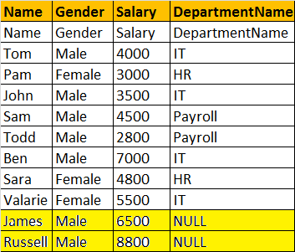

SELECT Name, Gender, Salary, DepartmentName

FROM tblEmployee

LEFT OUTER JOIN tblDepartment

ON tblEmployee.DepartmentId = tblDepartment.Id

OR

SELECT Name, Gender, Salary, DepartmentName

FROM tblEmployee

LEFT JOIN tblDepartment

ON tblEmployee.DepartmentId = tblDepartment.Id

Note: You can use, LEFT JOIN or LEFT OUTER JOIN. OUTER keyowrd is optional

LEFT JOIN, returns all the matching rows + non matching rows from the left table. In reality, INNER JOIN and LEFT JOIN are extensively used.

RIGHT JOIN or RIGHT OUTER JOIN

I want, all the rows from the right table. The query output should be, as shown below.

SELECT Name, Gender, Salary, DepartmentName

FROM tblEmployee

RIGHT OUTER JOIN tblDepartment

ON tblEmployee.DepartmentId = tblDepartment.Id

OR

SELECT Name, Gender, Salary, DepartmentName

FROM tblEmployee

RIGHT JOIN tblDepartment

ON tblEmployee.DepartmentId = tblDepartment.Id

Note: You can use, RIGHT JOIN or RIGHT OUTER JOIN. OUTER keyowrd is optional

RIGHT JOIN, returns all the matching rows + non matching rows from the right table.

FULL JOIN or FULL OUTER JOIN

I want all the rows from both the tables involved in the join. The query output should be, as shown below.

SELECT Name, Gender, Salary, DepartmentName

FROM tblEmployee

FULL OUTER JOIN tblDepartment

ON tblEmployee.DepartmentId = tblDepartment.Id

OR

SELECT Name, Gender, Salary, DepartmentName

FROM tblEmployee

FULL JOIN tblDepartment

ON tblEmployee.DepartmentId = tblDepartment.Id

Note: You can use, FULLJOIN or FULL OUTER JOIN. OUTER keyowrd is optional

FULL JOIN, returns all rows from both the left and right tables, including the non matching rows.

**Advanced Joins - Part 13**

In this video session we will learn about

1. Advanced or intelligent joins in SQL Server

2. Retrieve only the non matching rows from the left table

3. Retrieve only the non matching rows from the right table

4. Retrieve only the non matching rows from both the left and right table

**Considers Employees (tblEmployee) and Departments (tblDepartment) tables**

**How to retrieve only the non matching rows from the left table. The output should be as shown below:**

Query:

SELECT Name,Gender,Salary,DepartmentName

FROM tblEmployee E LEFT JOIN tblDepartment D ON E.DepartmentId = D.Id

WHERE D.Id IS NULL

**How to retrieve only the non matching rows from the right table**



Query:

SELECT Name, Gender, Salary, DepartmentName

FROM tblEmployee E RIGHT JOIN tblDepartment D ON E.DepartmentId = D.Id

WHERE E.DepartmentId IS NULL

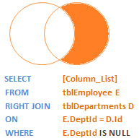

**How to retrieve only the non matching rows from both the left and right table. Matching rows should be eliminated.**

Query:

SELECT Name, Gender, Salary, DepartmentName

FROM tblEmployee E

FULL JOIN tblDepartment D ON E.DepartmentId = D.Id

WHERE E.DepartmentId IS NULL OR D.Id IS NULL

Query to generate 20 rows without using stored proc or function .. try this...

declare @Start int

declare @End int

set @Start = 1

set @End = 20

while(@Start <= @End)

begin

Select convert(varchar,@Start) + ' Row' as Rows

Set @Start = @Start + 1

End

**Self join in SQL server - Part 14**

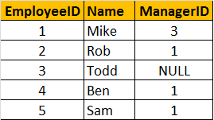

Self Join Query: A MANAGER is also an EMPLOYEE. Both the, EMPLOYEE and MANAGER rows, are present in the same table. Here we are joining tblEmployee with itself using different alias names, E for Employee and M for Manager. We are using LEFT JOIN, to get the rows with ManagerId NULL. You can see in the output TODD's record is also retrieved, but the MANAGER is NULL. If you replace LEFT JOIN with INNER JOIN, you will not get TODD's record.

Select E.Name as Employee, M.Name as Manager

from tblEmployee E

Left Join tblEmployee M

On E.ManagerId = M.EmployeeId

In short, joining a table with itself is called as SELF JOIN. SELF JOIN is not a different type of JOIN. It can be classified under any type of JOIN - INNER, OUTER or CROSS Joins. The above query is, LEFT OUTER SELF Join.

Inner Self Join tblEmployee table:

Select E.Name as Employee, M.Name as Manager

from tblEmployee E

Inner Join tblEmployee M

On E.ManagerId = M.EmployeeId

Cross Self Join tblEmployee table:

Select E.Name as Employee, M.Name as Manager

from tblEmployee

Cross Join tblEmployee

### **Different ways to replace NULL in sql server - Part 15**



In Part 14, we have learnt writing a LEFT OUTER SELF JOIN query, which produced the following output.

In the output, MANAGER column, for Todd's rows is NULL. I want to replace the NULL value, with 'No Manager'

Replacing NULL value using ISNULL() function: We are passing 2 parameters to IsNULL() function. If M.Name returns NULL, then 'No Manager' string is used as the replacement value.

SELECT E.Name as Employee, ISNULL(M.Name,'No Manager') as Manager

FROM tblEmployee E

LEFT JOIN tblEmployee M

ON E.ManagerID = M.EmployeeID

Replacing NULL value using CASE Statement:

SELECT E.Name as Employee, CASE WHEN M.Name IS NULL THEN 'No Manager'

ELSE M.Name END as Manager

FROM tblEmployee E

LEFT JOIN tblEmployee M

ON E.ManagerID = M.EmployeeID

Replacing NULL value using COALESCE() function: COALESCE() function, returns the first NON NULL value.

SELECT E.Name as Employee, COALESCE(M.Name, 'No Manager') as Manager

FROM tblEmployee E

LEFT JOIN tblEmployee M

ON E.ManagerID = M.EmployeeID

We will discuss about COALESCE() function in detail, in the next session

**Coalesce() function in sql server - Part 16**

[**https://youtu.be/AzkHAO4JzNQ**](https://youtu.be/AzkHAO4JzNQ)

According to the MSDN Books online COALESCE() returns the first Non NULL value. Let's understand this with an example.

Consider the Employees Table below. Not all employees have their First, Midde and Last Names filled. Some of the employees has First name missing, some of them have Middle Name missing and some of them last name.

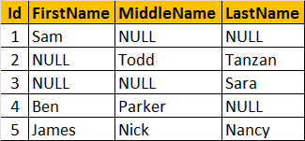

Now, let's write a query that returns the**Name of the Employee**. If an employee, has all the columns filled - **First, Middle and Last Names**, then we only want the **first name**.  
  
If the **FirstName is NULL**, and if **Middle and Last Names are filled** then, we only want the **middle name**. For example, Employee row with Id = 1, has the FirstName filled, so we want to retrieve his FirstName "Sam". Employee row with Id = 2, has Middle and Last names filled, but the First name is missing. Here, we want to retrieve his middle name "Todd". In short, The output of the query should be as shown below.

We are passing FirstName, MiddleName and LastName columns as parameters to the COALESCE() function. The COALESCE() function returns the first non null value from the 3 columns.

SELECT Id, COALESCE(FirstName, MiddleName, LastName) AS Name

FROM tblEmployee

**Union and union all in sql server - Part 17**

UNION and UNION ALL operators in SQL Server, are used to combine the result-set of two or more SELECT queries. Please consider India and UK customer tables below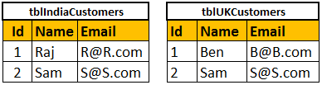

Combining the rows of tblIndiaCustomers and tblUKCustomers using UNION ALL

Select Id, Name, Email from tblIndiaCustomers

UNION ALL

Select Id, Name, Email from tblUKCustomers

Combining the rows of tblIndiaCustomers and tblUKCustomers using UNION

Select Id, Name, Email from tblIndiaCustomers

UNION Select Id, Name, Email from tblUKCustomers

Differences between UNION and UNION ALL (Common Interview Question)

From the output, it is very clear that, UNION removes duplicate rows, where as UNION ALL does not. When use UNION, to remove the duplicate rows, sql server has to to do a distinct sort, which is time consuming. For this reason, UNION ALL is much faster than UNION.

Note: If you want to see the cost of DISTINCT SORT, you can turn on the estimated query execution plan using CTRL + L.

Note: For UNION and UNION ALL to work, the Number, Data types, and the order of the columns in the select statements should be same.

If you want to sort, the results of UNION or UNION ALL, the ORDER BY caluse should be used on the last SELECT statement as shown below.

Select Id, Name, Email from tblIndiaCustomers

UNION ALL

Select Id, Name, Email from tblUKCustomers

UNION ALL

Select Id, Name, Email from tblUSCustomers

Order by Name

The following query, raises a syntax error

SELECT Id, Name, Email FROM tblIndiaCustomers

ORDER BY Name

UNION ALL

SELECT Id, Name, Email FROM tblUKCustomers

UNION ALL SELECT Id, Name, Email FROM tblUSCustomers

**Difference between JOIN and UNION**

JOINS and UNIONS are different things. However, this question is being asked very frequently now. UNION combines the result-set of two or more select queries into a single result-set which includes all the rows from all the queries in the union, where as JOINS, retrieve data from two or more tables based on logical relationships between the tables. In short, UNION combines rows from 2 or more tables, where JOINS combine columns from 2 or more table.

**Stored procedures - Part 18**

A stored procedure is group of T-SQL (Transact SQL) statements. If you have a situation, where you write the same query over and over again, you can save that specific query as a stored procedure and call it just by it's name.

There are several advantages of using stored procedures, which we will discuss in a later video session. In this session, we will learn how to create, execute, change and delete stored procedures

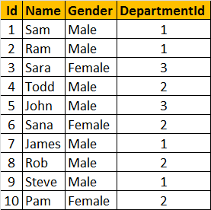

Creating a simple stored procedure without any parameters: This stored procedure, retrieves Name and Gender of all the employees. To create a stored procedure we use, CREATE PROCEDURE or CREATE PROC statement.

Create Procedure spGetEmployees

as

Begin

Select Name, Gender from tblEmployee

End

Note: When naming user defined stored procedures, Microsoft recommends not to use "sp\_" as a prefix. All system stored procedures, are prefixed with "sp\_". This avoids any ambiguity between user defined and system stored procedures and any conflicts, with some future system procedure.

To execute the stored procedure, you can just type the procedure name and press F5, or use EXEC or EXECUTE keywords followed by the procedure name as shown below.

1. spGetEmployees

2. EXEC spGetEmployees

3. Execute spGetEmployees

Note: You can also right click on the procedure name, in object explorer in SQL Server Management Studio and select EXECUTE STORED PROCEDURE.

Creating a stored procedure with input parameters: This SP, accepts GENDER and DEPARTMENTID parameters. Parameters and variables have an @ prefix in their name.

Create Procedure spGetEmployeesByGenderAndDepartment

@Gender nvarchar(50),

@DepartmentId int

as

Begin

Select Name, Gender from tblEmployee Where Gender = @Gender and DepartmentId = @DepartmentId

End

To invoke this procedure, we need to pass the value for @Gender and @DepartmentId parameters. If you don't specify the name of the parameters, you have to first pass value for @Gender parameter and then for @DepartmentId.

EXECUTE spGetEmployeesByGenderAndDepartment 'Male', 1

On the other hand, if you change the order, you will get an error stating "Error converting data type varchar to int." This is because, the value of "Male" is passed into @DepartmentId parameter. Since @DepartmentId is an integer, we get the type conversion error.

spGetEmployeesByGenderAndDepartment 1, 'Male'

When you specify the names of the parameters when executing the stored procedure the order doesn't matter.

EXECUTE spGetEmployeesByGenderAndDepartment @DepartmentId=1, @Gender = 'Male'

To view the text, of the stored procedure

1. Use system stored procedure sp\_helptext 'SPName'

OR

2. Right Click the SP in Object explorer -> Scrip Procedure as -> Create To -> New Query Editor Window

To change the stored procedure, use ALTER PROCEDURE statement:

Alter Procedure spGetEmployeesByGenderAndDepartment

@Gender nvarchar(50),

@DepartmentId int

as

Begin

Select Name, Gender from tblEmployee Where Gender = @Gender and DepartmentId = @DepartmentId order by Name

End

To encrypt the text of the SP, use WITH ENCRYPTION option. Once, encrypted, you cannot view the text of the procedure, using sp\_helptext system stored procedure. There are ways to obtain the original text, which we will talk about in a later session.

Alter Procedure spGetEmployeesByGenderAndDepartment

@Gender nvarchar(50),

@DepartmentId int

WITH ENCRYPTION

as

Begin

Select Name, Gender from tblEmployee Where Gender = @Gender and DepartmentId = @DepartmentId

End

To delete the SP, use DROP PROC 'SPName' or DROP PROCEDURE 'SPName'

In the next seesion, we will learn creating stored procedures with OUTPUT parameters.

Alter the procedure removing the encryption keyword as below

Alter Procedure spGetEmployeesByGenderAndDepartment

@Gender nvarchar(50),

@DepartmentId int

as

Begin

Select Name, Gender from tblEmployee Where Gender = @Gender and DepartmentId = @DepartmentId

End

step-1

Create the Table

create table tblEmp(Name nvarchar(30), Age tinyint)

step-2

Insert Some record to it.

insert into tblEmp

select 'Mike', 45

union all

select 'Jame', 40

union all

select 'Todd', 35

select \* from tblEmp

Step-3

Create the stored procedure

create procedure sp\_ChangeAgeinSecondRow\_tblEmp

As

Begin

declare @employee table(Name nvarchar(40), Age tinyint);

insert into @employee

select name, age from tblEmp;

update @employee set Age=30 where Name='jame';

select Name, Age from @employee;

End

step-4

execute the stored procedure

execute sp\_ChangeAgeinSecondRow\_tblEmp

select \* from tblEmp

### **Stored procedures with output parameters - Part 19**

In this video, we will learn about, creating stored procedures with output parameters.

To create an SP with output parameter, we use the keywords OUT or OUTPUT. @EmployeeCount is an OUTPUT parameter. Notice, it is specified with OUTPUT keyword.

Create Procedure spGetEmployeeCountByGender

@Gender nvarchar(20),

@EmployeeCount int Output

as

Begin

Select @EmployeeCount = COUNT(Id)

from tblEmployee

where Gender = @Gender

End

To execute this stored procedure with OUTPUT parameter

1. First initialise a variable of the same datatype as that of the output parameter. We have declared @EmployeeTotal integer variable.

2. Then pass the @EmployeeTotal variable to the SP. You have to specify the OUTPUT keyword. If you don't specify the OUTPUT keyword, the variable will be NULL.

3. Execute

Declare @EmployeeTotal int

Execute spGetEmployeeCountByGender 'Female', @EmployeeTotal output

Print @EmployeeTotal

If you don't specify the OUTPUT keyword, when executing the stored procedure, the @EmployeeTotal variable will be NULL. Here, we have not specified OUTPUT keyword. When you execute, you will see '@EmployeeTotal is null' printed.

Declare @EmployeeTotal int

Execute spGetEmployeeCountByGender 'Female', @EmployeeTotal

if(@EmployeeTotal is null)

Print '@EmployeeTotal is null'

else

Print '@EmployeeTotal is not null'

You can pass parameters in any order, when you use the parameter names. Here, we are first passing the OUTPUT parameter and then the input @Gender parameter.

Declare @EmployeeTotal int

Execute spGetEmployeeCountByGender @EmployeeCount = @EmployeeTotal OUT, @Gender = 'Male'

Print @EmployeeTotal

The following system stored procedures, are extremely useful when working procedures.

sp\_help SP\_Name : View the information about the stored procedure, like parameter names, their datatypes etc. sp\_help can be used with any database object, like tables, views, SP's, triggers etc. Alternatively, you can also press ALT+F1, when the name of the object is highlighted.

sp\_helptext SP\_Name : View the Text of the stored procedure

sp\_depends SP\_Name : View the dependencies of the stored procedure. This system SP is very useful, especially if you want to check, if there are any stored procedures that are referencing a table that you are abput to drop. sp\_depends can also be used with other database objects like table etc.

Note: All parameter and variable names in SQL server, need to have the @symbol.

**Stored procedure output parameters or return values - Part 20**

1. Understand what are stored procedure return values

2. Difference between stored procedure return values and output parameters

3. When to use output parameters over return values

What are stored procedure status variables?

Whenever, you execute a stored procedure, it returns an integer status variable. Usually, zero indicates success, and non-zero indicates failure. To see this yourself, execute any stored procedure from the object explorer, in sql server management studio.

1. Right Click and select 'Execute Stored Procedure

2. If the procedure, expects parameters, provide the values and click OK.

3. Along with the result that you expect, the stored procedure, also returns Return Value =0

So, from this we understood that, when a stored procedure is executed, it returns an integer status variable. With this in mind, let's understand the difference between output parameters and RETURN values. We will use the Employees table below for this purpose.

The following procedure returns total number of employees in the Employees table, using output parameter - @TotalCount.

Create Procedure spGetTotalCountOfEmployees1

@TotalCount int output as

Begin

Select @TotalCount = COUNT(ID) from tblEmployee

End

Executing spGetTotalCountOfEmployees1 returns 3.

Declare @TotalEmployees int

Execute spGetTotalCountOfEmployees @TotalEmployees Output Select @TotalEmployees

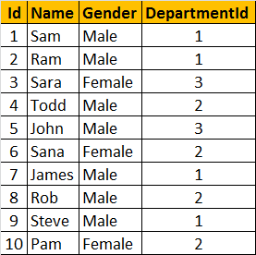

Re-written stored procedure using return variables

Create Procedure spGetTotalCountOfEmployees2

as

Begin

return (Select COUNT(ID) from Employees)

End

Executing spGetTotalCountOfEmployees2 returns 3.

Declare @TotalEmployees int

Execute @TotalEmployees = spGetTotalCountOfEmployees2

Select @TotalEmployees

So, we are able to achieve what we want, using output parameters as well as return values. Now, let's look at example, where return status variables cannot be used, but Output parameters can be used.

In this SP, we are retrieving the Name of the employee, based on their Id, using the output parameter @Name.

Create Procedure spGetNameById1

@Id int,

@Name nvarchar(20) Output

as

Begin

Select @Name = Name from tblEmployee Where Id = @Id

End

Executing spGetNameById1, prints the name of the employee

Declare @EmployeeName nvarchar(20)

Execute spGetNameById1 3, @EmployeeName out

Print 'Name of the Employee = ' + @EmployeeName

Now let's try to achieve the same thing, using return status variables.

Create Procedure spGetNameById2

@Id int

as

Begin

Return (Select Name from tblEmployee Where Id = @Id)

End

Executing spGetNameById2 returns an error stating 'Conversion failed when converting the nvarchar value 'Sam' to data type int.'. The return status variable is an integer, and hence, when we select Name of an employee and try to return that we get a converion error.

Declare @EmployeeName nvarchar(20)

Execute @EmployeeName = spGetNameById2 1

Print 'Name of the Employee = ' + @EmployeeName

So, using return values, we can only return integers, and that too, only one integer. It is not possible, to return more than one value using return values, where as output parameters, can return any datatype and an sp can have more than one output parameters. I always prefer, using output parameters, over RETURN values.

In general, RETURN values are used to indicate success or failure of stored procedure, especially when we are dealing with nested stored procedures.Return a value of 0, indicates success, and any nonzero value indicates failure.

**Difference between return values and output parameters**

### **Advantages of using stored procedures - Part 21**

The following advantages of using Stored Procedures over adhoc queries (inline SQL)

1. Execution plan retention and reusability - Stored Procedures are compiled and their execution plan is cached and used again, when the same SP is executed again. Although adhoc queries also create and reuse plan, the plan is reused only when the query is textual match and the datatypes are matching with the previous call. Any change in the datatype or you have an extra space in the query then, a new plan is created.

2. Reduces network traffic - You only need to send, EXECUTE SP\_Name statement, over the network, instead of the entire batch of adhoc SQL code.

3. Code reusability and better maintainability - A stored procedure can be reused with multiple applications. If the logic has to change, we only have one place to change, where as if it is inline sql, and if you have to use it in multiple applications, we end up with multiple copies of this inline sql. If the logic has to change, we have to change at all the places, which makes it harder maintaining inline sql.

4. Better Security - A database user can be granted access to an SP and prevent them from executing direct "select" statements against a table. This is fine grain access control which will help control what data a user has access to.

5. Avoids SQL Injection attack - SP's prevent sql injection attack. Please watch this video on SQL Injection Attack, for more information.

### **Built in string functions in sql server 2008 - Part 22**

Functions in SQL server can be broadly divided into 2 categoris  
**1.** Built-in functions  
**2.** User Defined functions  
  
There are several built-in functions. In this video session, we will look at the most common string functions available.

ASCII(Character\_Expression) - Returns the ASCII code of the given character expression.

To find the ACII Code of capital letter 'A'

Example: Select ASCII('A')

Output: 65

CHAR(Integer\_Expression) - Converts an int ASCII code to a character. The Integer\_Expression, should be between 0 and 255.

The following SQL, prints all the characters for the ASCII values from o thru 255

Declare @Number int

Set @Number = 1

While(@Number <= 255)

Begin

Print CHAR(@Number)

Set @Number = @Number + 1

End

Note: The while loop will become an infinite loop, if you forget to include the following line.

Set @Number = @Number + 1

Printing uppercase alphabets using CHAR() function:

Declare @Number int

Set @Number = 65

While(@Number <= 90)

Begin

Print CHAR(@Number)

Set @Number = @Number + 1

End

Printing lowercase alphabets using CHAR() function:

Declare @Number int

Set @Number = 97

While(@Number <= 122)

Begin

Print CHAR(@Number)

Set @Number = @Number + 1 End

Another way of printing lower case alphabets using CHAR() and LOWER() functions.

Declare @Number int

Set @Number = 65

While(@Number <= 90)

Begin

Print LOWER(CHAR(@Number))

Set @Number = @Number + 1

End

LTRIM(Character\_Expression) - Removes blanks on the left handside of the given character expression.

Example: Removing the 3 white spaces on the left hand side of the ' Hello' string using LTRIM() function.

Select LTRIM(' Hello')

Output: Hello

RTRIM(Character\_Expression) - Removes blanks on the right hand side of the given character expression.

Example: Removing the 3 white spaces on the left hand side of the 'Hello ' string using RTRIM() function.

Select RTRIM('Hello ')

Output: Hello

Example: To remove white spaces on either sides of the given character expression, use LTRIM() and RTRIM() as shown below.

Select LTRIM(RTRIM(' Hello '))

Output: Hello

LOWER(Character\_Expression) - Converts all the characters in the given Character\_Expression, to lowercase letters.

Example: Select LOWER('CONVERT This String Into Lower Case')

Output: convert this string into lower case

UPPER(Character\_Expression) - Converts all the characters in the given Character\_Expression, to uppercase letters.

Example: Select UPPER('CONVERT This String Into upper Case')

Output: CONVERT THIS STRING INTO UPPER CASE

REVERSE('Any\_String\_Expression') - Reverses all the characters in the given string expression.

Example: Select REVERSE('ABCDEFGHIJKLMNOPQRSTUVWXYZ')

Output: ZYXWVUTSRQPONMLKJIHGFEDCBA

LEN(String\_Expression) - Returns the count of total characters, in the given string expression, excluding the blanks at the end of the expression.

Example: Select LEN('SQL Functions ')

Output: 13

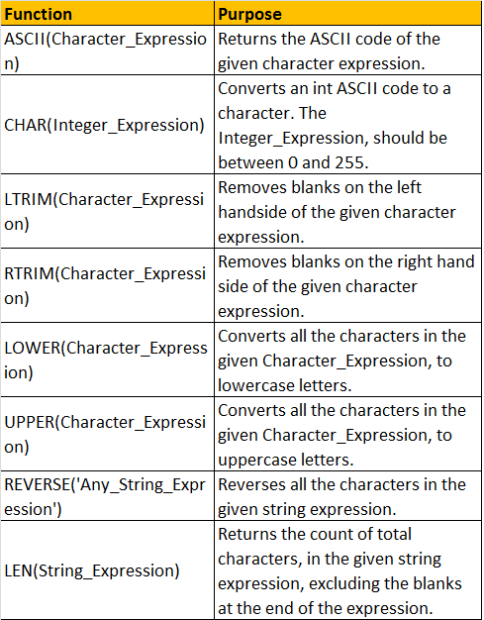

### **LEFT, RIGHT, CHARINDEX and SUBSTRING functions - Part 23**

In this video we will learn about the commonly used built-in string functions in SQL server and finally, a real time example of using string functions. Please watch the following videos, before continuing with this video.

LEFT(Character\_Expression, Integer\_Expression) - Returns the specified number of characters from the left hand side of the given character expression.

Example: Select LEFT('ABCDE', 3)

Output: ABC

RIGHT(Character\_Expression, Integer\_Expression) - Returns the specified number of characters from the right hand side of the given character expression.

Example: Select RIGHT('ABCDE', 3)

Output: CDE

CHARINDEX('Expression\_To\_Find', 'Expression\_To\_Search', 'Start\_Location') - Returns the starting position of the specified expression in a character string. Start\_Location parameter is optional.

Example: In this example, we get the starting position of '@' character in the email string 'sara@aaa.com'.

Select CHARINDEX('@','sara@aaa.com',1)

Output: 5

SUBSTRING('Expression', 'Start', 'Length') - As the name, suggests, this function returns substring (part of the string), from the given expression. You specify the starting location using the 'start' parameter and the number of characters in the substring using 'Length' parameter. All the 3 parameters are mandatory.

Example: Display just the domain part of the given email 'John@bbb.com'.

Select SUBSTRING('John@bbb.com',6, 7)

Output: bbb.com

In the above example, we have hardcoded the starting position and the length parameters. Instead of hardcoding we can dynamically retrieve them using CHARINDEX() and LEN() string functions as shown below.

Example:

Select SUBSTRING('John@bbb.com',(CHARINDEX('@', 'John@bbb.com') + 1), (LEN('John@bbb.com') - CHARINDEX('@','John@bbb.com')))

Output: bbb.com

Real time example, where we can use LEN(), CHARINDEX() and SUBSTRING() functions. Let us assume we have table as shown below.

Write a query to find out total number of emails, by domain. The result of the query should be as shown below.

Query

Select SUBSTRING(Email, CHARINDEX('@', Email) + 1,

LEN(Email) - CHARINDEX('@', Email)) as EmailDomain,

COUNT(Email) as Total

from tblEmployee

Group By SUBSTRING(Email, CHARINDEX('@', Email) + 1,

LEN(Email) - CHARINDEX('@', Email))

**Replicate, Space, Patindex, Replace and Stuff functions - Part 24**

REPLICATE(String\_To\_Be\_Replicated, Number\_Of\_Times\_To\_Replicate) - Repeats the given string, for the specified number of times.

Example: SELECT REPLICATE('Pragim', 3)

Output: Pragim Pragim Pragim

A practical example of using REPLICATE() function: We will be using this table, for the rest of our examples in this article.

Let's mask the email with 5 \* (star) symbols. The output should be as shown below.

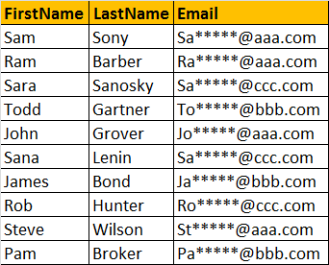

Query:

Select FirstName, LastName, SUBSTRING(Email, 1, 2) + REPLICATE('\*',5) +

SUBSTRING(Email, CHARINDEX('@',Email), LEN(Email) - CHARINDEX('@',Email)+1) as Email

from tblEmployee

SPACE(Number\_Of\_Spaces) - Returns number of spaces, specified by the Number\_Of\_Spaces argument.

Example: The SPACE(5) function, inserts 5 spaces between FirstName and LastName

Select FirstName + SPACE(5) + LastName as FullName

From tblEmployee

PATINDEX('%Pattern%', Expression)

Returns the starting position of the first occurrence of a pattern in a specified expression. It takes two arguments, the pattern to be searched and the expression. PATINDEX() is simial to CHARINDEX(). With CHARINDEX() we cannot use wildcards, where as PATINDEX() provides this capability. If the specified pattern is not found, PATINDEX() returns ZERO.

Example:

Select Email, PATINDEX('%@aaa.com', Email) as FirstOccurence

from tblEmployee

Where PATINDEX('%@aaa.com', Email) > 0

REPLACE(String\_Expression, Pattern , Replacement\_Value)

Replaces all occurrences of a specified string value with another string value.

Example: All .COM strings are replaced with .NET

Select Email, REPLACE(Email, '.com', '.net') as ConvertedEmail

from tblEmployee

STUFF(Original\_Expression, Start, Length, Replacement\_expression)

STUFF() function inserts Replacement\_expression, at the start position specified, along with removing the charactes specified using Length parameter.

Example:

Select FirstName, LastName,Email, STUFF(Email, 2, 3, '\*\*\*\*\*') as StuffedEmail

From tblEmployee

**DateTime functions in SQL Server - Part 25**

In this video session we will learn about

1. DateTime data types

2. DateTime functions available to select the current system date and time

3. Understanding concepts - UTC time and Time Zone offset

There are several built-in DateTime functions available in SQL Server. All the following functions can be used to get the current system date and time, where you have sql server installed.

|  |  |  |
| --- | --- | --- |
| **Function** | **Date Time Format** | **Description** |
| GETDATE() | 2012-08-31 20:15:04.543 | Commonly used function |
| CURRENT\_TIMESTAMP | 2012-08-31 20:15:04.543 | ANSI SQL equivalent to GETDATE |
| SYSDATETIME() | 2012-08-31 20:15:04.5380028 | More fractional seconds precision |
| SYSDATETIMEOFFSET() | 2012-08-31 20:15:04.5380028 + 01:00 | More fractional seconds precision + Time zone offset |
| GETUTCDATE() | 2012-08-31 19:15:04.543 | UTC Date and Time |
| SYSUTCDATETIME() | 2012-08-31 19:15:04.5380028 | UTC Date and Time, with More fractional seconds precision |

Note: UTC stands for Coordinated Universal Time, based on which, the world regulates clocks and time. There are slight differences between GMT and UTC, but for most common purposes, UTC is synonymous with GMT.

To practically understand how the different date time datatypes available in SQL Server, store data, create the sample table tblDateTime.

CREATE TABLE [tblDateTime]

(

[c\_time] [time](7) NULL,

[c\_date] [date] NULL,

[c\_smalldatetime] [smalldatetime] NULL,

[c\_datetime] [datetime] NULL,

[c\_datetime2] [datetime2](7) NULL,

[c\_datetimeoffset] [datetimeoffset](7) NULL

)

To Insert some sample data, execute the following query.

INSERT INTO tblDateTime VALUES (GETDATE(),GETDATE(),GETDATE(),GETDATE(),GETDATE(),GETDATE())

Now, issue a select statement, and you should see, the different types of datetime datatypes, storing the current datetime, in different formats.

**IsDate, Day, Month, Year and DateName DateTime functions in SQL Server - Part 26**

ISDATE() - Checks if the given value, is a valid date, time, or datetime. Returns 1 for success, 0 for failure.

Examples:

Select ISDATE('PRAGIM') -- returns 0

Select ISDATE(Getdate()) -- returns 1

Select ISDATE('2012-08-31 21:02:04.167') -- returns 1

Note: For datetime2 values, IsDate returns ZERO.

Example:

Select ISDATE('2012-09-01 11:34:21.1918447') -- returns 0.

Day() - Returns the 'Day number of the Month' of the given date

Examples:

Select DAY(GETDATE()) -- Returns the day number of the month, based on current system datetime.

Select DAY('01/31/2012') -- Returns 31

Month() - Returns the 'Month number of the year' of the given date

Examples:

Select Month(GETDATE()) -- Returns the Month number of the year, based on the current system date and time

Select Month('01/31/2012') -- Returns 1

Year() - Returns the 'Year number' of the given date

Examples:

Select Year(GETDATE()) -- Returns the year number, based on the current system date

Select Year('01/31/2012') -- Returns 2012

DateName(DatePart, Date) - Returns a string, that represents a part of the given date. This functions takes 2 parameters. The first parameter 'DatePart' specifies, the part of the date, we want. The second parameter, is the actual date, from which we want the part of the Date.

**Examples:**  
Select DATENAME(Day, '2012-09-30 12:43:46.837') -- Returns 30  
Select DATENAME(WEEKDAY, '2012-09-30 12:43:46.837') -- Returns Sunday

Select DATENAME(MONTH, '2012-09-30 12:43:46.837') -- Returns September

A simple practical example using some of these DateTime functions. Consider the table tblEmployees.

Write a query, which returns Name, DateOfBirth, Day, MonthNumber, MonthName, and Year as shown below.

Query:

Select Name, DateOfBirth, DateName(WEEKDAY,DateOfBirth) as [Day],

Month(DateOfBirth) as MonthNumber,

DateName(MONTH, DateOfBirth) as [MonthName],

Year(DateOfBirth) as [Year]

From tblEmployees

### **DatePart, DateAdd and DateDiff functions in SQL Server - Part 27**

**DatePart**(DatePart, Date) - Returns an integer representing the specified DatePart. This function is simialar to DateName(). DateName() returns nvarchar, where as DatePart() returns an integer. The valid DatePart parameter values are shown below.

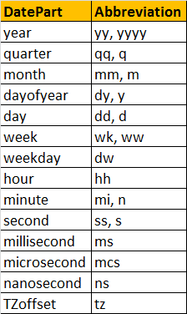

Examples:

Select DATEPART(weekday, '2012-08-30 19:45:31.793') -- returns 5

Select DATENAME(weekday, '2012-08-30 19:45:31.793') -- returns Thursday

DATEADD (datepart, NumberToAdd, date) - Returns the DateTime, after adding specified NumberToAdd, to the datepart specified of the given date.

Examples:

Select DateAdd(DAY, 20, '2012-08-30 19:45:31.793')

-- Returns 2012-09-19 19:45:31.793

Select DateAdd(DAY, -20, '2012-08-30 19:45:31.793')

-- Returns 2012-08-10 19:45:31.793

DATEDIFF(datepart, startdate, enddate) - Returns the count of the specified datepart boundaries crossed between the specified startdate and enddate.

Examples:

Select DATEDIFF(MONTH, '11/30/2005','01/31/2006') -- returns 2

Select DATEDIFF(DAY, '11/30/2005','01/31/2006') -- returns 62

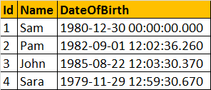

Write a query to compute the age of a person, when the date of birth is given. The output should be as shown below.

CREATE FUNCTION fnComputeAge(@DOB DATETIME)  
RETURNS NVARCHAR(50)  
AS  
BEGIN  
  
DECLARE @tempdate DATETIME, @years INT, @months INT, @days INT  
SELECT @tempdate = @DOB  
  
SELECT @years = DATEDIFF(YEAR, @tempdate, GETDATE()) - CASE WHEN (MONTH(@DOB) > MONTH(GETDATE())) OR (MONTH(@DOB) = MONTH(GETDATE()) AND DAY(@DOB) > DAY(GETDATE())) THEN 1 ELSE 0 END  
SELECT @tempdate = DATEADD(YEAR, @years, @tempdate)

SELECT @months = DATEDIFF(MONTH, @tempdate, GETDATE()) - CASE WHEN DAY(@DOB) > DAY(GETDATE()) THEN 1 ELSE 0 END  
SELECT @tempdate = DATEADD(MONTH, @months, @tempdate)  
  
SELECT @days = DATEDIFF(DAY, @tempdate, GETDATE())  
  
DECLARE @Age NVARCHAR(50)  
SET @Age = Cast(@years AS  NVARCHAR(4)) + ' Years ' + Cast(@months AS  NVARCHAR(2))+ ' Months ' +  Cast(@days AS  NVARCHAR(2))+ ' Days Old'  
RETURN @Age  
  
End  
  
**Using the function in a query to get the expected output along with the age of the person.**  
Select Id, Name, DateOfBirth, dbo.fnComputeAge(DateOfBirth) as Age from tblEmployees

select ISDATE('sunanda');--0

select ISDATE('23:52:41.8962531');--0

select ISDATE(GETDATE());--1

select ISDATE('2018-12-15');--1

select ISDATE('12-15-2018');--1

select ISDATE('12-15-2018 23:52:41.896');--1

select ISDATE('12-15-2018 23:52:41.8964124');--0

select ISDATE('12-15-2018 23:52:41.8964124 +12:00');--0

--NOTE time,datetime2 & datetimeoffset it retuens ZERO

---------------------------------------------------------

--retuens DAY or MONTH or YEAR number of perticular date

--DAY()

select DAY('1996-04-15') --DAY 15

select MONTH('1996-04-15') --DAY 04

select YEAR('1996-04-15') --DAY 1996

select DAY(GETDATE())

select MONTH(GETDATE())

select YEAR(GETDATE())

--------------------------------------------

--returns the string that part of pericular string

--DATENAME(daypart,date)

select DATENAME(Weekday,Getdate())

select DATENAME(month,Getdate())

select DATENAME(year,Getdate())

select DATENAME(hour,Getdate())

select DATENAME(minute,Getdate())

select DATENAME(second,Getdate())

select DATENAME(millisecond,Getdate())

select DATENAME(microsecond,Getdate())

select DATENAME(nanosecond,Getdate())

select DATENAME(QUARTER,Getdate())

select DATENAME(QUARTER,'03-25-2018')

select DATENAME(QUARTER,'06-25-2018')

select DATENAME(QUARTER,'09-25-2018')

select DATENAME(QUARTER,'12-25-2018')

select DATENAME(week,'01-01-2018')

select DATENAME(week,'01-31-2018')

select DATENAME(week,'02-01-2018')

select DATENAME(week,'02-21-2018')

select DATENAME(week,'02-28-2018')

select DATENAME(week,'12-31-2018')

select DATENAME(DAYOFYEAR,'01-01-2018')

select DATENAME(DAYOFYEAR,'12-31-2018')

select DATENAME(TZOFFSET,'12-31-2018')

-----------------------------------------

--returns the integer that part of pericular string

--DATEPART(daypart,date)

select DATEPART(Weekday,Getdate())

select DATEPART(month,Getdate())

select DATEPART(year,Getdate())

select DATEPART(hour,Getdate())

select DATEPART(minute,Getdate())

select DATEPART(second,Getdate())

select DATEPART(millisecond,Getdate())

select DATEPART(microsecond,Getdate())

select DATEPART(nanosecond,Getdate())

select DATEPART(QUARTER,Getdate())

select DATEPART(QUARTER,'03-25-2018')

select DATEPART(QUARTER,'06-25-2018')

select DATEPART(QUARTER,'09-25-2018')

select DATEPART(QUARTER,'12-25-2018')

select DATEPART(week,'01-01-2018')

select DATEPART(week,'01-31-2018')

select DATEPART(week,'02-01-2018')

select DATEPART(week,'02-21-2018')

select DATEPART(week,'02-28-2018')

select DATEPART(week,'12-31-2018')

select DATEPART(DAYOFYEAR,'01-01-2018')

select DATEPART(DAYOFYEAR,'12-31-2018')

select DATEPART(TZOFFSET,'12-31-2018')

---------------------------------------

--comaprision of DatePart & Date Name

select DATENAME(month,Getdate())

select DATENAME(year,Getdate())

select DATENAME(weekday,Getdate())

select DATEPART(month,Getdate())

select DATEPART(year,Getdate())

select DATEPART(weekday,Getdate())

-------------------------------------------

--DateAdd(datepart,NumberTOadd,Add)

select DateAdd(month,10,'2018-02-21')--it will add 10 mnths 2018-12-21 00:00:00.000

select DateAdd(year,10,'2018-02-21')--it will add 10 YEARS 2028-02-21 00:00:00.000

select DateAdd(weekday,10,'2018-02-21')--it will add 10 Days 2018-03-03 00:00:00.000

select DateAdd(month,-10,'2018-02-21')--it will remove 10 mnths 2017-04-21 00:00:00.000

select DateAdd(year,-10,'2018-02-21')--it will remove 10 YEARS 2008-02-21 00:00:00.000

select DateAdd(weekday,-10,'2018-02-21')--it will remove 10 Days 2018-02-11 00:00:00.000

### **Cast and Convert functions in SQL Server - Part 28**

To convert one data type to another, CAST and CONVERT functions can be used.   
  
**Syntax of CAST and CONVERT functions from MSDN:**  
CAST ( expression AS data\_type [ ( length ) ] )  
CONVERT ( data\_type [ ( length ) ] , expression [ , style ] )  
  
From the syntax, it is clear that CONVERT() function has an optional style parameter, where as CAST() function lacks this capability.

The following 2 queries convert, **DateOfBirth's DateTime datatype**to **NVARCHAR**. The first query uses the CAST() function, and the second one uses CONVERT() function. The output is exactly the same for both the queries as shown below.

Select Id, Name, DateOfBirth, CAST(DateofBirth as nvarchar) as ConvertedDOB  
from tblEmployees

Select Id, Name, DateOfBirth, Convert(nvarchar, DateOfBirth) as ConvertedDOB  
from tblEmployees  
  
**Output:**

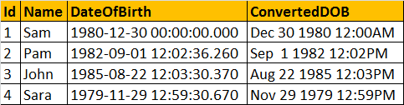

Now, let's use the **style**parameter of the CONVERT() function, to format the Date as we would like it. In the query below, we are using **103**as the argument for **style** parameter, which formats the date as **dd/mm/yyyy**.  
Select Id, Name, DateOfBirth, Convert(nvarchar, DateOfBirth, 103) as ConvertedDOB  
from tblEmployees  
  
**Output:**

**The following table lists a few of the common DateTime styles:**

[**For complete list of all the Date and Time Styles, please check MSDN.**](http://msdn.microsoft.com/en-us/library/ms187928.aspx)  
  
**To get just the date part, from DateTime**  
SELECT CONVERT(VARCHAR(10),GETDATE(),101)  
  
**In SQL Server 2008, Date datatype is introduced, so you can also use**  
SELECT CAST(GETDATE() as DATE)  
SELECT CONVERT(DATE, GETDATE())  
  
**Note:** To control the formatting of the Date part, DateTime has to be converted to NVARCHAR using the styles provided. When converting to DATE data type, the CONVERT() function will ignore the style parameter.

Now, let's write a query which produces the following output:

**In this query**, we are using CAST() function, to convert **Id (int)**to **nvarchar**, so it can be appended with the **NAME**column. If you remove the CAST() function, you will get an error stating - 'Conversion failed when converting the nvarchar value 'Sam - ' to data type int.'

Select Id, Name, Name + ' - ' + CAST(Id AS NVARCHAR) AS [Name-Id]  
FROM tblEmployees

**Now let's look at a practical example**of using CAST function. Consider the registrations table below.

**Write a query which returns the total number of registrations by day**

Query:

Select CAST(RegisteredDate as DATE) as RegistrationDate,

COUNT(Id) as TotalRegistrations

From tblRegistrations

Group By CAST(RegisteredDate as DATE)

The following are the differences between the 2 functions.

1. Cast is based on ANSI standard and Convert is specific to SQL Server. So, if portability is a concern and if you want to use the script with other database applications, use Cast().

2. Convert provides **more flexibility** than Cast. For example, it's possible to control how you want DateTime datatypes to be converted using styles with convert function.  
  
The general guideline is to use CAST(), unless you want to take advantage of the style functionality in CONVERT().

### **Mathematical functions in sql server - Part 29**

**In this video session**, we will understand the commonly used mathematical functions in sql server like, Abs, Ceiling, Floor, Power, Rand, Square, Sqrt, and Round functions  
  
**ABS ( numeric\_expression )** - ABS stands for absolute and returns, the absolute (positive) number.   
  
**For example**, Select ABS(-101.5) -- returns 101.5, without the - sign.

# **CEILING ( numeric\_expression ) and FLOOR ( numeric\_expression )** **CEILING**and **FLOOR** functions accept a numeric expression as a single parameter. CEILING() returns the smallest integer value greater than or equal to the parameter, whereas FLOOR() returns the largest integer less than or equal to the parameter.  **Examples:** Select CEILING(15.2) -- Returns 16 Select CEILING(-15.2) -- Returns -15 Select FLOOR(15.2) -- Returns 15 Select FLOOR(-15.2) -- Returns -16 **Power(expression, power)** - Returns the power value of the specified expression to the specified power. **Example**: The following example calculates '2 TO THE POWER OF 3' = 2\*2\*2 = 8

### Select POWER(2,3) -- Returns 8 **RAND([Seed\_Value])** - Returns a random float number between 0 and 1. Rand() function takes an optional seed parameter. When seed value is supplied the  RADN() function always returns the same value for the same seed. **Example:** Select RAND(1) -- Always returns the same value **If you want to generate a random number between 1 and 100**, RAND() and FLOOR() functions can be used as shown below. Every time, you execute this query, you get a random number between 1 and 100. Select FLOOR(RAND() \* 100) **The following query prints 10 random numbers between 1 and 100.** Declare @Counter INT Set @Counter = 1 While(@Counter <= 10) Begin Print FLOOR(RAND() \* 100) Set @Counter = @Counter + 1 End **SQUARE ( Number )** - Returns the square of the given number. **Example:** Select SQUARE(9) -- Returns 81 **SQRT ( Number )** - SQRT stands for Square Root. This function returns the square root of the given value. **Example:** Select SQRT(81) -- Returns 9 **ROUND ( numeric\_expression , length [ ,function ] )** - Rounds the given numeric expression based on the given length. This function takes 3 parameters.  **1. Numeric\_Expression** is the number that we want to round. **2. Length parameter**, specifies the number of the digits that we want to round to. If the length is a positive number, then the rounding is applied for the decimal part, where as if the length is negative, then the rounding is applied to the number before the decimal. **3. The optional function parameter**, is used to indicate rounding or truncation operations. A value of 0, indicates rounding, where as a value of non zero indicates truncation. Default, if not specified is 0. **Examples:** -- Round to 2 places after (to the right) the decimal point Select ROUND(850.556, 2) -- Returns 850.560 -- Truncate anything after 2 places, after (to the right) the decimal point Select ROUND(850.556, 2, 1) -- Returns 850.550 -- Round to 1 place after (to the right) the decimal point Select ROUND(850.556, 1) -- Returns 850.600 -- Truncate anything after 1 place, after (to the right) the decimal point Select ROUND(850.556, 1, 1) -- Returns 850.500 -- Round the last 2 places before (to the left) the decimal point Select ROUND(850.556, -2) -- 900.000 -- Round the last 1 place before (to the left) the decimal point Select ROUND(850.556, -1) -- 850.000

### **Scalar User Defined Functions in sql server - Part 30**

**We will cover**  
1. User Defined Functions in sql server  
2. Types of User Defined Functions  
3. Creating a Scalar User Defined Function  
4. Calling a Scalar User Defined Function  
5. Places where we can use Scalar User Defined Function  
6. Altering and Dropping a User Defined Function

**In SQL Server there are 3 types of User Defined functions**  
1. Scalar functions  
2. Inline table-valued functions  
3. Multistatement table-valued functions  
  
**Scalar functions** may or may not have parameters, but always return a single (scalar) value. The returned value can be of any data type, except **text, ntext, image, cursor, and timestamp**.  
  
**To create a function, we use the following syntax:**  
CREATE FUNCTION Function\_Name(@Parameter1 DataType, @Parameter2 DataType,..@Parametern Datatype)  
RETURNS Return\_Datatype  
AS  
BEGIN  
    Function Body  
    Return Return\_Datatype  
END  
  
Let us now create a function which calculates and returns the age of a person. To compute the age we require, date of birth. So, let's pass date of birth as a parameter. So, AGE() function returns an integer and accepts date parameter.  
CREATE FUNCTION Age(@DOB Date)    
RETURNS INT    
AS    
BEGIN    
 DECLARE @Age INT    
 SET @Age = DATEDIFF(YEAR, @DOB, GETDATE()) - CASE WHEN (MONTH(@DOB) > MONTH(GETDATE())) OR (MONTH(@DOB) = MONTH(GETDATE()) AND DAY(@DOB) > DAY(GETDATE())) THEN 1 ELSE 0 END    
 RETURN @Age    
END  
  
  
**When calling a scalar user-defined function**, you must supply a two-part name, **OwnerName.FunctionName**. **dbo** stands for database owner.  
Select dbo.Age( dbo.Age('10/08/1982')  
  
**You can also invoke it using the complete 3 part name**, DatabaseName.OwnerName.FunctionName.  
Select SampleDB.dbo.Age('10/08/1982')  
  
**Consider the Employees table below.**

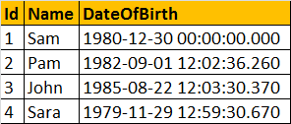

**Scalar user defined functions can be used in the Select clause** as shown below.  
Select Name, DateOfBirth, dbo.Age(DateOfBirth) as Age from tblEmployees

**Scalar user defined functions can be used in the Where clause**, as shown below.  
Select Name, DateOfBirth, dbo.Age(DateOfBirth) as Age   
from tblEmployees  
Where dbo.Age(DateOfBirth) > 30

**A stored procedure** also can accept DateOfBirth and return Age, but you cannot use stored procedures in a **select or where clause**. This is just one difference between a function and a stored procedure. There are several other differences, which we will talk about in a later session.  
  
To alter a function we use ALTER FUNCTION FuncationName statement and to delete it, we use DROP FUNCTION FuncationName.

### **Inline table valued functions - Part 31**

From Part 30, We learnt that, a scalar function, returns a **single**value. on the other hand, an Inline Table Valued function, return a **table**.   
  
**Syntax for creating an inline table valued function**

CREATE FUNCTION Function\_Name(@Param1 DataType, @Param2 DataType..., @ParamN DataType)  
RETURNS TABLE  
AS  
RETURN (Select\_Statement)

**Consider this Employees table** shown below, which we will be using for our example.

**Create a function that returns EMPLOYEES by GENDER.**

CREATE FUNCTION fn\_EmployeesByGender(@Gender nvarchar(10))  
RETURNS TABLE  
AS  
RETURN (Select Id, Name, DateOfBirth, Gender, DepartmentId  
     from tblEmployees  
     where Gender = @Gender)  
  
**If you look at the way we implemented this function**, it is very similar to SCALAR function, with the following differences  
1. We specify **TABLE**as the return type, instead of any **scalar** data type  
2. The **function body** is not enclosed between **BEGIN and END** block. Inline table valued function body, cannot have BEGIN and END block.  
3. The **structure of the table** that gets returned, is determined by the SELECT statement with in the function.  
  
**Calling the user defined function**  
Select \* from fn\_EmployeesByGender('Male')

OUTPUT :

As the inline user defined function, is returning a table, issue the select statement against the function, as if you are selecting the data from a TABLE.  
  
**Where can we use Inline Table Valued functions**  
1. Inline Table Valued functions can be used to achieve the functionality of parameterized views. We will talk about views, in a later session.  
2. The table returned by the table valued function, can also be used in joins with other tables.

**Consider the Departments Table**

**Joining the Employees returned by the function, with the Departments table**  
Select Name, Gender, DepartmentName   
from fn\_EmployeesByGender('Male') E  
Join tblDepartment D on D.Id = E.DepartmentId  
  
**Executing the above query should produce the following output**

### **Multi-Statement Table Valued Functions in SQL Server - Part 32**

We have discussed about [**scalar functions in Part 29**](http://csharp-video-tutorials.blogspot.com/2012/09/scalar-user-defined-functions-in-sql.html) and [**Inline Table Valued functions in Part 30**](http://csharp-video-tutorials.blogspot.com/2012/09/inline-table-valued-functions-part-31.html). In this video session, we will discuss about Multi-Statement Table Valued functions.

Multi statement table valued functions are very similar to Inline Table valued functions, with a few differences. Let's look at an example, and then note the differences.

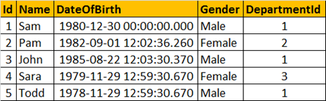

**Let's write an Inline and multi-statement Table Valued functions that can return the output shown below.**  
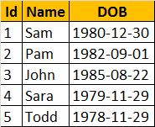

**Inline Table Valued function(ILTVF):**  
Create Function fn\_ILTVF\_GetEmployees()  
Returns Table  
as  
Return (Select Id, Name, Cast(DateOfBirth as Date) as DOB  
        From tblEmployees)  
  
  
**Multi-statement Table Valued function(MSTVF):**  
Create Function fn\_MSTVF\_GetEmployees()  
Returns @Table Table (Id int, Name nvarchar(20), DOB Date)  
as  
Begin  
 Insert into @Table  
 Select Id, Name, Cast(DateOfBirth as Date)  
 From tblEmployees  
   
 Return  
End  
  
**Calling the Inline Table Valued Function:**  
Select \* from fn\_ILTVF\_GetEmployees()  
  
**Calling the Multi-statement Table Valued Function:**  
Select \* from fn\_MSTVF\_GetEmployees()  
  
**Now let's understand the differences between Inline Table Valued functions and Multi-statement Table Valued functions**  
1. In an Inline Table Valued function, the RETURNS clause cannot contain the structure of the table, the function returns. Where as, with the multi-statement table valued function, we specify the structure of the table that gets returned

2. Inline Table Valued function cannot have BEGIN and END block, where as the multi-statement function can have.  
3. Inline Table valued functions are better for performance, than multi-statement table valued functions. If the given task, can be achieved using an inline table valued function, always prefer to use them, over multi-statement table valued functions.  
4. It's possible to update the underlying table, using an inline table valued function, but not possible using multi-statement table valued function.  
  
**Updating the underlying table using inline table valued function:**  
This query will change **Sam** to **Sam1**, in the underlying table **tblEmployees**. When you try do the same thing with the multi-statement table valued function, you will get an error stating 'Object 'fn\_MSTVF\_GetEmployees' cannot be modified.'  
Update fn\_ILTVF\_GetEmployees() set Name='Sam1' Where Id = 1  
  
**Reason for improved performance of an inline table valued function:**  
Internally, SQL Server treats an inline table valued function much like it would a view and treats a multi-statement table valued function similar to how it would a stored procedure.

### **Important concepts related to Functions in sql server - Part 33**

**Deterministic and Nondeterministic Functions:**  
Deterministic functions always return the **same result** any time they are called with a specific set of input values and given the same state of the database.   
**Examples**: Sum(), AVG(), Square(), Power() and Count()  
  
**Note**: All aggregate functions are deterministic functions.

**Nondeterministic functions** may return **different results** each time they are called with a specific set of input values even if the database state that they access remains the same.  
**Examples**: GetDate() and CURRENT\_TIMESTAMP  
  
Rand() function is a **Non-deterministic function**, but if you provide the **seed value**, the function becomes **deterministic**, as the same value gets returned for the same seed value.

**We will be using tblEmployees table, for the rest of our examples**. Please, create the table using this script.  
CREATE TABLE [dbo].[tblEmployees]  
(  
 [Id] [int] Primary Key,  
 [Name] [nvarchar](50) NULL,  
 [DateOfBirth] [datetime] NULL,  
 [Gender] [nvarchar](10) NULL,  
 [DepartmentId] [int] NULL )  
**Insert rows into the table using the insert script below.**  
Insert into tblEmployees values(1,'Sam','1980-12-30 00:00:00.000','Male',1) Insertinto tblEmployees values(2,'Pam','1982-09-01 12:02:36.260','Female',2)  
Insert into tblEmployees values(3,'John','1985-08-22 12:03:30.370','Male',1)  
Insert into tblEmployees values(4,'Sara','1979-11-29 12:59:30.670','Female',3)  
Insert into tblEmployees values(5,'Todd','1978-11-29 12:59:30.670','Male',1)  
  
**Encrypting a function definiton using WITH ENCRYPTION OPTION:**  
We have learnt how to encrypt Stored procedure text using WITH ENCRYPTION OPTION in [**Part 18 of this video series**](http://csharp-video-tutorials.blogspot.com/2012/08/stored-procedures-part-18.html). Along the same lines, you can also encrypt a function text. Once, encrypted, you cannot view the text of the function, using **sp\_helptext**system stored procedure. If you try to, you will get a message stating 'The text for object is encrypted.' There are ways to decrypt, which is beyond the scope of this video.  
  
**Scalar Function without encryption option:**  
Create Function fn\_GetEmployeeNameById(@Id int)  
Returns nvarchar(20)  
as  
Begin  
 Return (Select Name from tblEmployees Where Id = @Id)  
End  
  
**To view text of the function:**  
sp\_helptex fn\_GetEmployeeNameById  
  
**Now, let's alter the function to use WITH ENCRYPTION OPTION**  
Alter Function fn\_GetEmployeeNameById(@Id int)  
Returns nvarchar(20)  
With Encryption  
as  
Begin  
 Return (Select Name from tblEmployees Where Id = @Id)  
End  
  
**Now try to retrieve, the text of the function, using sp\_helptex fn\_GetEmployeeNameById**. You will get a message stating 'The text for object 'fn\_GetEmployeeNameById' is encrypted.'  
  
**Creating a function WITH SCHEMABINDING option:**  
1. **The function fn\_GetEmployeeNameById**(), is dependent on tblEmployeestable. 

2. Delete the table **tblEmployees** from the database.  Drop Table tblEmployees

3. Now, execute the function fn\_GetEmployeeNameById(), you will get an error stating 'Invalid object name tblEmployees'. So, we are able to delete the table, while the function is still refrencing it.

4. Now, **recreate the table** and insert data, using the scripts provided.

5. Next, **Alter the function fn\_GetEmployeeNameById()**, to use WITH SCHEMABINDING option.

Alter Function fn\_GetEmployeeNameById(@Id int)  
Returns nvarchar(20)  
With SchemaBinding  
as  
Begin  
 Return (Select Name from dbo.tblEmployees Where Id = @Id)  
End  
  
**Note**: You have to use the **2 part object name** i.e, dbo.tblEmployees, to use WITH SCHEMABINDING option. dbo is the schema name or owner name, tblEmployees is the table name.  
6. Now, **try to drop the table using** - Drop Table tblEmployees. You will get a message stating, 'Cannot DROP TABLE tblEmployees because it is being referenced by object fn\_GetEmployeeNameById.'

So, Schemabinding, specifies that the function is bound to the database objects that it references. When SCHEMABINDING is specified, the base objects cannot be modified in any way that would affect the function definition. The function definition itself must first be modified or dropped to remove dependencies on the object that is to be modified.

### **Temporary tables in SQL Server - Part 34**

**What are Temporary tables?**  
Temporary tables, are very similar to the permanent tables. Permanent tables get created in the database you specify, and remain in the database permanently, until you delete (drop) them. On the other hand, temporary tables get created in the TempDB and are automatically deleted, when they are no longer used.  
  
**Different Types of Temporary tables**  
In SQL Server, there are 2 types of Temporary tables - Local Temporary tables and Global Temporary tables.

**How to Create a Local Temporary Table:**  
Creating a local Temporary table is very similar to creating a permanent table, except that you prefix the **table name with 1 pound (#) symbol**. In the example below, **#PersonDetails** is a local temporary table, with Id and Name columns.  
**Create Table #PersonDetails(Id int, Name nvarchar(20))**  
  
**Insert Data into the temporary table:**  
Insert into #PersonDetails Values(1, 'Mike')  
Insert into #PersonDetails Values(2, 'John')  
Insert into #PersonDetails Values(3, 'Todd')  
  
**Select the data from the temporary table:**  
Select \* from #PersonDetails  
  
**How to check if the local temporary table is created**  
Temporary tables are created in the TEMPDB. Query the sysobjects system table in TEMPDB. The name of the table, is suffixed with lot of underscores and a random number. For this reason you have to use the LIKE operator in the query.  
Select name from tempdb..sysobjects   
where name like '#PersonDetails%'  
  
**You can also check the existence of temporary tables** using object explorer. In the object explorer, expand TEMPDB database folder, and then exapand TEMPORARY TABLES folder, and you should see the temporary table that we have created.  
  
**A local temporary table is available, only for the connection** that has created the table. If you open another query window, and execute the following query you get an error stating 'Invalid object name #PersonDetails'. This proves that local temporary tables are available, only for the connection that has created them.

**A local temporary table is automatically dropped**, when the connection that has created the it, is closed. If the user wants to explicitly drop the temporary table, he can do so using  
DROP TABLE #PersonDetails  
  
**If the temporary table, is created inside the stored procedure**, it get's dropped automatically upon the completion of stored procedure execution. The stored procedure below, creates **#PersonDetails** temporary table, populates it and then finally returns the data and destroys the temporary table immediately after the completion of the stored procedure execution.

Create Procedure spCreateLocalTempTable  
as  
Begin  
Create Table #PersonDetails(Id int, Name nvarchar(20))  
Insert into #PersonDetails Values(1, 'Mike')  
Insert into #PersonDetails Values(2, 'John')  
Insert into #PersonDetails Values(3, 'Todd')  
Select \* from #PersonDetails  
End  
  
**It is also possible for different connections**, to create a local temporary table with the same name. For example User1 and User2, both can create a local temporary table with the same name #PersonDetails. Now, if you expand the Temporary Tables folder in the TEMPDB database, you should see 2 tables with name #PersonDetails and some random number at the end of the name. To differentiate between, the User1 and User2 local temp tables, sql server appends the random number at the end of the temp table name.   
  
**How to Create a Global Temporary Table:**  
To create a Global Temporary Table, prefix the name of the table with 2 pound (##) symbols. EmployeeDetails Table is the global temporary table, as we have prefixed it with 2 ## symbols.  
Create Table ##EmployeeDetails(Id int, Name nvarchar(20))

**Global temporary tables are visible** to all the connections of the sql server, and are only destroyed when the last connection referencing the table is closed.  
  
**Multiple users, across multiple connections** can have local temporary tables with the same name, but, a global temporary table name has to be unique, and if you inspect the name of the global temp table, in the object explorer, there will be no random numbers suffixed at the end of the table name.  
  
**Difference Between Local and Global Temporary Tables:**  
1. Local Temp tables are prefixed with single pound (#) symbol, where as gloabl temp tables are prefixed with 2 pound (##) symbols.  
2. SQL Server appends some random numbers at the end of the local temp table name, where this is not done for global temp table names.  
3. Local temporary tables are only visible to that session of the SQL Server which has created it, where as Global temporary tables are visible to all the SQL server sessions  
4. Local temporary tables are automatically dropped, when the session that created the temporary tables is closed, where as Global temporary tables are destroyed when the last connection that is referencing the global temp table is closed.

### **Indexes in sql server - Part 35**

**Why indexes?**  
Indexes are used by queries to find data from tables quickly. Indexes are created on tables and views. Index on a table or a view, is very similar to an index that we find in a book.  
  
If you don't have an index in a book, and I ask you to locate a specific chapter in that book, you will have to look at every page starting from the first page of the book.  
  
On, the other hand, if you have the index, you lookup the page number of the chapter in the index, and then directly go to that page number to locate the chapter.  
  
Obviously, the book index is helping to drastically reduce the time it takes to find the chapter.  
  
In a similar way, Table and View indexes, can help the query to find data quickly.  
  
In fact, the existence of the right indexes, can drastically improve the performance of the query. If there is no index to help the query, then the query engine, checks every row in the table from the beginning to the end. This is called as Table Scan. Table scan is bad for performance.

**Index Example:**At the moment, the Employees table, does not have an index on SALARY column.

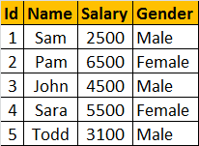  
  
**Consider, the following query**  
Select \* from tblEmployee where Salary > 5000 and Salary < 7000  
To find all the employees, who has salary **greater than 5000 and less than 7000**, the query engine has to check each and every row in the table, resulting in a table scan, which can adversely affect the performance, especially if the table is large. Since there is no index, to help the query, the query engine performs an entire table scan.  
**Now Let's Create the Index to help the query:**Here, we are creating an index on Salary column in the employee table

CREATE Index IX\_tblEmployee\_Salary   
ON tblEmployee (SALARY ASC)  
  
The index stores salary of each employee, in the ascending order as shown below. The actual index may look slightly different.

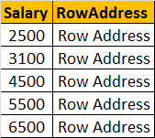

**Now, when the SQL server has to execute the same query**, it has an index on the salary column to help this query. Salaries between the range of 5000 and 7000 are usually present at the bottom, since the salaries are arranged in an ascending order. SQL server picks up the row addresses from the index and directly fetch the records from the table, rather than scanning each row in the table. This is called as Index Seek.  
  
**An Index can also be created graphically using SQL Server Management Studio**

1. In the Object Explorer, expand the Databases folder and then specific database you are working with.  
2. Expand the Tables folder  
3. Expand the Table on which you want to create the index  
4. Right click on the Indexes folder and select New Index  
5. In the New Index dialog box, type in a meaningful name  
6. Select the Index Type and specify Unique or Non Unique Index  
7. Click the Add  
8. Select the columns that you want to add as index key  
9 Click OK  
10. Save the table  
  
**To view the Indexes**: In the object explorer, expand Indexes folder. Alternatively use sp\_helptext system stored procedure. The following command query returns all the indexes on tblEmployee table.  
**Execute sp\_helptext tblEmployee**  
  
**To delete or drop the index:**When dropping an index, specify the table name as well

Drop Index tblEmployee.IX\_tblEmployee\_Salary

### **Clustered and Non-Clustered indexes - Part 36**

[Please watch Part 35 - Indexes in SQL Server, before continuing with this session](http://csharp-video-tutorials.blogspot.com/2012/09/indexes-in-sql-server-part-35.html)  
  
**The following are the different types of indexes in SQL Server**  
1. Clustered  
2. Nonclustered  
3. Unique  
4. Filtered  
5. XML  
6. Full Text  
7. Spatial  
8. Columnstore  
9. Index with included columns  
10. Index on computed columns  
  
We will talk about Clustered and Non-Clustered indexes.

**Clustered Index:**  
A clustered index determines the physical order of data in a table. For this reason, a table can have only one clustered index.   
  
**Create tblEmployees table using the script below.**  
CREATE TABLE [tblEmployee]  
(  
 [Id] int Primary Key,  
 [Name] nvarchar(50),  
 [Salary] int,  
 [Gender] nvarchar(10),  
 [City] nvarchar(50)  
)  
  
Note that **Id**column is marked as **primary key**. Primary key, constraint create **clustered indexes automatically** if no clustered index already exists on the table and a nonclustered index is not specified when you create the PRIMARY KEY constraint.   
  
**To confirm this**, execute sp\_helpindex tblEmployee, which will show a unique clustered index created on the**Id** column.   
  
**Now execute the following insert queries**. Note that, the values for Id column are not in a sequential order.  
Insert into tblEmployee Values(3,'John',4500,'Male','New York')  
Insert into tblEmployee Values(1,'Sam',2500,'Male','London')

Insert into tblEmployee Values(4,'Sara',5500,'Female','Tokyo')  
Insert into tblEmployee Values(5,'Todd',3100,'Male','Toronto')  
Insert into tblEmployee Values(2,'Pam',6500,'Female','Sydney')  
  
**Execute the following SELECT query**  
Select \* from tblEmployee  
  
**Inspite, of inserting the rows in a random order**, when we execute the select query we can see that all the rows in the table are arranged in an ascending order based on the Id column. This is because a clustered index determines the physical order of data in a table, and we have got a clustered index on the Id column.

**Because of the fact that, a clustered index dictates the physical storage order** of the data in a table, a table can contain only one clustered index. If you take the example of **tblEmployee** table, the data is already arranged by the Id column, and if we try to create another clustered index on the **Name column**, the data needs to be rearranged based on the **NAME column**, which will affect the ordering of rows that's already done based on the ID column.  
  
**For this reason**, SQL server doesn't allow us to create more than one clustered index per table. The following SQL script, raises an error stating 'Cannot create more than one clustered index on table 'tblEmployee'. Drop the existing clustered index PK\_\_tblEmplo\_\_3214EC0706CD04F7 before creating another.'  
Create Clustered Index IX\_tblEmployee\_Name  
ON tblEmployee(Name)  
  
**A clustered index is analogous to a telephone directory**, where the data is arranged by the last name. We just learnt that, a table can have only one clustered index. However, the index can contain multiple columns (a composite index), like the way a telephone directory is organized by last name and first name.  
  
**Let's now create a clustered index on 2 columns**. To do this we first have to drop the existing clustered index on the Id column.

Drop index tblEmployee.PK\_\_tblEmplo\_\_3214EC070A9D95DB  
  
**When you execute this query**, you get an error message stating 'An explicit DROP INDEX is not allowed on index 'tblEmployee.PK\_\_tblEmplo\_\_3214EC070A9D95DB'. It is being used for PRIMARY KEY constraint enforcement.' We will talk about the role of unique index in the next session. To successfully delete the clustered index, right click on the index in the Object explorer window and select DELETE.  
  
**Now, execute the following CREATE INDEX query**, to create a composite clustered Index on the Gender and Salary columns.  
Create Clustered Index IX\_tblEmployee\_Gender\_Salary  
ON tblEmployee(Gender DESC, Salary ASC)

**Now, if you issue a select query against this table** you should see the data physically arranged, FIRST by Gender in descending order and then by Salary in ascending order. The result is shown below.  
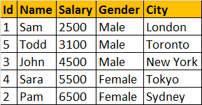  
  
  
**Non Clustered Index:**

A nonclustered index is analogous to an index in a textbook. The data is stored in one place, the index in another place. The index will have pointers to the storage location of the data. Since, the nonclustered index is stored separately from the actual data, a table can have more than one non clustered index, just like how a book can have an index by Chapters at the beginning and another index by common terms at the end.  
  
In the index itself, the data is stored in an ascending or descending order of the index key, which doesn't in any way influence the storage of data in the table.

**The following SQL creates a Nonclustered** index on the NAME column on tblEmployee table:  
Create NonClustered Index IX\_tblEmployee\_Name  
ON tblEmployee(Name)  
  
**Difference between Clustered and NonClustered Index:**  
1. **Only one clustered index per table**, where as you can have more than one non clustered index

2. **Clustered index is faster than a non clustered index**, because, the non-clustered index has to refer back to the table, if the selected column is not present in the index.

3. **Clustered index determines the storage order of rows in the table**, and hence doesn't require additional disk space, but where as a Non Clustered index is stored seperately from the table, additional storage space is required.

# **Difference between Clustered and Non-clustered index**

**1. Clustered Index :**   
Clustered index is created only when both the following conditions satisfy –

1. The data or file, that you are moving into secondary memory should be in sequential or sorted order.
2. There should be a key value, meaning it can not have repeated values.

Whenever you apply clustered indexing in a table, it will perform sorting in that table only. You can create only one clustered index in a table like primary key. Clustered index is as same as dictionary where the data is arranged by alphabetical order.

In clustered index, index contains pointer to block but not direct data. 

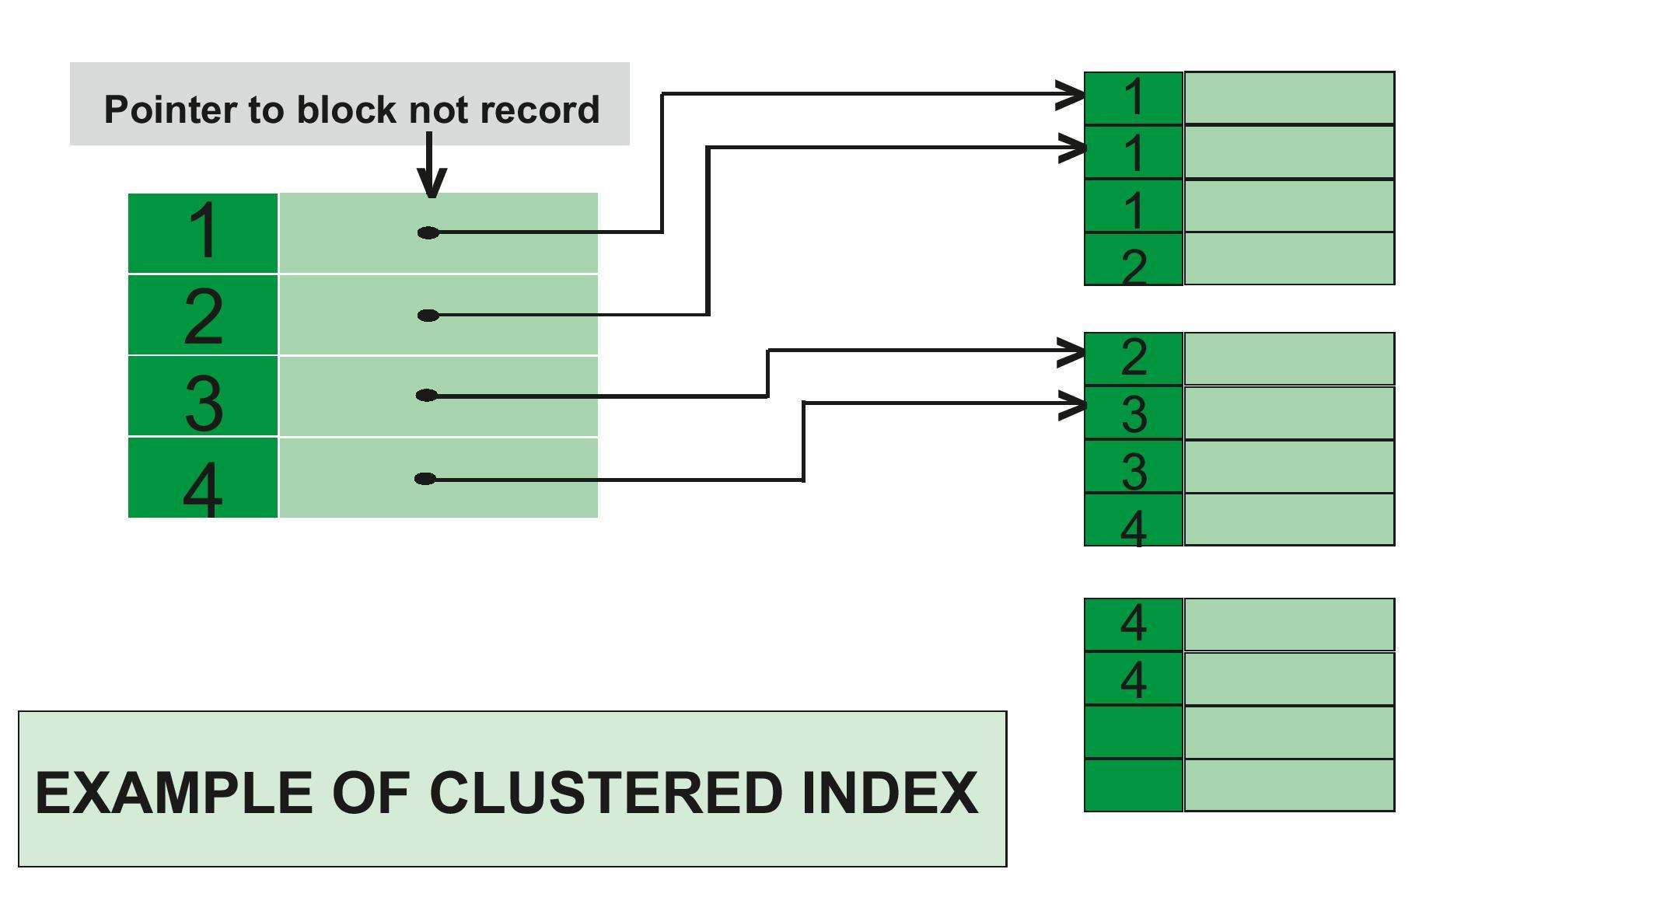

**Example of Clustered Index –**   
If you apply primary key to any column, then automatically it will become clustered index. 

create table Student

( Roll\_No int primary key,

Name varchar(50),

Gender varchar(30),

Mob\_No bigint );

insert into Student

values (4, 'ankita', 'female', 9876543210 );

insert into Student

values (3, 'anita', 'female', 9675432890 );

insert into Student

values (5, 'mahima', 'female', 8976453201 );

In this example, Roll no is a primary key, it will automatically act as a clustered index.   
The output of this code will produce in increasing order of roll no.

| Roll\_No | Name | Gender | Mob\_No |
| --- | --- | --- | --- |
| 3 | anita | female | 9675432890 |
| 4 | ankita | female | 9876543210 |
| 5 | mahima | female | 8976453201 |

You can have only one clustered index in one table, but you can have one clustered index on multiple columns, and that type of index is called composite index.

**2. Non-clustered Index :**   
Non-Clustered Index is similar to the index of a book. The index of a book consists of a chapter name and page number, if you want to read any topic or chapter then you can directly go to that page by using index of that book. No need to go through each and every page of a book.

The data is stored in one place, and index is stored in another place. Since, the data and non-clustered index is stored separately, then you can have multiple non-clustered index in a table.

In non-clustered index, index contains the pointer to data.

**Example of Non-clustered Index –**

create table Student

( Roll\_No int primary key,

Name varchar(50),

Gender varchar(30),

Mob\_No bigint );

insert into Student

values (4, 'afzal', 'male', 9876543210 );

insert into Student

values (3, 'sudhir', 'male', 9675432890 );

insert into Student

values (5, 'zoya', 'female', 8976453201 );

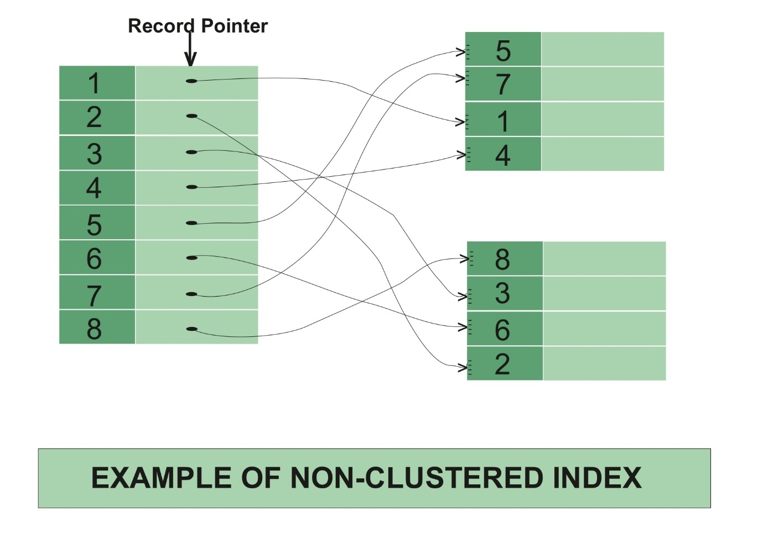

create nonclustered index NIX\_FTE\_Name

on Student (Name ASC);

Here, roll no is a primary key, hence there is automatically a clustered index.   
If we want to apply non-clustered index in NAME column (in ascending order), then the new table will be created for that column.

Output before applying non-clustered index : 

| Roll\_No | Name | Gender | Mob\_No |
| --- | --- | --- | --- |
| 3 | sudhir | male | 9675432890 |
| 4 | afzal | male | 9876543210 |
| 5 | zoya | female | 8976453201 |

Output after applying non-clustered index :

| Name | Row address |
| --- | --- |
| Afzal | 3452 |
| Sudhir | 5643 |
| zoya | 9876 |

Row address is used because, if someone wants to search the data for sudhir, then by using the row address he/she will directly go to that row address and can fetch the data directly.

**Difference between Clustered and Non-clustered index :**

| CLUSTERED INDEX | NON-CLUSTERED INDEX |
| --- | --- |
| Clustered index is faster. | Non-clustered index is slower. |
| Clustered index requires less memory for operations. | Non-Clustered index requires more memory for operations. |
| In clustered index, index is the main data. | In Non-Clustered index, index is the copy of data. |
| A table can have only one clustered index. | A table can have multiple non-clustered index. |
| Clustered index has inherent ability of storing data on the disk. | Non-Clustered index does not have inherent ability of storing data on the disk. |
| Clustered index store pointers to block not data. | Non-Clustered index store both value and a pointer to actual row that holds data. |
| In Clustered index leaf nodes are actual data itself. | In Non-Clustered index leaf nodes are not the actual data itself rather they only contains included columns. |
| In Clustered index, Clustered key defines order of data within table. | In Non-Clustered index, index key defines order of data within index. |
| A Clustered index is a type of index in which table records are physically reordered to match the index. | A Non-Clustered index is a special type of index in which logical order of index does not match physical stored order of the rows on disk. |
| The size of clustered index is large. | Size of non-clustered index is comparatively smaller. |
| Primary Keys of the table by default are clustered index. | Composite key when used with unique constraints of the table act as non-clustered index. |

### **Unique and Non-Unique Indexes - Part 37**

**Unique index** is used to enforce uniqueness of key values in the index. Let's understand this with an example.  
  
**Create the Employee table using the script below**  
CREATE TABLE [tblEmployee]  
(  
 [Id] int Primary Key,  
 [FirstName] nvarchar(50),  
 [LastName] nvarchar(50),  
 [Salary] int,  
 [Gender] nvarchar(10),  
 [City] nvarchar(50)  
)  
  
**Since, we have marked Id column**, as the Primary key for this table, a UNIQUE CLUSTERED INDEX gets created on the Id column, with Id as the index key.   
  
**We can verify** this by executing the sp\_helpindex system stored procedure as shown below.  
Execute sp\_helpindex tblEmployee  
  
**Output:**  
  
  
  
**Since, we now have a UNIQUE CLUSTERED INDEX** **on the Id** **column**, any attempt to duplicate the key values, will throw an error stating 'Violation of PRIMARY KEY constraint 'PK\_\_tblEmplo\_\_3214EC07236943A5'. Cannot insert duplicate key in object dbo.tblEmployee'  
  
**Example**: The following insert queries will fail  
Insert into tblEmployee Values(1,'Mike', 'Sandoz',4500,'Male','New York')  
Insert into tblEmployee Values(1,'John', 'Menco',2500,'Male','London')

**Now let's try to drop the Unique Clustered index** on the Id column. This will raise an error stating - 'An explicit DROP INDEX is not allowed on index tblEmployee.PK\_\_tblEmplo\_\_3214EC07236943A5. It is being used for PRIMARY KEY constraint enforcement.'  
Drop index tblEmployee.PK\_\_tblEmplo\_\_3214EC07236943A5  
  
**So this error message proves that**, SQL server internally, uses the UNIQUE index to enforce the uniqueness of values and primary key.  
  
**Expand keys folder in the object explorer window**, and you can see a primary key constraint. Now, expand the indexes folder and you should see a unique clustered index. In the object explorer it just shows the '**CLUSTERED**' word. To, confirm, this is infact an UNIQUE index, right click and select properties. The properties window, shows the UNIQUE checkbox being selected.

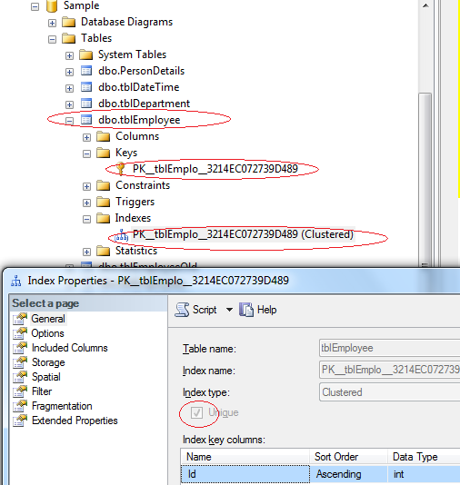  
  
  
**SQL Server allows us to delete this UNIQUE CLUSTERED INDEX** from the object explorer. so, Right click on the index, and select DELETE and finally, click OK. Along with the UNIQUE index, the primary key constraint is also deleted.  
  
**Now, let's try to insert duplicate values** for the ID column. The rows should be accepted, without any primary key violation error.

Insert into tblEmployee Values(1,'Mike', 'Sandoz',4500,'Male','New York')  
Insert into tblEmployee Values(1,'John', 'Menco',2500,'Male','London')  
  
So, the UNIQUE index is used to enforce the uniqueness of values and primary key constraint.  
  
**UNIQUENESS is a property of an Index**, and both CLUSTERED and NON-CLUSTERED indexes can be UNIQUE.  
  
**Creating a UNIQUE NON CLUSTERED index** on the FirstName and LastName columns.  
Create Unique NonClustered Index UIX\_tblEmployee\_FirstName\_LastName  
On tblEmployee(FirstName, LastName)  
  
**This unique non clustered index**, ensures that no 2 entires in the index has the same first and last names. [In Part 9, of this video series](http://csharp-video-tutorials.blogspot.com/2012/08/unique-key-constraint-part-9.html), we have learnt that, a Unique Constraint, can be used to enforce the uniqueness of values, across one or more columns. There are no major differences between a unique constraint and a unique index.   
  
**In fact, when you add a unique constraint**, a unique index gets created behind the scenes. To prove this, let's add a unique constraint on the city column of the tblEmployee table.  
ALTER TABLE tblEmployee   
ADD CONSTRAINT UQ\_tblEmployee\_City   
UNIQUE NONCLUSTERED (City)  
  
**At this point, we expect a unique constraint to be created**. Refresh and Expand the constraints folder in the object explorer window. The constraint is not present in this folder. Now, refresh and expand the 'indexes' folder. In the indexes folder, you will see a UNIQUE NONCLUSTERED index with name UQ\_tblEmployee\_City.  
  
Also, executing EXECUTE SP\_HELPCONSTRAINT tblEmployee, lists the constraint as a UNIQUE NONCLUSTERED index.  
  
  
  
**So creating a UNIQUE constraint**, actually creates a UNIQUE index. So a UNIQUE index can be created explicitly, using CREATE INDEX statement or indirectly using a UNIQUE constraint. So, when should you be creating a Unique constraint over a unique index.To make our intentions clear, create a unique constraint, when data integrity is the objective. This makes the objective of the index very clear. In either

cases, data is validated in the same manner, and the query optimizer does not differentiate between a unique index created by a unique constraint or manually created.  
  
**Note:**  
**1. By default, a PRIMARY KEY constraint**, creates a unique clustered index, where as a UNIQUE constraint creates a unique nonclustered index. These defaults can be changed if you wish to.  
  
**2. A UNIQUE constraint or a UNIQUE index** cannot be created on an existing table, if the table contains duplicate values in the key columns. Obviously, to solve this,remove the key columns from the index definition or delete or update the duplicate values.

**3. By default, duplicate values are not allowed on key columns**, when you have a unique index or constraint. For, example, if I try to insert 10 rows, out of which 5 rows contain duplicates, then all the 10 rows are rejected. However, if I want only the 5 duplicate rows to be rejected and accept the non-duplicate 5 rows, then I can use IGNORE\_DUP\_KEY option. An example of using IGNORE\_DUP\_KEY option is shown below.

CREATE UNIQUE INDEX IX\_tblEmployee\_City  
ON tblEmployee(City)  
WITH IGNORE\_DUP\_KEY

### **Advantages and disadvantages of indexes - Part 38**

we talk about the advantages and disadvantages of indexes. We wil also talk about a concept called covering queries. In Part 35, we have learnt that, Indexes are used by queries to find data quickly. In this part, we will learn about the different queries that can benefit from indexes.  
  
**Create Employees table**  
CREATE TABLE [tblEmployee]  
(  
 [Id] int Primary Key,  
 [FirstName] nvarchar(50),  
 [LastName] nvarchar(50),  
 [Salary] int,  
 [Gender] nvarchar(10),[City] nvarchar(50) )

**Insert sample data:**  
Insert into tblEmployee Values(1,'Mike', 'Sandoz',4500,'Male','New York')  
Insert into tblEmployee Values(2,'Sara', 'Menco',6500,'Female','London')

Insertinto tblEmployee Values(3,'John', 'Barber',2500,'Male','Sydney')

Insert into tblEmployee Values(4,'Pam', 'Grove',3500,'Female','Toronto')  
Insert into tblEmployee Values(5,'James', 'Mirch',7500,'Male','London')  
  
**Create a Non-Clustered Index on Salary Column**  
Create NonClustered Index IX\_tblEmployee\_Salary  
On tblEmployee (Salary Asc)  
  
**Data from tblEmployee table**  
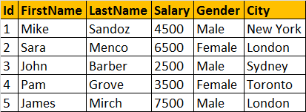  
  
**NonClustered Index**  
  
  
**The following select query benefits from the index on the Salary column**, because the salaries are sorted in ascending order in the index. From the index, it's easy to identify the records where salary is between 4000 and 8000, and using the row address the corresponding records from the table can be fetched quickly.  
Select \* from tblEmployee where Salary > 4000 and Salary < 8000

**Not only, the SELECT statement, even the following DELETE and UPDATE** statements can also benefit from the index. To update or delete a row, SQL server needs to first find that row, and the index can help in searching and finding that specific row quickly.  
Delete from tblEmployee where Salary = 2500  
Update tblEmployee Set Salary = 9000 where Salary = 7500  
  
**Indexes can also help queries**, that ask for sorted results. Since the Salaries are already sorted, the database engine, simply scans the index from the first entry to the last entry and retrieve the rows in sorted order. This avoids, sorting of rows during query execution, which can significantly imrpove the processing time.  
Select \* from tblEmployee order by Salary  
  
**The index on the Salary column**, can also help the query below, by scanning the index in reverse order.  
Select \* from tblEmployee order by Salary Desc  
  
**GROUP BY queries can also benefit from indexes**. To group the Employees with the same salary, the query engine, can use the index on Salary column, to retrieve the already sorted salaries. Since matching salaries are present in consecutive index entries, it is to count the total number of Employees  at each Salary quickly.   
Select Salary, COUNT(Salary) as Total  
from tblEmployee  
Group By Salary  
  
**Diadvantages of Indexes:**  
**Additional Disk Space**: Clustered Index does not, require any additional storage. Every Non-Clustered index requires additional space as it is stored separately from the table.The amount of space required will depend on the size of the table, and the number and types of columns used in the index.  
  
**Insert Update and Delete statements can become slow**: When **DML** (Data Manipulation Language) statements (**INSERT, UPDATE, DELETE**) modifies data in a table, the data in all the indexes also needs to be updated. Indexes can help, to search and locate the rows, that we want to delete, but too many indexes to update can actually hurt the performance of data modifications.  
  
**What is a covering query?**  
**If all the columns** that you have requested in the SELECT clause of query, are present in the index, then there is no need to lookup in the table again. The requested columns data can simply be returned from the index.  
  
**A clustered index**, always covers a query, since it contains all of the data in a table. A composite index is an index on two or more columns. Both clustered and nonclustered indexes can be composite indexes. To a certain extent, a composite index, can cover a query.

### **Views in sql server - Part 39**

**What is a View?**  
A view is nothing more than a**saved SQL query**. A view can also be considered as a **virtual table**.

**Let's understand views with an example**. We will base all our examples on **tblEmployee** and **tblDepartment** tables.   
  
**SQL Script to create tblEmployee table:**  
CREATE TABLE tblEmployee  
(  
  Id int Primary Key,  
  Name nvarchar(30),  
  Salary int,  
  Gender nvarchar(10),  
  DepartmentId int  
)  
  
**SQL Script to create tblDepartment table:**  
CREATE TABLE tblDepartment  
(  
 DeptId int Primary Key,  
 DeptName nvarchar(20)  
)  
  
**Insert data into tblDepartment table**  
Insert into tblDepartment values (1,'IT')  
Insert into tblDepartment values (2,'Payroll')  
Insert into tblDepartment values (3,'HR')  
Insert into tblDepartment values (4,'Admin')  
  
**Insert data into tblEmployee table**  
Insert into tblEmployee values (1,'John', 5000, 'Male', 3)  
Insert into tblEmployee values (2,'Mike', 3400, 'Male', 2)

Insert into tblEmployee values (3,'Pam', 6000, 'Female', 1)

Insert into tblEmployee values (4,'Todd', 4800, 'Male', 4)  
Insert into tblEmployee values (5,'Sara', 3200, 'Female', 1)  
Insert into tblEmployee values (6,'Ben', 4800, 'Male', 3)  
  
**At this point Employees and Departments table should look like this.**

Employees Table:  
  
Departments Table:  
  
**Now, let's write a Query which returns the output as shown below:**  
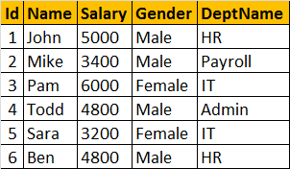  
  
  
**To get the expected output**, we need to join **tblEmployees** table with **tblDepartments** table. [If you are new to joins, please click here to view the video on Joins in SQL Server.](http://csharp-video-tutorials.blogspot.com/2012/08/joins-in-sql-server-part-12.html)   
Select Id, Name, Salary, Gender, DeptName  
from tblEmployee  
join tblDepartment  
on tblEmployee.DepartmentId = tblDepartment.DeptId  
  
**Now let's create a view, using the JOINS query, we have just written.**  
Create View vWEmployeesByDepartment  
as  
Select Id, Name, Salary, Gender, DeptName  
from tblEmployee  
join tblDepartment on tblEmployee.DepartmentId = tblDepartment.DeptId

**To select data from the view**, SELECT statement can be used the way, we use it with a table.  
SELECT \* from vWEmployeesByDepartment  
  
**When this query is executed**, the database engine actually retrieves the data from the underlying base tables, **tblEmployees and tblDepartments**. The View itself, doesnot store any data by default. However, we can change this default behaviour, which we will talk about in a later session. So, this is the reason, a view is considered, as just, a stored query or a virtual table.  
  
**Advantages of using views:**  
1. Views can be used to reduce the **complexity of the database schema**, for non IT users. The sample view, **vWEmployeesByDepartment**, hides the complexity of joins. Non-IT users, finds it easy to query the view, rather than writing complex joins.  
  
2. Views can be used as a mechanism to implement **row and column level security**.  
**Row Level Security:**  
For example, I want an end user, to have access only to IT Department employees. If I grant him access to the underlying tblEmployees and tblDepartments tables, he will be able to see, every department employees. To achieve this, I can create a view, which returns only IT Department employees, and grant the user access to the view and not to the underlying table.  
  
**View that returns only IT department employees:**  
Create View vWITDepartment\_Employees  
as  
Select Id, Name, Salary, Gender, DeptName  
from tblEmployee  
join tblDepartment  
on tblEmployee.DepartmentId = tblDepartment.DeptId  
where tblDepartment.DeptName = 'IT'  
  
**Column Level Security:**  
Salary is confidential information and I want to prevent access to that column. To achieve this, we can create a view, which excludes the Salary column, and then grant the end user access to this views, rather than the base tables.  
  
**View that returns all columns except Salary column:**  
Create View vWEmployeesNonConfidentialData  
as  
Select Id, Name, Gender, DeptName  
from tblEmployee  
join tblDepartment on tblEmployee.DepartmentId = tblDepartment.DeptId

3. Views can be used to present **only aggregated data** and **hide detailed data**.  
**View that returns summarized data**, Total number of employees by Department.  
Create View vWEmployeesCountByDepartment  
as  
Select DeptName, COUNT(Id) as TotalEmployees  
from tblEmployee  
join tblDepartment  
on tblEmployee.DepartmentId = tblDepartment.DeptId  
Group By DeptName  
  
To look at view definition - sp\_helptext vWName  
To modify a view - ALTER VIEW statement   
To Drop a view - DROP VIEW vWName

### **Updateable Views - Part 40**

[**In Part 39, we have discussed the basics of views**](http://csharp-video-tutorials.blogspot.com/2012/09/views-in-sql-server-part-39.html). In this session we will learn about Updateable Views. Let's create **tblEmployees**table and populate it with some sample data.

**Create Table tblEmployee Script:**  
CREATE TABLE tblEmployee  
(  
  Id int Primary Key,  
  Name nvarchar(30),  
  Salary int,  
  Gender nvarchar(10),  
  DepartmentId int  
)  
  
**Script to insert data:**  
Insert into tblEmployee values (1,'John', 5000, 'Male', 3)  
Insert into tblEmployee values (2,'Mike', 3400, 'Male', 2)  
Insert into tblEmployee values (3,'Pam', 6000, 'Female', 1)  
Insert into tblEmployee values (4,'Todd', 4800, 'Male', 4)  
Insert into tblEmployee values (5,'Sara', 3200, 'Female', 1)  
Insert into tblEmployee values (6,'Ben', 4800, 'Male', 3)  
  
**Let's create a view**, which returns all the columns from the tblEmployees table, except Salary column.  
Create view vWEmployeesDataExceptSalary  
as  
Select Id, Name, Gender, DepartmentId  
from tblEmployee  
  
**Select data from the view**: A view does not store any data. So, when this query is executed, the database engine actually retrieves data, from the underlying tblEmployee base table.  
Select \* from vWEmployeesDataExceptSalary  
  
**Is it possible to Insert, Update and delete rows**, from the underlying tblEmployees table, using view vWEmployeesDataExceptSalary?  
**Yes**, SQL server views are updateable.  
  
**The following query updates, Name column from Mike to Mikey**. Though, we are updating the view, SQL server, correctly updates the base table tblEmployee. To verify, execute, SELECT statement, on tblEmployee table.  
Update vWEmployeesDataExceptSalary   
Set Name = 'Mikey' Where Id = 2  
  
**Along the same lines**, it is also possible to insert and delete rows from the base table using views.  
Delete from vWEmployeesDataExceptSalary where Id = 2

Insert into vWEmployeesDataExceptSalary values (2, 'Mikey', 'Male', 2)  
  
**Now, let us see, what happens if our view is based on multiple base tables**. For this purpose, let's create tblDepartment table and populate with some sample data.  
**SQL Script to create tblDepartment table**  
CREATE TABLE tblDepartment  
(  
 DeptId int Primary Key,  
 DeptName nvarchar(20)  
)  
  
**Insert data into tblDepartment table**  
Insert into tblDepartment values (1,'IT')  
Insert into tblDepartment values (2,'Payroll')  
Insert into tblDepartment values (3,'HR')  
Insert into tblDepartment values (4,'Admin')  
  
**Create a view which joins tblEmployee and tblDepartment tables**, and return the result as shown below.  
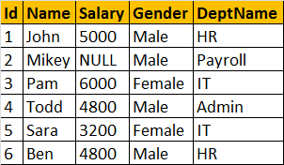  
  
**View that joins tblEmployee and tblDepartment**  
Create view vwEmployeeDetailsByDepartment  
as  
Select Id, Name, Salary, Gender, DeptName  
from tblEmployee  
join tblDepartment  
on tblEmployee.DepartmentId = tblDepartment.DeptId  
  
**Select Data from view vwEmployeeDetailsByDepartment**  
Select \* from vwEmployeeDetailsByDepartment  
  
**vwEmployeeDetailsByDepartment Data:**  
  
**Now, let's update, John's department, from HR to IT**. At the moment, there are 2 employees (Ben, and John) in the HR department.  
Update vwEmployeeDetailsByDepartment   
set DeptName='IT' where Name = 'John'  
**Now, Select data from the view vwEmployeeDetailsByDepartment:**  
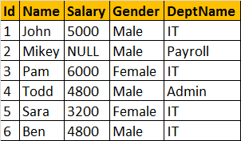  
  
**Notice, that Ben's department is also changed to IT**. To understand the reasons for incorrect UPDATE, select Data from tblDepartment and tblEmployee base tables.  
  
**tblEmployee Table**  
  
**tblDepartment**  
  
  
**The UPDATE statement, updated DeptName from HR to IT in tblDepartment table**, instead of upadting **DepartmentId** column in **tblEmployee** table. So, the conclusion - If a view is based on multiple tables, and if you update the view, it may not update the underlying base tables correctly. To correctly update a view, that is based on multiple table, INSTEAD OF triggers are used.  
  
We will discuss about triggers and correctly updating a view that is based on multiple tables, in a later video session.

### **Indexed views in sql server - Part 41**

**What is an Indexed View or What happens when you create an Index on a view?**  
A **standard** or **Non-indexed** view, is just a stored SQL query. When, we try to retrieve data from the view, the data is actually retrieved from the underlying base tables. So, a view is just a virtual table it does not store any data, by default.  
  
**However, when you create an index**, on a view, the view gets materialized. This means, the view is now, capable of storing data. In SQL server, we call them Indexed views and in Oracle, Materialized views.  
**Let's now, look at an example of creating an Indexed view**. For the purpose of this video, we will be using **tblProduct** and **tblProductSales** tables.

**Script to create table tblProduct**  
Create Table tblProduct  
(  
 ProductId int primary key,  
 Name nvarchar(20),  
 UnitPrice int  
)  
  
**Script to pouplate tblProduct, with sample data**  
Insert into tblProduct Values(1, 'Books', 20)  
Insert into tblProduct Values(2, 'Pens', 14)  
Insert into tblProduct Values(3, 'Pencils', 11)  
Insert into tblProduct Values(4, 'Clips', 10)  
  
**Script to create table tblProductSales**  
Create Table tblProductSales  
(  
 ProductId int,  
 QuantitySold int  
)  
  
**Script to pouplate tblProductSales, with sample data**  
Insert into tblProductSales values(1, 10)  
Insert into tblProductSales values(3, 23)  
Insert into tblProductSales values(4, 21)  
Insert into tblProductSales values(2, 12)  
Insert into tblProductSales values(1, 13)  
Insert into tblProductSales values(3, 12)  
Insert into tblProductSales values(4, 13)  
Insert into tblProductSales values(1, 11)  
Insert into tblProductSales values(2, 12)  
Insert into tblProductSales values(1, 14)  
  
**tblProduct Table**  
  
**tblProductSales Table**  
  
**Create a view which returns Total Sales and Total Transactions by Product.** The output should be, as shown below.  
  
**Script to create view vWTotalSalesByProduct**  
Create view vWTotalSalesByProduct  
with SchemaBinding  
as  
Select Name,   
SUM(ISNULL((QuantitySold \* UnitPrice), 0)) as TotalSales,   
COUNT\_BIG(\*) as TotalTransactions  
from dbo.tblProductSales  
join dbo.tblProduct  
on dbo.tblProduct.ProductId = dbo.tblProductSales.ProductId  
group by Name  
  
**If you want to create an Index**, on a view, the following rules should be followed by the view. For the complete list of all rules, please check [MSDN](http://msdn.microsoft.com/en-us/library/ms191432(v=sql.105).aspx).  
1. The view should be created with SchemaBinding option

2. If an Aggregate function in the SELECT LIST, references an expression, and if there is a possibility for that expression to become NULL, then, a replacement value should be specified. In this example, we are using, ISNULL() function, to replace NULL values with ZERO.

3. If GROUP BY is specified, the view select list must contain a COUNT\_BIG(\*) expression  
  
4. The base tables in the view, should be referenced with 2 part name. In this example, tblProduct and tblProductSales are referenced using dbo.tblProduct and dbo.tblProductSales respectively.  
  
**Now, let's create an Index on the view:**  
The first index that you create on a view, must be a unique clustered index. After the unique clustered index has been created, you can create additional nonclustered indexes.  
Create Unique Clustered Index UIX\_vWTotalSalesByProduct\_Name  
on vWTotalSalesByProduct(Name)  
  
**Since, we now have an index on the view, the view gets materialized**. The data is stored in the view. So when we execute Select \* from vWTotalSalesByProduct, the data is retrurned from the view itself, rather than retrieving data from the underlying base tables.  
  
Indexed views, can significantly improve the performance of queries that involves JOINS and Aggeregations. The cost of maintaining an indexed view is much higher than the cost of maintaining a table index.  
  
Indexed views are ideal for scenarios, where the underlying data is not frequently changed. Indexed views are more often used in OLAP systems, because the data is mainly used for reporting and analysis purposes. Indexed views, may not be suitable for OLTP systems, as the data is frequently addedd and changed.

### **Limitations of views - Part 42**

1. **You cannot pass parameters to a view**. Table Valued functions are an excellent replacement for parameterized views.  
  
**We will use tblEmployee table** for our examples. SQL Script to create tblEmployee table:  
CREATE TABLE tblEmployee  
(  
  Id int Primary Key,  
  Name nvarchar(30),  
  Salary int,  
  Gender nvarchar(10),  
  DepartmentId int  
)

**Insert data into tblEmployee table**  
Insert into tblEmployee values (1,'John', 5000, 'Male', 3)  
Insert into tblEmployee values (2,'Mike', 3400, 'Male', 2)

Insert into tblEmployee values (3,'Pam', 6000, 'Female', 1)

Insert into tblEmployee values (4,'Todd', 4800, 'Male', 4)  
Insert into tblEmployee values (5,'Sara', 3200, 'Female', 1)  
Insert into tblEmployee values (6,'Ben', 4800, 'Male', 3)  
  
**Employee Table**  
  
**-- Error : Cannot pass Parameters to Views**  
Create View vWEmployeeDetails  
@Gender nvarchar(20)  
as  
Select Id, Name, Gender, DepartmentId  
from  tblEmployee  
where Gender = @Gender  
  
**Table Valued functions can be used as a replacement** for parameterized views.  
Create function fnEmployeeDetails(@Gender nvarchar(20))  
Returns Table  
as  
Return   
(Select Id, Name, Gender, DepartmentId  
from tblEmployee where Gender = @Gender)  
  
**Calling the function**  
Select \* from dbo.fnEmployeeDetails('Male')  
  
**2. Rules and Defaults cannot be associated with views.**  
  
**3. The ORDER BY clause is invalid in views** unless TOP or FOR XML is specified.  
Create View vWEmployeeDetailsSorted  
as  
Select Id, Name, Gender, DepartmentId  
from tblEmployee  
order by Id  
If you use ORDER BY, you will get an error stating - 'The ORDER BY clause is invalid in views, inline functions, derived tables, subqueries, and common table expressions, unless TOP or FOR XML is also specified.'  
  
**4. Views cannot be based on temporary tables.**  
  
Create Table ##TestTempTable(Id int, Name nvarchar(20), Gender nvarchar(10))  
  
Insert into ##TestTempTable values(101, 'Martin', 'Male')

Insert into ##TestTempTable values(102, 'Joe', 'Female')  
Insert into ##TestTempTable values(103, 'Pam', 'Female')  
Insert into ##TestTempTable values(104, 'James', 'Male')  
  
**-- Error: Cannot create a view on Temp Tables**  
Create View vwOnTempTable  
as  
Select Id, Name, Gender  
from ##TestTempTable

### **DML Triggers - Part 43**

**In SQL server there are 3 types of triggers**  
1. DML triggers   
2. DDL triggers  
3. Logon trigger  
  
**We will discuss about DDL and logon triggers in a later session**. In this video, we will learn about DML triggers.

**In general, a trigger is a special kind of stored procedure** that automatically executes when an event occurs in the database server.  
  
**DML stands for Data Manipulation Language.** INSERT, UPDATE, and DELETE statements are DML statements. DML triggers are fired, when ever data is modified using INSERT, UPDATE, and DELETE events.  
  
**DML triggers can be again classified into 2 types.**  
1. After triggers (Sometimes called as FOR triggers)  
2. Instead of triggers  
  
**After triggers, as the name says, fires after the triggering action**. The INSERT, UPDATE, and DELETE statements, causes an after trigger to fire after the respective statements complete execution.  
  
**On ther hand, as the name says, INSTEAD of triggers, fires instead of the triggering action**. The INSERT, UPDATE, and DELETE statements, can cause an INSTEAD OF trigger to fire INSTEAD OF the respective statement execution.

**We will use tblEmployee and tblEmployeeAudit**tables for our examples  
  
**SQL Script to create tblEmployee table:**  
CREATE TABLE tblEmployee  
(  
  Id int Primary Key,  
  Name nvarchar(30),  
  Salary int,  
  Gender nvarchar(10),  
  DepartmentId int  
)  
  
**Insert data into tblEmployee table**

Insert into tblEmployee values (1,'John', 5000, 'Male', 3)  
Insert into tblEmployee values (2,'Mike', 3400, 'Male', 2)

Insert into tblEmployee values (3,'Pam', 6000, 'Female', 1)  
**tblEmployee**  
  
**SQL Script to create tblEmployeeAudit table:**  
CREATE TABLE tblEmployeeAudit  
(  
  Id int identity(1,1) primary key,  
  AuditData nvarchar(1000)  
)  
  
**When ever, a new Employee is added**, we want to capture the ID and the date and time, the new employee is added in tblEmployeeAudit table. The easiest way to achieve this, is by having an AFTER TRIGGER for INSERT event.  
  
**Example for AFTER TRIGGER for INSERT event on tblEmployee table:**  
CREATE TRIGGER tr\_tblEMployee\_ForInsert  
ON tblEmployee  
FOR INSERT  
AS  
BEGIN  
 Declare @Id int  
 Select @Id = Id from inserted  
   
 insert into tblEmployeeAudit   
 values('New employee with Id  = ' + Cast(@Id as nvarchar(5)) + ' is added at ' + cast(Getdate() as nvarchar(20)))  
END  
**In the trigger, we are getting the id from inserted table.** So, what is this inserted table? INSERTED table, is a special table used by DML triggers. When you add a new row into tblEmployee table, a copy of the row will also be made into inserted table, which only a trigger can access. You cannot access this table outside the context of the trigger. The structure of the inserted table will be identical to the structure of tblEmployee table.

**So, now if we execute the following INSERT statement on tblEmployee.** Immediately, after inserting the row into tblEmployee table, the trigger gets fired (executed automatically), and a row into tblEmployeeAudit, is also inserted.

**Insert into tblEmployee values (7,'Tan', 2300, 'Female', 3)**

**Along, the same lines, let us now capture audit information, when a row is deleted**from the table, tblEmployee.  
**Example for AFTER TRIGGER for DELETE event on tblEmployee table:**  
CREATE TRIGGER tr\_tblEMployee\_ForDelete  
ON tblEmployee  
FOR DELETE  
AS  
BEGIN  
 Declare @Id int  
 Select @Id = Id from deleted  
   
 insert into tblEmployeeAudit   
 values('An existing employee with Id  = ' + Cast(@Id as nvarchar(5)) + ' is deleted at ' + Cast(Getdate() as nvarchar(20)))  
END  
  
**The only difference here is that**, we are specifying, the triggering event as **DELETE** and retrieving the deleted row ID from **DELETED** table. DELETED table, is a special table used by DML triggers. When you delete a row from tblEmployee table, a copy of the deleted row will be made available in DELETED table, which only a trigger can access. Just like INSERTED table, DELETED table cannot be accessed, outside the context of the trigger and, the structure of the DELETED table will be identical to the structure of tblEmployee table..

### **After update trigger - Part 44**

**Triggers make use of 2 special tables**, INSERTED and DELETED. The inserted table contains the updated data and the deleted table contains the old data. The After trigger for UPDATE event, makes use of both inserted and deleted tables.   
  
**Create AFTER UPDATE trigger script:**  
Create trigger tr\_tblEmployee\_ForUpdate  
on tblEmployee  
for Update  
as

Begin  
 Select \* from deleted  
 Select \* from inserted   
End  
  
**Now, execute this query:**  
Update tblEmployee set Name = 'Tods', Salary = 2000,   
Gender = 'Female' where Id = 4  
  
**Immediately after the UPDATE statement execution**, the AFTER UPDATE trigger gets fired, and you should see the contenets of INSERTED and DELETED tables.  
  
**The following AFTER UPDATE trigger, audits employee information upon UPDATE**, and stores the audit data in tblEmployeeAudit table.

Alter trigger tr\_tblEmployee\_ForUpdate  
on tblEmployee  
for Update  
as  
Begin  
      -- Declare variables to hold old and updated data  
      Declare @Id int  
      Declare @OldName nvarchar(20), @NewName nvarchar(20)  
      Declare @OldSalary int, @NewSalary int  
      Declare @OldGender nvarchar(20), @NewGender nvarchar(20)  
      Declare @OldDeptId int, @NewDeptId int  
       
      -- Variable to build the audit string  
      Declare @AuditString nvarchar(1000)  
        
      -- Load the updated records into temporary table  
      Select \*  
      into #TempTable  
      from inserted  
       
      -- Loop thru the records in temp table  
      While(Exists(Select Id from #TempTable))  
      Begin  
            --Initialize the audit string to empty string  
            Set @AuditString = ''  
             
            -- Select first row data from temp table  
            Select Top 1 @Id = Id, @NewName = Name,   
            @NewGender = Gender, @NewSalary = Salary,  
            @NewDeptId = DepartmentId  
            from #TempTable  
             
            -- Select the corresponding row from deleted table  
            Select @OldName = Name, @OldGender = Gender,   
            @OldSalary = Salary, @OldDeptId = DepartmentId  
            from deleted where Id = @Id  
   
     -- Build the audit string dynamically             
            Set @AuditString = 'Employee with Id = ' + Cast(@Id as nvarchar(4)) + ' changed'  
            if(@OldName <> @NewName)  
                  Set @AuditString = @AuditString + ' NAME from ' + @OldName + ' to ' + @NewName  
                   
            if(@OldGender <> @NewGender)  
                  Set @AuditString = @AuditString + ' GENDER from ' + @OldGender + ' to ' + @NewGender  
                   
            if(@OldSalary <> @NewSalary)  
                  Set @AuditString = @AuditString + ' SALARY from ' + Cast(@OldSalary as nvarchar(10))+ ' to ' + Cast(@NewSalary as nvarchar(10))  
                    
     if(@OldDeptId <> @NewDeptId)  
                  Set @AuditString = @AuditString + ' DepartmentId from ' + Cast(@OldDeptId as nvarchar(10))+ ' to ' + Cast(@NewDeptId as nvarchar(10))  
             
            insert into tblEmployeeAudit values(@AuditString)  
              
            -- Delete the row from temp table, so we can move to the next row  
            Delete from #TempTable where Id = @Id  
      End  
End

### **Instead of insert trigger - Part 45**

[Part 39 - Views](http://csharp-video-tutorials.blogspot.com/2012/09/views-in-sql-server-part-39.html)  
[Part 40 - Updateable Views](http://csharp-video-tutorials.blogspot.com/2012/09/updateable-views-part-40.html)  
[Part 43 - DML triggers](http://csharp-video-tutorials.blogspot.com/2012/09/dml-triggers-part-43.html)  
[Part 44 - DML After Update Trigger](http://csharp-video-tutorials.blogspot.com/2012/09/after-update-trigger-part-44.html)

**In this we will learn about, INSTEAD OF triggers**, specifically INSTEAD OF INSERT trigger. We know that, AFTER triggers are fired after the triggering event(INSERT, UPDATE or DELETE events), where as, INSTEAD OF triggers are fired instead of the triggering event(INSERT, UPDATE or DELETE events). In general, INSTEAD OF triggers are usually used to correctly update views that are based on multiple tables.   
  
**We will base our demos on Employee and Department** tables. So, first, let's create these 2 tables.

**SQL Script to create tblEmployee table:**  
CREATE TABLE tblEmployee  
(  
  Id int Primary Key,  
  Name nvarchar(30),  
  Gender nvarchar(10),  
  DepartmentId int  
)  
  
**SQL Script to create tblDepartment table**  
CREATE TABLE tblDepartment  
(  
 DeptId int Primary Key,  
 DeptName nvarchar(20)  
)  
  
**Insert data into tblDepartment table**  
Insert into tblDepartment values (1,'IT')  
Insert into tblDepartment values (2,'Payroll')  
Insert into tblDepartment values (3,'HR')  
Insert into tblDepartment values (4,'Admin')  
  
**Insert data into tblEmployee table**  
Insert into tblEmployee values (1,'John', 'Male', 3)  
Insert into tblEmployee values (2,'Mike', 'Male', 2)

Insert into tblEmployee values (3,'Pam', 'Female', 1)

Insert into tblEmployee values (4,'Todd', 'Male', 4)  
Insert into tblEmployee values (5,'Sara', 'Female', 1)  
Insert into tblEmployee values (6,'Ben', 'Male', 3)  
  
**Since, we now have the required tables**, let's create a view based on these tables. The view should return Employee Id, Name, Gender and DepartmentName columns. So, the view is obviously based on multiple tables.  
  
**Script to create the view:**  
Create view vWEmployeeDetails  
as  
Select Id, Name, Gender, DeptName  
from tblEmployee   
join tblDepartment  
on tblEmployee.DepartmentId = tblDepartment.DeptId

**When you execute**, **Select \* from vWEmployeeDetails**, the data from the view, should be as shown below  
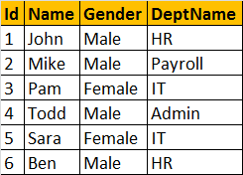  
  
**Now, let's try to insert a row into the view, vWEmployeeDetails**, by executing the following query. At this point, an error will be raised stating 'View or function vWEmployeeDetails is not updatable because the modification affects multiple base tables.'  
Insert into vWEmployeeDetails values(7, 'Valarie', 'Female', 'IT')

**So, inserting a row into a view that is based on multipe tables**, raises an error by default. Now, let's understand, how INSTEAD OF TRIGGERS can help us in this situation. Since, we are getting an error, when we are trying to insert a row into the view, let's create an INSTEAD OF INSERT trigger on the view **vWEmployeeDetails.**  
  
**Script to create INSTEAD OF INSERT trigger:**  
Create trigger tr\_vWEmployeeDetails\_InsteadOfInsert  
on vWEmployeeDetails  
Instead Of Insert  
as  
Begin  
 Declare @DeptId int  
   
 --Check if there is a valid DepartmentId  
 --for the given DepartmentName  
 Select @DeptId = DeptId   
 from tblDepartment   
 join inserted  
 on inserted.DeptName = tblDepartment.DeptName  
   
 --If DepartmentId is null throw an error  
 --and stop processing  
 if(@DeptId is null)  
 Begin  
 Raiserror('Invalid Department Name. Statement terminated', 16, 1)  
 return  
 End

--Finally insert into tblEmployee table  
 Insert into tblEmployee(Id, Name, Gender, DepartmentId)  
 Select Id, Name, Gender, @DeptId  
 from inserted  
End  
  
**Now, let's execute the insert query:**  
Insert into vWEmployeeDetails values(7, 'Valarie', 'Female', 'IT')  
  
**The instead of trigger correctly inserts**, the record into tblEmployee table. Since, we are inserting a row, the **inserted** table, contains the newly added row, where as the **deleted** table will be empty.  
  
**In the trigger, we used Raiserror() function**, to raise a custom error, when the DepartmentName provided in the insert query, doesnot exist. We are passing 3 parameters to the Raiserror() method. The first parameter is the error message, the second parameter is the severity level. Severity level 16, indicates general errors that can be corrected by the user. The final parameter is the state. We will talk about Raiserror() and exception handling in sql server, in a later video session.

### **Instead of update triggers - Part 46**

**Suggested SQL Server Videos before watching this Video**  
[Part 43 - DML triggers](http://csharp-video-tutorials.blogspot.com/2012/09/dml-triggers-part-43.html)  
[Part 44 - DML After Update Trigger](http://csharp-video-tutorials.blogspot.com/2012/09/after-update-trigger-part-44.html)  
[Part 45 - Instead of Insert Trigger](http://csharp-video-tutorials.blogspot.com/2012/09/instead-of-insert-trigger-part-45.html)

**In this video we will learn about, INSTEAD OF UPDATE** trigger. An INSTEAD OF UPDATE triggers gets fired instead of an update event, on a table or a view. For example, let's say we have, an INSTEAD OF UPDATE trigger on a view or a table, and then when you try to update a row with in that view or table, instead of the UPDATE, the trigger gets fired automatically. INSTEAD OF UPDATE TRIGGERS, are of immense help, to correctly update a view, that is based on multiple tables.  
  
**Let's create the required Employee and Department tables**, that we will be using for this demo.  
  
**SQL Script to create tblEmployee table:**  
CREATE TABLE tblEmployee  
(  
  Id int Primary Key,  
  Name nvarchar(30),  
  Gender nvarchar(10), DepartmentId int)

**SQL Script to create tblDepartment table**  
CREATE TABLE tblDepartment  
(  
 DeptId int Primary Key,  
 DeptName nvarchar(20)  
)  
  
**Insert data into tblDepartment table**  
Insert into tblDepartment values (1,'IT')  
Insert into tblDepartment values (2,'Payroll')  
Insert into tblDepartment values (3,'HR')  
Insert into tblDepartment values (4,'Admin')  
  
**Insert data into tblEmployee table**  
Insert into tblEmployee values (1,'John', 'Male', 3)  
Insert into tblEmployee values (2,'Mike', 'Male', 2)

Insert into tblEmployee values (3,'Pam', 'Female', 1)

Insert into tblEmployee values (4,'Todd', 'Male', 4)  
Insert into tblEmployee values (5,'Sara', 'Female', 1)  
Insert into tblEmployee values (6,'Ben', 'Male', 3)  
  
**Since, we now have the required tables**, let's create a view based on these tables. The view should return Employee Id, Name, Gender and DepartmentName columns. So, the view is obviously based on multiple tables.  
**Script to create the view:**  
Create view vWEmployeeDetails  
as  
Select Id, Name, Gender, DeptName  
from tblEmployee   
join tblDepartment  
on tblEmployee.DepartmentId = tblDepartment.DeptId  
  
**When you execute, Select \* from vWEmployeeDetails**, the data from the view, should be as shown below  


**In Part 45, we tried to insert a row into the view**, and we got an error stating - 'View or function vWEmployeeDetails is not updatable because the modification affects multiple base tables.'  
**Now, let's try to update the view**, in such a way that, it affects, both the underlying tables, and see, if we get the same error. The following UPDATE statement changes **Name column** from **tblEmployee** and **DeptName column** from **tblDepartment**. So, when we execute this query, we get the same error.  
Update vWEmployeeDetails   
set Name = 'Johny', DeptName = 'IT'  
where Id = 1  
  
**Now, let's try to change, just the department of John from HR to IT**. The following UPDATE query, affects only one table, tblDepartment. So, the query should succeed. But, before executing the query, please note that, employees **JOHN** and **BEN** are in **HR** department.  
Update vWEmployeeDetails   
set DeptName = 'IT'  
where Id = 1  
  
**After executing the query**, select the data from the view, and notice that **BEN's** **DeptName** is also changed to **IT**. We intended to just change **JOHN's DeptName**. So, the UPDATE didn't work as expected. This is because, the UPDATE query, updated the **DeptName from HR to IT**, in tblDepartment table. For the UPDATE to work correctly, we should change the **DeptId** of **JOHN** from 3 to 1.  
  
**Incorrectly Updated View**  
**Record with Id = 3, has the DeptName changed from 'HR' to 'IT'**

**We should have actually updated, JOHN's DepartmentId from 3 to 1**  
  
  
**So, the conclusion is that, if a view is based on multiple tables**, and if you update the view, the UPDATE may not always work as expected. To correctly update the underlying base tables, thru a view, INSTEAD OF UPDATE TRIGGER can be used.  
  
**Before, we create the trigger, let's update the DeptName to HR for record with Id = 3.**

Update tblDepartment set DeptName = 'HR' where DeptId = 3  
  
**Script to create INSTEAD OF UPDATE trigger:**  
Create Trigger tr\_vWEmployeeDetails\_InsteadOfUpdate  
on vWEmployeeDetails  
instead of update  
as  
Begin  
 -- if EmployeeId is updated  
 if(Update(Id))  
 Begin  
 Raiserror('Id cannot be changed', 16, 1)  
 Return  
 End  
   
 -- If DeptName is updated  
 if(Update(DeptName))   
 Begin  
 Declare @DeptId int  
  
 Select @DeptId = DeptId  
 from tblDepartment  
 join inserted  
 on inserted.DeptName = tblDepartment.DeptName  
   
 if(@DeptId is NULL )  
 Begin  
 Raiserror('Invalid Department Name', 16, 1)  
 Return  
 End  
   
 Update tblEmployee set DepartmentId = @DeptId  
 from inserted  
 join tblEmployee  
 on tblEmployee.Id = inserted.id  
 End  
   
 -- If gender is updated  
 if(Update(Gender))  
 Begin  
 Update tblEmployee set Gender = inserted.Gender  
 from inserted  
 join tblEmployee  
 on tblEmployee.Id = inserted.id  
 End  
   
 -- If Name is updated  
 if(Update(Name))  
 Begin  
 Update tblEmployee set Name = inserted.Name  
 from inserted  
 join tblEmployee  
 on tblEmployee.Id = inserted.id  
 End  
End  
  
**Now, let's try to update JOHN's Department to IT.**  
Update vWEmployeeDetails   
set DeptName = 'IT'  
where Id = 1  
  
**The UPDATE query works as expected.** The INSTEAD OF UPDATE trigger, correctly updates, JOHN's DepartmentId to 1, in tblEmployee table.  
  
**Now, let's try to update Name, Gender and DeptName.** The UPDATE query, works as expected, without raising the error - 'View or function vWEmployeeDetails is not updatable because the modification affects multiple base tables.'

Update vWEmployeeDetails   
set Name = 'Johny', Gender = 'Female', DeptName = 'IT'   
where Id = 1  
  
**Update**() function used in the trigger, returns true, even if you update with the same value. For this reason, I recomend to compare values between inserted and deleted tables, rather than relying on Update() function. The Update() function does not operate on a per row basis, but across all rows.

### **Instead of delete trigger - Part 47**

**Suggested SQL Server Videos before watching this Video**  
[Part 45 - Instead of Insert Trigger](http://csharp-video-tutorials.blogspot.com/2012/09/instead-of-insert-trigger-part-45.html)  
[Part 46 - Instead of Update Trigger](http://csharp-video-tutorials.blogspot.com/2012/09/instead-of-update-triggers-part-46.html)

**In this video we will learn about, INSTEAD OF DELETE trigger**. An INSTEAD OF DELETE trigger gets fired instead of the DELETE event, on a table or a view. For example, let's say we have, an INSTEAD OF DELETE trigger on a view or a table, and then when you try to update a row from that view or table, instead of the actual DELETE event, the trigger gets fired automatically. INSTEAD OF DELETE TRIGGERS, are used, to delete records from a view, that is based on multiple tables.  
  
Let's create the required Employee and Department tables, that we will be using for this demo.  
  
**SQL Script to create tblEmployee table:**  
CREATE TABLE tblEmployee  
(  
  Id int Primary Key,  
  Name nvarchar(30),  
  Gender nvarchar(10),  
  DepartmentId int  
)  
  
**SQL Script to create tblDepartment table**  
CREATE TABLE tblDepartment  
(  
 DeptId int Primary Key,  
 DeptName nvarchar(20)  
)  
  
**Insert data into tblDepartment table**

Insert into tblDepartment values (1,'IT')  
Insert into tblDepartment values (2,'Payroll')  
Insert into tblDepartment values (3,'HR')  
Insert into tblDepartment values (4,'Admin')  
  
**Insert data into tblEmployee table**  
Insert into tblEmployee values (1,'John', 'Male', 3)  
Insert into tblEmployee values (2,'Mike', 'Male', 2)

Insert into tblEmployee values (3,'Pam', 'Female', 1)

Insert into tblEmployee values (4,'Todd', 'Male', 4)  
Insert into tblEmployee values (5,'Sara', 'Female', 1)  
Insert into tblEmployee values (6,'Ben', 'Male', 3)  
  
**Since, we now have the required tables**, let's create a view based on these tables. The view should return Employee Id, Name, Gender and DepartmentName columns. So, the view is obviously based on multiple tables.  
**Script to create the view:**  
Create view vWEmployeeDetails  
as  
Select Id, Name, Gender, DeptName  
from tblEmployee   
join tblDepartment  
on tblEmployee.DepartmentId = tblDepartment.DeptId  
  
**When you execute, Select \* from vWEmployeeDetails**, the data from the view, should be as shown below  
  
  
**In**[**Part 45**](http://csharp-video-tutorials.blogspot.com/2012/09/instead-of-insert-trigger-part-45.html), we tried to insert a row into the view, and we got an error stating - 'View or function vWEmployeeDetails is not updatable because the modification affects multiple base tables'. Along, the same lines, in [**Part 46**](http://csharp-video-tutorials.blogspot.com/2012/09/instead-of-update-triggers-part-46.html), when we tried to update a view that is based on multiple tables, we got the same error. To get the error, the UPDATE should affect both the base tables. If the update affects only one base table, we don't get the error, but the UPDATE does not work correctly, if the **DeptName**column is updated.

**Now, let's try to delete a row from the view, and we get the same error.**  
Delete from vWEmployeeDetails where Id = 1  
  
**Script to create INSTEAD OF DELETE trigger:**  
Create Trigger tr\_vWEmployeeDetails\_InsteadOfDelete  
on vWEmployeeDetails  
instead of delete  
as  
Begin  
 Delete tblEmployee   
 from tblEmployee  
 join deleted  
 on tblEmployee.Id = deleted.Id  
   
 --Subquery  
 --Delete from tblEmployee   
 --where Id in (Select Id from deleted)  
End  
  
**Notice that, the trigger tr\_vWEmployeeDetails\_InsteadOfDelete**, makes use of DELETED table. DELETED table contains all the rows, that we tried to DELETE from the view. So, we are joining the DELETED table with tblEmployee, to delete the rows. You can also use sub-queries to do the same. In most cases JOINs are faster than SUB-QUERIEs. However, in cases, where you only need a subset of records from a table that you are joining with, sub-queries can be faster.  
  
**Upon executing the following DELETE statement**, the row gets DELETED as expected from tblEmployee table  
Delete from vWEmployeeDetails where Id = 1

|  |  |
| --- | --- |
| **Trigger** | **INSERTED or DELETED?** |
| Instead of Insert | DELETED table is always empty and the INSERTED table contains the newly inserted data. |
| Instead of Delete | INSERTED table is always empty and the DELETED table contains the rows deleted |
| Instead of Update | DELETED table contains OLD data (before update), and inserted table contains NEW data(Updated data) |

### **Derived table and CTE in sql server - Part 48**

**In this video we will learn about, Derived tables and common table expressions** (CTE's). We will also explore the differences between Views, Table Variable, Local and Global Temp Tables, Derived tables and common table expressions.

Let's create the required Employee and Department tables, that we will be using for this demo.  
  
**SQL Script to create tblEmployee table:**  
CREATE TABLE tblEmployee  
(  
  Id int Primary Key,  
  Name nvarchar(30),  
  Gender nvarchar(10),  
  DepartmentId int  
)  
  
**SQL Script to create tblDepartment table**  
CREATE TABLE tblDepartment  
(  
 DeptId int Primary Key,  
 DeptName nvarchar(20)  
)  
  
**Insert data into tblDepartment table**  
Insert into tblDepartment values (1,'IT')  
Insert into tblDepartment values (2,'Payroll')  
Insert into tblDepartment values (3,'HR')  
Insert into tblDepartment values (4,'Admin')  
  
**Insert data into tblEmployee table**  
Insert into tblEmployee values (1,'John', 'Male', 3)  
Insert into tblEmployee values (2,'Mike', 'Male', 2)

Insert into tblEmployee values (3,'Pam', 'Female', 1)

Insert into tblEmployee values (4,'Todd', 'Male', 4)  
Insert into tblEmployee values (5,'Sara', 'Female', 1)  
Insert into tblEmployee values (6,'Ben', 'Male', 3)  
  
**Now, we want to write a query which would return the following output**. The query should return, the Department Name and Total Number of employees, with in the department. The departments with greatar than or equal to 2 employee should only be returned.  
  
**Obviously, there are severl ways to do this**. Let's see how to achieve this, with the help of a view  
**Script to create the View**  
Create view vWEmployeeCount  
as  
Select DeptName, DepartmentId, COUNT(\*) as TotalEmployees  
from tblEmployee  
join tblDepartment  
on tblEmployee.DepartmentId = tblDepartment.DeptId  
group by DeptName, DepartmentId  
  
**Query using the view:**  
Select DeptName, TotalEmployees   
from vWEmployeeCount  
where  TotalEmployees >= 2  
  
**Note:** Views get saved in the database, and can be available to other queries and stored procedures. However, if this view is only used at this one place, it can be easily eliminated using other options, like CTE, Derived Tables, Temp Tables, Table Variable etc.  
  
**Now, let's see, how to achieve the same using, temporary tables**. We are using local temporary tables here.

Select DeptName, DepartmentId, COUNT(\*) as TotalEmployees  
into #TempEmployeeCount  
from tblEmployee  
join tblDepartment  
on tblEmployee.DepartmentId = tblDepartment.DeptId  
group by DeptName, DepartmentId  
  
Select DeptName, TotalEmployees  
From #TempEmployeeCount  
where TotalEmployees >= 2  
  
Drop Table #TempEmployeeCount

**Note:** Temporary tables are stored in TempDB. Local temporary tables are visible only in the current session, and can be shared between nested stored procedure calls. Global temporary tables are visible to other sessions and are destroyed, when the last connection referencing the table is closed.  
  
**Using Table Variable:**  
Declare @tblEmployeeCount table  
(DeptName nvarchar(20),DepartmentId int, TotalEmployees int)  
  
Insert @tblEmployeeCount  
Select DeptName, DepartmentId, COUNT(\*) as TotalEmployees  
from tblEmployee  
join tblDepartment  
on tblEmployee.DepartmentId = tblDepartment.DeptId  
group by DeptName, DepartmentId  
  
Select DeptName, TotalEmployees  
From @tblEmployeeCount  
where  TotalEmployees >= 2  
  
**Note**: Just like TempTables, a table variable is also created in TempDB. The scope of a table variable is the batch, stored procedure, or statement block in which it is declared. They can be passed as parameters between procedures.  
  
**Using Derived Tables**  
Select DeptName, TotalEmployees  
from   
 (  
 Select DeptName, DepartmentId, COUNT(\*) as TotalEmployees  
 from tblEmployee  
 join tblDepartment  
 on tblEmployee.DepartmentId = tblDepartment.DeptId  
 group by DeptName, DepartmentId  
 )   
as EmployeeCount  
where TotalEmployees >= 2  
  
**Note**: Derived tables are available only in the context of the current query.  
  
**Using CTE**  
With EmployeeCount(DeptName, DepartmentId, TotalEmployees)  
as  
(  
 Select DeptName, DepartmentId, COUNT(\*) as TotalEmployees  
 from tblEmployee  
 join tblDepartment  
 on tblEmployee.DepartmentId = tblDepartment.DeptId  
 group by DeptName, DepartmentId  
)  
  
Select DeptName, TotalEmployees  
from EmployeeCount  
where TotalEmployees >= 2  
  
**Note:** A CTE can be thought of as a temporary result set that is defined within the execution scope of a single SELECT, INSERT, UPDATE, DELETE, or CREATE VIEW statement. A CTE is similar to a derived table in that it is not stored as an object and lasts only for the duration of the query.

### **Common Table Expressions - Part 49**

**Common table expression (CTE)** is introduced in SQL server 2005. A **CTE** is a temporary result set, that can be referenced within a SELECT, INSERT, UPDATE, or DELETE statement, that immediately follows the **CTE.**

Let's create the required Employee and Department tables, that we will be using for this demo.  
  
**SQL Script to create tblEmployee table:**  
CREATE TABLE tblEmployee  
(  
  Id int Primary Key,  
  Name nvarchar(30),  
  Gender nvarchar(10),  
  DepartmentId int  
)  
  
**SQL Script to create tblDepartment table**  
CREATE TABLE tblDepartment  
(  
 DeptId int Primary Key,  
 DeptName nvarchar(20)  
)  
**Insert data into tblDepartment table**  
Insert into tblDepartment values (1,'IT')  
Insert into tblDepartment values (2,'Payroll')  
Insert into tblDepartment values (3,'HR') Insert into tblDepartment values (4,'Admin')  
  
**Insert data into tblEmployee table**  
Insert into tblEmployee values (1,'John', 'Male', 3)  
Insert into tblEmployee values (2,'Mike', 'Male', 2)

Insert into tblEmployee values (3,'Pam', 'Female', 1)

Insert into tblEmployee values (4,'Todd', 'Male', 4)  
Insert into tblEmployee values (5,'Sara', 'Female', 1)  
Insert into tblEmployee values (6,'Ben', 'Male', 3)  
  
**Write a query using CTE,**to display the total number of Employees by Department Name. The output should be as shown below.  
  
**Before we write the query, let's look at the syntax for creating a CTE.**  
**WITH cte\_name (Column1, Column2, ..)**  
**AS**  
**( CTE\_query )**  
  
**SQL query using CTE:**  
With EmployeeCount(DepartmentId, TotalEmployees)  
as  
(  
 Select DepartmentId, COUNT(\*) as TotalEmployees  
 from tblEmployee  
 group by DepartmentId  
)  
  
Select DeptName, TotalEmployees  
from tblDepartment  
join EmployeeCount  
on tblDepartment.DeptId = EmployeeCount.DepartmentId  
order by TotalEmployees  
  
**We define a CTE**, using **WITH** keyword, followed by the name of the CTE. In our example, **EmployeeCount**is the name of the CTE. Within parentheses, we specify the columns that make up the CTE. **DepartmentId** and **TotalEmployees** are the columns of **EmployeeCount** CTE. These 2 columns map to the columns returned by the **SELECT CTE query**. The CTE column names and CTE query column names can be different. Infact, CTE column names are optional. However, if you do specify, the number of **CTE columns** and the **CTE SELECT query** columns should be same. Otherwise you will get an error stating - 'EmployeeCount has fewer columns than were specified in the column list'. The column list, is followed by the as keyword, following which we have the CTE query within a pair of parentheses.  
  
**EmployeeCount CTE** is being joined with **tblDepartment** table, in the SELECT query, that immediately follows the CTE. Remember, a CTE can only be referenced by a SELECT, INSERT, UPDATE, or DELETE statement, **that immediately follows the CTE**. If you try to do something else in between, we get an error stating - 'Common table expression defined but not used'. The following SQL, raise an error.  
  
With EmployeeCount(DepartmentId, TotalEmployees)  
as  
(  
 Select DepartmentId, COUNT(\*) as TotalEmployees  
 from tblEmployee  
 group by DepartmentId  
)  
  
Select 'Hello'  
  
Select DeptName, TotalEmployees  
from tblDepartment  
join EmployeeCount  
on tblDepartment.DeptId = EmployeeCount.DepartmentId  
order by TotalEmployees  
  
**It is also, possible to create multiple CTE's using a single WITH clause.**  
With EmployeesCountBy\_Payroll\_IT\_Dept(DepartmentName, Total)  
as  
(  
 Select DeptName, COUNT(Id) as TotalEmployees  
 from tblEmployee  
 join tblDepartment   
 on tblEmployee.DepartmentId = tblDepartment.DeptId  
 where DeptName IN ('Payroll','IT')  
 group by DeptName  
),  
EmployeesCountBy\_HR\_Admin\_Dept(DepartmentName, Total)  
as  
(  
 Select DeptName, COUNT(Id) as TotalEmployees  
 from tblEmployee  
 join tblDepartment   
 on tblEmployee.DepartmentId = tblDepartment.DeptId  
 group by DeptName   
)  
Select \* from EmployeesCountBy\_HR\_Admin\_Dept   
UNION  
Select \* from EmployeesCountBy\_Payroll\_IT\_Dept

### **Updatable CTE - Part 50**

**Is it possible to UPDATE a CTE?**  
**Yes & No**, depending on the number of base tables, the CTE is created upon, and the number of base tables affected by the UPDATE statement. If this is not clear at the moment, don't worry. We will try to understand this with an example.

Let's create the required tblEmployee and tblDepartment tables, that we will be using for this demo.  
  
**SQL Script to create tblEmployee table:**  
CREATE TABLE tblEmployee  
(  
  Id int Primary Key,  
  Name nvarchar(30),  
  Gender nvarchar(10),  
  DepartmentId int  
)  
  
**SQL Script to create tblDepartment table**  
CREATE TABLE tblDepartment  
(  
 DeptId int Primary Key,  
 DeptName nvarchar(20)  
)  
  
**Insert data into tblDepartment table**  
Insert into tblDepartment values (1,'IT')  
Insert into tblDepartment values (2,'Payroll')  
Insert into tblDepartment values (3,'HR')  
Insert into tblDepartment values (4,'Admin')  
  
**Insert data into tblEmployee table**  
Insert into tblEmployee values (1,'John', 'Male', 3)  
Insert into tblEmployee values (2,'Mike', 'Male', 2)

Insert into tblEmployee values (3,'Pam', 'Female', 1)

Insert into tblEmployee values (4,'Todd', 'Male', 4)  
Insert into tblEmployee values (5,'Sara', 'Female', 1)  
Insert into tblEmployee values (6,'Ben', 'Male', 3)  
  
**Let's create a simple common table expression**, based on tblEmployee table. **Employees\_Name\_Gender** CTE is getting all the required columns from one base table tblEmployee.  
With Employees\_Name\_Gender  
as  
(  
 Select Id, Name, Gender from tblEmployee  
)  
Select \* from Employees\_Name\_Gender  
  
**Let's now, UPDATE JOHN's gender from Male to Female**, using the **Employees\_Name\_Gender CTE**  
With Employees\_Name\_Gender  
as  
(  
 Select Id, Name, Gender from tblEmployee  
)  
Update Employees\_Name\_Gender Set Gender = 'Female' where Id = 1  
  
**Now, query the tblEmployee table**. JOHN's gender is actually UPDATED. So, if a CTE is created on one base table, then it is possible to UPDATE the CTE, which in turn will update the underlying base table. In this case, UPDATING **Employees\_Name\_Gender** CTE, updates **tblEmployee** table.

**Now, let's create a CTE, on both the tables - tblEmployee and tblDepartment.** The CTE should return, Employee Id, Name, Gender and Department. In short the output should be as shown below.  
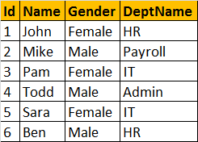

**CTE, that returns Employees by Department**  
With EmployeesByDepartment  
as  
(  
 Select Id, Name, Gender, DeptName   
 from tblEmployee  
 join tblDepartment  
 on tblDepartment.DeptId = tblEmployee.DepartmentId  
)  
Select \* from EmployeesByDepartment  
  
**Let's update this CTE.** Let's change JOHN's Gender from **Female to Male**. Here, the CTE is based on 2 tables, but the UPDATE statement affects only one base table **tblEmployee**. So the UPDATE succeeds. So, if a CTE is based on more than one table, and if the UPDATE affects only one base table, then the UPDATE is allowed.   
With EmployeesByDepartment  
as  
(  
 Select Id, Name, Gender, DeptName   
 from tblEmployee  
 join tblDepartment  
 on tblDepartment.DeptId = tblEmployee.DepartmentId  
)  
Update EmployeesByDepartment set Gender = 'Male' where Id = 1  
  
Now, let's try to **UPDATE the CTE**, in such a way, that the update affects both the tables - **tblEmployee and tblDepartment**. This UPDATE statement changes **Gender** from **tblEmployee** table and **DeptName** from **tblDepartment** table. When you execute this UPDATE, you get an error stating - 'View or function EmployeesByDepartment is not updatable because the modification affects multiple base tables'. So, if a CTE is based on multiple tables, and if the UPDATE statement affects more than 1 base table, then the UPDATE is not allowed.  
With EmployeesByDepartment  
as  
(  
 Select Id, Name, Gender, DeptName   
 from tblEmployee  
 join tblDepartment  
 on tblDepartment.DeptId = tblEmployee.DepartmentId  
)  
Update EmployeesByDepartment set   
Gender = 'Female', DeptName = 'IT' where Id = 1  
**Finally, let's try to UPDATE just the DeptName**. Let's change JOHN's DeptName from HR to IT. Before, you execute the UPDATE statement, notice that BEN is also currently in HR department.  
With EmployeesByDepartment  
as  
(  
 Select Id, Name, Gender, DeptName   
 from tblEmployee  
 join tblDepartment  
 on tblDepartment.DeptId = tblEmployee.DepartmentId  
)  
Update EmployeesByDepartment set   
DeptName = 'IT' where Id = 1  
  
After you execute the UPDATE. Select data from the CTE, and you will see that BEN's DeptName is also changed to IT.  
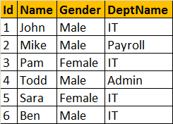  
  
**This is because**, when we updated the **CTE**, the UPDATE has actually changed the **DeptName** from **HR** to **IT**, in **tblDepartment** table, instead of changing the **DepartmentId** column (from 3 to 1) in **tblEmployee** table. So, if a CTE is based on multiple tables, and if the UPDATE statement affects only one base table, the update succeeds. But the update may not work as you expect.  
  
**So in short if,**  
**1.** A CTE is based on a single base table, then the UPDATE suceeds and works as expected.  
**2.** A CTE is based on more than one base table, and if the UPDATE affects multiple base tables, the update is not allowed and the statement terminates with an error.

**3.** A CTE is based on more than one base table, and if the UPDATE affects only one base table, the UPDATE succeeds(but not as expected always)

### **Recursive CTE - Part 51**

**A CTE that references itself is called as recursive CTE**. Recursive CTE's can be of great help when displaying hierarchical data. Example, displaying employees in an organization hierarchy. A simple organization chart is shown below.  
  
**Let's create tblEmployee table, which holds the data, that's in the organization chart.**  
Create Table tblEmployee  
(  
  EmployeeId int Primary key,  
  Name nvarchar(20),  
  ManagerId int  
)  
  
Insert into tblEmployee values (1, 'Tom', 2)  
Insert into tblEmployee values (2, 'Josh', null)  
Insert into tblEmployee values (3, 'Mike', 2)  
Insert into tblEmployee values (4, 'John', 3)  
Insert into tblEmployee values (5, 'Pam', 1)  
Insert into tblEmployee values (6, 'Mary', 3)  
Insert into tblEmployee values (7, 'James', 1)  
Insert into tblEmployee values (8, 'Sam', 5)  
Insert into tblEmployee values (9, 'Simon', 1)  
  
**Since, a MANAGER is also an EMPLOYEE**, both manager and employee details are stored in tblEmployee table. Data from tblEmployee is shown below.  
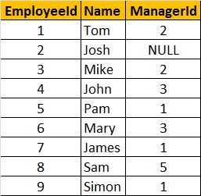  
  
**Let's say, we want to display, EmployeeName along with their ManagerName**. The ouptut should be as shown below.  
  
**To achieve this, we can simply join tblEmployee with itself.** Joining a table with itself is called as self join. We discussed about [**Self Joins in Part 14**](http://csharp-video-tutorials.blogspot.com/2012/08/self-join-in-sql-server-part-14.html) of this video series. In the output, notice that since **JOSH** does not have a Manager, we are displaying **'Super Boss'**, instead of **NULL**. We used **IsNull**(), function to replace NULL with 'Super Boss'. If you want to learn more about [**replacing NULL values, please watch Part 15**](http://csharp-video-tutorials.blogspot.com/2012/08/different-ways-to-replace-null-in-sql.html).  
**SELF JOIN QUERY:**  
Select Employee.Name as [Employee Name],  
IsNull(Manager.Name, 'Super Boss') as [Manager Name]  
from tblEmployee Employee  
left join tblEmployee Manager  
on Employee.ManagerId = Manager.EmployeeId  
  
**Along with Employee and their Manager name**, we also want to display their level in the organization. The output should be as shown below.  
  
**We can easily achieve this using a self referencing CTE.**  
With  
  EmployeesCTE (EmployeeId, Name, ManagerId, [Level])  
  as  
  (  
    Select EmployeeId, Name, ManagerId, 1  
    from tblEmployee  
    where ManagerId is null  
      
    union all  
      
    Select tblEmployee.EmployeeId, tblEmployee.Name,   
    tblEmployee.ManagerId, EmployeesCTE.[Level] + 1  
    from tblEmployee  
    join EmployeesCTE  
    on tblEmployee.ManagerID = EmployeesCTE.EmployeeId  
  )  
Select EmpCTE.Name as Employee, Isnull(MgrCTE.Name, 'Super Boss') as Manager,   
EmpCTE.[Level]   
from EmployeesCTE EmpCTE  
left join EmployeesCTE MgrCTE  
on EmpCTE.ManagerId = MgrCTE.EmployeeId  
  
The **EmployeesCTE**contains 2 queries with **UNION ALL** operator. The first query selects the EmployeeId, Name, ManagerId, and 1 as the level from **tblEmployee** where ManagerId is NULL. So, here we are giving a LEVEL = 1 for **super boss** (Whose Manager Id is NULL). In the second query, we are joining **tblEmployee** with **EmployeesCTE** itself, which allows us to loop thru the hierarchy. Finally to get the reuired output, we are joining **EmployeesCTE** with itself.

### **Database Normalization - Part 52**

**What are the goals of database normalization**?  
or  
**Why do we normalize databases**?  
or   
**What is database normalization**?  
  
**Database normalization** is the process of organizing data to minimize data redundancy (data duplication), which in turn ensures data consistency.

**Let's understand with an example**, how**redundant data**can cause **data inconsistency**. Consider **Employees**table below. For every employee with in the same department, we are repeating, all the 3 columns (DeptName, DeptHead and DeptLocation). Let's say for example, if there 50 thousand employees in the IT department, we would have unnecessarily repeated all the 3 department columns (DeptName, DeptHead and DeptLocation) data 50 thousand times. The obvious problem with redundant data is the disk space wastage.  
  
**Another common problem, is that data can become inconsistent.** For example, let's say, JOHN has resigned, and we have a new department head (STEVE) for IT department. At present, there are 3 IT department rows in the table, and we need to update all of them. Let's assume I updated only one row and forgot to update the other 2 rows, then obviously, the data becomes inconsistent.  
  
**Another problem**, DML queries (Insert, update and delete), **could become slow**, as there could many records and columns to process.  
  
**So, to reduce the data redundancy**, we can divide this large badly organised table into two (Employees and Departments), as shown below. Now, we have reduced redundant department data. So, if we have to update department head name, we only have one row to update, even if there are 10 million employees in that department.  
  
**Normalized Departments Table**  
  
**Normalized Employees Table**  
  
**Database normalization is a step by step process.** There are 6 normal forms, First Normal form (1NF) thru Sixth Normal Form (6NF). Most databases are in third normal form (3NF). There are certain rules, that each normal form should follow.  
  
**Now, let's explore the first normal form** (1NF). A table is said to be in 1NF, if

1. The data in each column should be **atomic**. No multiple values, sepearated by comma.  
2. The table does not contain any **repeating column groups**  
3. Identify each record **uniquely using primary key**.  
  
**In the table below, data in Employee column is not atomic**. It contains multiple employees seperated by comma. From the data you can see that in the IT department, we have 3 employees - Sam, Mike, Shan. Now, let's say I want to change just, SHAN name.**It is not possible, we have to update the entire cell.** Similary it is not possible to select or delete just one employee, as the data in the cell is not atomic.  
  
**The 2nd rule of the first normal form is that, the table should not contain any repeating column groups**. Consider the Employee table below. We have repeated the Employee column, from Employee1 to Employee3. The problem with this design is that, if a department is going to have more than 3 employees, then we have to **change the table structure** to add Employee4 column. Employee2 and Employee3 columns in the HR department are NULL, as there is only employee in this department. The **disk space is simply wasted.**  
  
**To eliminate the repeating column groups, we are dividing the table into 2**. The repeating Employee columns are moved into a seperate table, with a foreign key pointing to the primary key of the other table. We also, introduced primary key to uniquely identify each record.

### **Second Normal Form and Third Normal Form - Part 53**

In this video will learn about second normal form (2NF) and third normal form (3NF)  
**A table is said to be in 2NF, if**  
1. The table meets all the **conditions of 1NF**  
2. Move **redundant** data to a separate table  
3. Create **relationship** between these tables using foreign keys.  
  
**The table below violates second normal form**. There is lot of redundant data in the table. Let's say, in my organization there are 100,000 employees and only 2 departments (**IT & HR**). Since we are storing **DeptName, DeptHead and DeptLocation** columns also in the same table, all these columns should also be repeated 100,000 times, which results in unnecessary duplication of data.  
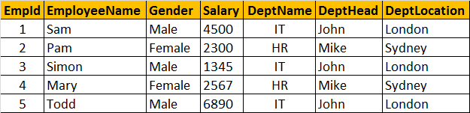  
  
**So this table is clearly violating the rules of the second normal form**, and the redundant data can cause the following issues.  
1. Disk space wastage  
2. Data inconsistency  
3. DML queries (Insert, Update, Delete) can become slow  
  
**Now, to put this table in the second normal form**, we need to break the table into 2, and move the redundant department data (**DeptName, DeptHead and DeptLocation**) into it's own table. To link the tables with each other, we use the **DeptId** foreign key. The tables below are in 2NF.  
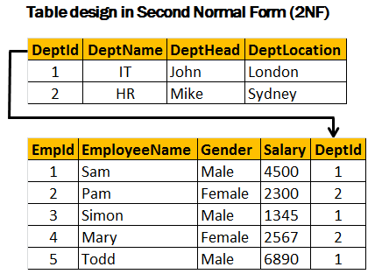  
  
**Third Normal Form (3NF):**  
**A table is said to be in 3NF, if the table**  
1. Meets all the conditions of **1NF and 2NF**  
2. Does not contain columns (attributes) that are not fully **dependent upon the primary key**  
  
**The table below, violates third normal form**, because **AnnualSalary** column is not fully dependent on the primary key **EmpId**. The **AnnualSalary** is also dependent on the **Salary** column. In fact, to compute the **AnnualSalary**, we multiply the **Salary** by **12**. Since **AnnualSalary** is not fully dependent on the primary key, and it can be computed, we can remove this column from the table, which then, will adhere to 3NF.  
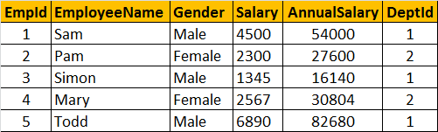  
  
**Let's look at another example of Third Normal Form violation**. In the table below, **DeptHead** column is not fully dependent on **EmpId** column. **DeptHead** is also dependent on **DeptName**. So, this table is not in **3NF**.  
  
**To put this table in 3NF, we break this down into 2**, and then move all the columns that are not fully dependent on the primary key to a separate table as shown below. This design is now in 3NF.

### **Pivot operator in sql server - Part 54**

**Suggested SQL Server Videos:**  
[Part 11 - Group By](http://csharp-video-tutorials.blogspot.com/2012/08/group-by-part-11.html)  
[Part 48 - Derived table and CTE in sql server](http://csharp-video-tutorials.blogspot.com/2012/09/derived-table-and-cte-in-sql-server.html)  
  
**Pivot is a sql server operator**that can be used to turn **unique values from one column**, into **multiple columns**in the output, there by effectively **rotating a table**.

**Let's understand the power of PIVOT operator with an example**  
Create Table tblProductSales  
(  
 SalesAgent nvarchar(50),  
 SalesCountry nvarchar(50),  
 SalesAmount int  
)

Insert into tblProductSales values('Tom', 'UK', 200)  
Insert into tblProductSales values('John', 'US', 180)  
Insert into tblProductSales values('John', 'UK', 260)  
Insert into tblProductSales values('David', 'India', 450)  
Insert into tblProductSales values('Tom', 'India', 350)  
Insert into tblProductSales values('David', 'US', 200)  
Insert into tblProductSales values('Tom', 'US', 130)  
Insert into tblProductSales values('John', 'India', 540)  
Insert into tblProductSales values('John', 'UK', 120)  
Insert into tblProductSales values('David', 'UK', 220)  
Insert into tblProductSales values('John', 'UK', 420)  
Insert into tblProductSales values('David', 'US', 320)  
Insert into tblProductSales values('Tom', 'US', 340)  
Insert into tblProductSales values('Tom', 'UK', 660)  
Insert into tblProductSales values('John', 'India', 430)  
Insert into tblProductSales values('David', 'India', 230)  
Insert into tblProductSales values('David', 'India', 280)  
Insert into tblProductSales values('Tom', 'UK', 480)  
Insert into tblProductSales values('John', 'US', 360)  
Insert into tblProductSales values('David', 'UK', 140)

**Select \* from tblProductSales**: As you can see, we have 3 sales agents selling in 3 countries  
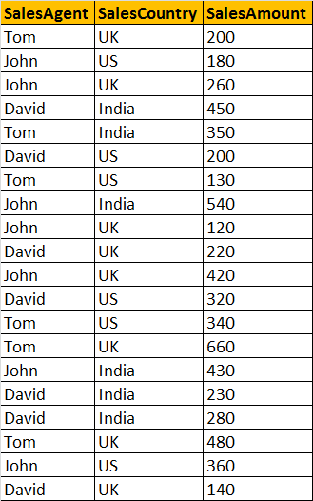  
  
**Now, let's write a query which returns TOTAL SALES**, grouped by **SALESCOUNTRY**and **SALESAGENT**. The output should be as shown below.  
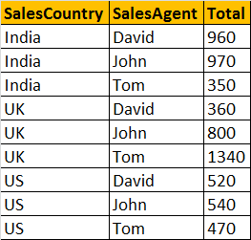  
**A simple GROUP BY query can produce this output.**  
Select SalesCountry, SalesAgent, SUM(SalesAmount) as Total  
from tblProductSales group by SalesCountry, SalesAgent order by SalesCountry, SalesAgent

**At, this point, let's try to present the same data in different format** using PIVOT operator.  
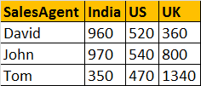  
**Query using PIVOT operator:**  
Select SalesAgent, India, US, UK  
from tblProductSales  
Pivot  
(  
   Sum(SalesAmount) for SalesCountry in ([India],[US],[UK])  
) as PivotTable

**This PIVOT query is converting the unique column values**(India, US, UK) in **SALESCOUNTRY** column, **into Columns**in the output, along with performing aggregations on the **SALESAMOUNT**column. The Outer query, simply, selects **SALESAGENT**column from **tblProductSales**table, along with pivoted columns from the PivotTable.  
  
**Having understood the basics of PIVOT**, let's look at another example. Let's create **tblProductsSale**, a slight variation of **tblProductSales**, that we have already created. The table, that we are creating now, has got an additional**Id** column.  
Create Table tblProductsSale  
(  
   Id int primary key,  
   SalesAgent nvarchar(50),  
   SalesCountry nvarchar(50),  
   SalesAmount int  
)

Insert into tblProductsSale values(1, 'Tom', 'UK', 200)  
Insert into tblProductsSale values(2, 'John', 'US', 180)  
Insert into tblProductsSale values(3, 'John', 'UK', 260)  
Insert into tblProductsSale values(4, 'David', 'India', 450)  
Insert into tblProductsSale values(5, 'Tom', 'India', 350)  
Insert into tblProductsSale values(6, 'David', 'US', 200)  
Insert into tblProductsSale values(7, 'Tom', 'US', 130)  
Insert into tblProductsSale values(8, 'John', 'India', 540) Insertinto tblProductsSale values(9, 'John', 'UK', 120)  
Insert into tblProductsSale values(10, 'David', 'UK', 220)  
Insert into tblProductsSale values(11, 'John', 'UK', 420)  
Insert into tblProductsSale values(12, 'David', 'US', 320)  
Insert into tblProductsSale values(13, 'Tom', 'US', 340)  
Insert into tblProductsSale values(14, 'Tom', 'UK', 660)  
Insert into tblProductsSale values(15, 'John', 'India', 430)  
Insert into tblProductsSale values(16, 'David', 'India', 230)  
Insert into tblProductsSale values(17, 'David', 'India', 280)  
Insert into tblProductsSale values(18, 'Tom', 'UK', 480)  
Insert into tblProductsSale values(19, 'John', 'US', 360)  
Insert into tblProductsSale values(20, 'David', 'UK', 140)

**Now, run the same PIVOT query**that we have already created, just by changing the name of the table to **tblProductsSale**instead of **tblProductSales**  
Select SalesAgent, India, US, UK  
from tblProductsSale  
Pivot  
(  
   Sum(SalesAmount) for SalesCountry in ([India],[US],[UK])  
)  
as PivotTable  
**This output is not what we have expected.**  
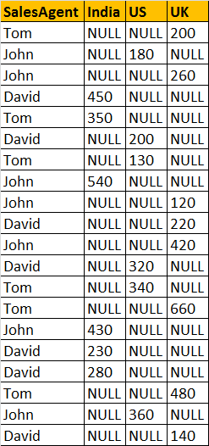

**This is because**of the presence of **Id**column in **tblProductsSale**, which is also considered when performing pivoting and group by. To eliminate this from the calculations, we have used derived table, which only selects, **SALESAGENT, SALESCOUNTRY**, and **SALESAMOUNT**. The rest of the query is very similar to what we have already seen.  
Select SalesAgent, India, US, UK  
from  
(  
   Select SalesAgent, SalesCountry, SalesAmount from tblProductsSale  
) as SourceTable  
Pivot  
(  
 Sum(SalesAmount) for SalesCountry in (India, US, UK)  
) as PivotTable

**UNPIVOT**performs the opposite operation to **PIVOT**by rotating columns of a table-valued expression into column values.  
  
**The syntax of PIVOT operator from MSDN**  
SELECT <non-pivoted column>,  
    [first pivoted column] AS <column name>,  
    [second pivoted column] AS <column name>,  
    ...  
    [last pivoted column] AS <column name>  
FROM  
    (<SELECT query that produces the data>)  
    AS <alias for the source query>  
PIVOT  
(  
    <aggregation function>(<column being aggregated>)  
FOR  
    [<column that contains the values that will become column headers>]  
    IN ( [first pivoted column], [second pivoted column], ... [last pivoted column])  
)  
AS <alias for the pivot table>  
<optional ORDER BY clause>;

Dynamic pivot:  
  
DECLARE @COLS NVARCHAR(2000)  
DECLARE @QUERY NVARCHAR(4000)  
  
SELECT @COLS = STUFF(( SELECT DISTINCT TOP 100 PERCENT '],[' + SalesCountry  
FROM tblProductsSale  
FOR XML PATH ('')),1,2,'') + ']'  
  
--SELECT @COLS  
  
SET @QUERY = 'SELECT SalesAgent, '+ @COLS + 'FROM  
(SELECT SalesAgent,SalesCountry,SalesAmount  
FROM tblProductsSale) AS stab  
PIVOT ( SUM(SalesAmount) FOR SalesCountry IN ('+@COLS+')) AS PivotTable;'  
  
EXECUTE (@QUERY);

### **Error handling in sql server 2000 - Part 55**

**Suggested SQL Server videos**  
[Part 18 - Stored procedures](http://csharp-video-tutorials.blogspot.com/2012/08/stored-procedures-part-18.html)  
**With the introduction of Try/Catch blocks in SQL Server 2005**, error handling in sql server, is now similar to programming languages like C#, and java. Before understanding error handling using try/catch, let's step back and understand how error handling was done in SQL Server 2000, using system function **@@Error**. Sometimes, system functions that begin with two at signs **(@@)**, are called as **global variables**. They are not variables and do not have the same behaviours as variables, instead they are very similar to functions.  
  
Now let's create **tblProduct** and **tblProductSales**, that we will be using for the rest of this demo.  
  
**SQL script to create tblProduct**  
Create Table tblProduct  
(  
 ProductId int NOT NULL primary key,  
 Name nvarchar(50),  
 UnitPrice int,  
 QtyAvailable int  
)  
  
**SQL script to load data into tblProduct**  
Insert into tblProduct values(1, 'Laptops', 2340, 100)  
Insert into tblProduct values(2, 'Desktops', 3467, 50)  
  
**SQL script to create tblProductSales**  
Create Table tblProductSales  
(  
 ProductSalesId int primary key,  
 ProductId int,  
 QuantitySold int  
)

Create Procedure spSellProduct  
@ProductId int,  
@QuantityToSell int  
as  
Begin  
 -- Check the stock available, for the product we want to sell  
 Declare @StockAvailable int  
 Select @StockAvailable = QtyAvailable   
 from tblProduct where ProductId = @ProductId

-- Throw an error to the calling application, if enough stock is not available  
 if(@StockAvailable < @QuantityToSell)  
   Begin  
 Raiserror('Not enough stock available',16,1)  
   End  
 -- If enough stock available  
 Else  
   Begin  
    Begin Tran  
         -- First reduce the quantity available  
 Update tblProduct set QtyAvailable = (QtyAvailable - @QuantityToSell)  
 where ProductId = @ProductId  
   
 Declare @MaxProductSalesId int  
 -- Calculate MAX ProductSalesId   
 Select @MaxProductSalesId = Case When   
 MAX(ProductSalesId) IS NULL   
 Then 0 else MAX(ProductSalesId) end   
 from tblProductSales  
 -- Increment @MaxProductSalesId by 1, so we don't get a primary key violation  
 Set @MaxProductSalesId = @MaxProductSalesId + 1  
 Insert into tblProductSales values(@MaxProductSalesId, @ProductId, @QuantityToSell)  
    Commit Tran  
   End  
End  
  
1. **Stored procedure - spSellProduct**, has 2 parameters - **@ProductId** and **@QuantityToSell**. @ProductId specifies the product that we want to sell, and @QuantityToSell specifies, the quantity we would like to sell.   
  
2. Sections of the stored procedure is commented, and is self explanatory.

3. In the procedure, we are using **Raiserror**() function to return an error message back to the calling application, if the stock available is less than the quantity we are trying to sell. We have to pass atleast 3 parameters to the Raiserror() function.  
**RAISERROR('Error Message', ErrorSeverity, ErrorState)**  
**Severity and State** are integers. In most cases, when you are returning custom errors, the severity level is 16, which indicates general errors that can be corrected by the user. In this case, the error can be corrected, by adjusting the **@QuantityToSell**, to be less than or equal to the stock available. ErrorState is also an integer between 1 and 255. RAISERROR only generates errors with state from 1 through 127.  
  
4. The problem with this procedure is that, the **transaction is always committed**. Even, if there is an error somewhere, between updating **tblProduct** and **tblProductSales** table. In fact, the main purpose of wrapping these 2 statments (Update tblProduct Statement & Insert into tblProductSales statement) in a transaction is to ensure that, both of the statements are treated as a single unit. For example, if we have an error when executing the second statement, then the first statement should also be rolledback.

In SQL server 2000, to detect errors, we can use **@@Error** system function. @@Error returns a NON-ZERO value, if there is an error, otherwise ZERO, indicating that the previous sql statement encountered no errors. The stored procedure **spSellProductCorrected**, makes use of @@ERROR system function to detect any errors that may have occurred. If there are errors, roll back the transaction, else commit the transaction. If you comment the line (Set @MaxProductSalesId = @MaxProductSalesId + 1), and then execute the stored procedure there will be a primary key violation error, when trying to insert into **tblProductSales**. As a result of this the entire transaction will be rolled back.  
Alter Procedure spSellProductCorrected  
@ProductId int,  
@QuantityToSell int  
as  
Begin  
 -- Check the stock available, for the product we want to sell  
 Declare @StockAvailable int  
 Select @StockAvailable = QtyAvailable   
 from tblProduct where ProductId = @ProductId  
   
 -- Throw an error to the calling application, if enough stock is not available  
 if(@StockAvailable < @QuantityToSell)  
   Begin  
 Raiserror('Not enough stock available',16,1)  
   End  
 -- If enough stock available  
 Else  
   Begin  
    Begin Tran  
         -- First reduce the quantity available  
 Update tblProduct set QtyAvailable = (QtyAvailable - @QuantityToSell)  
 where ProductId = @ProductId  
   
 Declare @MaxProductSalesId int  
 -- Calculate MAX ProductSalesId   
 Select @MaxProductSalesId = Case When   
 MAX(ProductSalesId) IS NULL   
 Then 0 else MAX(ProductSalesId) end   
 from tblProductSales  
 -- Increment @MaxProductSalesId by 1, so we don't get a primary key violation  
 Set @MaxProductSalesId = @MaxProductSalesId + 1  
 Insert into tblProductSales values(@MaxProductSalesId, @ProductId, @QuantityToSell)  
 if(@@ERROR <> 0)  
 Begin  
 Rollback Tran  
 Print 'Rolled Back Transaction'  
 End  
 Else  
 Begin  
 Commit Tran   
 Print 'Committed Transaction'  
 End  
   End  
End  
  
**Note**: @@ERROR is cleared and reset on each statement execution. Check it immediately following the statement being verified, or save it to a local variable that can be checked later.  
  
In **tblProduct** table, we already have a record with **ProductId = 2**. So the insert statement causes a primary key violation error. @@ERROR retains the error number, as we are checking for it immediately after the statement that cause the error.

Insert into tblProduct values(2, 'Mobile Phone', 1500, 100)  
if(@@ERROR <> 0)  
 Print 'Error Occurred'  
Else  
 Print 'No Errors'  
  
On the other hand, when you execute the code below, you get message**'No Errors'** printed. This is because the @@ERROR is cleared and reset on each statement execution.   
Insert into tblProduct values(2, 'Mobile Phone', 1500, 100)  
--At this point @@ERROR will have a NON ZERO value   
Select \* from tblProduct  
--At this point @@ERROR gets reset to ZERO, because the   
--select statement successfullyexecuted  
if(@@ERROR <> 0)  
 Print 'Error Occurred'  
Else  
 Print 'No Errors'  
  
In this example, we are storing the value of @@Error function to a local variable, which is then used later.  
Declare @Error int  
Insert into tblProduct values(2, 'Mobile Phone', 1500, 100)  
Set @Error = @@ERROR  
Select \* from tblProduct  
if(@Error <> 0)  
 Print 'Error Occurred'  
Else  
 Print 'No Errors'

### **Error handling in sql server 2005, and later versions - Part 56**

**Suggested SQL Server Videos**  
[Part 18 - Stored Procedures](http://csharp-video-tutorials.blogspot.com/2012/08/stored-procedures-part-18.html)  
[Part 55 - Error handling in SQL Server 2000](http://csharp-video-tutorials.blogspot.com/2012/10/error-handling-in-sql-server-2000-part.html)  
  
In [Part 55](http://csharp-video-tutorials.blogspot.com/2012/10/error-handling-in-sql-server-2000-part.html), of this video series we have seen Handling errors in SQL Server using **@@Error** system function. In this session we will see, how to achieve the same using Try/Catch blocks.  
  
**Syntax:**  
BEGIN TRY  
     { Any set of SQL statements }  
END TRY  
BEGIN CATCH  
     [ Optional: Any set of SQL statements ]  
END CATCH  
[Optional: Any other SQL Statements]  
  
**Any set of SQL statements**, that can possibly throw an exception are wrapped between BEGIN TRY and END TRY blocks. If there is an exception in the TRY block, the control immediately, jumps to the CATCH block. If there is no exception, CATCH block will be skipped, and the statements, after the CATCH block are executed.

**Errors trapped by a CATCH block are not returned to the calling application**. If any part of the error information must be returned to the application, the code in the CATCH block must do so by using RAISERROR() function.  
  
1. **In procedure spSellProduct**, Begin Transaction and Commit Transaction statements are wrapped between Begin Try and End Try block. If there are no errors in the code that is enclosed in the TRY block, then COMMIT TRANSACTION gets executed and the changes are made permanent. On the other hand, if there is an error, then the control immediately jumps to the CATCH block. In the CATCH block, we are rolling the transaction back. So, it's much easier to handle errors with Try/Catch construct than with @@Error system function.

2. Also notice that, in the scope of the CATCH block, there are several system functions, that are used to retrieve more information about the error that occurred  These functions return NULL if they are executed outside the scope of the CATCH block.  
  
3. TRY/CATCH cannot be used in a user-defined functions.

Create Procedure spSellProduct  
@ProductId int,  
@QuantityToSell int  
as  
Begin  
 -- Check the stock available, for the product we want to sell  
 Declare @StockAvailable int  
 Select @StockAvailable = QtyAvailable   
 from tblProduct where ProductId = @ProductId  
   
 -- Throw an error to the calling application, if enough stock is not available  
 if(@StockAvailable < @QuantityToSell)  
   Begin  
 Raiserror('Not enough stock available',16,1)  
   End  
 -- If enough stock available  
 Else  
   Begin  
    Begin Try  
     Begin Transaction  
         -- First reduce the quantity available  
 Update tblProduct set QtyAvailable = (QtyAvailable - @QuantityToSell)  
 where ProductId = @ProductId  
   
 Declare @MaxProductSalesId int  
 -- Calculate MAX ProductSalesId   
 Select @MaxProductSalesId = Case When   
 MAX(ProductSalesId) IS NULL   
 Then 0 else MAX(ProductSalesId) end   
 from tblProductSales  
 --Increment @MaxProductSalesId by 1, so we don't get a primary key violation  
 Set @MaxProductSalesId = @MaxProductSalesId + 1  
 Insert into tblProductSales values(@MaxProductSalesId, @ProductId, @QuantityToSell)  
     Commit Transaction  
    End Try  
    Begin Catch   
 Rollback Transaction  
 Select   
 ERROR\_NUMBER() as ErrorNumber,  
 ERROR\_MESSAGE() as ErrorMessage,  
 ERROR\_PROCEDURE() as ErrorProcedure,  
 ERROR\_STATE() as ErrorState,  
 ERROR\_SEVERITY() as ErrorSeverity,  
 ERROR\_LINE() as ErrorLine  
    End Catch   
   End  
End

### **Transactions in SQL Server - Part 57**

**What is a Transaction?**  
**A transaction is a group of commands** that change the data stored in a database. A transaction, is treated as a single unit. A transaction ensures that, either all of the commands succeed, or none of them. If one of the commands in the transaction fails, all of the commands fail, and any data that was modified in the database is rolled back. In this way, transactions maintain the integrity of data in a database.  
  
**Transaction processing follows these steps:**  
1. Begin a transaction.  
2. Process database commands.  
3. Check for errors.   
   If errors occurred,   
       rollback the transaction,   
   else,   
       commit the transaction  
  
**Let's understand transaction processing with an example.** For this purpose, let's Create and populate, tblMailingAddress and tblPhysicalAddress tables  
Create Table tblMailingAddress  
(  
   AddressId int NOT NULL primary key,  
   EmployeeNumber int,  
   HouseNumber nvarchar(50),  
   StreetAddress nvarchar(50),  
   City nvarchar(10),  
   PostalCode nvarchar(50)  
)  
  
Insert into tblMailingAddress values (1, 101, '#10', 'King Street', 'Londoon', 'CR27DW')

Create Table tblPhysicalAddress  
(  
 AddressId int NOT NULL primary key,  
 EmployeeNumber int,  
 HouseNumber nvarchar(50),  
 StreetAddress nvarchar(50),  
 City nvarchar(10),  
 PostalCode nvarchar(50)  
)  
  
Insert into tblPhysicalAddress values (1, 101, '#10', 'King Street', 'Londoon', 'CR27DW')  
  
**An employee with EmployeeNumber 101**, has the same address as his physical and mailing address. His city name is mis-spelled as **Londoon** instead of **London**. The following stored procedure **'spUpdateAddress'**, updates the physical and mailing addresses. Both the UPDATE statements are wrapped between **BEGIN TRANSACTION** and **COMMIT TRANSACTION** block, which in turn is wrapped between **BEGIN TRY** and **END TRY** block.

So, if both the UPDATE statements succeed, without any errors, then the transaction is committed. If there are errors, then the control is immediately transferred to the catch block. The **ROLLBACK TRANSACTION** statement, in the CATCH block, rolls back the transaction, and any data that was written to the database by the commands is backed out.  
  
Create Procedure spUpdateAddress  
as  
Begin  
 Begin Try  
 Begin Transaction  
 Update tblMailingAddress set City = 'LONDON'   
 where AddressId = 1 and EmployeeNumber = 101  
   
 Update tblPhysicalAddress set City = 'LONDON'   
 where AddressId = 1 and EmployeeNumber = 101  
 Commit Transaction  
 End Try  
 Begin Catch  
 Rollback Transaction  
 End Catch  
End

**Let's now make the second UPDATE statement, fail**. CITY column length in tblPhysicalAddress table is 10. The second UPDATE statement fails, because the value for CITY column is more than 10 characters.  
Alter Procedure spUpdateAddress  
as  
Begin  
 Begin Try  
 Begin Transaction  
 Update tblMailingAddress set City = 'LONDON12'   
 where AddressId = 1 and EmployeeNumber = 101  
   
 Update tblPhysicalAddress set City = 'LONDON LONDON'   
 where AddressId = 1 and EmployeeNumber = 101  
 Commit Transaction  
 End Try  
 Begin Catch  
 Rollback Transaction  
 End Catch  
End  
  
**Now, if we execute spUpdateAddress**, the first **UPDATE** statements succeeds, but the second **UPDATE** statement fails. As, soon as the second UPDATE statement fails, the control is immediately transferred to the CATCH block. The CATCH block rolls the transaction back. So, the change made by the first UPDATE statement is undone.

### **Transaction Acid Tests - Part 58**

**Suggested SQL Server Videos**  
[Part 57 - Transactions in SQL Server](http://csharp-video-tutorials.blogspot.com/2012/10/transactions-in-sql-server-part-57.html)  
  
A transaction is a group of database commands that are treated as a single unit. A successful transaction must pass the "ACID" test, that is, it must be  
A - Atomic  
C - Consistent  
I - Isolated  
D - Durable  
  
**Atomic** - All statements in the transaction either completed successfully or they were all rolled back. The task that the set of operations represents is either accomplished or not, but in any case not left half-done. For example, in the **spUpdateInventory\_and\_Sell** stored procedure, both the UPDATE statements, should succeed. If one UPDATE statement succeeds and the other UPDATE statement fails, the database should undo the change made by the first UPDATE statement, by rolling it back. In short, the transaction should be ATOMIC.  
  
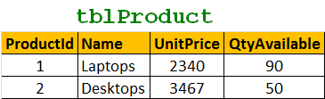  
  
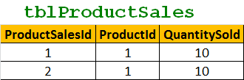  
  
Create Procedure spUpdateInventory\_and\_Sell  
as  
Begin  
  Begin Try  
    Begin Transaction  
      Update tblProduct set QtyAvailable = (QtyAvailable - 10)  
      where ProductId = 1  
  
      Insert into tblProductSales values(3, 1, 10)  
    Commit Transaction  
  End Try  
  Begin Catch   
    Rollback Transaction  
  End Catch   
End

**Consistent** - All data touched by the transaction is left in a **logically consistent state**. For example, if stock available numbers are decremented from **tblProductTable**, then, there has to be a related entry in **tblProductSales** table. The inventory can't just disappear.  
  
**Isolated** - The transaction must affect data without interfering with other concurrent transactions, or being interfered with by them. This prevents transactions from making changes to data based on uncommitted information, for example changes to a record that are subsequently rolled back. **Most databases use locking to maintain transaction isolation**.  
  
**Durable** - Once a change is made, it is permanent. If a system error or power failure occurs before a set of commands is complete, those commands are undone and the data is restored to its original state once the system begins running again.

### **Subqueries in sql - Part 59**

**Suggested Videos**  
[Part 56 - Error handling in sql server 2005, 2008](http://csharp-video-tutorials.blogspot.com/2012/10/error-handling-in-sql-server-2005-and_6.html)  
[Part 57 - Transactions](http://csharp-video-tutorials.blogspot.com/2012/10/transactions-in-sql-server-part-57.html)  
[Part 58 - Transaction Acid Tests](http://csharp-video-tutorials.blogspot.com/2012/10/transaction-acid-tests-part-58.html)  
  
**In this video we will discuss about subqueries in sql server.** Let us understand subqueris with an example. Please create the required tables and insert sample data using the script below.

Create Table tblProducts  
(  
 [Id] int identity primary key,  
 [Name] nvarchar(50),  
 [Description] nvarchar(250)  
)  
  
Create Table tblProductSales  
(  
 Id int primary key identity,  
 ProductId int foreign key references tblProducts(Id),  
 UnitPrice int,  
 QuantitySold int  
)

Insert into tblProducts values ('TV', '52 inch black color LCD TV')  
Insert into tblProducts values ('Laptop', 'Very thin black color acer laptop')

Insert into tblProducts values ('Desktop', 'HP high performance desktop')  
  
Insert into tblProductSales values(3, 450, 5)  
Insert into tblProductSales values(2, 250, 7)  
Insert into tblProductSales values(3, 450, 4)  
Insert into tblProductSales values(3, 450, 9)  
  
**Write a query to retrieve products that are not at all sold?**  
This can be very easily achieved using subquery as shown below. Select [Id], [Name], [Description]  
from tblProducts  
where Id not in (Select Distinct ProductId from tblProductSales)  
  
**Most of the times subqueries can be very easily replaced with joins.** The above query is rewritten using joins and produces the same results. Select tblProducts.[Id], [Name], [Description]  
from tblProducts  
left join tblProductSales  
on tblProducts.Id = tblProductSales.ProductId  
where tblProductSales.ProductId IS NULL  
  
**In this example, we have seen how to use a subquery in the where clause.**  
  
**Let us now discuss about using a sub query in the SELECT clause.**Write a query to retrieve the NAME and TOTALQUANTITY sold, using a subquery.Select [Name],

(Select SUM(QuantitySold) from tblProductSales where ProductId = tblProducts.Id) as TotalQuantity  
from tblProducts  
order by Name  
  
**Query with an equivalent join that produces the same result.**  
Select [Name], SUM(QuantitySold) as TotalQuantity  
from tblProducts  
left join tblProductSales  
on tblProducts.Id = tblProductSales.ProductId  
group by [Name]  
order by Name  
  
**From these examples,** it should be very clear that, a subquery is simply a select statement, that returns a single value and can be nested inside a SELECT, UPDATE, INSERT, or DELETE statement.   
  
It is also possible to nest a subquery inside another subquery.  
  
According to MSDN, subqueries can be nested upto 32 levels.  
  
Subqueries are always encolsed in paranthesis and are also called as inner queries, and the query containing the subquery is called as outer query.  
  
The columns from a table that is present only inside a subquery, cannot be used in the SELECT list of the outer query.  
  
**Next Video:**  
What to choose for performance? Queries that involve a subquery or a join

### **Correlated subquery in sql - Part 60**

**Suggested Videos**  
[Part 57 - Transactions](http://csharp-video-tutorials.blogspot.com/2012/10/transactions-in-sql-server-part-57.html)  
[Part 58 - Transaction Acid Tests](http://csharp-video-tutorials.blogspot.com/2012/10/transaction-acid-tests-part-58.html)  
[Part 59 - Subqueries](http://csharp-video-tutorials.blogspot.com/2013/01/subqueries-in-sql-part-59.html)  
  
  
**In Part 59, we discussed about 2 examples that uses subqueries.** Please watch Part 59, before proceeding with this video. We will be using the same tables and queries from Part 59.  
  
**In the example below, sub query is executed first and only once.** The sub query results are then used by the outer query. A non-corelated subquery can be executed independently of the outer query.  
Select [Id], [Name], [Description]  
from tblProducts  
where Id not in (Select Distinct ProductId from tblProductSales)

**If the subquery depends on the outer query for its values**, then that sub query is called as a correlated subquery. In the where clause of the subquery below, **"ProductId"** column get it's value from **tblProducts** table that is present in the outer query. So, here the subquery is dependent on the outer query for it's value, hence this subquery is a correlated subquery. Correlated subqueries get executed, once for every row that is selected by the outer query. Corelated subquery, cannot be executed independently of the outer query.  
Select [Name],  
(Select SUM(QuantitySold) from tblProductSales where ProductId = tblProducts.Id) as TotalQuantity  
from tblProducts  
order by Name

### **Creating a large table with random data for performance testing - Part 61**

**In this video we will discuss about inserting large amount of random data into sql server tables for performance testing.**

-- If Table exists drop the tables  
If (Exists (select \*   
            from information\_schema.tables   
            where table\_name = 'tblProductSales'))  
Begin  
 Drop Table tblProductSales  
End  
  
If (Exists (select \*   
            from information\_schema.tables   
            where table\_name = 'tblProducts'))  
Begin  
 Drop Table tblProducts  
End

-- Recreate tables  
Create Table tblProducts  
(  
 [Id] int identity primary key,  
 [Name] nvarchar(50),  
 [Description] nvarchar(250)  
)  
  
Create Table tblProductSales  
(  
 Id int primary key identity,  
 ProductId int foreign key references tblProducts(Id),  
 UnitPrice int,  
 QuantitySold int  
)  
  
--Insert Sample data into tblProducts table  
Declare @Id int  
Set @Id = 1  
  
While(@Id <= 300000)  
Begin  
 Insert into tblProducts values('Product - ' + CAST(@Id as nvarchar(20)),   
 'Product - ' + CAST(@Id as nvarchar(20)) + ' Description')  
   
 Print @Id  
 Set @Id = @Id + 1  
End  
  
-- Declare variables to hold a random ProductId,   
-- UnitPrice and QuantitySold  
declare @RandomProductId int  
declare @RandomUnitPrice int  
declare @RandomQuantitySold int  
  
-- Declare and set variables to generate a   
-- random ProductId between 1 and 100000  
declare @UpperLimitForProductId int  
declare @LowerLimitForProductId int  
  
set @LowerLimitForProductId = 1  
set @UpperLimitForProductId = 100000  
  
-- Declare and set variables to generate a   
-- random UnitPrice between 1 and 100  
declare @UpperLimitForUnitPrice int  
declare @LowerLimitForUnitPrice int  
  
set @LowerLimitForUnitPrice = 1  
set @UpperLimitForUnitPrice = 100  
  
-- Declare and set variables to generate a   
-- random QuantitySold between 1 and 10  
declare @UpperLimitForQuantitySold int  
declare @LowerLimitForQuantitySold int  
  
set @LowerLimitForQuantitySold = 1  
set @UpperLimitForQuantitySold = 10  
  
--Insert Sample data into tblProductSales table  
Declare @Counter int  
Set @Counter = 1  
  
While(@Counter <= 450000)  
Begin  
 select @RandomProductId = Round(((@UpperLimitForProductId - @LowerLimitForProductId) \* Rand() + @LowerLimitForProductId), 0)  
 select @RandomUnitPrice = Round(((@UpperLimitForUnitPrice - @LowerLimitForUnitPrice) \* Rand() + @LowerLimitForUnitPrice), 0)

select @RandomQuantitySold = Round(((@UpperLimitForQuantitySold - @LowerLimitForQuantitySold) \* Rand() + @LowerLimitForQuantitySold), 0)  
   
 Insert into tblProductsales   
 values(@RandomProductId, @RandomUnitPrice, @RandomQuantitySold)  
  
 Print @Counter  
 Set @Counter = @Counter + 1  
End  
  
**Finally, check the data in the tables using a simple SELECT query** to make sure the data has been inserted as expected.  
Select \* from tblProducts  
Select \* from tblProductSales  
  
**In our next video, we will be using these tables, for performance testing of queries that uses subqueries and joins.**

### **What to choose for performance - SubQueries or Joins - Part 62**

According to MSDN, in sql server, in most cases, there is usually no performance difference between queries that uses sub-queries and equivalent queries using joins. For example, on my machine I have  
**400,000 records in tblProducts table**  
**600,000 records in tblProductSales tables**

**The following query, returns, the list of products that we have sold atleast once.** This query is formed using sub-queries. When I execute this query I get 306,199 rows in 6 seconds  
Select Id, Name, Description  
from tblProducts  
where ID IN  
(  
 Select ProductId from tblProductSales  
)

### **At this stage please clean the query and execution plan cache using the following T-SQL command.** CHECKPOINT;  GO  DBCC DROPCLEANBUFFERS; -- Clears query cache Go DBCC FREEPROCCACHE; -- Clears execution plan cache GO **Now, run the query that is formed using joins.** Notice that I get the exact same 306,199 rows in 6 seconds.  Select distinct tblProducts.Id, Name, Description from tblProducts inner join tblProductSales on tblProducts.Id = tblProductSales.ProductId **Please Note:** I have used automated sql script to insert huge amounts of this random data. Please watch Part 61 of SQL Server tutorial, in which we have discussed about this automated script. According to MSDN, in some cases where existence must be checked, a join produces better performance. Otherwise, the nested query must be processed for each result of the outer query. In such cases, a join approach would yield better results. The following query returns the products that we have not sold at least once. This query is formed using sub-queries. When I execute this query I get 93,801 rows in 3 seconds Select Id, Name, [Description] from tblProducts where Not Exists(Select \* from tblProductSales where ProductId = tblProducts.Id) **When I execute the below equivalent query**, that uses joins, I get the exact same 93,801 rows in 3 seconds. Select tblProducts.Id, Name, [Description] from tblProducts left join tblProductSales on tblProducts.Id = tblProductSales.ProductId where tblProductSales.ProductId IS NULL  In general joins work faster than sub-queries, but in reality it all depends on the execution plan that is generated by SQL Server. It does not matter how we have written the query, SQL Server will always transform it on an execution plan. If sql server generates the same plan from both queries, we will get the same result.I would say, rather than going by theory, turn on client statistics and execution plan to see the performance of each option, and then DECIDE.

### **Cursors in sql server - Part 63**

**Relational Database Management Systems, including sql server are very good at handling data in SETS.** For example, the following "UPDATE" query, updates a set of rows that matches the condition in the "WHERE" clause at the same time.   
**Update tblProductSales Set UnitPrice = 50 where ProductId = 101**

**However, if there is ever a need to process the rows, on a row-by-row basis**, then cursors are your choice. Cursors are very bad for performance, and should be avoided always. Most of the time, cursors can be very easily replaced using joins.  
  
There are different types of cursors in sql server as listed below. We will talk about the differences between these cursor types in a later video session.   
**1.** Forward-Only  
**2.** Static  
**3.** Keyset  
**4.** Dynamic

**Let us now look at a simple example of using sql server cursor to process one row at time.** We will be using tblProducts and tblProductSales tables, for this example. The tables here show only 5 rows from each table. However, on my machine, there are 400,000 records in tblProducts and 600,000 records in tblProductSales tables. If you want to learn about generating huge amounts of random test data, [**please watch Part - 61 in sql server video tutorial.**](https://www.youtube.com/user/kudvenkat/videos?flow=grid&view=1)  
  
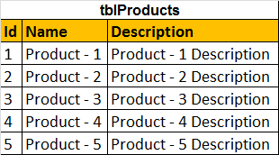  
  
**Cursor Example:** Let us say, I want to update the UNITPRICE column in tblProductSales table, based on the following criteria  
**1.** If the ProductName = 'Product - 55', Set Unit Price to 55

**2.** If the ProductName = 'Product - 65', Set Unit Price to 65  
**3.** If the ProductName is like 'Product - 100%', Set Unit Price to 1000  
  
Declare @ProductId int  
  
-- Declare the cursor using the declare keyword  
Declare ProductIdCursor CURSOR FOR   
Select ProductId from tblProductSales  
  
-- Open statement, executes the SELECT statment  
-- and populates the result set  
Open ProductIdCursor  
  
-- Fetch the row from the result set into the variable  
Fetch Next from ProductIdCursor into @ProductId  
  
-- If the result set still has rows, @@FETCH\_STATUS will be ZERO  
While(@@FETCH\_STATUS = 0)  
Begin  
 Declare @ProductName nvarchar(50)  
 Select @ProductName = Name from tblProducts where Id = @ProductId  
   
 if(@ProductName = 'Product - 55')  
 Begin  
 Update tblProductSales set UnitPrice = 55 where ProductId = @ProductId  
 End  
 else if(@ProductName = 'Product - 65')  
 Begin  
 Update tblProductSales set UnitPrice = 65 where ProductId = @ProductId  
 End  
 else if(@ProductName like 'Product - 100%')  
 Begin  
 Update tblProductSales set UnitPrice = 1000 where ProductId = @ProductId  
 End  
   
 Fetch Next from ProductIdCursor into @ProductId   
End  
  
-- Release the row set  
CLOSE ProductIdCursor   
-- Deallocate, the resources associated with the cursor  
DEALLOCATE ProductIdCursor  
  
The cursor will loop thru each row in tblProductSales table. As there are 600,000 rows, to be processed on a row-by-row basis, it takes around 40 to 45 seconds on my machine. We can achieve this very easily using a join, and this will significantly increase the performance. We will discuss about this in our next video session.  
  
**To check if the rows have been correctly updated, please use the following query.**  
Select  Name, UnitPrice   
from tblProducts join  
tblProductSales on tblProducts.Id = tblProductSales.ProductId  
where (Name='Product - 55' or Name='Product - 65' or Name like 'Product - 100%')

### **Replacing cursors using joins in sql server - Part 64**

Update tblProductSales  
set UnitPrice =   
 Case   
 When Name = 'Product - 55' Then 155  
 When Name = 'Product - 65' Then 165  
 When Name like 'Product - 100%' Then 10001  
 End   
from tblProductSales  
join tblProducts  
on tblProducts.Id = tblProductSales.ProductId  
Where Name = 'Product - 55' or Name = 'Product - 65' or   
Name like 'Product - 100%'

**When I executed this query,** on my machine it took less than a second. Where as the same thing using a cursor took 45 seconds. Just imagine the amount of impact cursors have on performance. Cursors should be used as your last option. Most of the time cursors can be very easily replaced using joins.  
  
**To check the result of the UPDATE statement, use the following query.**  
Select  Name, UnitPrice from   
tblProducts join  
tblProductSales on tblProducts.Id = tblProductSales.ProductId  
where (Name='Product - 55' or Name='Product - 65' or   
Name like 'Product - 100%')

### **Part 65 - List all tables in a sql server database using a query**

**Object explorer** with in sql server management studio can be used to get the list of tables in a specific database. However, if we have to write a query to achieve the same, there are 3 system views that we can use.  
**1.** **SYSOBJECTS** - Supported in SQL Server version 2000, 2005 & 2008  
**2.** **SYS.TABLES** - Supported in SQL Server version 2005 & 2008  
**3.** **INFORMATION\_SCHEMA.TABLES** - Supported in SQL Server version 2005 & 2008

-- Gets the list of tables only  
Select \* from SYSOBJECTS where XTYPE='U'  
-- Gets the list of tables only  
Select \* from  SYS.TABLES  
-- Gets the list of tables and views  
Select \* from INFORMATION\_SCHEMA.TABLES  
  
**To get the list of different object types (XTYPE) in a database**  
Select Distinct XTYPE from SYSOBJECTS  
  
Executing the above query on my SAMPLE database returned the following values for XTYPE column from SYSOBJECTS  
**IT** - Internal table  
**P** - Stored procedure  
**PK** - PRIMARY KEY constraint  
**S** - System table   
**SQ** - Service queue  
**U** - User table  
**V** - View  
  
Please check the following MSDN link for all possible XTYPE column values and what they represent.  
<http://msdn.microsoft.com/en-us/library/ms177596.aspx>

### **Writing re-runnable sql server scripts - Part 66**

**What is a re-runnable sql script?**  
A re-runnable script is a script, that, when run more than, once will not throw errors.

Let's understand **writing re-runnable sql scripts** with an example. To create a table **tblEmployee** in **Sample** database, we will write the following **CREATE TABLE** sql script.  
USE [Sample]  
Create table tblEmployee  
(  
 ID int identity primary key,  
 Name nvarchar(100),  
 Gender nvarchar(10),  
 DateOfBirth DateTime  
)

When you run this script once, the table **tblEmployee**gets created without any errors. If you run the script again, you will get an error - There is already an object named 'tblEmployee' in the database.  
  
**To make this script re-runnable**  
**1.** Check for the existence of the table  
**2.** Create the table if it does not exist  
**3.** Else print a message stating, the table already exists  
  
Use [Sample]  
If not exists (select \* from information\_schema.tables where table\_name = 'tblEmployee')  
Begin  
 Create table tblEmployee  
 (  
 ID int identity primary key,  
 Name nvarchar(100),  
 Gender nvarchar(10),  
 DateOfBirth DateTime  
 )  
 Print 'Table tblEmployee successfully created'  
End  
Else  
Begin  
 Print 'Table tblEmployee already exists'  
End  
  
The above **script is re-runnable**, and can be run any number of times. If the table is not already created, the script will create the table, else you will get a message stating - **The table already exists.** You will never get a sql script error.  
  
Sql server built-in function OBJECT\_ID(), can also be used to check for the existence of the table  
IF OBJECT\_ID('tblEmployee') IS NULL  
Begin  
   -- Create Table Script  
   Print 'Table tblEmployee created'  
End  
Else  
Begin  
   Print 'Table tblEmployee already exists'  
End  
  
Depending on what we are trying to achieve, sometime we may need **to drop (if the table already exists) and re-create it**. The sql script below, does exactly the same thing.  
Use [Sample]  
IF OBJECT\_ID('tblEmployee') IS NOT NULL  
Begin  
 Drop Table tblEmployee  
End  
Create table tblEmployee  
(  
 ID int identity primary key,  
 Name nvarchar(100),  
 Gender nvarchar(10),  
 DateOfBirth DateTime  
)  
  
Let's look at another example. The following sql script adds column **"EmailAddress"** to table **tblEmployee**. This script is not re-runnable because, if the column exists we get a script error.  
Use [Sample]  
ALTER TABLE tblEmployee  
ADD EmailAddress nvarchar(50)  
  
**To make this script re-runnable, check for the column existence**  
Use [Sample]  
if not exists(Select \* from INFORMATION\_SCHEMA.COLUMNS where COLUMN\_NAME='EmailAddress' and TABLE\_NAME = 'tblEmployee' and TABLE\_SCHEMA='dbo')   
Begin  
 ALTER TABLE tblEmployee  
 ADD EmailAddress nvarchar(50)  
End  
Else  
BEgin  
 Print 'Column EmailAddress already exists'  
End  
  
**Col\_length**() function can also be used to check for the existence of a column  
If col\_length('tblEmployee','EmailAddress') is not null  
Begin  
 Print 'Column already exists'  
End  
Else  
Begin  
 Print 'Column does not exist'  
End

### **Part 67 - Alter database table columns without dropping table**

We will be using table **tblEmployee**for this demo. Use the sql script below, to create and populate this table with some sample data.

Create table tblEmployee  
(  
 ID int primary key identity,  
 Name nvarchar(50),  
 Gender nvarchar(50),  
 Salary nvarchar(50)  
)

Insert into tblEmployee values('Sara Nani','Female','4500')  
Insert into tblEmployee values('James Histo','Male','5300')

Insert into tblEmployee values('Mary Jane','Female','6200')Insert into tblEmployee values('Paul Sensit','Male','4200')  
Insert into tblEmployee values('Mike Jen','Male','5500')  
The requirement is to group the salaries by gender. The output should be as shown below.  
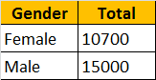  
  
To achieve this we would write a sql query using GROUP BY as shown below.  
Select Gender, Sum(Salary) as Total   
from tblEmployee  
Group by Gender  
  
When you execute this query, we will get an error - Operand data type nvarchar is invalid for sum operator. This is because, when we created **tblEmployee**table, the **"Salary"** column was created using **nvarchar** datatype. SQL server **Sum**() aggregate function can only be applied on numeric columns. So, let's try to modify **"Salary"** column to use **int** datatype. Let's do it using the designer.   
**1.** Right click on "tblEmployee" table in "Object Explorer" window, and select "Design"  
**2.** Change the datatype from nvarchar(50) to int  
**3.** Save the table  
  
At this point, you will get an error message - Saving changes is not permitted. The changes you have made require the following tables to be dropped and re-created. You have either made changes to a table that can't be re-created or enabled the option Prevent saving changes that require the table to be re-created.  
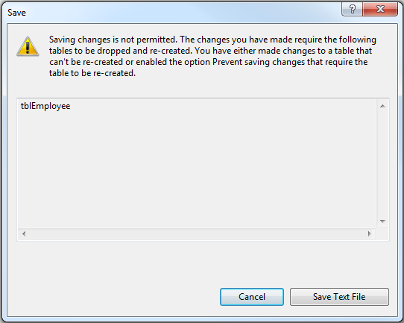  
  
So, the obvious next question is, **how to alter the database table definition without the need to drop, re-create and again populate the table with data?**  
There are 2 options  
  
**Option 1:** Use a sql query to alter the column as shown below.  
Alter table tblEmployee  
Alter column Salary int  
  
**Option 2:** Disable **"Prevent saving changes that require table re-creation"** option in sql server 2008  
**1.** Open Microsoft SQL Server Management Studio 2008  
**2.** Click Tools, select Options  
**3.** Expand Designers, and select "Table and Database Designers"  
**4.** On the right hand side window, uncheck, Prevent saving changes that require table re-creation  
**5**. Click OK  
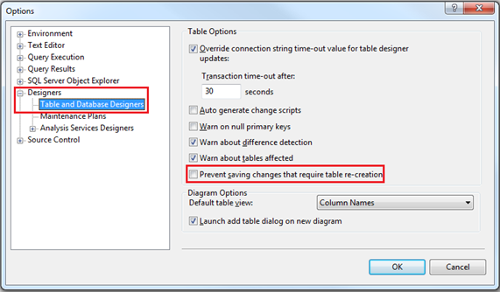

### **Part 68 - Optional parameters in sql server stored procedures**

**Parameters of a sql server stored procedure can be made optional by specifying default values.**  
  
**We wil be using table tblEmployee for this Demo.**  
CREATE TABLE tblEmployee  
(  
 Id int IDENTITY PRIMARY KEY,  
 Name nvarchar(50),  
 Email nvarchar(50),  
 Age int,  
 Gender nvarchar(50),  
 HireDate date,  
)

Insert into tblEmployee values  
('Sara Nan','Sara.Nan@test.com',35,'Female','1999-04-04')  
Insert into tblEmployee values  
('James Histo','James.Histo@test.com',33,'Male','2008-07-13')  
Insert into tblEmployee values  
('Mary Jane','Mary.Jane@test.com',28,'Female','2005-11-11')  
Insert into tblEmployee values  
('Paul Sensit','Paul.Sensit@test.com',29,'Male','2007-10-23')  
  
**Name, Email, Age and Gender** parameters of spSearchEmployees stored procedure are optional. Notice that, we have set defaults for all the parameters, and in the "WHERE" clause we are checking if the respective parameter IS NULL.  
Create Proc spSearchEmployees  
@Name nvarchar(50) = NULL,  
@Email nvarchar(50) = NULL,  
@Age int = NULL,  
@Gender nvarchar(50) = NULL  
as  
Begin  
 Select \* from tblEmployee where  
 (Name = @Name OR @Name IS NULL) AND  
 (Email = @Email OR @Email IS NULL) AND  
 (Age = @Age OR @Age IS NULL) AND  
 (Gender = @Gender OR @Gender IS NULL)   
End

**Testing the stored procedure**  
**1.** Execute spSearchEmployees -- This command will return all the rows  
**2.** Execute spSearchEmployees @Gender = 'Male' -- Retruns only Male employees

**3.** Execute spSearchEmployees @Gender = 'Male', @Age = 29 -- Retruns Male employees whose age is 29  
  
This stored procedure can be used by a search page that looks as shown below.  
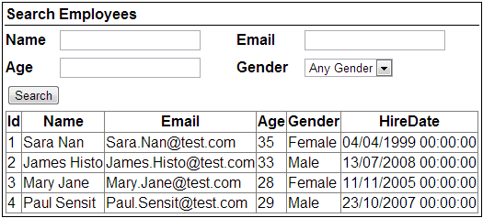

### **Part 69 - Merge in SQL Server**

**What is the use of MERGE statement in SQL Server**  
Merge statement introduced in SQL Server 2008 allows us to perform Inserts, Updates and Deletes in one statement. This means we no longer have to use multiple statements for performing Insert, Update and Delete.  
  
**With merge statement we require 2 tables**  
1. Source Table - Contains the changes that needs to be applied to the target table  
2. Target Table - The table that require changes (Inserts, Updates and Deletes)

The merge statement joins the target table to the source table by using a common column in both the tables. Based on how the rows match up as a result of the join, we can then perform insert, update, and delete on the target table.   
  
**Merge statement syntax**  
**MERGE [TARGET] AS T**  
**USING [SOURCE] AS S**  
**ON [JOIN\_CONDITIONS]**  
**WHEN MATCHED THEN**  
**[UPDATE STATEMENT]**  
**WHEN NOT MATCHED BY TARGET THEN**  
**[INSERT STATEMENT]**  
**WHEN NOT MATCHED BY SOURCE THEN**  
**[DELETE STATEMENT]**  
  
**Example 1 :** In the example below, INSERT, UPDATE and DELETE are all performed in one statement  
**1.**When matching rows are found, StudentTarget table is UPDATED (i.e WHEN MATCHED)  
  
**2.** When the rows are present in StudentSource table but not in StudentTarget table those rows are INSERTED into StudentTarget table (i.e WHEN NOT MATCHED BY TARGET)  
  
**3.** When the rows are present in StudentTarget table but not in StudentSource table those rows are DELETED from StudentTarget table (i.e WHEN NOT MATCHED BY SOURCE)  
  
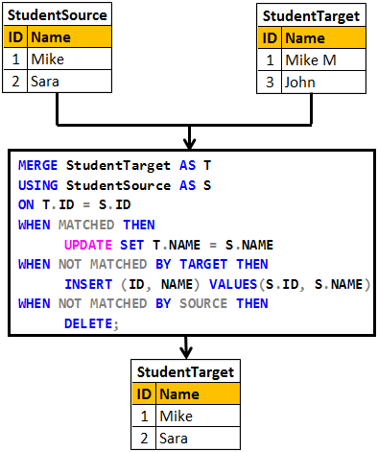

Create table StudentSource

(

     ID int primary key,

     Name nvarchar(20)

)

GO

Insert into StudentSource values (1, 'Mike')

Insert into StudentSource values (2, 'Sara')

GO

Create table StudentTarget

(

     ID int primary key,

     Name nvarchar(20)

)

GO

Insert into StudentTarget values (1, 'Mike M')

Insert into StudentTarget values (3, 'John')

GO

MERGE StudentTarget AS T

USING StudentSource AS S

ON T.ID = S.ID

WHEN MATCHED THEN

     UPDATE SET T.NAME = S.NAME

WHEN NOT MATCHED BY TARGET THEN

     INSERT (ID, NAME) VALUES(S.ID, S.NAME)

WHEN NOT MATCHED BY SOURCE THEN

     DELETE;

**Please Note :** Merge statement should end with a semicolon, otherwise you would get an error stating - A MERGE statement must be terminated by a semi-colon (;)  
  
**In real time we mostly perform INSERTS and UPDATES.**The rows that are present in target table but not in source table are usually not deleted from the target table.

**Example 2 :** In the example below, only INSERT and UPDATE is performed. We are not deleting the rows that are present in the target table but not in the source table.  
  
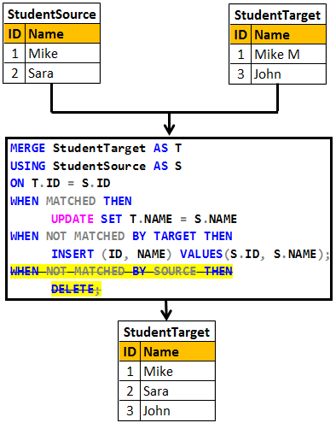

Truncate table StudentSource

Truncate table StudentTarget

GO

Insert into StudentSource values (1, 'Mike')

Insert into StudentSource values (2, 'Sara')

GO

Insert into StudentTarget values (1, 'Mike M')

Insert into StudentTarget values (3, 'John')

GO

MERGE StudentTarget AS T

USING StudentSource AS S

ON T.ID = S.ID

WHEN MATCHED THEN

     UPDATE SET T.NAME = S.NAME

WHEN NOT MATCHED BY TARGET THEN

     INSERT (ID, NAME) VALUES(S.ID, S.NAME);

### **PART 70 sql server concurrent transactions**

**In this video we will discuss**  
1. What a transaction is  
2. The problems that might arise when tarnsactions are run concurrently  
3. The different transaction isolation levels provided by SQL Server to address concurrency side effects

**What is a transaction**  
A transaction is a group of commands that change the data stored in a database. A transaction, is treated as a single unit of work. A transaction ensures that, either all of the commands succeed, or none of them. If one of the commands in the transaction fails, all of the commands fail, and any data that was modified in the database is rolled back. In this way, transactions maintain the integrity of data in a database.  
  
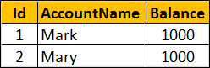  
  
**Example :** The following transaction ensures that both the UPDATE statements succeed or both of them fail if there is a problem with one UPDATE statement.

-- Transfer $100 from Mark to Mary Account

BEGIN TRY

    BEGIN TRANSACTION

         UPDATE Accounts SET Balance = Balance - 100 WHERE Id = 1

         UPDATE Accounts SET Balance = Balance + 100 WHERE Id = 2

    COMMIT TRANSACTION

    PRINT 'Transaction Committed'

END TRY

BEGIN CATCH

    ROLLBACK TRANSACTION

    PRINT 'Transaction Rolled back'

END CATCH

Databases are powerful systems and are potentially used by many users or applications at the same time. Allowing concurrent transactions is essential for performance but may introduce concurrency issues when two or more transactions are working with the same data at the same time.  
  
**Some of the common concurrency problems**

* Dirty Reads
* Lost Updates
* Nonrepeatable Reads
* Phantom Reads

We will discuss what these problems are in detail with examples in our upcomning videos  
  
One way to solve all these concurrency problems is by allowing only one user to execute, only one transaction at any point in time. Imagine what could happen if you have a large database with several users who want to execute several transactions. All the transactions get queued and they may have to wait a long time before they could get a chance to execute their transactions. So you are getting poor performance and the whole purpose of having a powerful database system is defeated if you serialize access this way.  
  
At this point you might be thinking, for best performance let us allow all transactions to execute concurrently. The problem with this approach is that it may cause all sorts of concurrency problems (i.e Dirty Reads, Lost Updates, Nonrepeatable Reads, Phantom Reads) if two or more transactions work with the same data at the same time.  
  
SQL Server provides different **transaction isolation levels**, to balance concurrency problems and performance depending on our application needs.

* Read Uncommitted
* Read Committed
* Repeatable Read
* Snapshot
* Serializable

**The isolation level that you choose for your transaction**, defines the degree to which one transaction must be isolated from resource or data modifications made by other transactions. Depending on the isolation level you have chosen you get varying degrees of performance and concurrency problems. The table here has the list of isoltaion levels along with concurrency side effects.

|  |  |  |  |  |
| --- | --- | --- | --- | --- |
| **Isolation Level** | **Dirty Reads** | **Lost Update** | **Nonrepeatable Reads** | **Phantom Reads** |
| **Read Uncommitted** | Yes | Yes | Yes | Yes |
| **Read Committed** | No | Yes | Yes | Yes |
| **Repeatable Read** | No | No | No | Yes |
| **Snapshot** | No | No | No | No |
| **Serializable** | No | No | No | No |

If you choose the lowest isolation level (i.e Read Uncommitted), it increases the number of concurrent transactions that can be executed at the same time, but the down side is you have all sorts of concurrency issues. On the other hand if you choose the highest isolation level (i.e Serializable), you will have no concurrency side effects, but the downside is that, this will reduce the number of concurrent transactions that can be executed at the same time if those transactions work with same data.

### **part 71 : sql server dirty read example**

In this video we will discuss, **dirty read concurrency problem** with an example. This is continuation to [Part 70](http://csharp-video-tutorials.blogspot.com/2015/08/sql-server-concurrent-transactions.html). Please watch [Part 70](http://csharp-video-tutorials.blogspot.com/2015/08/sql-server-concurrent-transactions.html) from [SQL Server tutorial for beginners](https://www.youtube.com/playlist?list=PL08903FB7ACA1C2FB).  
  
A dirty read happens when one transaction is permitted to read data that has been modified by another transaction that has not yet been committed. In most cases this would not cause a problem. However, if the first transaction is rolled back after the second reads the data, the second transaction has dirty data that does not exist anymore.  
  
SQL script to create table tblInventory

Create table tblInventory

(

    Id int identity primary key,

    Product nvarchar(100),  ItemsInStock int)

Insert into tblInventory values ('iPhone', 10)

**Table tblInventory**  
dirty read problem in concurrency control  
  
**Dirty Read Example :** In the example below, Transaction 1, updates the value of ItemsInStock to 9. Then it starts to bill the customer. While Transaction 1 is still in progress, Transaction 2 starts and reads ItemsInStock value which is 9 at the moment. At this point, Transaction 1 fails because of insufficient funds and is rolled back. The ItemsInStock is reverted to the original value of 10, but Transaction 2 is working with a different value (i.e 10).  
  
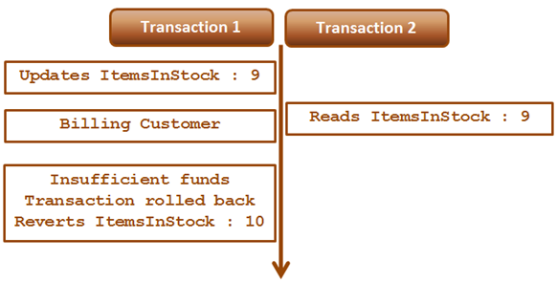  
  
**Transaction 1 :**  
Begin Tran

Update tblInventory set ItemsInStock = 9 where Id=1

-- Billing the customer

Waitfor Delay '00:00:15'

-- Insufficient Funds. Rollback transaction

Rollback Transaction

**Transaction 2 :**

Set Transaction Isolation Level Read Uncommitted

Select \* from tblInventory where Id=1

Read Uncommitted transaction isolation level is the only isolation level that has dirty read side effect. This is the least restrictive of all the isolation levels. When this transaction isolation level is set, it is possible to read uncommitted or dirty data. Another option to read dirty data is by using NOLOCK table hint. The query below is equivalent to the query in Transaction 2.

Select \* from tblInventory (NOLOCK) where Id=1

### **PARTT 72 sql server lost update problem**

**Lost update problem happens when 2 transactions read and update the same data**. Let's understand this with an example. We will use the following table **tblInventory**for this example.  
  
lost update concurrency problem example  
  
As you can see in the diagram below there are 2 transactions - Transaction 1 and Transaction 2. Transaction 1 starts first, and it is processing an order for 1 iPhone. It sees ItemsInStock as 10.  
  
At this time Transaction 2 is processing another order for 2 iPhones. It also sees ItemsInStock as 10. Transaction 2 makes the sale first and updates ItemsInStock with a value of 8.

At this point Transaction 1 completes the sale and silently overwrites the update of Transaction 2. As Transaction 1 sold 1 iPhone it has updated ItemsInStock to 9, while it actually should have updated it to 7.  
  
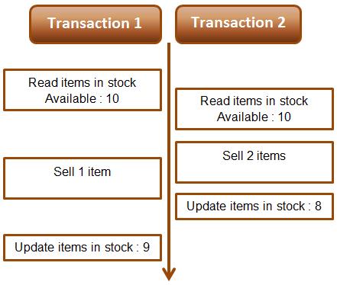  
  
**Example :** The lost update problem example. Open 2 instances of SQL Server Management studio. From the first window execute Transaction 1 code and from the second window, execute Transaction 2 code. Transaction 1 is processing an order for 1 iPhone, while Transaction 2 is processing an order for 2 iPhones. At the end of both the transactions ItemsInStock must be 7, but we have a value of 9. This is because Transaction 1 silently overwrites the update of Transaction 2. This is called the **lost update problem**.

-- Transaction 1

Begin Tran

Declare @ItemsInStock int

Select @ItemsInStock = ItemsInStock

from tblInventory where Id=1

-- Transaction takes 10 seconds

Waitfor Delay '00:00:10'

Set @ItemsInStock = @ItemsInStock - 1

Update tblInventory

Set ItemsInStock = @ItemsInStock where Id=1

Print @ItemsInStock

Commit Transaction

-- Transaction 2

Begin Tran

Declare @ItemsInStock int

Select @ItemsInStock = ItemsInStock

from tblInventory where Id=1

-- Transaction takes 1 second

Waitfor Delay '00:00:1'

Set @ItemsInStock = @ItemsInStock - 2

Update tblInventory

Set ItemsInStock = @ItemsInStock where Id=1

Print @ItemsInStock

Commit Transaction

Both Read Uncommitted and Read Committed transaction isolation levels have the lost update side effect. Repeatable Read, Snapshot, and Serializable isolation levels does not have this side effect. If you run the above Transactions using any of the higher isolation levels (Repeatable Read, Snapshot, or Serializable) you will not

have lost update problem. The repeatable read isolation level uses additional locking on rows that are read by the current transaction, and prevents them from being updated or deleted elsewhere. This solves the lost update problem.  
  
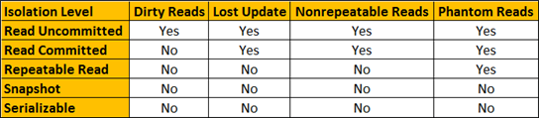  
  
For both the above transactions, set Repeatable Read Isolation Level. Run Transaction 1 first and then a few seconds later run Transaction 2. Transaction 1 completes successfully, but Transaction 2 competes with the following error.  
Transaction was deadlocked on lock resources with another process and has been chosen as the deadlock victim. Rerun the transaction.

Once you rerun Transaction 2, ItemsInStock will be updated correctly as expected.

### **part 73 : Non repeatable read example in sql server**

Non repeatable read problem happens when one transaction reads the same data twice and another transaction updates that data in between the first and second read of transaction one. 

We will use the following table **tblInventory** in this demo  
sql server non-repeatable read

**The following diagram explains the problem :** Transaction 1 starts first. Reads ItemsInStock. Gets a value of 10 for first read. Transaction 1 is doing some work and at this point Transaction 2 starts and UpdatesItemsInStock to 5. Transaction 1 then makes a second read. At this point Transaction 1 gets a value of 5, reulting in non-repeatable read problem.  
  
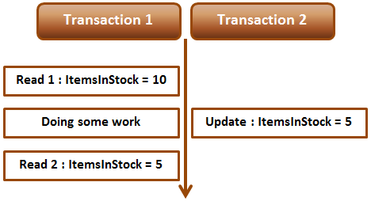  
  
**Non-repeatable read example :** Open 2 instances of SQL Server Management studio. From the first window execute Transaction 1 code and from the second window, execute Transaction 2 code. Notice that when Transaction 1 completes, it gets different values for read 1 and read 2, resulting in non-repeatable read.

-- Transaction 1

Begin Transaction

Select ItemsInStock from tblInventory where Id = 1

-- Do Some work

waitfor delay '00:00:10'

Select ItemsInStock from tblInventory where Id = 1

Commit Transaction

-- Transaction 2

Update tblInventory set ItemsInStock = 5 where Id = 1

Repeatable read or any other higher isolation level should solve the non-repeatable read problem.  
  
  
**Fixing non repeatable read concurrency problem :** To fix the non-repeatable read problem, set transaction isolation level of Transaction 1 to repeatable read. This will ensure that the data that Transaction 1 has read, will be prevented from being updated or deleted elsewhere. This solves the non-repeatable read problem.   
  
When you execute Transaction 1 and 2 from 2 different instances of SQL Server management studio, Transaction 2 is blocked until Transaction 1 completes and at the end of Transaction 1, both the reads get the same value for ItemsInStock.

-- Transaction 1

Set transaction isolation level repeatable read

Begin Transaction

Select ItemsInStock from tblInventory where Id = 1

-- Do Some work

waitfor delay '00:00:10'

Select ItemsInStock from tblInventory where Id = 1

Commit Transaction

-- Transaction 2

Update tblInventory set ItemsInStock = 5 where Id = 1

### **PART 74 :Phantom reads example in sql server** In this video we will discuss **phantom read concurrency problem** with examples.

### Phantom read happens when one transaction executes a query twice and it gets a different number of rows in the result set each time. This happens when a second transaction inserts a new row that matches the WHERE clause of the query executed by the first transaction.  We will use the following table tblEmployees in this demo phantom reads in sql server **Scrip to create the table tblEmployees**

Create table tblEmployees

(

    Id int primary key,

    Name nvarchar(50)

)

Go

Insert into tblEmployees values(1,'Mark')

Insert into tblEmployees values(3, 'Sara')

Insert into tblEmployees values(100, 'Mary')

**The following diagram explains the problem :** Transaction 1 starts first. Reads from Emp table where Id between 1 and 3. 2 rows retrieved for first read. Transaction 1 is doing some work and at this point Transaction 2 starts and inserts a new employee with Id = 2. Transaction 1 then makes a second read. 3 rows retrieved for second read, reulting in phantom read problem.  
  
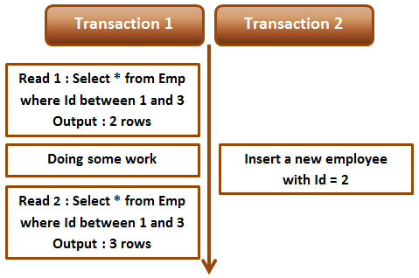  
  
**Phantom read example :** Open 2 instances of SQL Server Management studio. From the first window execute Transaction 1 code and from the second window, execute Transaction 2 code. Notice that when Transaction 1 completes, it gets different number of rows for read 1 and read 2, resulting in phantom read.

-- Transaction 1

Begin Transaction

Select \* from tblEmployees where Id between 1 and 3

-- Do Some work

waitfor delay '00:00:10'

Select \* from tblEmployees where Id between 1 and 3

Commit Transaction

-- Transaction 2

Insert into tblEmployees values(2, 'Marcus')

Serializable or any other higher isolation level should solve the phantom read problem.  
  
  
**Fixing phantom read concurrency problem :** To fix the phantom read problem, set transaction isolation level of Transaction 1 to serializable. This will place a range lock on the rows between 1 and 3, which prevents any other transaction from inserting new rows with in that range. This solves the phantom read problem.   
  
When you execute Transaction 1 and 2 from 2 different instances of SQL Server management studio, Transaction 2 is blocked until Transaction 1 completes and at the end of Transaction 1, both the reads get the same number of rows.

-- Transaction 1

Set transaction isolation level serializable

Begin Transaction

Select \* from tblEmployees where Id between 1 and 3

-- Do Some work

waitfor delay '00:00:10'

Select \* from tblEmployees where Id between 1 and 3

Commit Transaction

-- Transaction 2

Insert into tblEmployees values(2, 'Marcus')

**Difference between repeatable read and serializable**  
**Repeatable read prevents only non-repeatable read.** Repeatable read isolation level ensures that the data that one transaction has read, will be prevented from being updated or deleted by any other transaction, but it doe not prevent new rows from being inserted by other transactions resulting in phantom read concurrency problem.  
  
**Serializable prevents both non-repeatable read and phantom read problems.** Serializable isolation level ensures that the data that one transaction has read, will be prevented from being updated or deleted by any other transaction. It also prevents new rows from being inserted by other transactions, so this isolation level prevents both non-repeatable read and phantom read problems.

### **part 75 :Snapshot isolation level in sql server**

In this video we will discuss, **snapshot isolation level in sql server** with examples.  
  
As you can see from the table below, just like serializable isolation level, snapshot isolation level does not have any concurrency side effects.  
  
  
**What is the difference between serializable and snapshot isolation levels**  
Serializable isolation is implemented by acquiring locks which means the resources are locked for the duration of the current transaction. This isolation level does not have any concurrency side effects but at the cost of significant reduction in concurrency.  
  
Snapshot isolation doesn't acquire locks, it maintains versioning in Tempdb. Since, snapshot isolation does not lock resources, it can significantly increase the number of concurrent transactions while providing the same level of data consistency as serializable isolation does.  
  
Let us understand Snapshot isolation with an example. We will be using the following table tblInventory for this example.  
snapshot isolation example  
  
Open 2 instances of SQL Server Management studio. From the first window execute Transaction 1 code and from the second window execute Transaction 2 code. Notice that Transaction 2 is blocked until Transaction 1 is completed.

--Transaction 1

Set transaction isolation level serializable

Begin Transaction

Update tblInventory set ItemsInStock = 5 where Id = 1

waitfor delay '00:00:10'

Commit Transaction

-- Transaction 2

Set transaction isolation level serializable

Select ItemsInStock from tblInventory where Id = 1

Now change the isolation level of Transaction 2 to snapshot. To set snapshot isolation level, it must first be enabled at the database level, and then set the transaction isolation level to snapshot.

-- Transaction 2

-- Enable snapshot isloation for the database

Alter database SampleDB SET ALLOW\_SNAPSHOT\_ISOLATION ON

-- Set the transaction isolation level to snapshot

Set transaction isolation level snapshot

Select ItemsInStock from tblInventory where Id = 1

From the first window execute Transaction 1 code and from the second window, execute Transaction 2 code. Notice that Transaction 2 is not blocked and returns the data from the database as it was before Transaction 1 has started.  
  
**Modifying data with snapshot isolation level :** Now let's look at an example of what happens when a transaction that is using snapshot isolation tries to update the same data that another transaction is updating at the same time.  
  
In the following example, Transaction 1 starts first and it is updating ItemsInStock to 5. At the same time, Transaction 2 that is using snapshot isolation level is also updating the same data. Notice that Transaction 2 is blocked until Transaction 1 completes. When Transaction 1 completes, Transaction 2 fails with the following error to prevent concurrency side effect - Lost update. If Transaction 2 was allowed to continue, it would have changed the ItemsInStock value to 8 and when Transaction 1 completes it overwrites ItemsInStock to 5, which means we have lost an update. To complete the work that Transaction 2 is doing we will have to rerun the transaction.  
  
Snapshot isolation transaction aborted due to update conflict. You cannot use snapshot isolation to access table 'dbo.tblInventory' directly or indirectly in database 'SampleDB' to update, delete, or insert the row that has been modified or deleted by another transaction. Retry the transaction or change the isolation level for the update/delete statement.

--Transaction 1

Set transaction isolation level serializable

Begin Transaction

Update tblInventory set ItemsInStock = 5 where Id = 1

waitfor delay '00:00:10'

Commit Transaction

-- Transaction 2

-- Enable snapshot isloation for the database

Alter database SampleDB SET ALLOW\_SNAPSHOT\_ISOLATION ON

-- Set the transaction isolation level to snapshot

Set transaction isolation level snapshot

Update tblInventory set ItemsInStock = 8 where Id = 1

### **PART 76 : Read committed snapshot isolation level in sql server**

In this video we will discuss **Read committed snapshot isolation level** in sql server. This is continuation [Part 75](http://csharp-video-tutorials.blogspot.com/2015/08/snapshot-isolation-level-in-sql-server.html). Please watch [Part 75](http://csharp-video-tutorials.blogspot.com/2015/08/snapshot-isolation-level-in-sql-server.html) from [SQL Server tutorial](https://www.youtube.com/playlist?list=PL08903FB7ACA1C2FB) before proceeding.  
  
**We will use the following table tblInventory in this demo**  
Read committed snapshot isolation level example  
  
Read committed snapshot isolation level is not a different isolation level. It is a different way of implementing Read committed isolation level. One problem we have with Read Committed isloation level is that, it blocks the transaction if it is trying to read the data, that another transaction is updating at the same time.  
  
The following example demonstrates the above point. Open 2 instances of SQL Server Management studio. From the first window execute Transaction 1 code and from the second window execute Transaction 2 code. Notice that Transaction 2 is blocked until Transaction 1 is completed.

--Transaction 1

Set transaction isolation level Read Committed

Begin Transaction

Update tblInventory set ItemsInStock = 5 where Id = 1

waitfor delay '00:00:10'

Commit Transaction

-- Transaction 2

Set transaction isolation level read committed

Begin Transaction

Select ItemsInStock from tblInventory where Id = 1

Commit Transaction

We can make Transaction 2 to use row versioning technique instead of locks by enabling Read committed snapshot isolation at the database level. Use the following command to enable READ\_COMMITTED\_SNAPSHOT isolation

Alter database SampleDB SET READ\_COMMITTED\_SNAPSHOT ON

**Please note :** For the above statement to execute successfully all the other database connections should be closed.  
  
After enabling READ\_COMMITTED\_SNAPSHOT, execute Transaction 1 first and then Transaction 2 simultaneously. Notice that the Transaction 2 is not blocked. It immediately returns the committed data that is in the database before Transaction 1 started. This is because Transaction 2 is now using Read committed snapshot isolation level.  
  
Let's see if we can achieve the same thing using snapshot isolation level instead of read committed snapshot isolation level.   
  
**Step 1 :** Turn off READ\_COMMITTED\_SNAPSHOT

Alter database SampleDB SET READ\_COMMITTED\_SNAPSHOT OFF

**Step 2 :** Enable snapshot isolation level at the database level

Alter database SampleDB SET ALLOW\_SNAPSHOT\_ISOLATION ON

**Step 3 :**Execute Transaction 1 first and then Transaction 2 simultaneously. Just like in the previous example, notice that the Transaction 2 is not blocked. It immediately returns the committed data that is in the database before Transaction 1 started.

--Transaction 1

Set transaction isolation level Read Committed

Begin Transaction

Update tblInventory set ItemsInStock = 5 where Id = 1

waitfor delay '00:00:10'

Commit Transaction

-- Transaction 2

Set transaction isolation level snapshot

Begin Transaction

Select ItemsInStock from tblInventory where Id = 1

Commit Transaction

**So what is the point in using read committed snapshot isolation level over snapshot isolation level?**  
There are some differences between read committed snapshot isolation level and snapshot isolation level. We will discuss these in our next video.

### **part 77 Difference between snapshot isolation and read committed snapshot**

In this video we will discuss the differences between snapshot isolation and read committed snapshot isolation in sql server. This is continuation to [Parts 75](http://csharp-video-tutorials.blogspot.com/2015/08/snapshot-isolation-level-in-sql-server.html) and [76](http://csharp-video-tutorials.blogspot.com/2015/08/read-committed-snapshot-isolation-level.html). Please watch [Part 75](http://csharp-video-tutorials.blogspot.com/2015/08/snapshot-isolation-level-in-sql-server.html) and [76](http://csharp-video-tutorials.blogspot.com/2015/08/read-committed-snapshot-isolation-level.html) from [SQL Server tutorial](https://www.youtube.com/playlist?list=PL08903FB7ACA1C2FB) before proceeding.

|  |  |
| --- | --- |
| **Read Committed Snapshot Isolation** | **Snapshot Isolation** |
| No update conflicts | Vulnerable to update conflicts |
| Works with existing applications without requiring any change to the application | Application change may be required to use with an existing application |
| Can be used with distributed transactions | Cannot be used with distributed transactions |
| Provides statement-level read consistency | Provides transaction-level read consistency |

**Update conflicts :** Snapshot isolation is vulnerable to update conflicts where as Read Committed Snapshot Isolation is not. When a transaction running under snapshot isolation triess to update data that an another transaction is already updating at the sametime, an update conflict occurs and the transaction terminates and rolls back with an error.  
  
**We will use the following table tblInventory in this demo**  
Read committed snapshot isolation level example  
  
Enable Snapshot Isolation for the SampleDB database using the following command

Alter database SampleDB SET ALLOW\_SNAPSHOT\_ISOLATION ON

Open 2 instances of SQL Server Management studio. From the first window execute Transaction 1 code and from the second window execute Transaction 2 code. Notice that Transaction 2 is blocked until Transaction 1 is completed. When Transaction 1 completes, Transaction 2 raises an update conflict and the transaction terminates and rolls back with an error.

--Transaction 1

Set transaction isolation level snapshot

Begin Transaction

Update tblInventory set ItemsInStock = 8 where Id = 1

waitfor delay '00:00:10'

Commit Transaction

-- Transaction 2

Set transaction isolation level snapshot

Begin Transaction

Update tblInventory set ItemsInStock = 5 where Id = 1

Commit Transaction

Now let's try the same thing using **Read Committed Sanpshot Isolation**  
  
**Step 1 :** Disable Snapshot Isolation for the SampleDB database using the following command

Alter database SampleDB SET ALLOW\_SNAPSHOT\_ISOLATION OFF

**Step 2 :**Enable Read Committed Sanpshot Isolation at the database level using the following command

Alter database SampleDB SET READ\_COMMITTED\_SNAPSHOT ON

**Step 3 :**Open 2 instances of SQL Server Management studio. From the first window execute Transaction 1 code and from the second window execute Transaction 2 code. Notice that Transaction 2 is blocked until Transaction 1 is completed. When Transaction 1 completes, Transaction 2 also completes successfully without any update conflict.

--Transaction 1

Set transaction isolation level read committed

Begin Transaction

Update tblInventory set ItemsInStock = 8 where Id = 1

waitfor delay '00:00:10'

Commit Transaction

-- Transaction 2

Set transaction isolation level read committed

Begin Transaction

Update tblInventory set ItemsInStock = 5 where Id = 1

Commit Transaction

**Existing application :** If your application is using the default Read Committed isolation level, you can very easily make the application to use Read Committed Snapshot Isolation without requiring any change to the application at all. All you need to do is turn on READ\_COMMITTED\_SNAPSHOT option in the database, which will change read committed isolation to use row versioning when reading the committed data.  
  
**Distributed transactions :** Read Committed Snapshot Isolation works with distributed transactions, whereas snapshot isolation does not.  
  
**Read consistency :**Read Committed Snapshot Isolation provides statement-level read consistency where as Snapshot Isolation provides transaction-level read consistency. The following diagrams explain this.  
  
Transaction 2 has 2 select statements. Notice that both of these select statements return different data. This is because Read Committed Snapshot Isolation returns the last committed data before the select statement began and not the last committed data before the transaction began.  
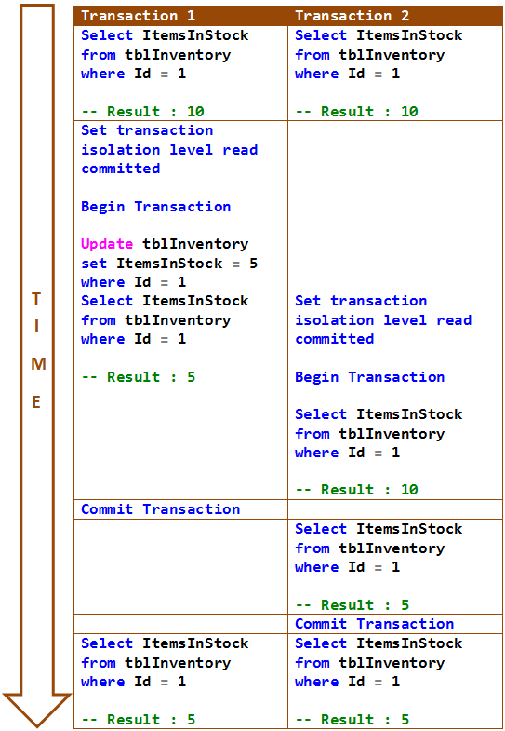  
  
In the following example, both the select statements of Transaction 2 return same data. This is because Snapshot Isolation returns the last committed data before the transaction began and not the last committed data before the select statement began.  
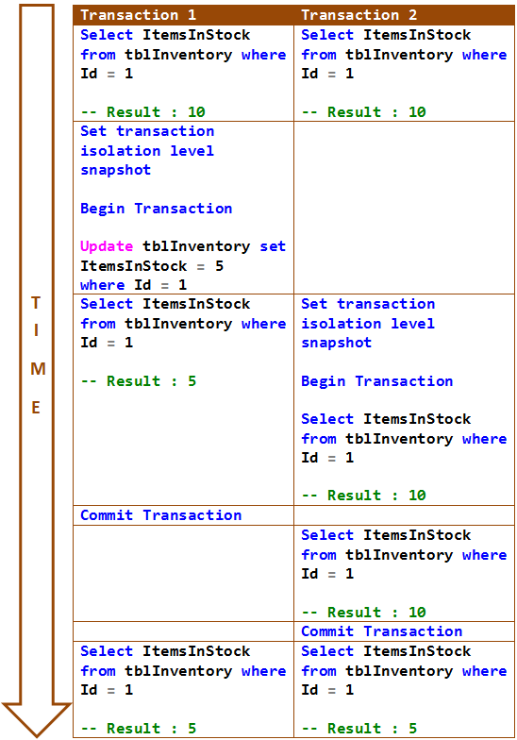

### **PART 78 : SQL Server deadlock example**

In this video we will discuss a scenario when a deadlock can occur in SQL Server.  
  
**When can a deadlock occur**  
In a database, a deadlock occurs when two or more processes have a resource locked, and each process requests a lock on the resource that another process has already locked. Neither of the transactions here can move forward, as each one is waiting for the other to release the lock. The following diagram explains this.

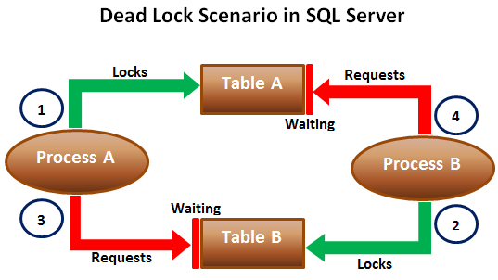  
  
When deadlocks occur, SQL Server will choose one of processes as the deadlock victim and rollback that process, so the other process can move forward. The transaction that is chosen as the deadlock victim will produce the following error.  
Msg 1205, Level 13, State 51, Line 1  
Transaction (Process ID 57) was deadlocked on lock resources with another process and has been chosen as the deadlock victim. Rerun the transaction.  
  
Let us look at this in action. We will use the following 2 tables for this example.

|  |  |
| --- | --- |
|  |  |

SQL script to create the tables and populate them with test data

Create table TableA

(

    Id int identity primary key,

    Name nvarchar(50)

)

Go

Insert into TableA values ('Mark')

Go

Create table TableB

(

    Id int identity primary key,

    Name nvarchar(50)

)

Go

Insert into TableB values ('Mary')

Go

The following 2 transactions will result in a dead lock. Open 2 instances of SQL Server Management studio. From the first window execute Transaction 1 code and from the second window execute Transaction 2 code.

-- Transaction 1

Begin Tran

Update TableA Set Name = 'Mark Transaction 1' where Id = 1

-- From Transaction 2 window execute the first update statement

Update TableB Set Name = 'Mary Transaction 1' where Id = 1

-- From Transaction 2 window execute the second update statement

Commit Transaction

-- Transaction 2

Begin Tran

Update TableB Set Name = 'Mark Transaction 2' where Id = 1

-- From Transaction 1 window execute the second update statement

Update TableA Set Name = 'Mary Transaction 2' where Id = 1

-- After a few seconds notice that one of the transactions complete

-- successfully while the other transaction is made the deadlock victim

Commit Transaction

### **part 79 :SQL Server deadlock victim selection**

**In this video we will discuss**   
1. How SQL Server detects deadlocks  
2. What happens when a deadlock is detected  
3. What is DEADLOCK\_PRIORITY  
4. What is the criteria that SQL Server uses to choose a deadlock victim when there is a deadlock  
  
This is continuation to [Part 78](http://csharp-video-tutorials.blogspot.com/2015/08/sql-server-deadlock-example.html), please watch [Part 78](http://csharp-video-tutorials.blogspot.com/2015/08/sql-server-deadlock-example.html) before proceeding.  
  
**How SQL Server detects deadlocks**  
Lock monitor thread in SQL Server, runs every 5 seconds by default to detect if there are any deadlocks. If the lock monitor thread finds deadlocks, the deadlock detection interval will drop from 5 seconds to as low as 100 milliseconds depending on the frequency of deadlocks. If the lock monitor thread stops finding deadlocks, the Database Engine increases the intervals between searches to 5 seconds.  
  
**What happens when a deadlock is detected**  
When a deadlock is detected, the Database Engine ends the deadlock by choosing one of the threads as the deadlock victim. The deadlock victim's transaction is then rolled back and returns a 1205 error to the application. Rolling back the transaction of the deadlock victim releases all locks held by that transaction. This allows the other transactions to become unblocked and move forward.  
  
**What is DEADLOCK\_PRIORITY**  
By default, SQL Server chooses a transaction as the deadlock victim that is least expensive to roll back. However, a user can specify the priority of sessions in a deadlock situation using the SET DEADLOCK\_PRIORITY statement. The session with the lowest deadlock priority is chosen as the deadlock victim.  
  
Example : SET DEADLOCK\_PRIORITY NORMAL  
  
**DEADLOCK\_PRIORITY**  
1. The default is Normal  
2. Can be set to LOW, NORMAL, or HIGH  
3. Can also be set to a integer value in the range of -10 to 10.  
 LOW : -5  
 NORMAL : 0  
 HIGH : 5  
  
**What is the deadlock victim selection criteria**  
1. If the DEADLOCK\_PRIORITY is different, the session with the lowest priority is selected as the victim  
2. If both the sessions have the same priority, the transaction that is least expensive to rollback is selected as the victim

3. If both the sessions have the same deadlock priority and the same cost, a victim is chosen randomly  
  
**SQL Script to setup the tables for the examples**

Create table TableA

(

    Id int identity primary key,

    Name nvarchar(50)

)

Go

Insert into TableA values ('Mark')

Insert into TableA values ('Ben')

Insert into TableA values ('Todd')

Insert into TableA values ('Pam')

Insert into TableA values ('Sara')

Go

Create table TableB

(

    Id int identity primary key,

    Name nvarchar(50)

)

Go

Insert into TableB values ('Mary')

Go

Open 2 instances of SQL Server Management studio. From the first window execute Transaction 1 code and from the second window execute Transaction 2 code. We have not explicitly set DEADLOCK\_PRIORITY, so both the sessions have the default DEADLOCK\_PRIORITY which is NORMAL. So in this case SQL Server is going to choose Transaction 2 as the deadlock victim as it is the least expensive one to rollback.

-- Transaction 1

Begin Tran

Update TableA Set Name = Name + ' Transaction 1' where Id IN (1, 2, 3, 4, 5)

-- From Transaction 2 window execute the first update statement

Update TableB Set Name = Name + ' Transaction 1' where Id = 1

-- From Transaction 2 window execute the second update statement

Commit Transaction

-- Transaction 2

Begin Tran

Update TableB Set Name = Name + ' Transaction 2' where Id = 1

-- From Transaction 1 window execute the second update statement

Update TableA Set Name = Name + ' Transaction 2' where Id IN (1, 2, 3, 4, 5)

-- After a few seconds notice that this transaction will be chosen as the deadlock

-- victim as it is less expensive to rollback this transaction than Transaction 1

Commit Transaction

In the following example we have set DEADLOCK\_PRIORITY of Transaction 2 to HIGH. Transaction 1 will be chosen as the deadlock victim, because it's DEADLOCK\_PRIORITY (Normal) is lower than the DEADLOCK\_PRIORITY of Transaction 2.

-- Transaction 1

Begin Tran

Update TableA Set Name = Name + ' Transaction 1' where Id IN (1, 2, 3, 4, 5)

-- From Transaction 2 window execute the first update statement

Update TableB Set Name = Name + ' Transaction 1' where Id = 1

-- From Transaction 2 window execute the second update statement

Commit Transaction

-- Transaction 2

SET DEADLOCK\_PRIORITY HIGH

GO

Begin Tran

Update TableB Set Name = Name + ' Transaction 2' where Id = 1

-- From Transaction 1 window execute the second update statement

Update TableA Set Name = Name + ' Transaction 2' where Id IN (1, 2, 3, 4, 5)

-- After a few seconds notice that Transaction 2 will be chosen as the

-- deadlock victim as it's DEADLOCK\_PRIORITY (Normal) is lower than the

-- DEADLOCK\_PRIORITY this transaction (HIGH)

Commit Transaction

### **PART 80 :Logging deadlocks in sql server**

In this video we will discuss **how to write the deadlock information to the SQL Server error log**  
  
**When deadlocks occur**, SQL Server chooses one of the transactions as the deadlock victim and rolls it back. There are several ways in SQL Server to track down the queries that are causing deadlocks. One of the options is to use SQL Server trace flag 1222 to write the deadlock information to the SQL Server error log.  
  
**Enable Trace flag :** To enable trace flags use DBCC command. -1 parameter indicates that the trace flag must be set at the global level. If you omit -1 parameter the trace flag will be set only at the session level.

DBCC Traceon(1222, -1)  
  
To check the status of the trace flag  
DBCC TraceStatus(1222, -1)  
  
To turn off the trace flag  
DBCC Traceoff(1222, -1)  
  
The following SQL code generates a dead lock. This is the same code we discussed in [Part 78](http://csharp-video-tutorials.blogspot.com/2015/08/sql-server-deadlock-example.html) of [SQL Server Tutorial](https://www.youtube.com/playlist?list=PL08903FB7ACA1C2FB).

**--SQL script to create the tables and populate them with test data**

Create table TableA

(

    Id int identity primary key,

    Name nvarchar(50)

)

Go

Insert into TableA values ('Mark')

Go

Create table TableB

(

    Id int identity primary key,

    Name nvarchar(50)

)

Go

Insert into TableB values ('Mary')

Go

**--SQL Script to create stored procedures**

Create procedure spTransaction1

as

Begin

    Begin Tran

    Update TableA Set Name = 'Mark Transaction 1' where Id = 1

    Waitfor delay '00:00:05'

    Update TableB Set Name = 'Mary Transaction 1' where Id = 1

    Commit Transaction

End

Create procedure spTransaction2

as

Begin

    Begin Tran

    Update TableB Set Name = 'Mark Transaction 2' where Id = 1

    Waitfor delay '00:00:05'

    Update TableA Set Name = 'Mary Transaction 2' where Id = 1

    Commit Transaction

End

Open 2 instances of SQL Server Management studio. From the first window execute **spTransaction1** and from the second window execute **spTransaction2**.   
  
After a few seconds notice that one of the transactions complete successfully while the other transaction is made the deadlock victim and rollback.

The information about this deadlock should now have been logged in sql server error log.  
  
**To read the error log**  
execute sp\_readerrorlog

### **part 81 : SQL Server deadlock analysis and prevention**

In this video we will discuss **how to read and analyze sql server deadlock information captured in the error log**, so we can understand what's causing the deadlocks and take appropriate actions to prevent or minimize the occurrence of deadlocks. This is continuation to [Part 80](http://csharp-video-tutorials.blogspot.com/2015/08/logging-deadlocks-in-sql-server.html). Please watch [Part 80](http://csharp-video-tutorials.blogspot.com/2015/08/logging-deadlocks-in-sql-server.html) from [SQL Server tutorial](https://www.youtube.com/playlist?list=PL08903FB7ACA1C2FB) before proceeding.

**The deadlock information in the error log has three sections**

|  |  |
| --- | --- |
| **Section** | **Description** |
| Deadlock Victim | Contains the ID of the process that was selected as the deadlock victim and killed by SQL Server. |
| Process List | Contains the list of the processes that participated in the deadlock. |
| Resource List | Contains the list of the resources (database objects) owned by the processes involved in the deadlock |

**Process List :** The process list has lot of items. Here are some of them that are particularly useful in understanding what caused the deadlock.

|  |  |
| --- | --- |
| **Node** | **Description** |
| loginname | The loginname associated with the process |
| isolationlevel | What isolation level is used |
| procname | The stored procedure name |
| Inputbuf | The code the process is executing when the deadlock occured |
|  |  |

**Resource List :** Some of the items in the resource list that are particularly useful in understanding what caused the deadlock.

|  |  |
| --- | --- |
| **Node** | **Description** |
| objectname | Fully qualified name of the resource involved in the deadlock |
| owner-list | Contains (owner id) the id of the owning process and the lock mode it has acquired on the resource. lock mode determines how the resource can be accessed by concurrent transactions. S for Shared lock, U for Update lock, X for Exclusive lock etc |
| waiter-list | Contains (waiter id) the id of the process that wants to acquire a lock on the resource and the lock mode it is requesting |

To prevent the deadlock that we have in our case, we need to ensure that database objects (Table A & Table B) are accessed in the same order every time.

### **PART 82 : Capturing deadlocks in sql profiler**

In this video we will discuss **how to capture deadlock graph using SQL profiler.**  
  
To capture deadlock graph, all you need to do is add Deadlock graph event to the trace in SQL profiler.  
  
**Here are the steps :**   
**1.** Open SQL Profiler  
**2.** Click **File - New Trace**. Provide the credentials and connect to the server  
**3.** On the general tab, select **"Blank"** template from **"Use the template"** dropdownlist  
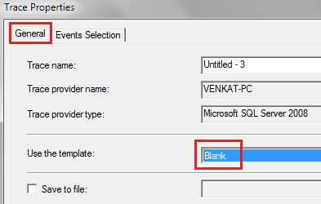  
  
**4.** On the **"Events Selection"** tab, expand **"Locks"**section and select **"Deadlock graph"**event  
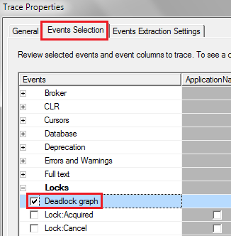  
  
**5.** Finally click the **Run**button to start the trace  
**6.** At this point execute the code that causes deadlock  
**7.** The deadlock graph should be captured in the profiler as shown below.  
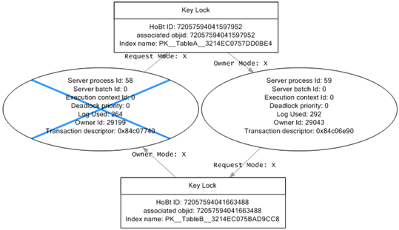  
  
**The deadlock graph data is captured in XML format.** If you want to extract this XML data to a physical file for later analysis, you can do so by following the steps below.  
**1.** In SQL profiler, click on **"File - Export - Extract SQL Server Events - Extract Deadlock Events"**  
**2.** Provide a name for the file  
**3.** The extension for the deadlock xml file is **.xdl**  
**4.** Finally choose if you want to export all events in a single file or each event in a separate file  
  
The deadlock information in the XML file is similar to what we have captured using the trace flag 1222.  
  
**Analyzing the deadlock graph**  
**1.** The oval on the graph, with the blue cross, represents the transaction that was chosen as the deadlock victim by SQL Server.  
**2.** The oval on the graph represents the transaction that completed successfully.  
**3.** When you move the mouse pointer over the oval, you can see the SQL code that was running that caused the deadlock.  
**4.** The oval symbols represent the process nodes

* **Server Process Id :** If you are using SQL Server Management Studio you can see the server process id on information bar at the bottom.
* **Deadlock Priority :**If you have not set DEADLOCK PRIORITY explicitly using SET DEADLOCK PRIORITY statement, then both the processes should have the same default deadlock priority NORMAL (0).
* **Log Used :**The transaction log space used. If a transaction has used a lot of log space then the cost to roll it back is also more. So the transaction that has used the least log space is killed and rolled back.

**5.** The rectangles represent the resource nodes.

* **HoBt ID :** Heap Or Binary Tree ID. Using this ID query **sys.partitions** view to find the database objects involved in the deadlock.

SELECT object\_name([object\_id])

FROM sys.partitions

WHERE hobt\_id = 72057594041663488

**6.** The arrows represent types of locks each process has on each resource node.

### **part 83 : SQL Server deadlock error handling**

In this video we will discuss **how to catch deadlock error using try/catch in SQL Server**.  
  
Modify the stored procedure as shown below to catch the deadlock error. The code is commented and is self-explanatory.

Alter procedure spTransaction1

as

Begin

    Begin Tran

    Begin Try

         Update TableA Set Name = 'Mark Transaction 1' where Id = 1

         Waitfor delay '00:00:05'

         Update TableB Set Name = 'Mary Transaction 1' where Id = 1

         -- If both the update statements succeeded.

         -- No Deadlock occurred. So commit the transaction.

         Commit Transaction

         Select 'Transaction Successful'

    End Try

    Begin Catch

         -- Check if the error is deadlock error

         If(ERROR\_NUMBER() = 1205)

         Begin

             Select 'Deadlock. Transaction failed. Please retry'

         End

         -- Rollback the transaction

         Rollback

    End Catch

End

Alter procedure spTransaction2

as

Begin

    Begin Tran

    Begin Try

         Update TableB Set Name = 'Mary Transaction 2' where Id = 1

         Waitfor delay '00:00:05'

         Update TableA Set Name = 'Mark Transaction 2' where Id = 1

         Commit Transaction

         Select 'Transaction Successful'

    End Try

    Begin Catch

         If(ERROR\_NUMBER() = 1205)

         Begin

             Select 'Deadlock. Transaction failed. Please retry'

        End

         Rollback

    End Catch

End

After modifying the stored procedures, execute both the procedures from 2 different windows simultaneously. Notice that the deadlock error is handled by the catch block.  
  
In our next video, we will discuss **how applications using ADO.NET can handle deadlock errors**.

### **part 86 : How to find blocking queries in sql server**

In this video we will discuss, **how to find blocking queries in sql server**.  
  
Blocking occurs if there are open transactions. Let us understand this with an example.  
  
**Execute the following 2 sql statements**  
Begin Tran  
Update TableA set Name='Mark Transaction 1' where Id = 1  
  
Now from a different window, execute any of the following commands. Notice that all the queries are blocked.

Select Count(\*) from TableA

Delete from TableA where Id = 1

Truncate table TableA

Drop table TableA

This is because there is an open transaction. Once the open transaction completes, you will be able to execute the above queries.  
  
So the obvious next question is - **How to identify all the active transactions**.   
  
One way to do this is by using DBCC OpenTran. DBCC OpenTran will display only the oldest active transaction. It is not going to show you all the open transactions.  
DBCC OpenTran  
  
The following link has the SQL script that you can use to identify all the active transactions.   
<http://www.sqlskills.com/blogs/paul/script-open-transactions-with-text-and-plans>  
  
The beauty about this script is that it has a lot more useful information about the open transactions  
Session Id  
Login Name  
Database Name  
Transaction Begin Time  
The actual query that is executed  
  
You can now use this information and ask the respective developer to either commit or rollback the transactions that they have left open unintentionally.  
  
For some reason if the person who initiated the transaction is not available, you also have the option to KILL the associated process. However, this may have unintended consequences, so use it with extreme caution.  
  
There are 2 ways to kill the process are described below  
  
**Killing the process using SQL Server Activity Monitor :**   
1. Right Click on the Server Name in Object explorer and select **"Activity Monitor"**  
2. In the **"Activity Monitor"** window expand Processes section  
3. Right click on the associated **"Session ID"** and select **"Kill Process"** from the context menu  
  
**Killing the process using SQL command :**  
KILL Process\_ID  
  
**What happens when you kill a session**  
All the work that the transaction has done will be rolled back. The database must be put back in the state it was in, before the transaction started.

### **PART 87 SQL Server except operator**

**Suggested Videos**  
[Part 84 - Handling deadlocks in ado.net](http://csharp-video-tutorials.blogspot.com/2015/08/handling-deadlocks-in-adonet.html)  
[Part 85 - Retry logic for deadlock exceptions](http://csharp-video-tutorials.blogspot.com/2015/08/retry-logic-for-deadlock-exceptions.html)  
[Part 86 - How to find blocking queries in sql server](http://csharp-video-tutorials.blogspot.com/2015/09/how-to-find-blocking-queries-in-sql.html)  
  
In this we will discuss **SQL Server except operator with examples.**  
  
  
**EXCEPT operator** returns unique rows from the left query that aren’t in the right query’s results.

* Introduced in SQL Server 2005
* The number and the order of the columns must be the same in all queries
* The data types must be same or compatible
* This is similar to minus operator in oracle

Let us understand this with an example. We will use the following 2 tables for this example.

|  |  |
| --- | --- |
|  |  |

**SQL Script to create the tables**

Create Table TableA

(

    Id int primary key,

    Name nvarchar(50),

    Gender nvarchar(10)

)

Go

Insert into TableA values (1, 'Mark', 'Male')

Insert into TableA values (2, 'Mary', 'Female')

Insert into TableA values (3, 'Steve', 'Male')

Insert into TableA values (4, 'John', 'Male')

Insert into TableA values (5, 'Sara', 'Female')

Go

Create Table TableB

(

    Id int primary key,

    Name nvarchar(50),

    Gender nvarchar(10)

)

Go

Insert into TableB values (4, 'John', 'Male')

Insert into TableB values (5, 'Sara', 'Female')

Insert into TableB values (6, 'Pam', 'Female')

Insert into TableB values (7, 'Rebeka', 'Female')

Insert into TableB values (8, 'Jordan', 'Male')

Go

Notice that the following query returns the unique rows from the left query that aren’t in the right query’s results.

Select Id, Name, Gender

From TableA

Except

Select Id, Name, Gender

From TableB

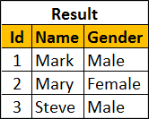  
  
To retrieve all of the rows from Table B that does not exist in Table A, reverse the two queries as shown below.

Select Id, Name, Gender

From TableB

Except

Select Id, Name, Gender

From TableA

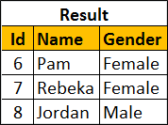  
  
You can also use Except operator on a single table. Let's use the following tblEmployees table for this example.  
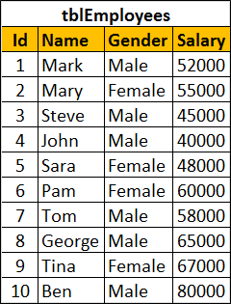  
  
SQL script to create tblEmployees table

Create table tblEmployees

(

    Id int identity primary key,

    Name nvarchar(100),

    Gender nvarchar(10),

    Salary int

)

Go

Insert into tblEmployees values ('Mark', 'Male', 52000)

Insert into tblEmployees values ('Mary', 'Female', 55000)

Insert into tblEmployees values ('Steve', 'Male', 45000)

Insert into tblEmployees values ('John', 'Male', 40000)

Insert into tblEmployees values ('Sara', 'Female', 48000)

Insert into tblEmployees values ('Pam', 'Female', 60000)

Insert into tblEmployees values ('Tom', 'Male', 58000)

Insert into tblEmployees values ('George', 'Male', 65000)

Insert into tblEmployees values ('Tina', 'Female', 67000)

Insert into tblEmployees values ('Ben', 'Male', 80000)

Go

**Result :**  
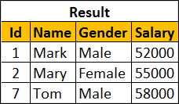  
  
**Order By clause should be used only once after the right query**

Select Id, Name, Gender, Salary

From tblEmployees

Where Salary >= 50000

Except

Select Id, Name, Gender, Salary

From tblEmployees

Where Salary >= 60000

order By Name

### **PART 88 : Difference between except and not in sql server**

**Suggested Videos**  
[Part 85 - Retry logic for deadlock exceptions](http://csharp-video-tutorials.blogspot.com/2015/08/retry-logic-for-deadlock-exceptions.html)  
[Part 86 - How to find blocking queries in sql server](http://csharp-video-tutorials.blogspot.com/2015/09/how-to-find-blocking-queries-in-sql.html)  
[Part 87 - SQL Server except operator](http://csharp-video-tutorials.blogspot.com/2015/09/sql-server-except-operator.html)  
  
  
In this we will discuss the **difference between EXCEPT and NOT IN operators in SQL Server**.  
  
We will use the following 2 tables for this example.

|  |  |
| --- | --- |
|  |  |

The following query returns the rows from the left query that aren’t in the right query’s results.

Select Id, Name, Gender From TableA

Except

Select Id, Name, Gender From TableB

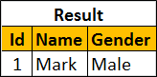  
  
**The same result can also be achieved using NOT IN operator.**

Select Id, Name, Gender From TableA

Where Id NOT IN (Select Id from TableB)

**So, what is the difference between EXCEPT and NOT IN operators**  
1. Except filters duplicates and returns only DISTINCT rows from the left query that aren’t in the right query’s results, where as NOT IN does not filter the duplicates.  
  
Insert the following row into TableA

Insert into TableA values (1, 'Mark', 'Male')

Now execute the following EXCEPT query. Notice that we get only the DISTINCT rows

Select Id, Name, Gender From TableA

Except

Select Id, Name, Gender From TableB

Result:  
  
  
Now execute the following query. Notice that the duplicate rows are not filtered.

Select Id, Name, Gender From TableA

Where Id NOT IN (Select Id from TableB)

Result:  
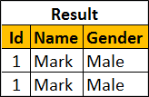  
  
2. EXCEPT operator expects the same number of columns in both the queries, where as NOT IN, compares a single column from the outer query with a single column from the subquery.  
  
In the following example, the number of columns are different.

Select Id, Name, Gender From TableA

Except

Select Id, Name From TableB

The above query would produce the following error.  
Msg 205, Level 16, State 1, Line 1  
All queries combined using a UNION, INTERSECT or EXCEPT operator must have an equal number of expressions in their target lists.  
  
NOT IN, compares a single column from the outer query with a single column from subquery.   
  
In the following example, the subquery returns multiple columns

Select Id, Name, Gender From TableA

Where Id NOT IN (Select Id, Name from TableB)

Msg 116, Level 16, State 1, Line 2  
Only one expression can be specified in the select list when the subquery is not introduced with EXISTS.

### **PART 89 : Intersect operator in sql server**

**Suggested Videos**  
[Part 86 - How to find blocking queries in sql server](http://csharp-video-tutorials.blogspot.com/2015/09/how-to-find-blocking-queries-in-sql.html)  
[Part 87 - SQL Server except operator](http://csharp-video-tutorials.blogspot.com/2015/09/sql-server-except-operator.html)  
[Part 88 - Difference between except and not in sql server](http://csharp-video-tutorials.blogspot.com/2015/09/difference-between-except-and-not-in.html)  
  
  
**In this video we will discuss**  
1. Intersect operator in sql server  
2. Difference between intersect and inner join  
  
  
**Intersect operator retrieves the common records from both the left and the right query of the Intersect operator.**

* Introduced in SQL Server 2005
* The number and the order of the columns must be same in both the queries
* The data types must be same or at least compatible

Let us understand INTERSECT operator with an example.  
  
We will use the following 2 tables for this example.

|  |  |
| --- | --- |
|  |  |

SQL Script to create the tables and populate with test data

Create Table TableA

(

    Id int,

    Name nvarchar(50),

    Gender nvarchar(10)

)

Go

Insert into TableA values (1, 'Mark', 'Male')

Insert into TableA values (2, 'Mary', 'Female')

Insert into TableA values (3, 'Steve', 'Male')

Go

Create Table TableB

(

    Id int,

    Name nvarchar(50),

    Gender nvarchar(10)

)

Go

Insert into TableB values (2, 'Mary', 'Female')

Insert into TableB values (3, 'Steve', 'Male')

Go

The following query retrieves the common records from both the left and the right query of the Intersect operator.

Select Id, Name, Gender from TableA

Intersect

Select Id, Name, Gender from TableB

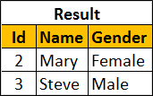  
  
We can also achieve the same thinkg using INNER join. The following INNER join query would produce the exact same result.

Select TableA.Id, TableA.Name, TableA.Gender

From TableA Inner Join TableB

On TableA.Id = TableB.Id

**What is the difference between INTERSECT and INNER JOIN**  
1. INTERSECT filters duplicates and returns only DISTINCT rows that are common between the LEFT and Right Query, where as INNER JOIN does not filter the duplicates.  
  
To understand this difference, insert the following row into TableA

Insert into TableA values (2, 'Mary', 'Female')

Now execute the following INTERSECT query. Notice that we get only the DISTINCT rows

Select Id, Name, Gender from TableA

Intersect

Select Id, Name, Gender from TableB

  
  
Now execute the following INNER JOIN query. Notice that the duplicate rows are not filtered.

Select TableA.Id, TableA.Name, TableA.Gender

From TableA Inner Join TableB

On TableA.Id = TableB.Id

**Result :**   
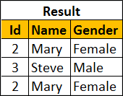  
  
You can make the INNER JOIN behave like INTERSECT operator by using the DISTINCT operator

Select DISTINCT TableA.Id, TableA.Name, TableA.Gender

From TableA Inner Join TableB

On TableA.Id = TableB.Id

**Result :**  
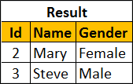  
  
**2. INNER JOIN treats two NULLS as two different values**. So if you are joining two tables based on a nullable column and if both tables have NULLs in that joining column then, INNER JOIN will not include those rows in the result-set, where as INTERSECT treats two NULLs as a same value and it returns all matching rows.  
  
To understand this difference, execute the following 2 insert statements

Insert into TableA values(NULL, 'Pam', 'Female')

Insert into TableB values(NULL, 'Pam', 'Female')

**INTERSECT query**

Select Id, Name, Gender from TableA

Intersect

Select Id, Name, Gender from TableB

**Result :**  
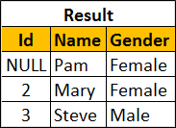  
  
**INNER JOIN query**

Select TableA.Id, TableA.Name, TableA.Gender

From TableA Inner Join TableB

On TableA.Id = TableB.Id

**Result :**  
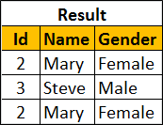

### PART 90 Difference between union intersect and except in sql server

In this we will discuss the **difference between union intersect and except in sql server with examples**.  
  
  
The following diagram explains the difference graphically  
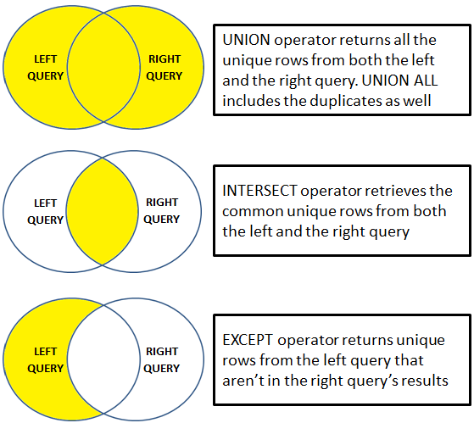  
  
UNION operator returns all the unique rows from both the left and the right query. UNION ALL included the duplicates as well.  
  
INTERSECT operator retrieves the common unique rows from both the left and the right query  
EXCEPT operator returns unique rows from the left query that aren’t in the right query’s results.   
  
Let us understand these differences with examples. We will use the following 2 tables for the examples.

|  |  |
| --- | --- |
|  |  |

**SQL Script to create the tables**

Create Table TableA

(

    Id int,

    Name nvarchar(50),

    Gender nvarchar(10)

)

Go

Insert into TableA values (1, 'Mark', 'Male')

Insert into TableA values (2, 'Mary', 'Female')

Insert into TableA values (3, 'Steve', 'Male')

Insert into TableA values (3, 'Steve', 'Male')

Go

Create Table TableB

(

    Id int primary key,

    Name nvarchar(50),

    Gender nvarchar(10)

)

Go

Insert into TableB values (2, 'Mary', 'Female')

Insert into TableB values (3, 'Steve', 'Male')

Insert into TableB values (4, 'John', 'Male')

Go

UNION operator returns all the unique rows from both the queries. Notice the duplicates are removed.

Select Id, Name, Gender from TableA

UNION

Select Id, Name, Gender from TableB

**Result :**  
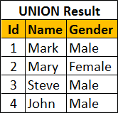  
  
UNION ALL operator returns all the rows from both the queries, including the duplicates.

Select Id, Name, Gender from TableA

UNION ALL

Select Id, Name, Gender from TableB

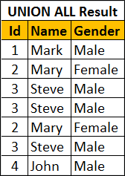  
  
INTERSECT operator retrieves the common unique rows from both the left and the right query. Notice the duplicates are removed.

Select Id, Name, Gender from TableA

INTERSECT

Select Id, Name, Gender from TableB

**Result :**  
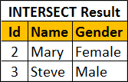  
  
EXCEPT operator returns unique rows from the left query that aren’t in the right query’s results.

Select Id, Name, Gender from TableA

EXCEPT

Select Id, Name, Gender from TableB

**Result :**  
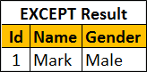  
  
If you wnat the rows that are present in Table B but not in Table A, reverse the queries.

Select Id, Name, Gender from TableB

EXCEPT

Select Id, Name, Gender from TableA

Result :  
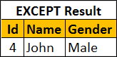  
  
**For all these 3 operators to work the following 2 conditions must be met**

* The number and the order of the columns must be same in both the queries
* The data types must be same or at least compatible

For example, if the number of columns are different, you will get the following error  
Msg 205, Level 16, State 1, Line 1  
All queries combined using a UNION, INTERSECT or EXCEPT operator must have an equal number of expressions in their target lists.

### **PART 91 : Cross apply and outer apply in sql server**

**Suggested Videos**  
[Part 88 - Difference between except and not in sql server](http://csharp-video-tutorials.blogspot.com/2015/09/difference-between-except-and-not-in.html)  
[Part 89 - Intersect operator in sql server](http://csharp-video-tutorials.blogspot.com/2015/09/intersect-operator-in-sql-server.html)  
[Part 90 - Difference between union intersect and except in sql server](http://csharp-video-tutorials.blogspot.com/2015/09/difference-between-union-intersect-and.html)  
  
We will use the following 2 tables for examples in this demo

|  |  |
| --- | --- |
| department table | employee table |

SQL Script to create the tables and populate with test data

Create table Department

(

    Id int primary key,

    DepartmentName nvarchar(50)

)

Go

Insert into Department values (1, 'IT')

Insert into Department values (2, 'HR')

Insert into Department values (3, 'Payroll')

Insert into Department values (4, 'Administration')

Insert into Department values (5, 'Sales')

Go

Create table Employee

(

    Id int primary key,

    Name nvarchar(50),

    Gender nvarchar(10),

    Salary int,

    DepartmentId int foreign key references Department(Id)

)

Go

Insert into Employee values (1, 'Mark', 'Male', 50000, 1)

Insert into Employee values (2, 'Mary', 'Female', 60000, 3)

Insert into Employee values (3, 'Steve', 'Male', 45000, 2)

Insert into Employee values (4, 'John', 'Male', 56000, 1)

Insert into Employee values (5, 'Sara', 'Female', 39000, 2)

Go

We want to retrieve all the matching rows between **Department**and **Employee**tables.  
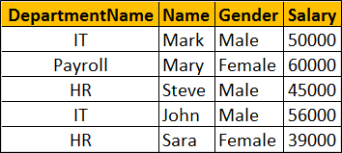  
  
This can be very easily achieved using an Inner Join as shown below.

Select D.DepartmentName, E.Name, E.Gender, E.Salary

from Department D

Inner Join Employee E

On D.Id = E.DepartmentId

Now if we want to retrieve all the matching rows between **Department**and **Employee**tables + the non-matching rows from the LEFT table (**Department**)  
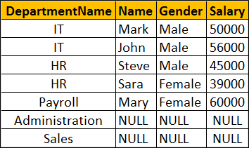  
  
This can be very easily achieved using a Left Join as shown below.

Select D.DepartmentName, E.Name, E.Gender, E.Salary

from Department D

Left Join Employee E

On D.Id = E.DepartmentId

Now let's assume we do not have access to the Employee table. Instead we have access to the following Table Valued function, that returns all employees belonging to a department by Department Id.

Create function fn\_GetEmployeesByDepartmentId(@DepartmentId int)

Returns Table

as

Return

(

    Select Id, Name, Gender, Salary, DepartmentId

    from Employee where DepartmentId = @DepartmentId

)

Go

The following query returns the employees of the department with Id =1.

Select \* from fn\_GetEmployeesByDepartmentId(1)

Now if you try to perform an Inner or Left join between **Department**table and **fn\_GetEmployeesByDepartmentId**() function you will get an error.

Select D.DepartmentName, E.Name, E.Gender, E.Salary

from Department D

Inner Join fn\_GetEmployeesByDepartmentId(D.Id) E

On D.Id = E.DepartmentId

If you execute the above query you will get the following error  
Msg 4104, Level 16, State 1, Line 3  
The multi-part identifier "D.Id" could not be bound.  
  
This is where we use **Cross Apply** and **Outer Apply** operators. **Cross Apply** is semantically equivalent to **Inner Join**and **Outer Apply**is semantically equivalent to **Left Outer Join**.  
  
Just like Inner Join, Cross Apply retrieves only the matching rows from the Department table and fn\_GetEmployeesByDepartmentId() table valued function.

Select D.DepartmentName, E.Name, E.Gender, E.Salary

from Department D

Cross Apply fn\_GetEmployeesByDepartmentId(D.Id) E

Just like Left Outer Join, Outer Apply retrieves all matching rows from the Department table and fn\_GetEmployeesByDepartmentId() table valued function + non-matching rows from the left table (Department)

Select D.DepartmentName, E.Name, E.Gender, E.Salary

from Department D

Outer Apply fn\_GetEmployeesByDepartmentId(D.Id) E

**How does Cross Apply and Outer Apply work**

* The APPLY operator introduced in SQL Server 2005, is used to join a table to a table-valued function.
* The Table Valued Function on the right hand side of the APPLY operator gets called for each row from the left (also called outer table) table.
* Cross Apply returns only matching rows (semantically equivalent to Inner Join)
* Outer Apply returns matching + non-matching rows (semantically equivalent to Left Outer Join). The unmatched columns of the table valued function will be set to NULL.

### **PART 92 : DDL Triggers in sql server**

**Suggested Videos**  
[Part 89 - Intersect operator in sql server](http://csharp-video-tutorials.blogspot.com/2015/09/intersect-operator-in-sql-server.html)  
[Part 90 - Difference between union intersect and except in sql server](http://csharp-video-tutorials.blogspot.com/2015/09/difference-between-union-intersect-and.html)  
[Part 91 - Cross apply and outer apply in sql server](http://csharp-video-tutorials.blogspot.com/2015/09/cross-apply-and-outer-apply-in-sql.html)  
  
**In SQL Server there are 4 types of triggers**  
**1.** DML Triggers - Data Manipulation Language. Discussed in Parts 43 to 47 of [SQL Server](https://www.youtube.com/playlist?list=PL08903FB7ACA1C2FB) Tutorial.  
**2.** DDL Triggers - Data Definition Language  
**3.** CLR triggers - Common Language Runtime  
**4.** Logon triggers  
  
**What are DDL triggers**  
**DDL triggers fire in response to DDL events** - CREATE, ALTER, and DROP (Table, Function, Index, Stored Procedure etc...). For the list of all DDL events please visit https://msdn.microsoft.com/en-us/library/bb522542.aspx  
  
**Certain system stored procedures** that perform DDL-like operations can also fire DDL triggers. Example - sp\_rename system stored procedure  
  
**What is the use of DDL triggers**

* If you want to execute some code in response to a specific DDL event
* To prevent certain changes to your database schema
* Audit the changes that the users are making to the database structure

**Syntax for creating DDL trigger**

CREATE TRIGGER [Trigger\_Name]

ON [Scope (Server|Database)]

FOR [EventType1, EventType2, EventType3, ...],

AS

BEGIN

   -- Trigger Body

END

**DDL triggers scope :** DDL triggers can be created in a specific database or at the server level.   
  
**The following trigger will fire in response to CREATE\_TABLE DDL event.**

CREATE TRIGGER trMyFirstTrigger

ON Database

FOR CREATE\_TABLE

AS

BEGIN

   Print 'New table created' END

**To check if the trigger has been created**

1. In the Object Explorer window, expand the **SampleDB**database by clicking on the plus symbol.
2. Expand **Programmability**folder
3. Expand **Database Triggers** folder

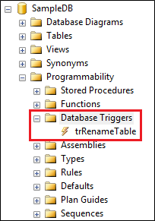  
  
**Please note :** If you can't find the trigger that you just created, make sure to refresh the Database Triggers folder.  
  
When you execute the following code to create the table, the trigger will automatically fire and will print the message - New table created  
Create Table Test (Id int)  
  
The above trigger will be fired only for one DDL event CREATE\_TABLE. If you want this trigger to be fired for multiple events, for example when you alter or drop a table, then separate the events using a comma as shown below.

ALTER TRIGGER trMyFirstTrigger

ON Database

FOR CREATE\_TABLE, ALTER\_TABLE, DROP\_TABLE

AS

BEGIN

   Print 'A table has just been created, modified or deleted'

END

Now if you create, alter or drop a table, the trigger will fire automatically and you will get the message - A table has just been created, modified or deleted.   
  
The 2 DDL triggers above execute some code in response to DDL events  
  
Now let us look at an example of how to prevent users from creating, altering or dropping tables. To do this modify the trigger as shown below.

ALTER TRIGGER trMyFirstTrigger

ON Database

FOR CREATE\_TABLE, ALTER\_TABLE, DROP\_TABLE

AS

BEGIN

   Rollback

   Print 'You cannot create, alter or drop a table'

END

To be able to create, alter or drop a table, you either have to disable or delete the trigger.  
  
**To disable trigger**  
**1.** Right click on the trigger in object explorer and select **"Disable"**from the context menu   
**2.** You can also disable the trigger using the following T-SQL command

DISABLE TRIGGER trMyFirstTrigger ON DATABASE

**To enable trigger**  
**1.** Right click on the trigger in object explorer and select "Enable" from the context menu   
**2.** You can also enable the trigger using the following T-SQL command  
ENABLE TRIGGER trMyFirstTrigger ON DATABASE  
  
**To drop trigger**  
**1.** Right click on the trigger in object explorer and select "Delete" from the context menu   
**2.** You can also drop the trigger using the following T-SQL command  
DROP TRIGGER trMyFirstTrigger ON DATABASE  
  
Certain system stored procedures that perform DDL-like operations can also fire DDL triggers. The following trigger will be fired when ever you rename a database object using sp\_rename system stored procedure.

CREATE TRIGGER trRenameTable

ON DATABASE

FOR RENAME

AS

BEGIN

    Print 'You just renamed something'

END

The following code changes the name of the TestTable to NewTestTable. When this code is executed, it will fire the trigger trRenameTable

sp\_rename 'TestTable', 'NewTestTable'

The following code changes the name of the Id column in NewTestTable to NewId. When this code is executed, it will fire the trigger trRenameTable

sp\_rename 'NewTestTable.Id' , 'NewId', 'column'

### **PART 93 : Server-scoped ddl triggers**

**Suggested Videos**  
[Part 90 - Difference between union intersect and except in sql server](http://csharp-video-tutorials.blogspot.com/2015/09/difference-between-union-intersect-and.html)  
[Part 91 - Cross apply and outer apply in sql server](http://csharp-video-tutorials.blogspot.com/2015/09/cross-apply-and-outer-apply-in-sql.html)  
[Part 92 - DDL Triggers in sql server](http://csharp-video-tutorials.blogspot.com/2015/09/ddl-triggers-in-sql-server.html)  
  
The following trigger is a database scoped trigger. This will prevent users from creating, altering or dropping tables only from the database in which it is created.

CREATE TRIGGER tr\_DatabaseScopeTrigger

ON DATABASE

FOR CREATE\_TABLE, ALTER\_TABLE, DROP\_TABLE

AS

BEGIN

    ROLLBACK

    Print 'You cannot create, alter or drop a table in the current database'

END

If you have another database on the server, they will be able to create, alter or drop tables in that database. If you want to prevent users from doing this you may create the trigger again in this database.  
  
**But, what if you have 100 different databases on your SQL Server**, and you want to prevent users from creating, altering or dropping tables from all these 100 databases. Creating the same trigger for all the 100 different databases is not a good approach for 2 reasons.  
1. It is tedious and error prone  
2. Maintainability is a night mare. If for some reason you have to change the trigger, you will have to do it in 100 different databases, which again is tedious and error prone.  
  
This is where server-scoped DDL triggers come in handy. When you create a server scoped DDL trigger, it will fire in response to the DDL events happening in all of the databases on that server.    
  
**Creating a Server-scoped DDL trigger :** Similar to creating a database scoped trigger, except that you will have to change the scope to ALL Server as shown below.

CREATE TRIGGER tr\_ServerScopeTrigger

ON ALL SERVER

FOR CREATE\_TABLE, ALTER\_TABLE, DROP\_TABLE

AS

BEGIN

    ROLLBACK

    Print 'You cannot create, alter or drop a table in any database on the server'

END

Now if you try to create, alter or drop a table in any of the databases on the server, the trigger will be fired.  
  
**Where can I find the Server-scoped DDL triggers**  
**1.** In the Object Explorer window, expand "Server Objects" folder  
**2.** Expand Triggers folder  
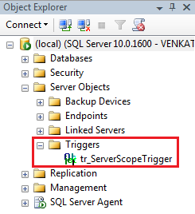  
  
**To disable Server-scoped ddl trigger**  
1. Right click on the trigger in object explorer and select "Disable" from the context menu   
2. You can also disable the trigger using the following T-SQL command

DISABLE TRIGGER tr\_ServerScopeTrigger ON ALL SERVER

**To enable Server-scoped ddl trigger**  
1. Right click on the trigger in object explorer and select "Enable" from the context menu   
2. You can also enable the trigger using the following T-SQL command  
ENABLE TRIGGER tr\_ServerScopeTrigger ON ALL SERVER  
  
**To drop Server-scoped ddl trigger**  
1. Right click on the trigger in object explorer and select "Delete" from the context menu   
2. You can also drop the trigger using the following T-SQL command  
DROP TRIGGER tr\_ServerScopeTrigger ON ALL SERVER

### **PART 94 : sql server trigger execution order**

**Suggested Videos**  
[Part 91 - Cross apply and outer apply in sql server](http://csharp-video-tutorials.blogspot.com/2015/09/cross-apply-and-outer-apply-in-sql.html)  
[Part 92 - DDL Triggers in sql server](http://csharp-video-tutorials.blogspot.com/2015/09/ddl-triggers-in-sql-server.html)  
[Part 93 - Server-scoped ddl triggers](http://csharp-video-tutorials.blogspot.com/2015/09/server-scoped-ddl-triggers.html)  
  
In this video we will discuss **how to set the execution order of triggers** using **sp\_settriggerorder**stored procedure.  
  
**Server scoped triggers will always fire before any of the database scoped triggers**. This execution order cannot be changed.  
  
In the example below, we have a database-scoped and a server-scoped trigger handling the same event (CREATE\_TABLE). When you create a table, notice that server-scoped trigger is always fired before the database-scoped trigger.

CREATE TRIGGER tr\_DatabaseScopeTrigger

ON DATABASE

FOR CREATE\_TABLE

AS

BEGIN

    Print 'Database Scope Trigger'

END

GO

CREATE TRIGGER tr\_ServerScopeTrigger

ON ALL SERVER

FOR CREATE\_TABLE

AS

BEGIN

    Print 'Server Scope Trigger'

END

GO

Using the **sp\_settriggerorder**stored procedure, you can set the execution order of server-scoped or database-scoped triggers.  
  
**sp\_settriggerorder stored procedure has 4 parameters**

|  |  |
| --- | --- |
| **Parameter** | **Description** |
| @triggername | Name of the trigger |
| @order | Value can be First, Last or None. When set to None, trigger is fired in random order |
| @stmttype | SQL statement that fires the trigger. Can be INSERT, UPDATE, DELETE or any DDL event |
| @namespace | Scope of the trigger. Value can be DATABASE, SERVER, or NULL |

EXEC sp\_settriggerorder

@triggername = 'tr\_DatabaseScopeTrigger1',

@order = 'none',

@stmttype = 'CREATE\_TABLE',

@namespace = 'DATABASE'

GO

**If you have a database-scoped and a server-scoped trigger handling the same event**, and if you have set the execution order at both the levels. Here is the execution order of the triggers.  
1. The server-scope trigger marked First  
2. Other server-scope triggers  
3. The server-scope trigger marked Last  
4. The database-scope trigger marked First  
5. Other database-scope triggers  
6. The database-scope trigger marked Last

### **PART 95 : Audit table changes in sql server**

**Suggested Videos**  
[Part 92 - DDL Triggers in sql server](http://csharp-video-tutorials.blogspot.com/2015/09/ddl-triggers-in-sql-server.html)  
[Part 93 - Server-scoped ddl triggers](http://csharp-video-tutorials.blogspot.com/2015/09/server-scoped-ddl-triggers.html)  
[Part 94 - SQL Server trigger execution order](http://csharp-video-tutorials.blogspot.com/2015/09/sql-server-trigger-execution-order.html)  
  
**Table to store the audit data**

Create table TableChanges

(

    DatabaseName nvarchar(250),

    TableName nvarchar(250),

    EventType nvarchar(250),

    LoginName nvarchar(250),

    SQLCommand nvarchar(2500),

    AuditDateTime datetime

)

Go

**The following trigger audits all table changes in all databases on a SQL Server**

CREATE TRIGGER tr\_AuditTableChanges

ON ALL SERVER

FOR CREATE\_TABLE, ALTER\_TABLE, DROP\_TABLE

AS

BEGIN

    DECLARE @EventData XML

    SELECT @EventData = EVENTDATA()

    INSERT INTO SampleDB.dbo.TableChanges

    (DatabaseName, TableName, EventType, LoginName,

     SQLCommand, AuditDateTime)

    VALUES

    (

         @EventData.value('(/EVENT\_INSTANCE/DatabaseName)[1]', 'varchar(250)'),

         @EventData.value('(/EVENT\_INSTANCE/ObjectName)[1]', 'varchar(250)'),

         @EventData.value('(/EVENT\_INSTANCE/EventType)[1]', 'nvarchar(250)'),

         @EventData.value('(/EVENT\_INSTANCE/LoginName)[1]', 'varchar(250)'),

         @EventData.value('(/EVENT\_INSTANCE/TSQLCommand)[1]', 'nvarchar(2500)'),

         GetDate()

    )

END  
  
In the above example we are using **EventData**() function which returns event data in XML format. The following XML is returned by the **EventData**() function when I created a table with name = **MyTable** in **SampleDB**database.

<EVENT\_INSTANCE>

  <EventType>CREATE\_TABLE</EventType>

  <PostTime>2015-09-11T16:12:49.417</PostTime>

  <SPID>58</SPID>

  <ServerName>VENKAT-PC</ServerName>

  <LoginName>VENKAT-PC\Tan</LoginName>

  <UserName>dbo</UserName>

  <DatabaseName>SampleDB</DatabaseName>

  <SchemaName>dbo</SchemaName>

  <ObjectName>MyTable</ObjectName>

  <ObjectType>TABLE</ObjectType>

  <TSQLCommand>

    <SetOptions ANSI\_NULLS="ON" ANSI\_NULL\_DEFAULT="ON"

                ANSI\_PADDING="ON" QUOTED\_IDENTIFIER="ON"

                ENCRYPTED="FALSE" />

    <CommandText>

      Create Table MyTable

      (

         Id int,

         Name nvarchar(50),

         Gender nvarchar(50)

      )

    </CommandText>

  </TSQLCommand>

</EVENT\_INSTANCE>

### **PART 96 : Logon triggers in sql server**

**Suggested Videos**  
[Part 93 - Server-scoped ddl triggers](http://csharp-video-tutorials.blogspot.com/2015/09/server-scoped-ddl-triggers.html)  
[Part 94 - SQL Server trigger execution order](http://csharp-video-tutorials.blogspot.com/2015/09/sql-server-trigger-execution-order.html)  
[Part 95 - Audit table changes in sql server](http://csharp-video-tutorials.blogspot.com/2015/09/audit-table-changes-in-sql-server.html)  
  
  
As the name implies **Logon triggers fire in response to a LOGON event**. Logon triggers fire after the authentication phase of logging in finishes, but before the user session is actually established.   
  
**Logon triggers can be used for**  
1. Tracking login activity  
2. Restricting logins to SQL Server  
3. Limiting the number of sessions for a specific login  
  
**Logon trigger example :** The following trigger limits the maximum number of open connections for a user to 3.

CREATE TRIGGER tr\_LogonAuditTriggers

ON ALL SERVER

FOR LOGON

AS

BEGIN

    DECLARE @LoginName NVARCHAR(100)

    Set @LoginName = ORIGINAL\_LOGIN()

    IF (SELECT COUNT(\*) FROM sys.dm\_exec\_sessions

         WHERE is\_user\_process = 1

         AND original\_login\_name = @LoginName) > 3

    BEGIN

         Print 'Fourth connection of ' + @LoginName + ' blocked'

         ROLLBACK

    END

END

**An attempt to make a fourth connection, will be blocked.**  
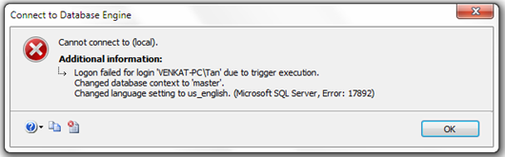  
  
The trigger error message will be written to the error log. Execute the following command to read the error log.  
Execute sp\_readerrorlog  
  
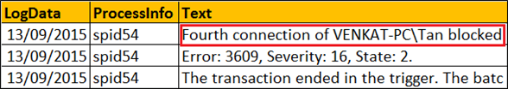

### **PART 97 : Select into in sql server**

**Suggested Videos**  
[Part 94 - SQL Server trigger execution order](http://csharp-video-tutorials.blogspot.com/2015/09/sql-server-trigger-execution-order.html)  
[Part 95 - Audit table changes in sql server](http://csharp-video-tutorials.blogspot.com/2015/09/audit-table-changes-in-sql-server.html)  
[Part 96 - Logon triggers in sql server](http://csharp-video-tutorials.blogspot.com/2015/09/logon-triggers-in-sql-server.html)  
  
We will be using the following 2 tables for the examples.

|  |  |
| --- | --- |
| departments table | employees table |

**SQL Script to create Departments and Employees tables**

Create table Departments

(

    DepartmentId int primary key,

    DepartmentName nvarchar(50)

)

Go

Insert into Departments values (1, 'IT')

Insert into Departments values (2, 'HR')

Insert into Departments values (3, 'Payroll')

Go

Create table Employees

(

    Id int primary key,

    Name nvarchar(100),

    Gender nvarchar(10),

    Salary int,

    DeptId int foreign key references Departments(DepartmentId)

)

Go

Insert into Employees values (1, 'Mark', 'Male', 50000, 1)

Insert into Employees values (2, 'Sara', 'Female', 65000, 2)

Insert into Employees values (3, 'Mike', 'Male', 48000, 3)

Insert into Employees values (4, 'Pam', 'Female', 70000, 1)

Insert into Employees values (5, 'John', 'Male', 55000, 2)

Go

The **SELECT INTO statement in SQL Server**, selects data from one table and inserts it into a new table.  
  
**SELECT INTO statement in SQL Server can do the following**  
1. Copy all rows and columns from an existing table into a new table. This is extremely useful when you want to make a backup copy of the existing table.

SELECT \* INTO EmployeesBackup FROM Employees

2. Copy all rows and columns from an existing table into a new table in an external database.

SELECT \* INTO HRDB.dbo.EmployeesBackup FROM Employees

3. Copy only selected columns into a new table

SELECT Id, Name, Gender INTO EmployeesBackup FROM Employees

4. Copy only selected rows into a new table

SELECT \* INTO EmployeesBackup FROM Employees WHERE DeptId = 1

5. Copy columns from 2 or more table into a new table

SELECT \* INTO EmployeesBackup

FROM Employees

INNER JOIN Departments

ON Employees.DeptId = Departments.DepartmentId

6. Create a new table whose columns and datatypes match with an existing table.

SELECT \* INTO EmployeesBackup FROM Employees WHERE 1 <> 1

7. Copy all rows and columns from an existing table into a new table on a different SQL Server instance. For this, create a linked server and use the 4 part naming convention

SELECT \* INTO TargetTable

FROM [SourceServer].[SourceDB].[dbo].[SourceTable]

**Please note :** You cannot use SELECT INTO statement to select data into an existing table. For this you will have to use INSERT INTO statement.

INSERT INTO ExistingTable (ColumnList)

SELECT ColumnList FROM SourceTable

### **PART 98 : Difference between where and having in sql server**

**Suggested Videos**  
[Part 95 - Audit table changes in sql server](http://csharp-video-tutorials.blogspot.com/2015/09/audit-table-changes-in-sql-server.html)  
[Part 96 - Logon triggers in sql server](http://csharp-video-tutorials.blogspot.com/2015/09/logon-triggers-in-sql-server.html)  
[Part 97 - Select into in sql server](http://csharp-video-tutorials.blogspot.com/2015/09/select-into-in-sql-server.html)  
  
  
Let us understand the difference with an example. For the examples in this video we will use the following Sales table.  
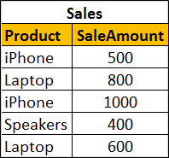  
  
**SQL Script to create and populate Sales table with test data**

Create table Sales

(

    Product nvarchar(50),

    SaleAmount int

)

Go

Insert into Sales values ('iPhone', 500)

Insert into Sales values ('Laptop', 800)

Insert into Sales values ('iPhone', 1000)

Insert into Sales values ('Speakers', 400)

Insert into Sales values ('Laptop', 600)

Go

To calculate total sales by product, we would write a GROUP BY query as shown below

SELECT Product, SUM(SaleAmount) AS TotalSales

FROM Sales

GROUP BY Product

**The above query produces the following result**  
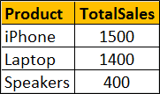  
  
Now if we want to find only those **products where the total sales amount is greater than $1000**, we will use HAVING clause to filter products

SELECT Product, SUM(SaleAmount) AS TotalSales

FROM Sales

GROUP BY Product HAVING SUM(SaleAmount) > 1000

**Result :**  
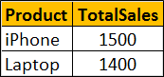  
  
If we use WHERE clause instead of HAVING clause, we will get a syntax error. This is because the WHERE clause doesn’t work with aggregate functions like sum, min, max, avg, etc.

SELECT Product, SUM(SaleAmount) AS TotalSales

FROM Sales

GROUP BY Product

WHERE SUM(SaleAmount) > 1000

So in short, the difference is **WHERE clause cannot be used with aggregates where as HAVING can.**  
  
However, there are other differences as well that we need to keep in mind when using WHERE and HAVING clauses. WHERE clause filters rows before aggregate calculations are performed where as HAVING clause filters rows after aggregate calculations are performed. Let us understand this with an example.  
  
Total sales of iPhone and Speakers can be calculated by using either WHERE or HAVING clause  
  
**Calculate Total sales of iPhone and Speakers using WHERE clause :** In this example the WHERE clause retrieves only iPhone and Speaker products and then performs the sum.

SELECT Product, SUM(SaleAmount) AS TotalSales

FROM Sales

WHERE Product in ('iPhone', 'Speakers')

GROUP BY Product

**Result :**  
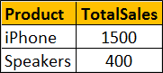

**Calculate Total sales of iPhone and Speakers using HAVING clause :** This example retrieves all rows from Sales table, performs the sum and then removes all products except iPhone and Speakers.

SELECT Product, SUM(SaleAmount) AS TotalSales

FROM Sales

GROUP BY Product

HAVING Product in ('iPhone', 'Speakers')

**Result :**  
  
  
So from a performance standpoint, HAVING is slower than WHERE and should be avoided when possible.  
  
Another difference is WHERE comes before GROUP BY and HAVING comes after GROUP BY.  
  
**Difference between WHERE and Having**  
1. WHERE clause cannot be used with aggregates where as HAVING can. This means WHERE clause is used for filtering individual rows where as HAVING clause is used to filter groups.  
  
2. WHERE comes before GROUP BY. This means WHERE clause filters rows before aggregate calculations are performed. HAVING comes after GROUP BY. This means HAVING clause filters rows after aggregate calculations are performed. So from a performance standpoint, HAVING is slower than WHERE and should be avoided when possible.  
  
3. WHERE and HAVING can be used together in a SELECT query. In this case WHERE clause is applied first to filter individual rows. The rows are then grouped and aggregate calculations are performed, and then the HAVING clause filters the groups.

### **PART 99 : Table valued parameters in SQL Server**

**Suggested Videos**  
[Part 96 - Logon triggers in sql server](http://csharp-video-tutorials.blogspot.com/2015/09/logon-triggers-in-sql-server.html)  
[Part 97 - Select into in sql server](http://csharp-video-tutorials.blogspot.com/2015/09/select-into-in-sql-server.html)  
[Part 98 - Difference between where and having in sql server](http://csharp-video-tutorials.blogspot.com/2015/09/difference-between-where-and-having-in.html)  
  
**Table Valued Parameter** is a new feature introduced in SQL SERVER 2008. Table Valued Parameter allows a table (i.e multiple rows of data) to be passed as a parameter to a stored procedure from T-SQL code or from an application. Prior to SQL SERVER 2008, it is not possible to pass a table variable as a parameter to a stored procedure.  
  
Let us understand how to pass multiple rows to a stored procedure using Table Valued Parameter with an example. We want to insert multiple rows into the following Employees table. At the moment this table does not have any rows.  
employees table  
  
**SQL Script to create the Employees table**

Create Table Employees

(

    Id int primary key,

    Name nvarchar(50),

    Gender nvarchar(10)

)

Go

**Step 1 :** Create User-defined Table Type

CREATE TYPE EmpTableType AS TABLE

(

    Id INT PRIMARY KEY,

    Name NVARCHAR(50),

    Gender NVARCHAR(10)

)

**Step 2 :** Use the User-defined Table Type as a parameter in the stored procedure. Table valued parameters must be passed as read-only to stored procedures, functions etc. This means you cannot perform DML operations like INSERT, UPDATE or DELETE on a table-valued parameter in the body of a function, stored procedure etc.

CREATE PROCEDURE spInsertEmployees

@EmpTableType EmpTableType READONLY

AS

BEGIN

    INSERT INTO Employees

    SELECT \* FROM @EmpTableType

END

**Step 3 :** Declare a table variable, insert the data and then pass the table variable as a parameter to the stored procedure.

DECLARE @EmployeeTableType EmpTableType

INSERT INTO @EmployeeTableType VALUES (1, 'Mark', 'Male')

INSERT INTO @EmployeeTableType VALUES (2, 'Mary', 'Female')

INSERT INTO @EmployeeTableType VALUES (3, 'John', 'Male')

INSERT INTO @EmployeeTableType VALUES (4, 'Sara', 'Female')

INSERT INTO @EmployeeTableType VALUES (5, 'Rob', 'Male')

EXECUTE spInsertEmployees @EmployeeTableType

### That's it. Now select the data from Employees table and notice that all the rows of the table variable are inserted into the Employees table. table valued parameters example

### **PART 101: Grouping Sets in SQL Server**

**Suggested Videos**  
[Part 98 - Difference between where and having in sql server](http://csharp-video-tutorials.blogspot.com/2015/09/difference-between-where-and-having-in.html)  
[Part 99 - Table valued parameters in SQL Server](http://csharp-video-tutorials.blogspot.com/2015/09/table-valued-parameters-in-sql-server.html)  
[Part 100 - Send datatable as parameter to stored procedure](http://csharp-video-tutorials.blogspot.com/2015/09/send-datatable-as-parameter-to-stored.html)  
  
  
**Grouping sets is a new feature introduced in SQL Server 2008**. Let us understand Grouping sets with an example.   
  
  
We will be using the following **Employees table**for the examples in this video.  
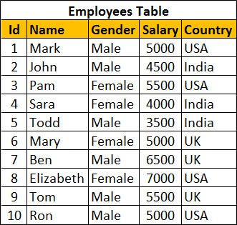  
  
**SQL Script to create and populate Employees table**

Create Table Employees

(

    Id int primary key,

    Name nvarchar(50),

    Gender nvarchar(10),

    Salary int,

    Country nvarchar(10)

)

Go

Insert Into Employees Values (1, 'Mark', 'Male', 5000, 'USA')

Insert Into Employees Values (2, 'John', 'Male', 4500, 'India')

Insert Into Employees Values (3, 'Pam', 'Female', 5500, 'USA')

Insert Into Employees Values (4, 'Sara', 'Female', 4000, 'India')

Insert Into Employees Values (5, 'Todd', 'Male', 3500, 'India')

Insert Into Employees Values (6, 'Mary', 'Female', 5000, 'UK')

Insert Into Employees Values (7, 'Ben', 'Male', 6500, 'UK')

Insert Into Employees Values (8, 'Elizabeth', 'Female', 7000, 'USA')

Insert Into Employees Values (9, 'Tom', 'Male', 5500, 'UK')

Insert Into Employees Values (10, 'Ron', 'Male', 5000, 'USA')

Go

We want to calculate **Sum of Salary by Country and Gender**. The result should be as shown below.  
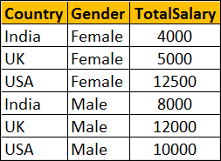  
  
We can very easily achieve this using a Group By query as shown below

Select Country, Gender, Sum(Salary) as TotalSalary

From Employees

Group By Country, Gender

Within the same result set we also want Sum of Salary just by Country. The Result should be as shown below. Notice that Gender column within the resultset is NULL as we are grouping only by Country column  
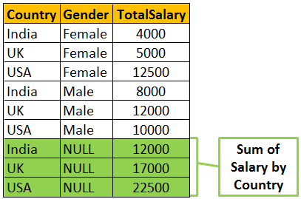  
  
To achieve the above result we could combine 2 Group By queries using UNION ALL as shown below.

Select Country, Gender, Sum(Salary) as TotalSalary

From Employees

Group By Country, Gender

UNION ALL

Select Country, NULL, Sum(Salary) as TotalSalary

From Employees

Group By Country

Within the same result set we also want Sum of Salary just by Gender. The Result should be as shown below. Notice that the Country column within the resultset is NULL as we are grouping only by Gender column.   
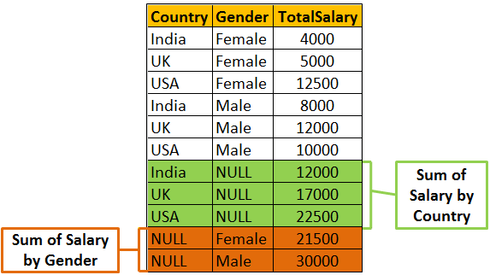  
  
We can achieve this by combining 3 Group By queries using UNION ALL as shown below

Select Country, Gender, Sum(Salary) as TotalSalary

From Employees

Group By Country, Gender

UNION ALL

Select Country, NULL, Sum(Salary) as TotalSalary

From Employees

Group By Country

UNION ALL

Select NULL, Gender, Sum(Salary) as TotalSalary

From Employees

Group By Gender

Finally we also want the grand total of Salary. In this case we are not grouping on any particular column. So both Country and Gender columns will be NULL in the resultset.  
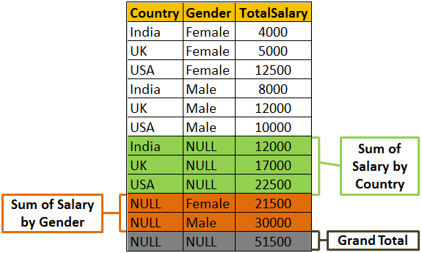  
  
To achieve this we will have to combine the fourth query using UNION ALL as shown below.

Select Country, Gender, Sum(Salary) as TotalSalary

From Employees

Group By Country, Gender

UNION ALL

Select Country, NULL, Sum(Salary) as TotalSalary

From Employees

Group By Country

UNION ALL

Select NULL, Gender, Sum(Salary) as TotalSalary

From Employees

Group By Gender

UNION ALL

Select NULL, NULL, Sum(Salary) as TotalSalary From Employees   
  
**There are 2 problems with the above approach.**  
1. The query is huge as we have combined different Group By queries using UNION ALL operator. This can grow even more if we start to add more groups  
2. The Employees table has to be accessed 4 times, once for every query.  
  
If we use **Grouping Sets** feature introduced in SQL Server 2008, the amount of T-SQL code that you have to write will be greatly reduced. The following Grouping Sets query produce the same result as the above UNION ALL query.

Select Country, Gender, Sum(Salary) TotalSalary

From Employees

Group BY

      GROUPING SETS

      (

            (Country, Gender), -- Sum of Salary by Country and Gender

            (Country),               -- Sum of Salary by Country

            (Gender) ,               -- Sum of Salary by Gender

            ()                             -- Grand Total

      )

Output of the above query  
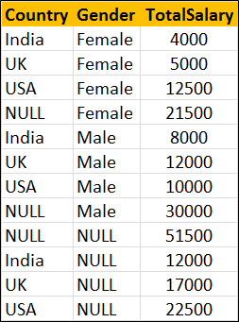  
  
The order of the rows in the result set is not the same as in the case of UNION ALL query. To control the order use order by as shown below.

Select Country, Gender, Sum(Salary) TotalSalary

From Employees

Group BY

      GROUPING SETS

      (

            (Country, Gender), -- Sum of Salary by Country and Gender

            (Country),               -- Sum of Salary by Country

            (Gender) ,               -- Sum of Salary by Gender

            ()                             -- Grand Total

      )

Order By Grouping(Country), Grouping(Gender), Gender

Output of the above query  
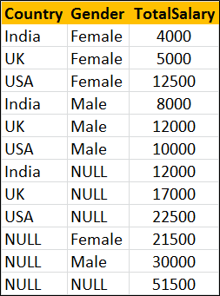

### **PART 102 : Rollup in SQL Server**

**Suggested Videos**  
[Part 99 - Table valued parameters in SQL Server](http://csharp-video-tutorials.blogspot.com/2015/09/table-valued-parameters-in-sql-server.html)  
[Part 100 - Send datatable as parameter to stored procedure](http://csharp-video-tutorials.blogspot.com/2015/09/send-datatable-as-parameter-to-stored.html)  
[Part 101 - Grouping sets in SQL Server](http://csharp-video-tutorials.blogspot.com/2015/09/grouping-sets-in-sql-server.html)  
  
**ROLLUP in SQL Server** is used to do aggregate operation on multiple levels in hierarchy.   
Let us understand Rollup in SQL Server with examples. We will use the following **Employees table** for the examples in this video.  
  
  
Retrieve Salary by country along with grand total  
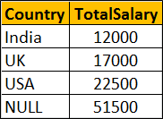  
  
There are several ways to achieve this. The easiest way is by using Rollup with Group By.

SELECT Country, SUM(Salary) AS TotalSalary

FROM Employees

GROUP BY ROLLUP(Country)

The above query can also be rewritten as shown below

SELECT Country, SUM(Salary) AS TotalSalary

FROM Employees GROUP BY Country WITH ROLLUP

We can also use UNION ALL operator along with GROUP BY

SELECT Country, SUM(Salary) AS TotalSalary

FROM Employees

GROUP BY Country

UNION ALL

SELECT NULL, SUM(Salary) AS TotalSalary

FROM Employees

We can also use Grouping Sets to achieve the same result

SELECT Country, SUM(Salary) AS TotalSalary

FROM Employees

GROUP BY GROUPING SETS

(

    (Country),

    ()

)

Let's look at another example.   
Group Salary by Country and Gender. Also compute the Subtotal for Country level and Grand Total as shown below.  
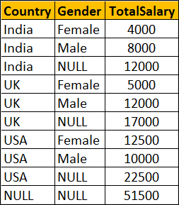  
  
**Using ROLLUP with GROUP BY**

SELECT Country, Gender, SUM(Salary) AS TotalSalary

FROM Employees

GROUP BY ROLLUP(Country, Gender)

--OR

SELECT Country, Gender, SUM(Salary) AS TotalSalary

FROM Employees

GROUP BY Country, Gender WITH ROLLUP

**Using UNION ALL with GROUP BY**

SELECT Country, Gender, SUM(Salary) AS TotalSalary

FROM Employees

GROUP BY Country, Gender

UNION ALL

SELECT Country, NULL, SUM(Salary) AS TotalSalary

FROM Employees

GROUP BY Country

UNION ALL

SELECT NULL, NULL, SUM(Salary) AS TotalSalary

FROM Employees

**Using GROUPING SETS**

SELECT Country, Gender, SUM(Salary) AS TotalSalary

FROM Employees

GROUP BY GROUPING SETS

(

    (Country, Gender),

    (Country), () )

### **PART 103 : Cube in SQL Server**

**Suggested Videos**  
[Part 100 - Send datatable as parameter to stored procedure](http://csharp-video-tutorials.blogspot.com/2015/09/send-datatable-as-parameter-to-stored.html)  
[Part 101 - Grouping sets in SQL Server](http://csharp-video-tutorials.blogspot.com/2015/09/grouping-sets-in-sql-server.html)  
[Part 102 - Rollup in SQL Server](http://csharp-video-tutorials.blogspot.com/2015/09/rollup-in-sql-server.html)  
  
  
Cube() in SQL Server produces the result set by generating all combinations of columns specified in GROUP BY CUBE().   
  
  
Let us understand Cube() in SQL Server with examples. We will use the following **Employees table** for the examples in this video.   
  
  
Write a query to retrieve Sum of Salary grouped by all combinations of the following 2 columns as well as Grand Total.  
Country,  
Gender   
  
**The output of the query should be as shown below**  
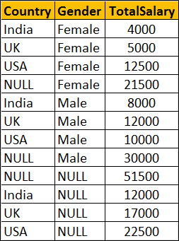  
  
**Using Cube with Group By**

SELECT Country, Gender, SUM(Salary) AS TotalSalary

FROM Employees

GROUP BY Cube(Country, Gender)

--OR

SELECT Country, Gender, SUM(Salary) AS TotalSalary

FROM Employees

GROUP BY Country, Gender with Cube

**The above query is equivalent to the following Grouping Sets query**

SELECT Country, Gender, SUM(Salary) AS TotalSalary

FROM Employees

GROUP BY

    GROUPING SETS

    (

         (Country, Gender),

         (Country),

         (Gender),

         ()

    )

**The above query is equivalent to the following UNION ALL query.** While the data in the result set is the same, the ordering is not. Use ORDER BY to control the ordering of rows in the result set.

SELECT Country, Gender, SUM(Salary) AS TotalSalary

FROM Employees

GROUP BY Country, Gender

UNION ALL

SELECT Country, NULL, SUM(Salary) AS TotalSalary

FROM Employees

GROUP BY Country

UNION ALL

SELECT NULL, Gender, SUM(Salary) AS TotalSalary

FROM Employees

GROUP BY Gender

UNION ALL

SELECT NULL, NULL, SUM(Salary) AS TotalSalary

FROM Employees

### **PART 104 : Difference between cube and rollup in SQL Server**

**Suggested Videos**  
[Part 101 - Grouping sets in SQL Server](http://csharp-video-tutorials.blogspot.com/2015/09/grouping-sets-in-sql-server.html)  
[Part 102 - Rollup in SQL Server](http://csharp-video-tutorials.blogspot.com/2015/09/rollup-in-sql-server.html)  
[Part 103 - Cube in SQL Server](http://csharp-video-tutorials.blogspot.com/2015/09/cube-in-sql-server.html)  
  
In this video we will discuss the **difference between cube and rollup in SQL Server**.  
  
**CUBE generates a result set** that shows aggregates for all combinations of values in the selected columns, where as ROLLUP generates a result set that shows aggregates for a hierarchy of values in the selected columns.  
  
Let us understand this difference with an example. Consider the following **Sales**table.  
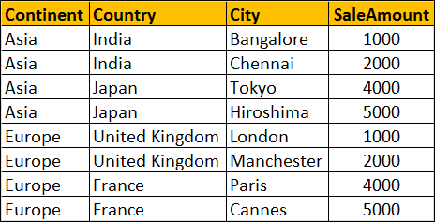  
  
**SQL Script to create and populate Sales table**

Create table Sales

(

    Id int primary key identity,

    Continent nvarchar(50),

    Country nvarchar(50),

    City nvarchar(50),

    SaleAmount int

)

Go

Insert into Sales values('Asia','India','Bangalore',1000)

Insert into Sales values('Asia','India','Chennai',2000)

Insert into Sales values('Asia','Japan','Tokyo',4000)

Insert into Sales values('Asia','Japan','Hiroshima',5000)

Insert into Sales values('Europe','United Kingdom','London',1000)

Insert into Sales values('Europe','United Kingdom','Manchester',2000)

Insert into Sales values('Europe','France','Paris',4000)

Insert into Sales values('Europe','France','Cannes',5000)

Go

**ROLLUP(Continent, Country, City)** produces Sum of Salary for the following hierarchy  
Continent, Country, City  
Continent, Country,   
Continent  
()  
  
**CUBE(Continent, Country, City)** produces Sum of Salary for all the following column combinations  
Continent, Country, City  
Continent, Country,   
Continent, City  
Continent  
Country, City  
Country,  
City  
()

SELECT Continent, Country, City, SUM(SaleAmount) AS TotalSales

FROM Sales

GROUP BY ROLLUP(Continent, Country, City)

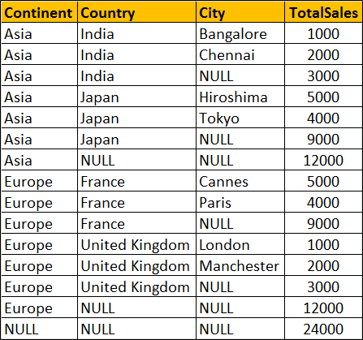

SELECT Continent, Country, City, SUM(SaleAmount) AS TotalSales

FROM Sales

GROUP BY CUBE(Continent, Country, City)

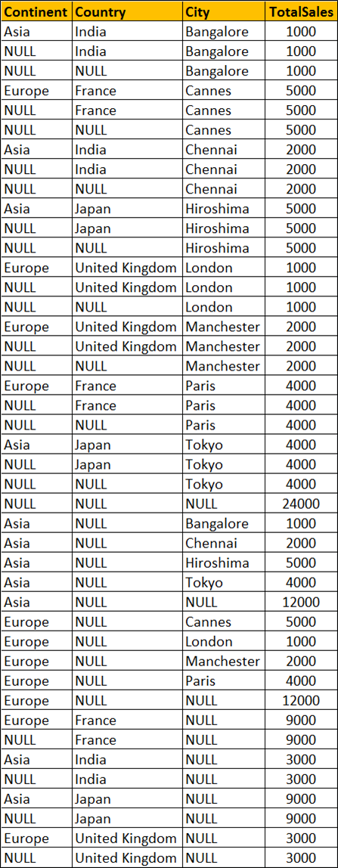  
You won't see any difference when you use ROLLUP and CUBE on a single column. Both the following queries produces the same output.

SELECT Continent, Sum(SaleAmount) AS TotalSales

FROM Sales

GROUP BY ROLLUP(Continent)

-- OR

SELECT Continent, SUM(SaleAmount) AS TotalSales

FROM Sales

GROUP BY CUBE(Continent)

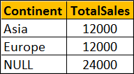

### **PART 105 : Grouping function in SQL Server**

**Suggested Videos**  
[Part 102 - Rollup in SQL Server](http://csharp-video-tutorials.blogspot.com/2015/09/rollup-in-sql-server.html)  
[Part 103 - Cube in SQL Server](http://csharp-video-tutorials.blogspot.com/2015/09/cube-in-sql-server.html)  
[Part 104 - Difference between cube and rollup in SQL Server](http://csharp-video-tutorials.blogspot.com/2015/09/difference-between-cube-and-rollup-in.html)  
In this video we will discuss the use of **Grouping function in SQL Server**.   
This is continuation to [Part 104](http://csharp-video-tutorials.blogspot.com/2015/09/difference-between-cube-and-rollup-in.html). Please watch [Part 104](http://csharp-video-tutorials.blogspot.com/2015/09/difference-between-cube-and-rollup-in.html) from [SQL Server tutorial](https://www.youtube.com/playlist?list=PL08903FB7ACA1C2FB) before proceeding. We will use the following Sales table for this example.  
  
  
**What is Grouping function**  
Grouping(Column) indicates whether the column in a GROUP BY list is aggregated or not. Grouping returns 1 for aggregated or 0 for not aggregated in the result set.   
  
The following query returns 1 for aggregated or 0 for not aggregated in the result set

SELECT   Continent, Country, City, SUM(SaleAmount) AS TotalSales,

         GROUPING(Continent) AS GP\_Continent,

         GROUPING(Country) AS GP\_Country,

         GROUPING(City) AS GP\_City

FROM Sales

GROUP BY ROLLUP(Continent, Country, City)

**Result :**  
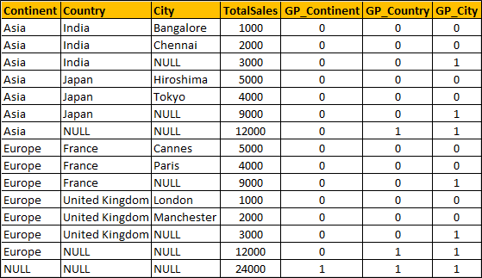  
**What is the use of Grouping function in real world**  
When a column is aggregated in the result set, the column will have a NULL value. If you want to replace NULL with All then this GROUPING function is very handy.

SELECT

    CASE WHEN

         GROUPING(Continent) = 1 THEN 'All' ELSE ISNULL(Continent, 'Unknown')

    END AS Continent,

    CASE WHEN

         GROUPING(Country) = 1 THEN 'All' ELSE ISNULL(Country, 'Unknown')

    END AS Country,

    CASE

         WHEN GROUPING(City) = 1 THEN 'All' ELSE ISNULL(City, 'Unknown')

    END AS City,

    SUM(SaleAmount) AS TotalSales

FROM Sales

GROUP BY ROLLUP(Continent, Country, City)

:   
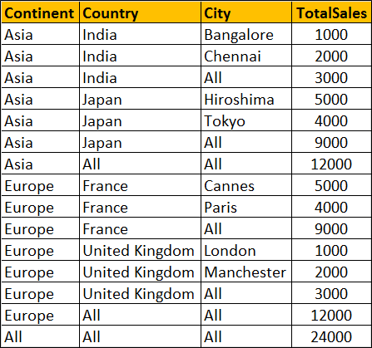  
  
**Can't I use ISNULL function instead as shown below**

SELECT   ISNULL(Continent, 'All') AS Continent,

         ISNULL(Country, 'All') AS Country,

         ISNULL(City, 'All') AS City,

         SUM(SaleAmount) AS TotalSales

FROM Sales

GROUP BY ROLLUP(Continent, Country, City)

Well, you can, but only if your data does not contain NULL values. Let me explain what I mean.  
  
At the moment the raw data in our Sales has no NULL values. Let's introduce a NULL value in the City column of the row where Id = 1

Update Sales Set City = NULL where Id = 1

Now execute the following query with ISNULL function

SELECT   ISNULL(Continent, 'All') AS Continent,

         ISNULL(Country, 'All') AS Country,

         ISNULL(City, 'All') AS City,

         SUM(SaleAmount) AS TotalSales

FROM Sales

GROUP BY ROLLUP(Continent, Country, City)

**Result :** Notice that the actuall NULL value in the raw data is also replaced with the word 'All', which is incorrect. Hence the need for Grouping function.  
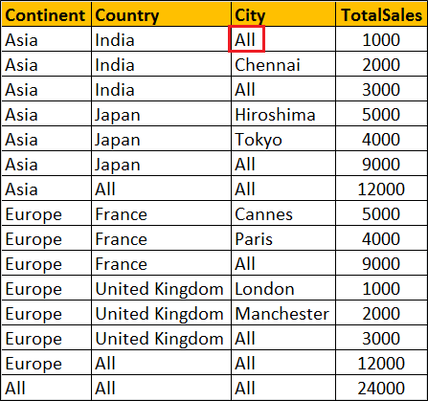  
**Please note :** Grouping function can be used with Rollup, Cube and Grouping Sets

### **PART 106 : GROUPING\_ID function in SQL Server**

**Suggested Videos**  
[Part 103 - Cube in SQL Server](http://csharp-video-tutorials.blogspot.com/2015/09/cube-in-sql-server.html)  
[Part 104 - Difference between cube and rollup in SQL Server](http://csharp-video-tutorials.blogspot.com/2015/09/difference-between-cube-and-rollup-in.html)  
[Part 105 - Grouping function in SQL Server](http://csharp-video-tutorials.blogspot.com/2015/09/grouping-function-in-sql-server.html)  
  
  
  
**In this video we will discuss**  
1. GROUPING\_ID function in SQL Server  
2. Difference between GROUPING and GROUPING\_ID functions  
3. Use of GROUPING\_ID function  
  
GROUPING\_ID function computes the level of grouping.  
  
**Difference between GROUPING and GROUPING\_ID**  
  
**Syntax :** GROUPING function is used on single column, where as the column list for GROUPING\_ID function must match with GROUP BY column list.

GROUPING(Col1)

GROUPING\_ID(Col1, Col2, Col3,...)

GROUPING indicates whether the column in a GROUP BY list is aggregated or not. Grouping returns 1 for aggregated or 0 for not aggregated in the result set.   
  
GROUPING\_ID() function concatenates all the GOUPING() functions, perform the binary to decimal conversion, and returns the equivalent integer. In short  
GROUPING\_ID(A, B, C) =  GROUPING(A) + GROUPING(B) + GROUPING(C)  
  
**Let us understand this with an example.**

SELECT   Continent, Country, City, SUM(SaleAmount) AS TotalSales,

         CAST(GROUPING(Continent) AS NVARCHAR(1)) +

         CAST(GROUPING(Country) AS NVARCHAR(1)) +

         CAST(GROUPING(City) AS NVARCHAR(1)) AS Groupings,

         GROUPING\_ID(Continent, Country, City) AS GPID

FROM Sales

GROUP BY ROLLUP(Continent, Country, City)

**Query result :**  
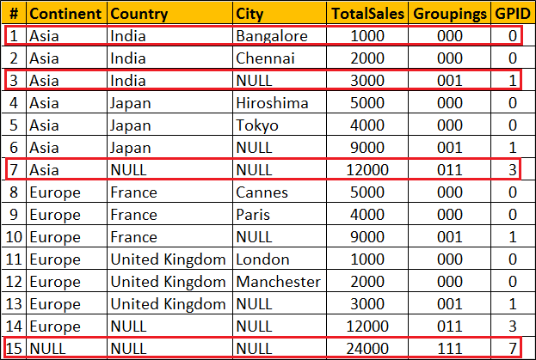  
  
**Row Number 1 :** Since the data is not aggregated by any column GROUPING(Continent), GROUPING(Country) and GROUPING(City) return 0 and as result we get a binar string with all ZEROS (000). When this converted to decimal we get 0 which is displayed in GPID column.  
  
**Row Number 7 :** The data is aggregated for Country and City columns, so GROUPING(Country) and GROUPING(City) return 1 where as  GROUPING(Continent) return 0. As result we get a binar string (011). When this converted to decimal we get 10 which is displayed in GPID column.  
  
**Row Number 15 :** This is the Grand total row. Notice in this row the data is aggregated by all the 3 columns. Hence all the 3 GROUPING functions return 1. So we get a binary string with all ONES (111). When this converted to decimal we get 7 which is displayed in GPID column.  
  
**Use of GROUPING\_ID function :** GROUPING\_ID function is very handy if you want to sort and filter by level of grouping.  
  
**Sorting by level of grouping :**

SELECT   Continent, Country, City, SUM(SaleAmount) AS TotalSales,

         GROUPING\_ID(Continent, Country, City) AS GPID

FROM Sales

GROUP BY ROLLUP(Continent, Country, City)

ORDER BY GPID

**Result :**   
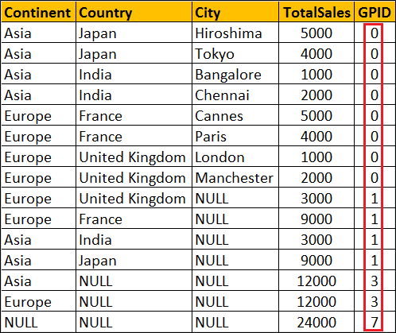  
  
**Filter by level of grouping :** The following query retrieves only continent level aggregated data

SELECT   Continent, Country, City, SUM(SaleAmount) AS TotalSales,

         GROUPING\_ID(Continent, Country, City) AS GPID

FROM Sales

GROUP BY ROLLUP(Continent, Country, City)

HAVING GROUPING\_ID(Continent, Country, City) = 3

**Result :**   
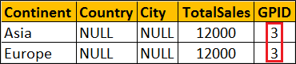

### **PART 107 : Debugging sql server stored procedures**

**Suggested Videos**  
[Part 104 - Difference between cube and rollup in SQL Server](http://csharp-video-tutorials.blogspot.com/2015/09/difference-between-cube-and-rollup-in.html)  
[Part 105 - Grouping function in SQL Server](http://csharp-video-tutorials.blogspot.com/2015/09/grouping-function-in-sql-server.html)  
[Part 106 - Grouping\_Id function in SQL Server](http://csharp-video-tutorials.blogspot.com/2015/09/groupingid-function-in-sql-server.html)  
  
In this video we will discuss **how to debug stored procedures in SQL Server**.  
  
**Setting up the Debugger in SSMS :** If you have connected to SQL Server using (local) or . (period), and when you start the debugger you will get the following error  
Unable to start T-SQL Debugging. Could not connect to computer.  
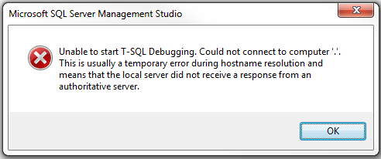  
  
To fix this error, use the computer name to connect to the SQL Server instead of using (local) or .  
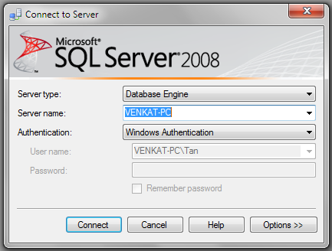  
  
For the examples in this video we will be using the following stored procedure.

Create procedure spPrintEvenNumbers

@Target int

as

Begin

     Declare @StartNumber int

     Set @StartNumber = 1

     while(@StartNumber < @Target)

     Begin

          If(@StartNumber%2 = 0)

          Begin

              Print @StartNumber

          End

          Set @StartNumber = @StartNumber + 1

     End

     Print 'Finished printing even numbers till ' + RTRIM(@Target)

End

Connect to SQL Server using your computer name, and then execute the above code to create the stored procedure. At this point, open a New Query window. Copy and paste the following T-SQL code to execute the stored procedure.

DECLARE @TargetNumber INT

SET @TargetNumber = 10

EXECUTE spPrintEvenNumbers @TargetNumber

Print 'Done'

**Starting the Debugger in SSMS :** There are 2 ways to start the debugger  
1. In SSMS, click on the **Debug**Menu and select **Start Debugging**  
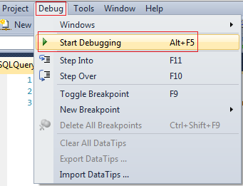  
  
2. Use the keyboard shortcut **ALT + F5**  
  
At this point you should have the debugger running. The line that is about to be executed is marked with an yellow arrow  
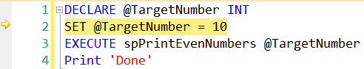  
  
Step Over, Step into and Step Out in SSMS : You can find the keyboard shortcuts in the Debug menu in SSMS.  
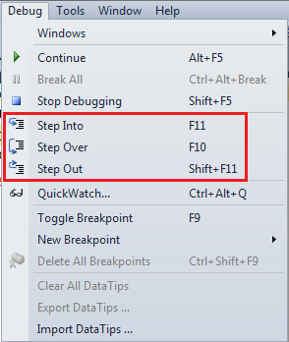  
  
Let us understand what Step Over, Step into and Step Out does when debugging the following piece of code  
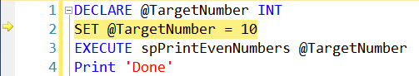  
  
1. There is no difference when you STEP INTO (F11) or STEP OVER (F10) the code on LINE 2  
  
2. On LINE 3, we are calling a Stored Procedure. On this statement if we press F10 (STEP OVER), it won't give us the opportunity to debug the stored procedure code. To be able to debug the stored procedure code you will have to STEP INTO it by pressing F11.  
  
3. If the debugger is in the stored procedure, and you don't want to debug line by line with in that stored procedure, you can STEP OUT of it by pressing SHIFT + F11. When you do this, the debugger completes the execution of the stored procedure and waits on the next line in the main query, i.e on LINE 4 in this example.  
  
**To stop debugging :** There are 2 ways to stop debugging  
1. In SSMS, click on the Debug Menu and select Stop Debugging  
2. Use the keyboard shortcut SHIFT + F5  
  
**Show Next Statement**shows the next statement that the debugger is about to execute.  
Run to Cursor command executes all the statements in a batch up to the current cursor position  
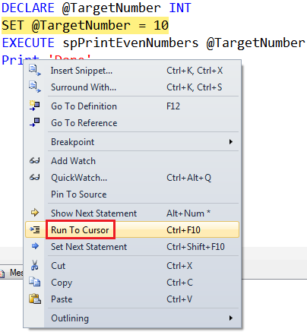  
  
**Locals Window in SSMS :** Displays the current values of variables and parameters   
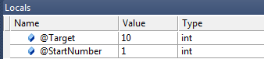  
  
If you cannot see the locals window or if you have closed it and if you want to open it, you can do so using the following menu option. Locals window is only available if you are in DEBUG mode.  
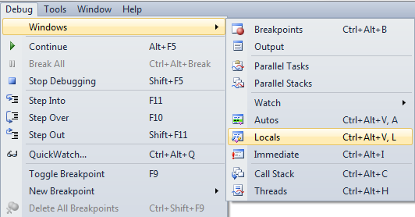  
  
**Watch Window in SSMS :** Just like Locals window, Watch window is used to watch the values of variables. You can add and remove variables from the watch window. To add a variable to the Watch Window, right click on the variable and select "Add Watch" option from the context menu.  
Watch Window in SSMS  
  
**Call Stack Window in SSMS :** Allows you to navigate up and down the call stack to see what values your application is storing at different levels. It's an invaluable tool for determining why your code is doing what it's doing.  
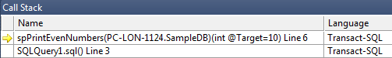  
  
**Immediate Window in SSMS :** Very helpful during debugging to evaluate expressions, and print variable values. To clear immediate window type **>cls** and press enter.  
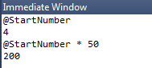  
  
**Breakpoints in SSMS :** There are 2 ways to set a breakpoint in SSMS.  
1. By clicking on the grey margin on the left hand side in SSMS (to remove click again)  
2. By pressing F9 (to remove press F9 again)  
  
**Enable, Disable or Delete all breakpoints :** There are 2 ways to Enable, Disable or Delete all breakpoints  
  
1. From the Debug menu  
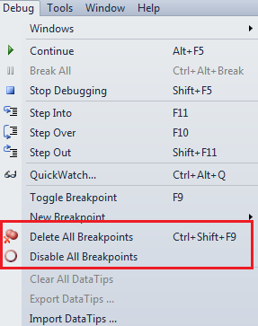  
  
2. From the Breakpoints window. To view Breakpoints window select Debug => Windows => Breakpoints or use the keyboard shortcut ALT + CTRL + B  
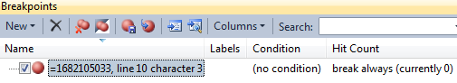  
  
**Conditional Breakpoint :** Conditional Breakpoints are hit only when the specified condition is met. These are extremely useful when you have some kind of a loop and you want to break, only when the loop variable has a specific value (For example loop varible = 100).  
  
**How to set a conditional break point in SSMS :**  
1. Right click on the Breakpoint and select **Condition** from the context menu  
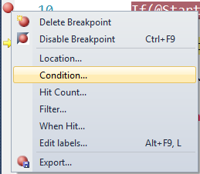  
  
2. In the Breakpoint window **specify the condition**  
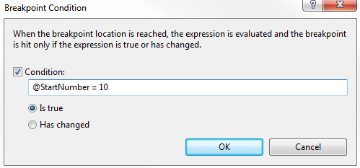

### **PART 108 : Over clause in SQL Server**

**Suggested Videos**  
[Part 105 - Grouping function in SQL Server](http://csharp-video-tutorials.blogspot.com/2015/09/grouping-function-in-sql-server.html)  
[Part 106 - Grouping\_Id function in SQL Server](http://csharp-video-tutorials.blogspot.com/2015/09/groupingid-function-in-sql-server.html)  
[Part 107 - Debugging sql server stored procedures](http://csharp-video-tutorials.blogspot.com/2015/09/debugging-sql-server-stored-procedures.html)  
  
  
In this video we will discuss the power and use of Over clause in SQL Server.  
  
  
The **OVER** clause combined with **PARTITION BY** is used to break up data into partitions.   
**Syntax :** function (...) OVER (PARTITION BY col1, Col2, ...)

The specified function operates for each partition.  
**For example :**  
COUNT(Gender) OVER (PARTITION BY Gender) will partition the data by **GENDER**i.e there will 2 partitions (Male and Female) and then the COUNT() function is applied overeach partition.  
  
Any of the following functions can be used. Please note this is not the complete list.  
COUNT(), AVG(), SUM(), MIN(), MAX(), ROW\_NUMBER(), RANK(), DENSE\_RANK() etc.  
  
**Example :**We will use the following **Employees table**for the examples in this video.  
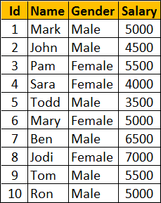  
  
**SQl Script to create Employees table**

Create Table Employees

(

     Id int primary key,

     Name nvarchar(50),

     Gender nvarchar(10),

     Salary int

)

Go

Insert Into Employees Values (1, 'Mark', 'Male', 5000)

Insert Into Employees Values (2, 'John', 'Male', 4500)

Insert Into Employees Values (3, 'Pam', 'Female', 5500)

Insert Into Employees Values (4, 'Sara', 'Female', 4000)

Insert Into Employees Values (5, 'Todd', 'Male', 3500)

Insert Into Employees Values (6, 'Mary', 'Female', 5000)

Insert Into Employees Values (7, 'Ben', 'Male', 6500)

Insert Into Employees Values (8, 'Jodi', 'Female', 7000)

Insert Into Employees Values (9, 'Tom', 'Male', 5500)

Insert Into Employees Values (10, 'Ron', 'Male', 5000)

Go

Write a query to retrieve total count of employees by Gender. Also in the result we want Average, Minimum and Maximum salary by Gender. The result of the query should be as shown below.  
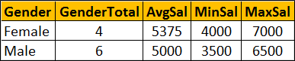  
  
This can be very easily achieved using a simple **GROUP BY** query as show below.

SELECT Gender, COUNT(\*) AS GenderTotal, AVG(Salary) AS AvgSal,

        MIN(Salary) AS MinSal, MAX(Salary) AS MaxSal

FROM Employees

GROUP BY Gender

What if we want **non-aggregated values** (like employee Name and Salary) in result set along with aggregated values  
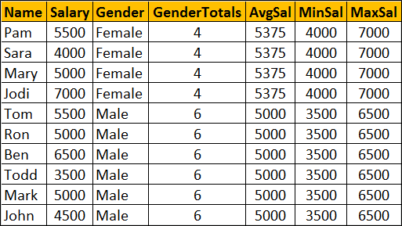  
  
You cannot include **non-aggregated** columns in the **GROUP BY** query.

SELECT Name, Salary, Gender, COUNT(\*) AS GenderTotal, AVG(Salary) AS AvgSal,

 MIN(Salary) AS MinSal, MAX(Salary) AS MaxSal

FROM Employees

GROUP BY Gender

The above query will result in the following error  
Column 'Employees.Name' is invalid in the select list because it is not contained in either an aggregate function or the GROUP BY clause  
  
One way to achieve this is by including the aggregations in a subquery and then **JOINING** it with the main query as shown in the example below. Look at the amount of T-SQL code we have to write.

SELECT Name, Salary, Employees.Gender, Genders.GenderTotals,

        Genders.AvgSal, Genders.MinSal, Genders.MaxSal

FROM Employees

INNER JOIN

(SELECT Gender, COUNT(\*) AS GenderTotals,

          AVG(Salary) AS AvgSal,

         MIN(Salary) AS MinSal, MAX(Salary) AS MaxSal

FROM Employees

GROUP BY Gender) AS Genders

ON Genders.Gender = Employees.Gender

Better way of doing this is by using the **OVER**clause combined with **PARTITION BY**

SELECT Name, Salary, Gender,

        COUNT(Gender) OVER(PARTITION BY Gender) AS GenderTotals,

        AVG(Salary) OVER(PARTITION BY Gender) AS AvgSal,

        MIN(Salary) OVER(PARTITION BY Gender) AS MinSal,

        MAX(Salary) OVER(PARTITION BY Gender) AS MaxSal

FROM Employees

### **PART 109 : Row\_Number function in SQL Server**

**Suggested Videos**  
[Part 106 - Grouping\_Id function in SQL Server](http://csharp-video-tutorials.blogspot.com/2015/09/groupingid-function-in-sql-server.html)  
[Part 107 - Debugging sql server stored procedures](http://csharp-video-tutorials.blogspot.com/2015/09/debugging-sql-server-stored-procedures.html)  
[Part 108 - Over clause in SQL Server](http://csharp-video-tutorials.blogspot.com/2015/09/over-clause-in-sql-server.html)  
  
In this video we will discuss Row\_Number function in SQL Server. This is continuation to [Part 108](http://csharp-video-tutorials.blogspot.com/2015/09/over-clause-in-sql-server.html). Please watch [Part 108](http://csharp-video-tutorials.blogspot.com/2015/09/over-clause-in-sql-server.html) from [SQL Server tutorial](https://www.youtube.com/playlist?list=PL08903FB7ACA1C2FB) before proceeding.  
  
**Row\_Number function**

* Introduced in SQL Server 2005
* Returns the sequential number of a row starting at 1
* ORDER BY clause is required
* PARTITION BY clause is optional
* When the data is partitioned, row number is reset to 1 when the partition changes

**Syntax :** ROW\_NUMBER() OVER (ORDER BY Col1, Col2)

**Row\_Number function without PARTITION BY :** In this example, data is not partitioned, so ROW\_NUMBER will provide a consecutive numbering for all the rows in the table based on the order of rows imposed by the ORDER BY clause.

SELECT Name, Gender, Salary,

        ROW\_NUMBER() OVER (ORDER BY Gender) AS RowNumber

FROM Employees  
  
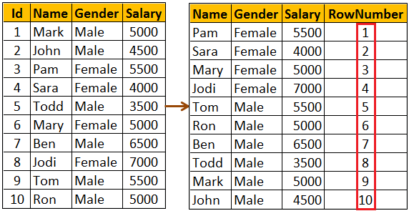  
  
**Please note :** If ORDER BY clause is not specified you will get the following error  
The function 'ROW\_NUMBER' must have an OVER clause with ORDER BY  
  
**Row\_Number function with PARTITION BY :** In this example, data is partitioned by Gender, so ROW\_NUMBER will provide a consecutive numbering only for the rows with in a parttion. When the partition changes the row number is reset to 1.

SELECT Name, Gender, Salary,

        ROW\_NUMBER() OVER (PARTITION BY Gender ORDER BY Gender) AS RowNumber

FROM Employees  
  
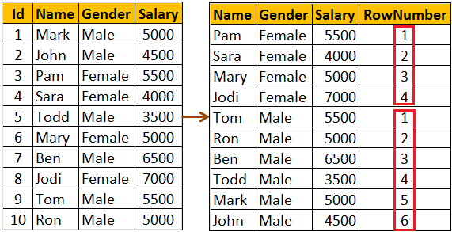  
  
**Use case for Row\_Number function :** Deleting all duplicate rows except one from a sql server table.   
  
Discussed in detail in[Part 4](http://csharp-video-tutorials.blogspot.com/2014/05/part-4-delete-duplicate-rows-in-sql.html) of [SQL Server Interview Questions and Answers video series](https://www.youtube.com/playlist?list=PL6n9fhu94yhXcztdLO7i6mdyaegC8CJwR).

### **PART 110 : Rank and Dense\_Rank in SQL Server**

**Suggested Videos**  
[Part 107 - Debugging sql server stored procedures](http://csharp-video-tutorials.blogspot.com/2015/09/debugging-sql-server-stored-procedures.html)  
[Part 108 - Over clause in SQL Server](http://csharp-video-tutorials.blogspot.com/2015/09/over-clause-in-sql-server.html)  
[Part 109 - Row\_Number function in SQL Server](http://csharp-video-tutorials.blogspot.com/2015/09/rownumber-function-in-sql-server.html)  
  
In this video we will discuss **Rank and Dense\_Rank functions in SQL Server**  
  
**Rank and Dense\_Rank functions**

* Introduced in SQL Server 2005
* Returns a rank starting at 1 based on the ordering of rows imposed by the ORDER BY clause
* ORDER BY clause is required
* PARTITION BY clause is optional
* When the data is partitioned, rank is reset to 1 when the partition changes

**Difference between Rank and Dense\_Rank functions**  
Rank function skips ranking(s) if there is a tie where as Dense\_Rank will not.  
  
**For example :**If you have 2 rows at rank 1 and you have 5 rows in total.

RANK() returns - 1, 1, 3, 4, 5

DENSE\_RANK returns - 1, 1, 2, 3, 4

**Syntax :**

RANK() OVER (ORDER BY Col1, Col2, ...)

DENSE\_RANK() OVER (ORDER BY Col1, Col2, ...)

**Example :** We will use the following **Employees**table for the examples in this video  
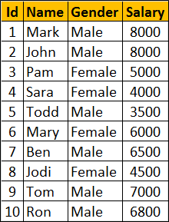  
  
**SQl Script to create Employees table**

Create Table Employees

(

    Id int primary key,

    Name nvarchar(50),

    Gender nvarchar(10),

    Salary int

)

Go

Insert Into Employees Values (1, 'Mark', 'Male', 8000)

Insert Into Employees Values (2, 'John', 'Male', 8000)

Insert Into Employees Values (3, 'Pam', 'Female', 5000)

Insert Into Employees Values (4, 'Sara', 'Female', 4000)

Insert Into Employees Values (5, 'Todd', 'Male', 3500)

Insert Into Employees Values (6, 'Mary', 'Female', 6000)

Insert Into Employees Values (7, 'Ben', 'Male', 6500)

Insert Into Employees Values (8, 'Jodi', 'Female', 4500)

Insert Into Employees Values (9, 'Tom', 'Male', 7000)

Insert Into Employees Values (10, 'Ron', 'Male', 6800)

Go

**RANK() and DENSE\_RANK() functions without PARTITION BY clause :** In this example, data is not partitioned, so RANK() function provides a consecutive numbering except when there is a tie. Rank 2 is skipped as there are 2 rows at rank 1. The third row gets rank 3.  
  
DENSE\_RANK() on the other hand will not skip ranks if there is a tie. The first 2 rows get rank 1. Third row gets rank 2.

SELECT Name, Salary, Gender,

RANK() OVER (ORDER BY Salary DESC) AS [Rank],

DENSE\_RANK() OVER (ORDER BY Salary DESC) AS DenseRank

FROM Employees

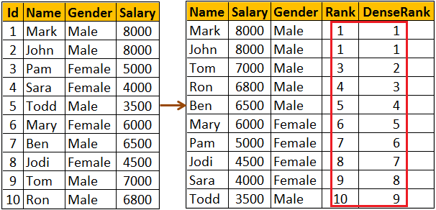  
  
**RANK() and DENSE\_RANK() functions with PARTITION BY clause :** Notice when the partition changes from Female to Male Rank is reset to 1

SELECT Name, Salary, Gender,

RANK() OVER (PARTITION BY Gender ORDER BY Salary DESC) AS [Rank],

DENSE\_RANK() OVER (PARTITION BY Gender ORDER BY Salary DESC)  
AS DenseRank

FROM Employees

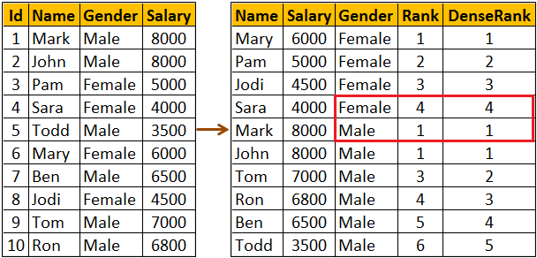  
  
**Use case for RANK and DENSE\_RANK functions :** Both these functions can be used to find Nth highest salary. However, which function to use depends on what you want to do when there is a tie. Let me explain with an example.  
  
**If there are 2 employees with the FIRST highest salary, there are 2 different business cases**

* If your business case is, not to produce any result for the SECOND highest salary, then use RANK function
* If your business case is to return the next Salary after the tied rows as the SECOND highest Salary, then use DENSE\_RANK function

Since we have 2 Employees with the FIRST highest salary. Rank() function will not return any rows for the SECOND highest Salary.

WITH Result AS

(

    SELECT Salary, RANK() OVER (ORDER BY Salary DESC) AS Salary\_Rank

    FROM Employees

)

SELECT TOP 1 Salary FROM Result WHERE Salary\_Rank = 2

Though we have 2 Employees with the FIRST highest salary. Dense\_Rank() function returns, the next Salary after the tied rows as the SECOND highest Salary

WITH Result AS

(

    SELECT Salary, DENSE\_RANK() OVER (ORDER BY Salary DESC) AS Salary\_Rank

    FROM Employees

)

SELECT TOP 1 Salary FROM Result WHERE Salary\_Rank = 2

You can also use RANK and DENSE\_RANK functions to find the Nth highest Salary among Male or Female employee groups. The following query finds the 3rd highest salary amount paid among the Female employees group

WITH Result AS

(

    SELECT Salary, Gender,

           DENSE\_RANK() OVER (PARTITION BY Gender ORDER BY Salary DESC)

           AS Salary\_Rank

    FROM Employees

)SELECT TOP 1 Salary FROM Result WHERE Salary\_Rank = 3AND Gender = 'Female'

### **PART 111 : Difference between rank dense\_rank and row\_number in SQL**

**Suggested Videos**  
[Part 108 - Over clause in SQL Server](http://csharp-video-tutorials.blogspot.com/2015/09/over-clause-in-sql-server.html)  
[Part 109 - Row\_Number function in SQL Server](http://csharp-video-tutorials.blogspot.com/2015/09/rownumber-function-in-sql-server.html)  
[Part 110 - Rank and Dense\_Rank in SQL Server](http://csharp-video-tutorials.blogspot.com/2015/10/rank-and-denserank-in-sql-server.html)  
  
  
In this video we will discuss the similarities and **difference between RANK, DENSE\_RANK and ROW\_NUMBER** functions in SQL Server.  
  
  
**Similarities between RANK, DENSE\_RANK and ROW\_NUMBER functions**

* Returns an increasing integer value starting at 1 based on the ordering of rows imposed by the ORDER BY clause (if there are no ties)
* ORDER BY clause is required
* PARTITION BY clause is optional
* When the data is partitioned, the integer value is reset to 1 when the partition changes

We will use the following **Employees**table for the examples in this video  
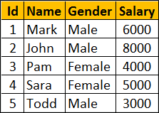  
  
**SQL Script to create the Employees table**

Create Table Employees

(

     Id int primary key,

     Name nvarchar(50),

     Gender nvarchar(10),

     Salary int

)

Go

Insert Into Employees Values (1, 'Mark', 'Male', 6000)

Insert Into Employees Values (2, 'John', 'Male', 8000)

Insert Into Employees Values (3, 'Pam', 'Female', 4000)

Insert Into Employees Values (4, 'Sara', 'Female', 5000)

Insert Into Employees Values (5, 'Todd', 'Male', 3000)

Notice that no two employees in the table have the same salary. So all the 3 functions RANK, DENSE\_RANK and ROW\_NUMBER produce the same increasing integer value when ordered by Salary column.

SELECT Name, Salary, Gender,

ROW\_NUMBER() OVER (ORDER BY Salary DESC) AS RowNumber,

RANK() OVER (ORDER BY Salary DESC) AS [Rank],

DENSE\_RANK() OVER (ORDER BY Salary DESC) AS DenseRank

FROM Employees

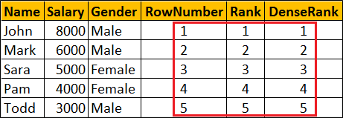  
  
You will only see the difference when there ties (duplicate values in the column used in the ORDER BY clause).  
  
Now let's include duplicate values for Salary column.   
  
To do this   
**First delete existing data from the Employees table**  
DELETE FROM Employees  
  
**Insert new rows with duplicate valuse for Salary column**

Insert Into Employees Values (1, 'Mark', 'Male', 8000)

Insert Into Employees Values (2, 'John', 'Male', 8000)

Insert Into Employees Values (3, 'Pam', 'Female', 8000)

Insert Into Employees Values (4, 'Sara', 'Female', 4000)

Insert Into Employees Values (5, 'Todd', 'Male', 3500)

At this point data in the Employees table should be as shown below  
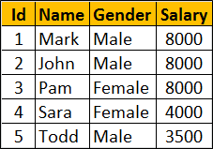  
  
Notice 3 employees have the same salary 8000. When you execute the following query you can clearly see the difference between RANK, DENSE\_RANK and ROW\_NUMBER functions.

SELECT Name, Salary, Gender,

ROW\_NUMBER() OVER (ORDER BY Salary DESC) AS RowNumber,

RANK() OVER (ORDER BY Salary DESC) AS [Rank],

DENSE\_RANK() OVER (ORDER BY Salary DESC) AS DenseRank

FROM Employees

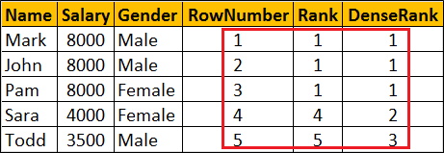  
  
**Difference between RANK, DENSE\_RANK and ROW\_NUMBER functions**

* **ROW\_NUMBER :** Returns an increasing unique number for each row starting at 1, even if there are duplicates.
* **RANK :**Returns an increasing unique number for each row starting at 1. When there are duplicates, same rank is assigned to all the duplicate rows, but the next row after the duplicate rows will have the rank it would have been assigned if there had been no duplicates. So RANK function skips rankings if there are duplicates.
* **DENSE\_RANK :**Returns an increasing unique number for each row starting at 1. When there are duplicates, same rank is assigned to all the duplicate rows but the DENSE\_RANK function will not skip any ranks. This means the next row after the duplicate rows will have the next rank in the sequence.

### **PART 112 : Calculate running total in SQL Server 2012**

**Suggested Videos**  
[Part 109 - Row\_Number function in SQL Server](http://csharp-video-tutorials.blogspot.com/2015/09/rownumber-function-in-sql-server.html)  
[Part 110 - Rank and Dense\_Rank in SQL Server](http://csharp-video-tutorials.blogspot.com/2015/10/rank-and-denserank-in-sql-server.html)  
[Part 111 - Difference between rank dense\_rank and row\_number in SQL](http://csharp-video-tutorials.blogspot.com/2015/10/difference-between-rank-denserank-and.html)  
  
In this video we will discuss how to calculate running total in SQL Server 2012 and later versions.  
  
We will use the following **Employees table** for the examples in this video.  
  
  
**SQL Script to create Employees table**  
Create Table Employees

(

     Id int primary key,

     Name nvarchar(50),

     Gender nvarchar(10),

     Salary int

)

Go

Insert Into Employees Values (1, 'Mark', 'Male', 5000)

Insert Into Employees Values (2, 'John', 'Male', 4500)

Insert Into Employees Values (3, 'Pam', 'Female', 5500)

Insert Into Employees Values (4, 'Sara', 'Female', 4000)

Insert Into Employees Values (5, 'Todd', 'Male', 3500)

Insert Into Employees Values (6, 'Mary', 'Female', 5000)

Insert Into Employees Values (7, 'Ben', 'Male', 6500)

Insert Into Employees Values (8, 'Jodi', 'Female', 7000)

Insert Into Employees Values (9, 'Tom', 'Male', 5500)

Insert Into Employees Values (10, 'Ron', 'Male', 5000)

Go

**SQL Query to compute running total without partitions**

SELECT Name, Gender, Salary,

        SUM(Salary) OVER (ORDER BY ID) AS RunningTotal

FROM Employees  
  
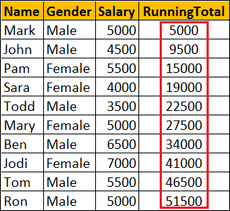  
  
**SQL Query to compute running total with partitions**  
SELECT Name, Gender, Salary,

        SUM(Salary) OVER (PARTITION BY Gender ORDER BY ID) AS RunningTotal

FROM Employees  
  
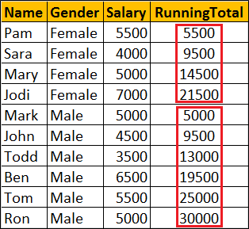  
  
**What happens if I use order by on Salary column**  
If you have duplicate values in the Salary column, all the duplicate values will be added to the running total at once. In the example below notice that we have 5000 repeated 3 times. So 15000 (i.e 5000 + 5000 + 5000) is added to the running total at once.

SELECT Name, Gender, Salary,

        SUM(Salary) OVER (ORDER BY Salary) AS RunningTotal

FROM Employees  
  
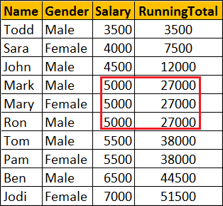  
  
So when computing running total, it is better to use a column that has unique data in the ORDER BY clause.

### **PART 113: NTILE function in SQL Server**

**Suggested Videos**  
[Part 110 - Rank and Dense\_Rank in SQL Server](http://csharp-video-tutorials.blogspot.com/2015/10/rank-and-denserank-in-sql-server.html)  
[Part 111 - Difference between rank dense\_rank and row\_number in SQL](http://csharp-video-tutorials.blogspot.com/2015/10/difference-between-rank-denserank-and.html)  
[Part 112 - Calculate running total in SQL Server 2012](http://csharp-video-tutorials.blogspot.com/2015/10/calculate-running-total-in-sql-server.html)  
  
In this video we will discuss **NTILE function in SQL Server**  
  
**NTILE function**

* Introduced in SQL Server 2005
* ORDER BY Clause is required
* PARTITION BY clause is optional
* Distributes the rows into a specified number of groups
* If the number of rows is not divisible by number of groups, you may have groups of two different sizes.
* Larger groups come before smaller groups

**For example**

* NTILE(2) of 10 rows divides the rows in 2 Groups (5 in each group)
* NTILE(3) of 10 rows divides the rows in 3 Groups (4 in first group, 3 in 2nd & 3rd group)

**Syntax :** NTILE (Number\_of\_Groups) OVER (ORDER BY Col1, Col2, ...)

We will use the following **Employees table** for the examples in this video.  


**SQL Script to create Employees table**

Create Table Employees

(

    Id int primary key,

    Name nvarchar(50),

    Gender nvarchar(10),

    Salary int

)

Go

Insert Into Employees Values (1, 'Mark', 'Male', 5000)

Insert Into Employees Values (2, 'John', 'Male', 4500)

Insert Into Employees Values (3, 'Pam', 'Female', 5500)

Insert Into Employees Values (4, 'Sara', 'Female', 4000)

Insert Into Employees Values (5, 'Todd', 'Male', 3500)

Insert Into Employees Values (6, 'Mary', 'Female', 5000)

Insert Into Employees Values (7, 'Ben', 'Male', 6500)

Insert Into Employees Values (8, 'Jodi', 'Female', 7000)

Insert Into Employees Values (9, 'Tom', 'Male', 5500)

Insert Into Employees Values (10, 'Ron', 'Male', 5000)

Go

**NTILE function without PARTITION BY clause :** Divides the 10 rows into 3 groups. 4 rows in first group, 3 rows in the 2nd & 3rd group.

SELECT Name, Gender, Salary,

NTILE(3) OVER (ORDER BY Salary) AS [Ntile]

FROM Employees

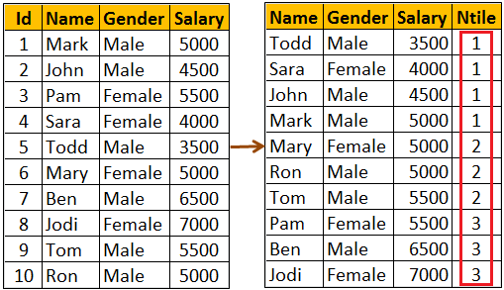  
  
**What if the specified number of groups is GREATER THAN the number of rows**  
NTILE function will try to create as many groups as possible with one row in each group.   
  
With 10 rows in the table, NTILE(11) will create 10 groups with 1 row in each group.

SELECT Name, Gender, Salary,

NTILE(11) OVER (ORDER BY Salary) AS [Ntile]

FROM Employees

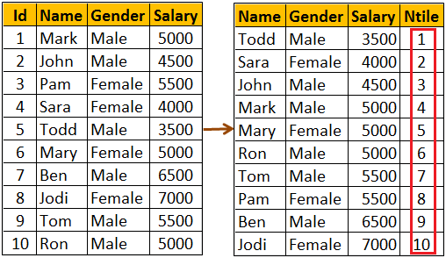  
  
**NTILE function with PARTITION BY clause :** When the data is partitioned, NTILE function creates the specified number of groups with in each partition.  
  
The following query partitions the data into 2 partitions (Male & Female). NTILE(3) creates 3 groups in each of the partitions.

SELECT Name, Gender, Salary,

NTILE(3) OVER (PARTITION BY GENDER ORDER BY Salary) AS [Ntile]

FROM Employees

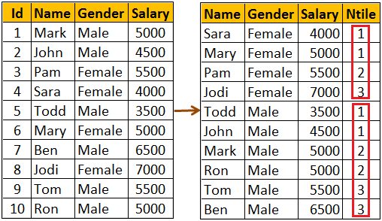

### **PART 114 : Lead and Lag functions in SQL Server 2012**

**Suggested Videos**  
[Part 111 - Difference between rank dense\_rank and row\_number in SQL](http://csharp-video-tutorials.blogspot.com/2015/10/difference-between-rank-denserank-and.html)  
[Part 112 - Calculate running total in SQL Server 2012](http://csharp-video-tutorials.blogspot.com/2015/10/calculate-running-total-in-sql-server.html)  
[Part 113 - NTILE function in SQL Server](http://csharp-video-tutorials.blogspot.com/2015/10/ntile-function-in-sql-server.html)  
  
In this video we will discuss about Lead and Lag functions.  
  
**Lead and Lag functions**

* Introduced in SQL Server 2012
* Lead function is used to access subsequent row data along with current row data
* Lag function is used to access previous row data along with current row data
* ORDER BY clause is required
* PARTITION BY clause is optional

**Syntax**

LEAD(Column\_Name, Offset, Default\_Value) OVER (ORDER BY Col1, Col2, ...)

LAG(Column\_Name, Offset, Default\_Value) OVER (ORDER BY Col1, Col2, ...)

* **Offset -**Number of rows to lead or lag.
* **Default\_Value -** The default value to return if the number of rows to lead or lag goes beyond first row or last row in a table or partition. If default value is not specified NULL is returned.

We will use the following **Employees table** for the examples in this video  
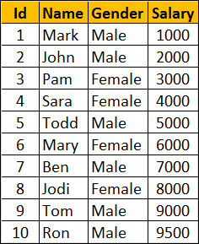  
  
**SQL Script to create the Employees table**

Create Table Employees

(

     Id int primary key,

     Name nvarchar(50),

     Gender nvarchar(10),

     Salary int

)

Go

Insert Into Employees Values (1, 'Mark', 'Male', 1000)

Insert Into Employees Values (2, 'John', 'Male', 2000)

Insert Into Employees Values (3, 'Pam', 'Female', 3000)

Insert Into Employees Values (4, 'Sara', 'Female', 4000)

Insert Into Employees Values (5, 'Todd', 'Male', 5000)

Insert Into Employees Values (6, 'Mary', 'Female', 6000)

Insert Into Employees Values (7, 'Ben', 'Male', 7000)

Insert Into Employees Values (8, 'Jodi', 'Female', 8000)

Insert Into Employees Values (9, 'Tom', 'Male', 9000)

Insert Into Employees Values (10, 'Ron', 'Male', 9500)

Go  
  
**Lead and Lag functions example WITHOUT partitions :** This example Leads 2 rows and Lags 1 row from the current row.

* When you are on the first row, LEAD(Salary, 2, -1) allows you to move forward 2 rows and retrieve the salary from the 3rd row.
* When you are on the first row, LAG(Salary, 1, -1) allows us to move backward 1 row. Since there no rows beyond row 1, Lag function in this case returns the default value -1.
* When you are on the last row, LEAD(Salary, 2, -1) allows you to move forward 2 rows. Since there no rows beyond the last row 1, Lead function in this case returns the default value -1.
* When you are on the last row, LAG(Salary, 1, -1) allows us to move backward 1 row and retrieve the salary from the previous row.

SELECT Name, Gender, Salary,

        LEAD(Salary, 2, -1) OVER (ORDER BY Salary) AS Lead\_2,

        LAG(Salary, 1, -1) OVER (ORDER BY Salary) AS Lag\_1

FROM Employees  
  
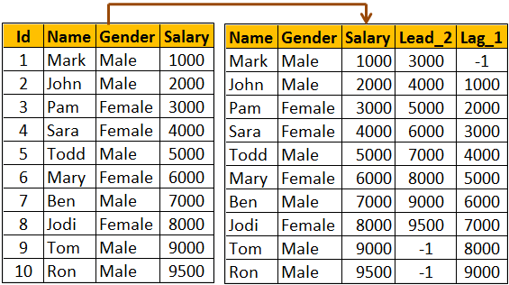  
  
**Lead and Lag functions example WITH partitions :** Notice that in this example, Lead and Lag functions return default value if the number of rows to lead or lag goes beyond first row or last row in the partition.

SELECT Name, Gender, Salary,

        LEAD(Salary, 2, -1) OVER (PARTITION By Gender ORDER BY Salary) AS Lead\_2,

        LAG(Salary, 1, -1) OVER (PARTITION By Gender ORDER BY Salary) AS Lag\_1

FROM Employees  
  
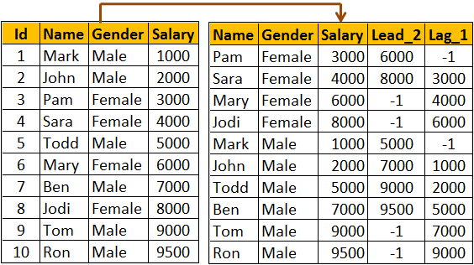

### **PART 115 : FIRST\_VALUE function in SQL Server**

**Suggested Videos**  
[Part 112 - Calculate running total in SQL Server 2012](http://csharp-video-tutorials.blogspot.com/2015/10/calculate-running-total-in-sql-server.html)  
[Part 113 - NTILE function in SQL Server](http://csharp-video-tutorials.blogspot.com/2015/10/ntile-function-in-sql-server.html)  
[Part 114 - Lead and Lag functions in SQL Server 2012](http://csharp-video-tutorials.blogspot.com/2015/10/lead-and-lag-functions-in-sql-server.html)  
  
  
In this video we will discuss FIRST\_VALUE function in SQL Server  
  
  
**FIRST\_VALUE function**

* Introduced in SQL Server 2012
* Retrieves the first value from the specified column
* ORDER BY clause is required
* PARTITION BY clause is optional

**Syntax :** FIRST\_VALUE(Column\_Name) OVER (ORDER BY Col1, Col2, ...)

**FIRST\_VALUE function example WITHOUT partitions :** In the following example, FIRST\_VALUE function returns the name of the lowest paid employee from the entire table.

SELECT Name, Gender, Salary,FIRST\_VALUE(Name) OVER (ORDER BY Salary) AS FirstValue

FROM Employees  
  
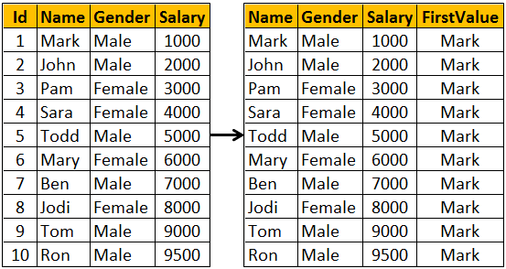  
  
**FIRST\_VALUE function example WITH partitions :** In the following example, FIRST\_VALUE function returns the name of the lowest paid employee from the respective partition.

SELECT Name, Gender, Salary,

FIRST\_VALUE(Name) OVER (PARTITION BY Gender ORDER BY Salary) AS FirstValue

FROM Employees  
  
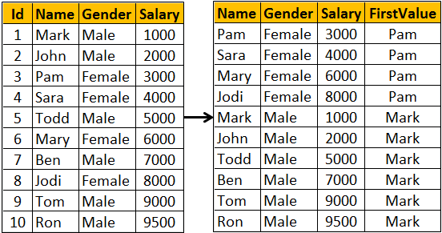

### **PART 116: Window functions in SQL Server**

**Suggested Videos**  
[Part 113 - NTILE function in SQL Server](http://csharp-video-tutorials.blogspot.com/2015/10/ntile-function-in-sql-server.html)  
[Part 114 - Lead and Lag functions in SQL Server 2012](http://csharp-video-tutorials.blogspot.com/2015/10/lead-and-lag-functions-in-sql-server.html)  
[Part 115 - FIRST\_VALUE function in SQL Server](http://csharp-video-tutorials.blogspot.com/2015/10/firstvalue-function-in-sql-server.html)  
  
In this video we will discuss **window functions in SQL Server**  
  
In SQL Server we have different categories of window functions

* **Aggregate functions -** AVG, SUM, COUNT, MIN, MAX etc..
* **Ranking functions -** RANK, DENSE\_RANK, ROW\_NUMBER etc..
* **Analytic functions -** LEAD, LAG, FIRST\_VALUE, LAST\_VALUE etc...

**OVER** Clause defines the partitioning and ordering of a rows (i.e a window) for the above functions to operate on. Hence these functions are called window functions. The OVER clause accepts the following three arguments to define a window for these functions to operate on.

* **ORDER BY :** Defines the logical order of the rows
* **PARTITION BY :** Divides the query result set into partitions. The window function is applied to each partition separately.
* **ROWSor RANGE clause :** Further limits the rows within the partition by specifying start and end points within the partition.

The default for **ROWS**or **RANGE**clause is

RANGE BETWEEN UNBOUNDED PRECEDING AND CURRENT ROW

Let us understand the use of **ROWS**or **RANGE**clause with an example.   
  
Compute average salary and display it against every employee row as shown below.  
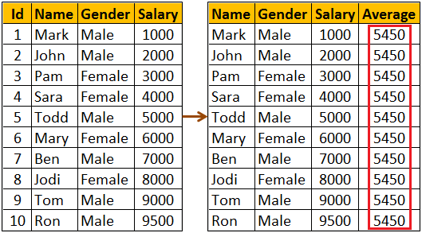  
  
We might think the following query would do the job.

SELECT Name, Gender, Salary,AVG(Salary) OVER(ORDER BY Salary) AS AveragFROM Employees

As you can see from the result below, the above query does not produce the overall salary average. It produces the average of the current row and the rows preceeding the current row. This is because, the default value of ROWS or RANGE clause (RANGE BETWEEN UNBOUNDED PRECEDING AND CURRENT ROW) is applied.  
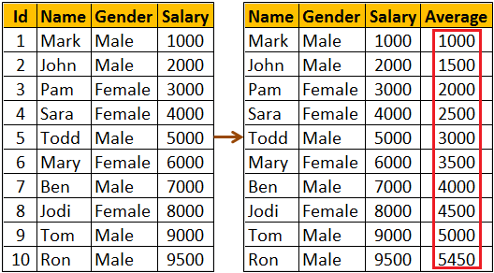  
  
To fix this, provide an explicit value for ROWS or RANGE clause as shown below. ROWS BETWEEN UNBOUNDED PRECEDING AND UNBOUNDED FOLLOWING tells the window function to operate on the set of rows starting from the first row in the partition to the last row in the partition.

SELECT Name, Gender, Salary,

        AVG(Salary) OVER(ORDER BY Salary ROWS BETWEEN

        UNBOUNDED PRECEDING AND UNBOUNDED FOLLOWING) AS Average

FROM Employees

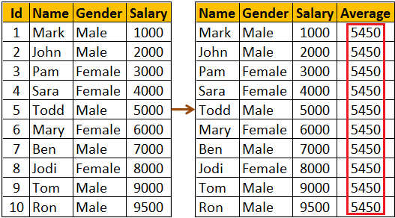  
  
The same result can also be achieved by using RANGE BETWEEN UNBOUNDED PRECEDING AND UNBOUNDED FOLLOWING  
  
**What is the difference between ROWS and RANGE**  
We will discuss this in a later video  
  
The following query can be used if you want to compute the average salary of   
1. The current row  
2. One row PRECEDING the current row and   
3. One row FOLLOWING the current row

SELECT Name, Gender, Salary,

        AVG(Salary) OVER(ORDER BY Salary

        ROWS BETWEEN 1 PRECEDING AND 1 FOLLOWING) AS Average

FROM Employees

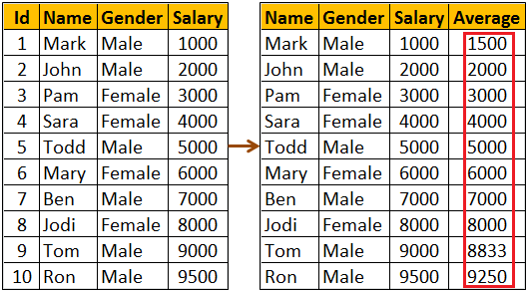

### **PART 117 : Difference between rows and range**

**Suggested Videos**  
[Part 114 - Lead and Lag functions in SQL Server 2012](http://csharp-video-tutorials.blogspot.com/2015/10/lead-and-lag-functions-in-sql-server.html)  
[Part 115 - FIRST\_VALUE function in SQL Server](http://csharp-video-tutorials.blogspot.com/2015/10/firstvalue-function-in-sql-server.html)  
[Part 116 - Window functions in SQL Server](http://csharp-video-tutorials.blogspot.com/2015/10/window-functions-in-sql-server.html)  
  
In this video we will discuss the **difference between rows and range in SQL Server**. This is continuation to [Part 116](http://csharp-video-tutorials.blogspot.com/2015/10/window-functions-in-sql-server.html). Please watch [Part 116](http://csharp-video-tutorials.blogspot.com/2015/10/window-functions-in-sql-server.html) from [SQL Server tutorial](https://www.youtube.com/playlist?list=PL08903FB7ACA1C2FB) before proceeding.  
  
  
  
Let us understand the difference with an example. We will use the following **Employees**table in this demo.  
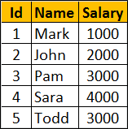  
  
**SQL Script to create the Employees table**

Create Table Employees

(

     Id int primary key,

     Name nvarchar(50),

     Salary int

)

Go

Insert Into Employees Values (1, 'Mark', 1000)

Insert Into Employees Values (2, 'John', 2000)

Insert Into Employees Values (3, 'Pam', 3000)

Insert Into Employees Values (4, 'Sara', 4000)

Insert Into Employees Values (5, 'Todd', 5000)

Go  
  
**Calculate the running total of Salary and display it against every employee row**  
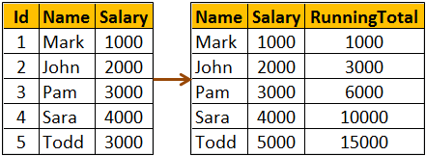  
  
The following query calculates the running total. We have not specified an explicit value for ROWS or RANGE clause.

SELECT Name, Salary,

        SUM(Salary) OVER(ORDER BY Salary) AS RunningTotal

FROM Employees

So the above query is using the default value which is

RANGE BETWEEN UNBOUNDED PRECEDING AND CURRENT ROW

This means the above query can be re-written using an explicit value for ROWS or RANGE clause as shown below.

SELECT Name, Salary,

        SUM(Salary) OVER(ORDER BY Salary

        RANGE BETWEEN UNBOUNDED PRECEDING AND CURRENT ROW) AS RunningTotal

FROM Employees  
  
We can also achieve the same result, by replacing RANGE with ROWS

SELECT Name, Salary,

        SUM(Salary) OVER(ORDER BY Salary

        ROWS BETWEEN UNBOUNDED PRECEDING AND CURRENT ROW) AS RunningTotal

FROM Employees  
  
**What is the difference between ROWS and RANGE**  
To understand the difference we need some duplicate values for the Salary column in the Employees table.  
  
Execute the following UPDATE script to introduce duplicate values in the Salary column

Update Employees set Salary = 1000 where Id = 2

Update Employees set Salary = 3000 where Id = 4

Go

Now execute the following query. Notice that we get the running total as expected.

SELECT Name, Salary,

        SUM(Salary) OVER(ORDER BY Salary

        ROWS BETWEEN UNBOUNDED PRECEDING AND CURRENT ROW) AS RunningTotal

FROM Employees

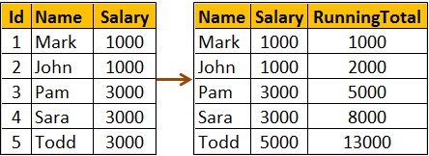  
  
**The following query uses RANGE instead of ROWS**

SELECT Name, Salary,

        SUM(Salary) OVER(ORDER BY Salary

        RANGE BETWEEN UNBOUNDED PRECEDING AND CURRENT ROW) AS RunningTotal

FROM Employees  
  
You get the following result when you execute the above query. Notice we don't get the running total as expected.  
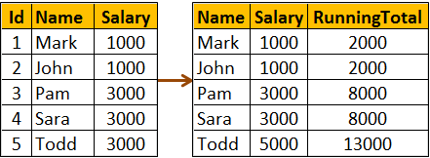  
  
So, the main difference between ROWS and RANGE is in the way duplicate rows are treated. ROWS treat duplicates as distinct values, where as RANGE treats them as a single entity.  
  
All together side by side. The following query shows how running total changes  
1. When no value is specified for ROWS or RANGE clause  
2. When RANGE clause is used explicitly with it's default value  
3. When ROWS clause is used instead of RANGE clause

SELECT Name, Salary,

        SUM(Salary) OVER(ORDER BY Salary) AS [Default],

        SUM(Salary) OVER(ORDER BY Salary

        RANGE BETWEEN UNBOUNDED PRECEDING AND CURRENT ROW) AS [Range],

        SUM(Salary) OVER(ORDER BY Salary

        ROWS BETWEEN UNBOUNDED PRECEDING AND CURRENT ROW) AS [Rows]

FROM Employees

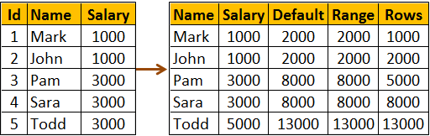

### **PART 118 : LAST\_VALUE function in SQL Server**

**Suggested Videos**  
[Part 115 - FIRST\_VALUE function in SQL Server](http://csharp-video-tutorials.blogspot.com/2015/10/firstvalue-function-in-sql-server.html)  
[Part 116 - Window functions in SQL Server](http://csharp-video-tutorials.blogspot.com/2015/10/window-functions-in-sql-server.html)  
[Part 117 - Difference between rows and range](http://csharp-video-tutorials.blogspot.com/2015/10/difference-between-rows-and-range.html)  
  
In this video we will discuss LAST\_VALUE function in SQL Server.  
  
**LAST\_VALUE function**

* Introduced in SQL Server 2012
* Retrieves the last value from the specified column
* ORDER BY clause is required
* PARTITION BY clause is optional
* ROWS or RANGE clause is optional, but for it to work correctly you may have to explicitly specify a value

**Syntax :** LAST\_VALUE(Column\_Name) OVER (ORDER BY Col1, Col2, ...)

**LAST\_VALUE function not working as expected :** In the following example, LAST\_VALUE function does not return the name of the highest paid employee. This is because we have not specified an explicit value for ROWS or RANGE clause. As a result it is using it's default value RANGE BETWEEN UNBOUNDED PRECEDING AND CURRENT ROW.

SELECT Name, Gender, Salary,

    LAST\_VALUE(Name) OVER (ORDER BY Salary) AS LastValue

FROM Employees  
  
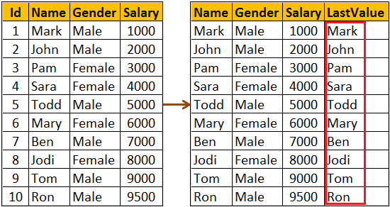  
  
**LAST\_VALUE function working as expected :** In the following example, LAST\_VALUE function returns the name of the highest paid employee as expected. Notice we have set an explicit value for ROWS or RANGE clause to ROWS BETWEEN UNBOUNDED PRECEDING AND UNBOUNDED FOLLOWING

This tells the LAST\_VALUE function that it's window starts at the first row and ends at the last row in the result set.

SELECT Name, Gender, Salary,

    LAST\_VALUE(Name) OVER (ORDER BY Salary ROWS BETWEEN UNBOUNDED PRECEDING AND UNBOUNDED FOLLOWING) AS LastValue

FROM Employees

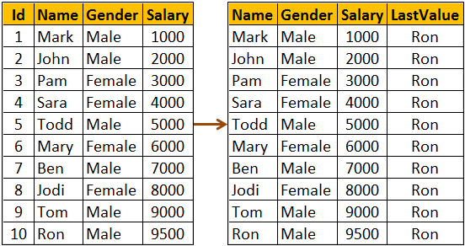  
  
**LAST\_VALUE function example with partitions :** In the following example, LAST\_VALUE function returns the name of the highest paid employee from the respective partition.

SELECT Name, Gender, Salary,

    LAST\_VALUE(Name) OVER (PARTITION BY Gender ORDER BY Salary

    ROWS BETWEEN UNBOUNDED PRECEDING AND UNBOUNDED FOLLOWING) AS LastValue

FROM Employees  
  
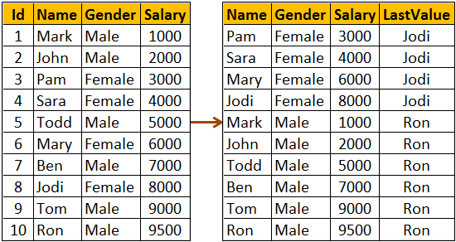

### **PART 119 : UNPIVOT in SQL Server**

**Suggested Videos**  
[Part 116 - Window functions in SQL Server](http://csharp-video-tutorials.blogspot.com/2015/10/window-functions-in-sql-server.html)  
[Part 117 - Difference between rows and range](http://csharp-video-tutorials.blogspot.com/2015/10/difference-between-rows-and-range.html)  
[Part 118 - LAST\_VALUE function in SQL Server](http://csharp-video-tutorials.blogspot.com/2015/10/lastvalue-function-in-sql-server.html)  
  
In this video we will discuss UNPIVOT operator in SQL Server.   
  
PIVOT operator turns ROWS into COLUMNS, where as UNPIVOT turns COLUMNS into ROWS.  
  
We discussed PIVOT operator in [Part 54](http://csharp-video-tutorials.blogspot.com/2012/10/pivot-operator-in-sql-server-part-54.html)of [SQL Server tutorial](https://www.youtube.com/playlist?list=PL08903FB7ACA1C2FB). Please watch [Part 54](http://csharp-video-tutorials.blogspot.com/2012/10/pivot-operator-in-sql-server-part-54.html) before proceeding.  
  
Let us understand UNPIVOT with an example. We will use the following tblProductSales table in this demo.  
  
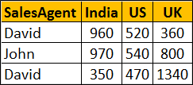  
  
**SQL Script to create tblProductSales table**

Create Table tblProductSales

(

 SalesAgent nvarchar(50),

 India int,

 US int,

 UK int

)

Go

Insert into tblProductSales values ('David', 960, 520, 360)

Insert into tblProductSales values ('John', 970, 540, 800)

Go  
  
Write a query to turn COLUMNS into ROWS. The result of the query should be as shown   
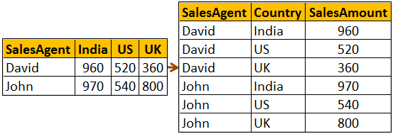  
  
SELECT SalesAgent, Country, SalesAmount

FROM tblProductSales

UNPIVOT

(

       SalesAmount

       FOR Country IN (India, US ,UK)

) AS UnpivotExample

### **PART 120 : Reverse PIVOT table in SQL Server**

**Suggested Videos**  
[Part 117 - Difference between rows and range](http://csharp-video-tutorials.blogspot.com/2015/10/difference-between-rows-and-range.html)  
[Part 118 - LAST\_VALUE function in SQL Server](http://csharp-video-tutorials.blogspot.com/2015/10/lastvalue-function-in-sql-server.html)  
[Part 119 - UNPIVOT in SQL Server](http://csharp-video-tutorials.blogspot.com/2015/10/unpivot-in-sql-server.html)  
  
In this video we will discuss if it's always possible to reverse what PIVOT operator has done using UNPIVOT operator.  
  
**Is it always possible to reverse what PIVOT operator has done using UNPIVOT operator.**  
No, not always. If the PIVOT operator has not aggregated the data, you can get your original data back using the UNPIVOT operator but not if the data is aggregated.  
  
Let us understand this with an example. We will use the following table **tblProductSales**for the examples in this video.  
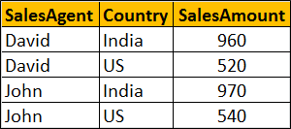  
  
**SQL Script to create tblProductSales table**

Create Table tblProductSales

(

     SalesAgent nvarchar(10),

     Country nvarchar(10),

     SalesAmount int

)

Go

Insert into tblProductSales values('David','India',960)

Insert into tblProductSales values('David','US',520)

Insert into tblProductSales values('John','India',970)

Insert into tblProductSales values('John','US',540)

Go

**Let's now use the PIVOT operator to turn ROWS into COLUMNS**

SELECT SalesAgent, India, US

FROM tblProductSales

PIVOT

(

     SUM(SalesAmount)

     FOR Country IN (India, US)

) AS PivotTable

The above query produces the following output  
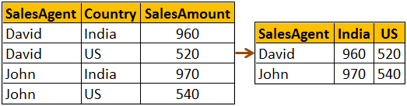  
  
**Now let's use the UNPIVOT operator to reverse what PIVOT operator has done**

SELECT SalesAgent, Country, SalesAmount

FROM

(SELECT SalesAgent, India, US

FROM tblProductSales

PIVOT

(

     SUM(SalesAmount)

     FOR Country IN (India, US)

) AS PivotTable) P

UNPIVOT

(

     SalesAmount

     FOR Country IN (India, US)

) AS UnpivotTable

The above query reverses what PIVOT operator has done, and we get the original data back as shown below. We are able to get the original data back, because the SUM aggregate function that we used with the PIVOT operator did not perform any aggregation.  
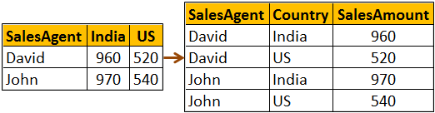  
  
Now execute the following **INSERT** statement to insert a new row into **tblProductSales** table.

Insert into tblProductSales values('David','India',100)

With this new row in the table, if you execute the following **PIVOT** query data will be aggregated

SELECT SalesAgent, India, US

FROM tblProductSales

PIVOT

(

     SUM(SalesAmount)

     FOR Country IN (India, US)

) AS PivotTable

**The following is the result of the above query**  
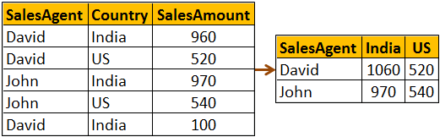  
  
Now if we use UNPIVOT opertaor with the above query, we wouldn't get our orginial data back as the PIVOT operator has already aggrgated the data, and there is no way for SQL Server to know how to undo the aggregations.

SELECT SalesAgent, Country, SalesAmount

FROM

(SELECT SalesAgent, India, US

FROM tblProductSales

PIVOT

(

     SUM(SalesAmount)

     FOR Country IN (India, US)

) AS PivotTable) P

UNPIVOT

(

     SalesAmount

     FOR Country IN (India, US)

) AS UnpivotTable

Notice that for SalesAgent - David and Country - India we get only one row. In the original table we had 2 rows for the same combination.  
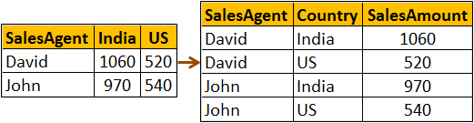

### **PART 121 : Choose function in SQL Server**

**Suggested Videos**  
[Part 118 - LAST\_VALUE function in SQL Server](http://csharp-video-tutorials.blogspot.com/2015/10/lastvalue-function-in-sql-server.html)  
[Part 119 - UNPIVOT in SQL Server](http://csharp-video-tutorials.blogspot.com/2015/10/unpivot-in-sql-server.html)  
[Part 120 - Reverse PIVOT table in SQL Server](http://csharp-video-tutorials.blogspot.com/2015/10/reverse-pivot-table-in-sql-server.html)  
  
In this video we will discuss **Choose function in SQL Server**  
  
**Choose function**

* Introduced in SQL Server 2012
* Returns the item at the specified index from the list of available values
* The index position starts at 1 and NOT 0 (ZERO)

**Syntax :**CHOOSE( index, val\_1, val\_2, ... )  
  
**Example :** Returns the item at index position 2

SELECT CHOOSE(2, 'India','US', 'UK') AS Country

**Output :**  
Choose function in SQL Server  
  
**Example :** Using CHOOSE() function with table data. We will use the following **Employees**table for this example.  
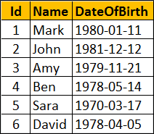  
  
**SQL Script to create Employees table**

Create table Employees

(

     Id int primary key identity,

     Name nvarchar(10),

     DateOfBirth date

)

Go

Insert into Employees values ('Mark', '01/11/1980')

Insert into Employees values ('John', '12/12/1981')

Insert into Employees values ('Amy', '11/21/1979')

Insert into Employees values ('Ben', '05/14/1978')

Insert into Employees values ('Sara', '03/17/1970')

Insert into Employees values ('David', '04/05/1978')

Go

We want to display Month name along with employee Name and Date of Birth.  
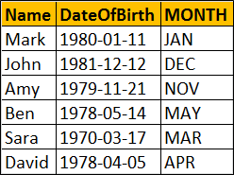  
  
**Using CASE statement in SQL Server**

SELECT Name, DateOfBirth,

        CASE DATEPART(MM, DateOfBirth)

            WHEN 1 THEN 'JAN'

            WHEN 2 THEN 'FEB'

            WHEN 3 THEN 'MAR'

            WHEN 4 THEN 'APR'

            WHEN 5 THEN 'MAY'

            WHEN 6 THEN 'JUN'

            WHEN 7 THEN 'JUL'

            WHEN 8 THEN 'AUG'

            WHEN 9 THEN 'SEP'

            WHEN 10 THEN 'OCT'

            WHEN 11 THEN 'NOV'

            WHEN 12 THEN 'DEC'

        END

       AS [MONTH]

FROM Employees

**Using CHOOSE function in SQL Server :** The amount of code we have to write is lot less than using CASE statement.

SELECT Name, DateOfBirth,CHOOSE(DATEPART(MM, DateOfBirth),  'JAN', 'FEB', 'MAR', 'APR', 'MAY', 'JUN', 'JUL', 'AUG', 'SEP', 'OCT', 'NOV', 'DEC') AS [MONTH]

FROM Employees

### **PART 122 : IIF function in SQL Server**

**Suggested Videos**  
[Part 119 - UNPIVOT in SQL Server](http://csharp-video-tutorials.blogspot.com/2015/10/unpivot-in-sql-server.html)  
[Part 120 - Reverse PIVOT table in SQL Server](http://csharp-video-tutorials.blogspot.com/2015/10/reverse-pivot-table-in-sql-server.html)  
[Part 121 - Choose function in SQL Server](http://csharp-video-tutorials.blogspot.com/2015/10/choose-function-in-sql-server.html)  
  
In this video we will discuss **IIF function in SQL Server**.  
  
**IIF function**

* Introduced in SQL Server 2012
* Returns one of two the values, depending on whether the Boolean expression evaluates to true or false
* IIF is a shorthand way for writing a CASE expression

**Syntax :**IIF ( boolean\_expression, true\_value, false\_value )

**Example :** Returns Male as the boolean expression evaluates to TRUE

DECLARE @Gender INT

SET @Gender = 1

SELECT IIF( @Gender = 1, 'Male', 'Femlae') AS Gender

Output :   
iif function in sql server example  
  
**Example :** Using IIF() function with table data. We will use the following **Employees**table for this example.  
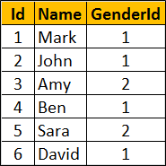  
  
**SQL Script to create Employees table**

Create table Employees

(

     Id int primary key identity,

     Name nvarchar(10),

     GenderId int

)

Go

Insert into Employees values ('Mark', 1)

Insert into Employees values ('John', 1)

Insert into Employees values ('Amy', 2)

Insert into Employees values ('Ben', 1)

Insert into Employees values ('Sara', 2)

Insert into Employees values ('David', 1)

Go

Write a query to display **Gender**along with **employee Name**and **GenderId**. We can achieve this either by using **CASE**or **IIF**.  
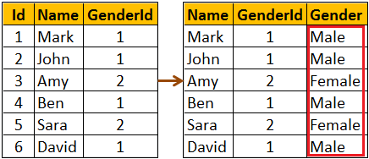  
  
**Using CASE statement**

SELECT Name, GenderId,

        CASE WHEN GenderId = 1

                      THEN 'Male'

                      ELSE 'Female'

                   END AS Gender

FROM Employees

**Using IIF function**

SELECT Name, GenderId, IIF(GenderId = 1, 'Male', 'Female') AS Gender

FROM Employees

### **PART 123 : TRY\_PARSE function in SQL Server 2012**

**Suggested Videos**  
[Part 120 - Reverse PIVOT table in SQL Server](http://csharp-video-tutorials.blogspot.com/2015/10/reverse-pivot-table-in-sql-server.html)  
[Part 121 - Choose function in SQL Server](http://csharp-video-tutorials.blogspot.com/2015/10/choose-function-in-sql-server.html)  
[Part 122 - IIF function in SQL Server](http://csharp-video-tutorials.blogspot.com/2015/10/iif-function-in-sql-server.html)  
  
**In this video we will discuss**

* TRY\_PARSE function
* Difference between PARSE and TRY\_PARSE functions

**TRY\_PARSE function**

* Introduced in SQL Server 2012
* Converts a string to Date/Time or Numeric type
* Returns NULL if the provided string cannot be converted to the specified data type
* Requires .NET Framework Common Language Runtime (CLR)

**Syntax :** TRY\_PARSE ( string\_value AS data\_type )

**Example :** Convert string to INT. As the string can be converted to INT, the result will be 99 as expected.  
  
SELECT TRY\_PARSE('99' AS INT) AS Result  
  
**Output :**  
try_parse function in sql server 2012  
  
**Example :** Convert string to INT. The string cannot be converted to INT, so TRY\_PARSE returns NULL  
  
SELECT TRY\_PARSE('ABC' AS INT) AS Result  
  
**Output :**  
sql server tryparse  
  
Use **CASE**statement or **IIF**function to provide a meaningful error message instead of NULL when the conversion fails.  
  
**Example :**Using CASE statement to provide a meaningful error message when the conversion fails.

SELECT

CASE WHEN TRY\_PARSE('ABC' AS INT) IS NULL

           THEN 'Conversion Failed'

           ELSE 'Conversion Successful'

END AS Result

**Output :** As the conversion fails, you will now get a message 'Conversion Failed' instead of NULL  
sql server try_parse  
  
**Example :**Using IIF function to provide a meaningful error message when the conversion fails.

SELECT IIF(TRY\_PARSE('ABC' AS INT) IS NULL, 'Conversion Failed',

                 'Conversion Successful') AS Result

**What is the difference between PARSE and TRY\_PARSE**  
PARSE will result in an error if the conversion fails, where as TRY\_PARSE will return NULL instead of an error.   
  
Since ABC cannot be converted to INT, PARSE will return an error  
SELECT PARSE('ABC' AS INT) AS Result  
  
Since ABC cannot be converted to INT, TRY\_PARSE will return NULL instead of an error  
SELECT TRY\_PARSE('ABC' AS INT) AS Result  
  
**Example :** Using TRY\_PARSE() function with table data. We will use the following Employees table for this example.  
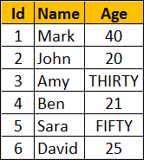  
  
**SQL Script to create Employees table**

Create table Employees

(

     Id int primary key identity,

     Name nvarchar(10),

     Age nvarchar(10)

)

Go

Insert into Employees values ('Mark', '40')

Insert into Employees values ('John', '20')

Insert into Employees values ('Amy', 'THIRTY')

Insert into Employees values ('Ben', '21')

Insert into Employees values ('Sara', 'FIFTY')

Insert into Employees values ('David', '25')

Go

The data type of Age column is nvarchar. So string values like (THIRTY, FIFTY ) are also stored. Now, we want to write a query to convert the values in Age column to int and return along with the Employee name. Notice TRY\_PARSE function returns NULL for the rows where age cannot be converted to INT.

SELECT Name, TRY\_PARSE(Age AS INT) AS Age

FROM Employees

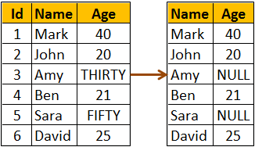  
  
If you use PARSE instead of TRY\_PARSE, the query fails with an error.

SELECT Name, PARSE(Age AS INT) AS Age

FROM Employees

The above query returns the following error  
Error converting string value 'THIRTY' into data type int using culture

### **PART 124 : TRY\_CONVERT function in SQL Server 2012**

**Suggested Videos**  
[Part 121 - Choose function in SQL Server](http://csharp-video-tutorials.blogspot.com/2015/10/choose-function-in-sql-server.html)  
[Part 122 - IIF function in SQL Server](http://csharp-video-tutorials.blogspot.com/2015/10/iif-function-in-sql-server.html)  
[Part 123 - TRY\_PARSE function in SQL Server 2012](http://csharp-video-tutorials.blogspot.com/2015/10/tryparse-function-in-sql-server-2012.html)  
  
**In this video we will discuss**

* TRY\_CONVERT function
* Difference between CONVERT and TRY\_CONVERT functions
* Difference between TRY\_PARSE and TRY\_CONVERT functions

**TRY\_CONVERT function**

* Introduced in SQL Server 2012
* Converts a value to the specified data type
* Returns NULL if the provided value cannot be converted to the specified data type
* If you request a conversion that is explicitly not permitted, then TRY\_CONVERT fails with an error

**Syntax :**TRY\_CONVERT ( data\_type, value, [style] )  
  
**Style parameter is optional**. The range of acceptable values is determined by the target data\_type. For the list of all possible values for style parameter, please visit the following MSDN article  
<https://msdn.microsoft.com/en-us/library/ms187928.aspx>  
  
**Example :** Convert string to INT. As the string can be converted to INT, the result will be 99 as expected.  
  
SELECT TRY\_CONVERT(INT, '99') AS Result  
  
Output :   
try_convert function in sql server 2012  
  
**Example :** Convert string to INT. The string cannot be converted to INT, so TRY\_CONVERT returns NULL  
  
SELECT TRY\_CONVERT(INT, 'ABC') AS Result  
  
Output :   
try convert function in sql  
  
**Example :** Converting an integer to XML is not explicitly permitted. so in this case TRY\_CONVERT fails with an error  
  
SELECT TRY\_CONVERT(XML, 10) AS Result  
  
If you want to provide a meaningful error message instead of NULL when the conversion fails, you can do so using CASE statement or IIF function.  
  
**Example :** Using CASE statement to provide a meaningful error message when the conversion fails.

SELECT

CASE WHEN TRY\_CONVERT(INT, 'ABC') IS NULL

           THEN 'Conversion Failed'

           ELSE 'Conversion Successful'

END AS Result

**Output :** As the conversion fails, you will now get a message 'Conversion Failed' instead of NULL  
sql server try_convert  
  
**Example :**Using IIF function to provide a meaningful error message when the conversion fails.

SELECT IIF(TRY\_CONVERT(INT, 'ABC') IS NULL, 'Conversion Failed',

                 'Conversion Successful') AS Result

**What is the difference between CONVERT and TRY\_CONVERT**  
CONVERT will result in an error if the conversion fails, where as TRY\_CONVERT will return NULL instead of an error.   
  
Since ABC cannot be converted to INT, CONVERT will return an error  
SELECT CONVERT(INT, 'ABC') AS Result  
  
Since ABC cannot be converted to INT, TRY\_CONVERT will return NULL instead of an error  
SELECT TRY\_CONVERT(INT, 'ABC') AS Result  
  
**Example :** Using TRY\_CONVERT() function with table data. We will use the following Employees table for this example.  
  
  
**SQL Script to create Employees table**

Create table Employees

(

     Id int primary key identity,

     Name nvarchar(10),

     Age nvarchar(10)

)

Go

Insert into Employees values ('Mark', '40')

Insert into Employees values ('John', '20')

Insert into Employees values ('Amy', 'THIRTY')

Insert into Employees values ('Ben', '21')

Insert into Employees values ('Sara', 'FIFTY')

Insert into Employees values ('David', '25')

Go

The data type of Age column is nvarchar. So string values like (THIRTY, FIFTY ) are also stored. Now, we want to write a query to convert the values in Age column to int and return along with the Employee name. Notice TRY\_CONVERT function returns NULL for the rows where age cannot be converted to INT.

SELECT Name, TRY\_CONVERT(INT, Age) AS Age

FROM Employees

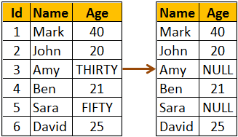  
  
If you use CONVERT instead of TRY\_CONVERT, the query fails with an error.

SELECT NAME, CONVERT(INT, Age) AS Age

FROM Employees

The above query returns the following error  
Conversion failed when converting the nvarchar value 'THIRTY' to data type int.  
  
**Difference between TRY\_PARSE and TRY\_CONVERT functions**  
TRY\_PARSE can only be used for converting from string to date/time or number data types where as TRY\_CONVERT can be used for any general type conversions.  
  
**For example,** you can use TRY\_CONVERT to convert a string to XML data type, where as you can do the same using TRY\_PARSE  
  
Converting a string to XML data type using TRY\_CONVERT  
SELECT TRY\_CONVERT(XML, '<root><child/></root>') AS [XML]  
  
The above query produces the following  
try_parse vs try_convert sql server  
  
Converting a string to XML data type using TRY\_PARSE  
SELECT TRY\_PARSE('<root><child/></root>' AS XML) AS [XML]  
  
The above query will result in the following error  
Invalid data type xml in function TRY\_PARSE  
  
Another difference is TRY\_PARSE relies on the presence of .the .NET Framework Common Language Runtime (CLR) where as TRY\_CONVERT does not.

### **PART 125 : EOMONTH function in SQL Server 2012**

**Suggested Videos**  
[Part 122 - IIF function in SQL Server](http://csharp-video-tutorials.blogspot.com/2015/10/iif-function-in-sql-server.html)  
[Part 123 - TRY\_PARSE function in SQL Server 2012](http://csharp-video-tutorials.blogspot.com/2015/10/tryparse-function-in-sql-server-2012.html)  
[Part 124 - TRY\_CONVERT function in SQL Server 2012](http://csharp-video-tutorials.blogspot.com/2015/10/tryconvert-function-in-sql-server-2012.html)  
  
In this video we will discuss **EOMONTH function in SQL Server 2012**  
  
  
**EOMONTH function**

* Introduced in SQL Server 2012
* Returns the last day of the month of the specified date

**Syntax :** EOMONTH ( start\_date [, month\_to\_add ] )

**start\_date :**The date for which to return the last day of the month  
**month\_to\_add :** Optional. Number of months to add to the start\_date. EOMONTH adds the specified number of months to start\_date, and then returns the last day of the month for the resulting date.  
  
**Example :** Returns last day of the month November

SELECT EOMONTH('11/20/2015') AS LastDay

**Output :**   
sql eomonth example  
  
**Example :** Returns last day of the month of February from a NON-LEAP year

SELECT EOMONTH('2/20/2015') AS LastDay

**Output :**  
eomonth function in sql server 2012  
  
**Example :** Returns last day of the month of February from a LEAP year

SELECT EOMONTH('2/20/2016') AS LastDay

Output :  
sql server eomonth function  
  
**month\_to\_add** optional parameter can be used to add or subtract a specified number of months from the start\_date, and then return the last day of the month from the resulting date.  
  
The following example adds 2 months to the start\_date and returns the last day of the month from the resulting date

SELECT EOMONTH('3/20/2016', 2) AS LastDay

**Output :**  
ms sql server eomonth  
  
The following example subtracts 1 month from the start\_date and returns the last day of the month from the resulting date

SELECT EOMONTH('3/20/2016', -1) AS LastDay

**Output :**   
sql server 2012 eomonth  
  
Using **EOMONTH** function with table data. We will use the following **Employees**table for this example.  
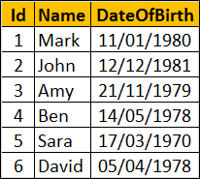  
  
**SQL Script to create Employees table**

Create table Employees

(

    Id int primary key identity,

    Name nvarchar(10),

    DateOfBirth date )

Go

Insert into Employees values ('Mark', '01/11/1980')

Insert into Employees values ('John', '12/12/1981')

Insert into Employees values ('Amy', '11/21/1979')

Insert into Employees values ('Ben', '05/14/1978')

Insert into Employees values ('Sara', '03/17/1970')

Insert into Employees values ('David', '04/05/1978')

Go  
  
The following example returns the last day of the month from the DateOfBirth of every employee.

SELECT Name, DateOfBirth, EOMONTH(DateOfBirth) AS LastDay

FROM Employees  
  
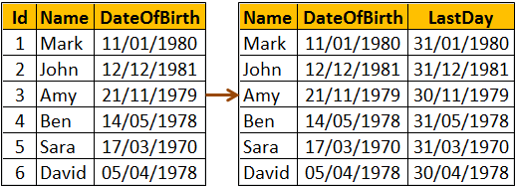  
  
If you want just the last day instead of the full date, you can use **DATEPART** function

SELECT Name, DateOfBirth, DATEPART(DD,EOMONTH(DateOfBirth)) AS LastDay

FROM Employees  
  
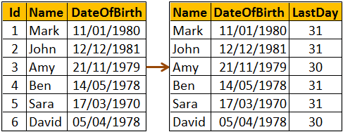

### **PART 126 : DATEFROMPARTS function in SQL Server**

**Suggested Videos**  
[Part 123 - TRY\_PARSE function in SQL Server 2012](http://csharp-video-tutorials.blogspot.com/2015/10/tryparse-function-in-sql-server-2012.html)  
[Part 124 - TRY\_CONVERT function in SQL Server 2012](http://csharp-video-tutorials.blogspot.com/2015/10/tryconvert-function-in-sql-server-2012.html)  
[Part 125 - EOMONTH function in SQL Server 2012](http://csharp-video-tutorials.blogspot.com/2015/10/eomonth-function-in-sql-server-2012.html)  
  
In this video we will discuss **DATEFROMPARTS function in SQL Server**  
  
**DATEFROMPARTS function**

* Introduced in SQL Server 2012
* Returns a date value for the specified year, month, and day
* The data type of all the 3 parameters (year, month, and day) is integer
* If invalid argument values are specified, the function returns an error
* If any of the arguments are NULL, the function returns null

**Syntax :** DATEFROMPARTS ( year, month, day )

**Example :**All the function arguments have valid values, so DATEFROMPARTS returns the expected date

SELECT DATEFROMPARTS ( 2015, 10, 25) AS [Date]

**Output :**  
datefromparts function in sql server  
  
**Example :** Invalid value specified for month parameter, so the function returns an error

SELECT DATEFROMPARTS ( 2015, 15, 25) AS [Date]

**Output :** Cannot construct data type date, some of the arguments have values which are not valid.  
  
**Example :** NULL specified for month parameter, so the function returns NULL.

SELECT DATEFROMPARTS ( 2015, NULL, 25) AS [Date]

**Output :**  
datefromparts in sql server  
  
**Other new date and time functions introduced in SQL Server 2012**

* EOMONTH (Discussed in [Part 125](http://csharp-video-tutorials.blogspot.com/2015/10/eomonth-function-in-sql-server-2012.html) of [SQL Server tutorial](https://www.youtube.com/watch?v=ZNObiptSMSI&list=PL08903FB7ACA1C2FB))
* **DATETIMEFROMPARTS :** Returns DateTime
* **Syntax :**DATETIMEFROMPARTS ( year, month, day, hour, minute, seconds, milliseconds )
* **SMALLDATETIMEFROMPARTS :** Returns SmallDateTime
* **Syntax :**SMALLDATETIMEFROMPARTS ( year, month, day, hour, minute )
* **We will discuss the following functions in a later video**
  + TIMEFROMPARTS
  + DATETIME2FROMPARTS
  + DATETIMEOFFSETFROMPARTS

In our next video we will discuss the **difference between DateTime and SmallDateTime**.

### **PART 127 : Difference between DateTime and SmallDateTime in SQL Server**

**Suggested Videos**  
[Part 124 - TRY\_CONVERT function in SQL Server 2012](http://csharp-video-tutorials.blogspot.com/2015/10/tryconvert-function-in-sql-server-2012.html)  
[Part 125 - EOMONTH function in SQL Server 2012](http://csharp-video-tutorials.blogspot.com/2015/10/eomonth-function-in-sql-server-2012.html)  
[Part 126 - DATEFROMPARTS function in SQL Server](http://csharp-video-tutorials.blogspot.com/2015/10/datefromparts-function-in-sql-server.html)  
  
  
In this video we will discuss the **difference between DateTime and SmallDateTime in SQL Server**  
  
The following **table summarizes the differences**

|  |  |  |
| --- | --- | --- |
| **Attribute** | **SmallDateTime** | **DateTime** |
| Date Range | January 1, 1900, through June 6, 2079 | January 1, 1753, through December 31, 9999 |
| Time Range | 00:00:00 through 23:59:59 | 00:00:00 through 23:59:59.997 |
| Accuracy | 1 Minute | 3.33 Milli-seconds |
| Size | 4 Bytes | 8 Bytes |
| Default value | 1900-01-01 00:00:00 | 1900-01-01 00:00:00 |

The range for SmallDateTime is **January 1, 1900**, through **June 6, 2079**. A value outside of this range, is not allowed.  
  
**The following 2 queries have values outside of the range of SmallDateTime data type.**

Insert into Employees ([SmallDateTime]) values ('01/01/1899')

Insert into Employees ([SmallDateTime]) values ('07/06/2079')

**When executed, the above queries fail with the following error**  
The conversion of a varchar data type to a smalldatetime data type resulted in an out-of-range value  
  
The range for DateTime is **January 1, 1753**, through **December 31, 9999**. A value outside of this range, is not allowed.  
  
The following query has a value outside of the range of DateTime data type.  
Insert into Employees ([DateTime]) values ('01/01/1752')  
  
**When executed, the above query fails with the following error**  
The conversion of a varchar data type to a datetime data type resulted in an out-of-range value.

### **PART 128 : DateTime2FromParts function in SQL Server 2012**

**Suggested Videos**  
[Part 125 - EOMONTH function in SQL Server 2012](http://csharp-video-tutorials.blogspot.com/2015/10/eomonth-function-in-sql-server-2012.html)  
[Part 126 - DATEFROMPARTS function in SQL Server](http://csharp-video-tutorials.blogspot.com/2015/10/datefromparts-function-in-sql-server.html)  
[Part 127 - Difference between DateTime and SmallDateTime in SQL Server](http://csharp-video-tutorials.blogspot.com/2015/10/difference-between-datetime-and.html)  
  
In this video we will discuss **DateTime2FromParts function in SQL Server 2012**.  
  
**DateTime2FromParts function**

* Introduced in SQL Server 2012
* Returns DateTime2
* The data type of all the parameters is integer
* If invalid argument values are specified, the function returns an error
* If any of the required arguments are NULL, the function returns null
* If the precision argument is null, the function returns an error

**Syntax :** DATETIME2FROMPARTS ( year, month, day, hour, minute, seconds, fractions, precision )  
  
**Example :** All the function arguments have valid values, so DATETIME2FROMPARTS returns DATETIME2 value as expected.  
  
SELECT DATETIME2FROMPARTS ( 2015, 11, 15, 20, 55, 55, 0, 0 ) AS [DateTime2]  
  
**Output :**  
datetime2fromparts function in sql server 2012  
  
**Example :** Invalid value specified for month parameter, so the function returns an error  
  
SELECT DATETIME2FROMPARTS ( 2015, 15, 15, 20, 55, 55, 0, 0 ) AS [DateTime2]  
  
**Output :** Cannot construct data type datetime2, some of the arguments have values which are not valid.  
  
**Example :** If any of the required arguments are NULL, the function returns null. NULL specified for month parameter, so the function returns NULL.  
  
SELECT DATETIME2FROMPARTS ( 2015, NULL, 15, 20, 55, 55, 0, 0 ) AS [DateTime2]  
  
Output :   
datetimefromparts sql 2012  
  
**Example :** If the precision argument is null, the function returns an error  
  
SELECT DATETIME2FROMPARTS ( 2015, 15, 15, 20, 55, 55, 0, NULL ) AS [DateTime2]  
  
**Output :** Scale argument is not valid. Valid expressions for data type datetime2 scale argument are integer constants and integer constant expressions.  
  
**TIMEFROMPARTS :** Returns time value  
  
**Syntax :**TIMEFROMPARTS ( hour, minute, seconds, fractions, precision )  
  
**Next video :** We will discuss the **difference between DateTime and DateTime2 in SQL Server**

### **PART 129 : Difference between DateTime and DateTime2 in SQL Server**

**Suggested Videos**  
[Part 126 - DATEFROMPARTS function in SQL Server](http://csharp-video-tutorials.blogspot.com/2015/10/datefromparts-function-in-sql-server.html)  
[Part 127 - Difference between DateTime and SmallDateTime in SQL Server](http://csharp-video-tutorials.blogspot.com/2015/10/difference-between-datetime-and.html)  
[Part 128 - DateTime2FromParts function in SQL Server 2012](http://csharp-video-tutorials.blogspot.com/2015/10/datetime2fromparts-function-in-sql.html)  
  
In this video we will discuss the **difference between DateTime and DateTime2 in SQL Server**  
  
**Differences between DateTime and DateTime2**

|  |  |  |
| --- | --- | --- |
| **Attribute** | **DateTime** | **DateTime2** |
| **Date Range** | January 1, 1753, through December 31, 9999 | January 1, 0001, through December 31, 9999 |
| **Time Range** | 00:00:00 through 23:59:59.997 | 00:00:00 through 23:59:59.9999999 |
| **Accuracy** | 3.33 Milli-seconds | 100 nanoseconds |
| **Size** | 8 Bytes | 6 to 8 Bytes (Depends on the precision) |
| **Default Value** | 1900-01-01 00:00:00 | 1900-01-01 00:00:00 |

DATETIME2 has a bigger date range than DATETIME. Also, DATETIME2 is more accurate than DATETIME. So I would recommend using DATETIME2 over DATETIME when possible. I think the only reason for using DATETIME over DATETIME2 is for backward compatibility.  
  
**DateTime2 Syntax :** DATETIME2 [ (fractional seconds precision) ]  
  
**With DateTime2**

* Optional fractional seconds precision can be specified
* The precision scale is from 0 to 7 digits
* The default precision is 7 digits
* For precision 1 and 2, storage size is 6 bytes
* For precision 3 and 4, storage size is 7 bytes
* For precision 5, 6 and 7, storage size is 8 bytes

The following script creates a table variable with 7 DATETIME2 columns with different precision start from 1 through 7

DECLARE @TempTable TABLE

(

    DateTime2Precision1 DATETIME2(1),

    DateTime2Precision2 DATETIME2(2),

    DateTime2Precision3 DATETIME2(3),

    DateTime2Precision4 DATETIME2(4),

    DateTime2Precision5 DATETIME2(5),

    DateTime2Precision6 DATETIME2(6),

    DateTime2Precision7 DATETIME2(7)

)

Insert DateTime value into each column

INSERT INTO @TempTable VALUES

(

    '2015-10-20 15:09:12.1234567',

    '2015-10-20 15:09:12.1234567',

    '2015-10-20 15:09:12.1234567',

    '2015-10-20 15:09:12.1234567',

    '2015-10-20 15:09:12.1234567',

    '2015-10-20 15:09:12.1234567',

    '2015-10-20 15:09:12.1234567'

)

The following query retrieves the prcision, the datetime value, and the storage size.

SELECT 'Precision - 1' AS [Precision],

         DateTime2Precision1 AS DateValue,

         DATALENGTH(DateTime2Precision1) AS StorageSize

FROM @TempTable

UNION ALL

SELECT 'Precision - 2',

         DateTime2Precision2,

         DATALENGTH(DateTime2Precision2) AS StorageSize

FROM @TempTable

UNION ALL

SELECT 'Precision - 3',

         DateTime2Precision3,

         DATALENGTH(DateTime2Precision3)

FROM @TempTable

UNION ALL

SELECT 'Precision - 4',

         DateTime2Precision4,

         DATALENGTH(DateTime2Precision4)

FROM @TempTable

UNION ALL

SELECT 'Precision - 5',

         DateTime2Precision5,

         DATALENGTH(DateTime2Precision5)

FROM @TempTable

UNION ALL

SELECT 'Precision - 6',

         DateTime2Precision6,

         DATALENGTH(DateTime2Precision6)

FROM @TempTable

UNION ALL

SELECT 'Precision - 7',

         DateTime2Precision7,

         DATALENGTH(DateTime2Precision7) AS StorageSize

FROM @TempTable

Notice as the precision increases the storage size also increases

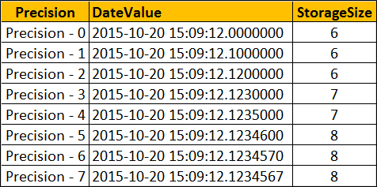

### **PART 130 : Offset fetch next in SQL Server 2012**

**Suggested Videos**  
  
[Part 129 - Difference between DateTime and DateTime2 in SQL Server](http://csharp-video-tutorials.blogspot.com/2015/10/difference-between-datetime-and_21.html)  
  
In this video we will discuss **OFFSET FETCH Clause in SQL Server 2012**  
  
One of the common tasks for a SQL developer is to come up with a stored procedure that can return a page of results from the result set. With SQL Server 2012 OFFSET FETCH Clause it is very easy to implement paging.   
  
Let's understand this with an example. We will use the following **tblProducts**table for the examples in this video. The table has got 100 rows. In the image I have shown just 10 rows.  
  
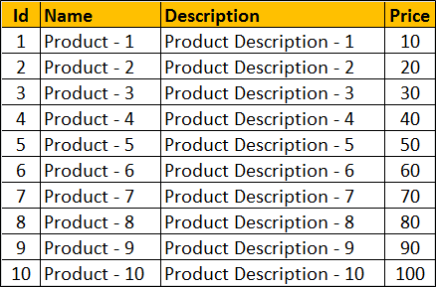  
  
**SQL Script to create tblProducts table**

Create table tblProducts

(

    Id int primary key identity,

    Name nvarchar(25),

    [Description] nvarchar(50),

    Price int

)

Go

**SQL Script to populate tblProducts table with 100 rows**

Declare @Start int

Set @Start = 1

Declare @Name varchar(25)

Declare @Description varchar(50)

While(@Start <= 100)

Begin

    Set @Name = 'Product - ' + LTRIM(@Start)

    Set @Description = 'Product Description - ' + LTRIM(@Start)

    Insert into tblProducts values (@Name, @Description, @Start \* 10)

    Set @Start = @Start + 1

End

**OFFSET FETCH Clause**

* Introduced in SQL Server 2012
* Returns a page of results from the result set
* ORDER BY clause is required

**OFFSET FETCH Syntax :**

SELECT \* FROM Table\_Name

ORDER BY Column\_List

OFFSET Rows\_To\_Skip ROWS

FETCH NEXT Rows\_To\_Fetch ROWS ONLY

**The following SQL query**  
1. Sorts the table data by Id column  
2. Skips the first 10 rows and  
3. Fetches the next 10 rows

SELECT \* FROM tblProducts

ORDER BY Id

OFFSET 10 ROWS

FETCH NEXT 10 ROWS ONLY

**Result :**  
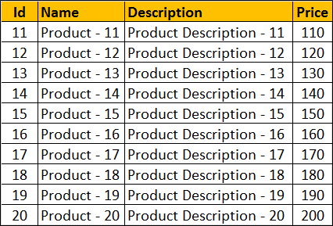  
  
From the front-end application, we would typically send the **PAGE NUMBER** and the **PAGE SIZE**to get a page of rows. The following stored procedure accepts PAGE NUMBER and the PAGE SIZE as parameters and returns the correct set of rows.

CREATE PROCEDURE spGetRowsByPageNumberAndSize

@PageNumber INT,

@PageSize INT

AS

BEGIN

    SELECT \* FROM tblProducts

    ORDER BY Id

    OFFSET (@PageNumber - 1) \* @PageSize ROWS

    FETCH NEXT @PageSize ROWS ONLY

END

With PageNumber = 3 and PageSize = 10, the stored procedure returns the correct set of rows  
  
EXECUTE spGetRowsByPageNumberAndSize 3, 10  
  
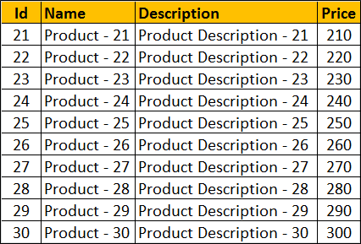

### **PART 131: Identifying object dependencies in SQL Server**

**Suggested Videos**  
[Part 128 - DateTime2FromParts function in SQL Server 2012](http://csharp-video-tutorials.blogspot.com/2015/10/datetime2fromparts-function-in-sql.html)  
[Part 129 - Difference between DateTime and DateTime2 in SQL Server](http://csharp-video-tutorials.blogspot.com/2015/10/difference-between-datetime-and_21.html)  
[Part 130 - Offset fetch next in SQL Server 2012](http://csharp-video-tutorials.blogspot.com/2015/10/offset-fetch-next-in-sql-server-2012.html)  
  
  
In this video we will discuss **how to identify object dependencies in SQL Server using SQL Server Management Studio**.  
  
The following SQL Script creates 2 tables, 2 stored procedures and a view

Create table Departments

(

    Id int primary key identity,

    Name nvarchar(50)

)

Go

Create table Employees

(

    Id int primary key identity,

    Name nvarchar(50),

    Gender nvarchar(10),

    DeptId int foreign key references Departments(Id)

)

Go

Create procedure sp\_GetEmployees

as

Begin

    Select \* from Employees

End

Go

Create procedure sp\_GetEmployeesandDepartments

as

Begin

    Select Employees.Name as EmployeeName,

                   Departments.Name as DepartmentName

    from Employees join Departments on Employees.DeptId = Departments.Id

End

Go

Create view VwDepartments

as

Select \* from Departments

Go

**How to find dependencies using SQL Server Management Studio**  
Use View Dependencies option in SQL Server Management studio to find the object dependencies  
  
**For example :**To find the dependencies on the Employees table, right click on it and select View Dependencies from the context menu  
  
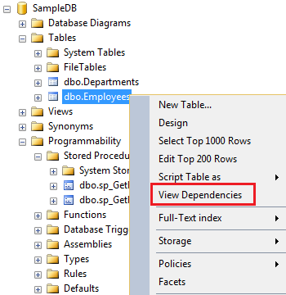  
  
In the **Object Dependencies** window, depending on the radio button you select, you can find the objects that depend on **Employees**table and the objects on which **Employees**table depends on.  
  
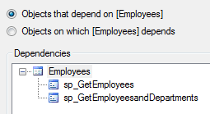  
  
**Identifying object dependencies** is important especially when you intend to modify or delete an object upon which other objects depend. Otherwise you may risk breaking the functionality.  
  
**For example**, there are 2 stored procedures (sp\_GetEmployees and sp\_GetEmployeesandDepartments) that depend on the Employees table. If we are not aware of these dependencies and if we delete the Employees table, both stored procedures will fail with the following error.  
  
Msg 208, Level 16, State 1, Procedure sp\_GetEmployees, Line 4  
Invalid object name 'Employees'.  
  
There are other ways for finding object dependencies in SQL Server which we will discuss in our upcoming videos.

### **PART 132 : sys.dm\_sql\_referencing\_entities in SQL Server**

**Suggested Videos**  
[Part 129 - Difference between DateTime and DateTime2 in SQL Server](http://csharp-video-tutorials.blogspot.com/2015/10/difference-between-datetime-and_21.html)  
[Part 130 - Offset fetch next in SQL Server 2012](http://csharp-video-tutorials.blogspot.com/2015/10/offset-fetch-next-in-sql-server-2012.html)  
[Part 131 - Identifying object dependencies in SQL Server](http://csharp-video-tutorials.blogspot.com/2015/10/identifying-object-dependencies-in-sql.html)  
  
  
In this video we will discuss

* How to find object dependencies using the following dynamic management functions
  + sys.dm\_sql\_referencing\_entities
  + sys.dm\_sql\_referenced\_entities
* Difference between
  + Referencing entity and Referenced entity
  + Schema-bound dependency and Non-schema-bound dependency

This is continuation to [Part 131](http://csharp-video-tutorials.blogspot.com/2015/10/identifying-object-dependencies-in-sql.html), in which we discussed how to find object dependencies using SQL Server Management Studio. Please watch [Part 131](http://csharp-video-tutorials.blogspot.com/2015/10/identifying-object-dependencies-in-sql.html) from [SQL Server tutorial](https://www.youtube.com/playlist?list=PL08903FB7ACA1C2FB) before proceeding.  
  
The following example returns all the objects that depend on Employees table.  
Select \* from sys.dm\_sql\_referencing\_entities('dbo.Employees','Object')  
  
**Difference between referencing entity and referenced entity**  
A dependency is created between two objects when one object appears by name inside a SQL statement stored in another object. The object which is appearing inside the SQL expression is known as referenced entity and the object which has the SQL expression is known as a referencing entity.  
To get the REFERENCING ENTITIES use SYS.DM\_SQL\_REFERENCING\_ENTITIES dynamic management function  
  
To get the REFERENCED ENTITIES use SYS.DM\_SQL\_REFERENCED\_ENTITIES dynamic management function  
  
Now, let us say we have a stored procedure and we want to find the all objects that this stored procedure depends on. This can be very achieved using another dynamic management function, sys.dm\_sql\_referenced\_entities.   
  
The following query returns all the referenced entities of the stored procedure sp\_GetEmployeesandDepartments

Select \* from

sys.dm\_sql\_referenced\_entities('dbo.sp\_GetEmployeesandDepartments','Object')

**Please note :** For both these dynamic management functions to work we need to specify the schema name as well. Without the schema name you may not get any results.  
  
**Difference between Schema-bound dependency and Non-schema-bound dependency**  
**Schema-bound dependency :**Schema-bound dependency prevents referenced objects from being dropped or modified as long as the referencing object exists  
  
**Example :**A view created with SCHEMABINDING, or a table created with foreign key constraint.  
  
**Non-schema-bound dependency :**A non-schema-bound dependency doesn't prevent the referenced object from being dropped or modified.

### **PART 133: sp\_depends in SQL Server**

**Suggested Videos**  
[Part 130 - Offset fetch next in SQL Server 2012](http://csharp-video-tutorials.blogspot.com/2015/10/offset-fetch-next-in-sql-server-2012.html)  
[Part 131 - Identifying object dependencies in SQL Server](http://csharp-video-tutorials.blogspot.com/2015/10/identifying-object-dependencies-in-sql.html)  
[Part 132 - sys.dm\_sql\_referencing\_entities in SQL Server](http://csharp-video-tutorials.blogspot.com/2015/10/sysdmsqlreferencingentities-in-sql.html)  
  
In this video we will discuss sp\_depends system stored procedure.  
  
**There are several ways to find object dependencies in SQL Server**

**1.** View Dependencies feature in SQL Server Management Studio - [Part 131](http://csharp-video-tutorials.blogspot.com/2015/10/identifying-object-dependencies-in-sql.html)  
**2.** SQL Server dynamic management functions - [Part 132](http://csharp-video-tutorials.blogspot.com/2015/10/sysdmsqlreferencingentities-in-sql.html)  
     sys.dm\_sql\_referencing\_entities  
     sys.dm\_sql\_referenced\_entities  
**3.** sp\_depends system stored procedure - This video

**sp\_depends**  
A system stored procedure that returns object dependencies  
For example,

* If you specify a table name as the argument, then the views and procedures that depend on the specified table are displayed
* If you specify a view or a procedure name as the argument, then the tables and views on which the specified view or procedure depends are displayed.

**Syntax :**Execute sp\_depends 'ObjectName'

**The following SQL Script creates a table and a stored procedure**

Create table Employees

(

    Id int primary key identity,

    Name nvarchar(50),

    Gender nvarchar(10)

)

Go

Create procedure sp\_GetEmployees

as

Begin

    Select \* from Employees

End

Go

Returns the stored procedure that depends on table Employees

sp\_depends 'Employees'

**Ouptut :**  
sp_depends in sql server  
  
Returns the name of the table and the respective column names on which the stored procedure sp\_GetEmployees depends

sp\_depends 'sp\_GetEmployees'

**Output :**  
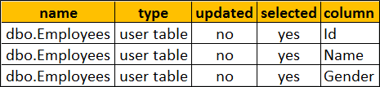  
   
Sometime sp\_depends does not report dependencies correctly. For example, at the moment we have Employees table and a stored procedure sp\_GetEmployees.   
  
**Now drop the table Employees**

Drop table Employees

**and then recreate the table again**

Create table Employees

(

    Id int primary key identity,

    Name nvarchar(50),

    Gender nvarchar(10)

)

Go  
  
Now execute the following, to find the objects that depend on Employees table

sp\_depends 'Employees'

We know that stored procedure **sp\_GetEmployees** still depends on **Employees** table. But sp\_depends does not report this dependency, as the Employees table is dropped and recreated.  
**Object does not reference any object, and no objects reference it.**  
  
sp\_depends is on the deprecation path. This might be removed from the future versions of SQL server.

### **PART 134 : Sequence object in SQL Server 2012**

**Suggested Videos**  
[Part 131 - Identifying object dependencies in SQL Server](http://csharp-video-tutorials.blogspot.com/2015/10/identifying-object-dependencies-in-sql.html)  
[Part 132 - sys.dm\_sql\_referencing\_entities in SQL Server](http://csharp-video-tutorials.blogspot.com/2015/10/sysdmsqlreferencingentities-in-sql.html)  
[Part 133 - sp\_depends in SQL Server](http://csharp-video-tutorials.blogspot.com/2015/10/spdepends-in-sql-server.html)  
  
  
In this video we will discuss **sequence object in SQL Server**.  
  
  
**Sequence object**

* Introduced in SQL Server 2012
* Generates sequence of numeric values in an ascending or descending order

**Syntax :**  
CREATE SEQUENCE [schema\_name . ] sequence\_name  
    [ AS [ built\_in\_integer\_type | user-defined\_integer\_type ] ]  
    [ START WITH <constant> ]  
    [ INCREMENT BY <constant> ]  
    [ { MINVALUE [ <constant> ] } | { NO MINVALUE } ]  
    [ { MAXVALUE [ <constant> ] } | { NO MAXVALUE } ]  
    [ CYCLE | { NO CYCLE } ]  
    [ { CACHE [ <constant> ] } | { NO CACHE } ]  
    [ ; ]

|  |  |
| --- | --- |
| **Property** | **Description** |
| DataType | Built-in integer type (tinyint , smallint, int, bigint, decimal etc...) or user-defined integer type. Default bigint. |
| START WITH | The first value returned by the sequence object |
| INCREMENT BY | The value to increment or decrement by. The value will be decremented if a negative value is specified. |
| MINVALUE | Minimum value for the sequence object |
| MAXVALUE | Maximum value for the sequence object |
| CYCLE | Specifies whether the sequence object should restart when the max value (for incrementing sequence object) or min value (for decrementing sequence object) is reached. Default is NO CYCLE, which throws an error when minimum or maximum value is exceeded. |
| CACHE | Cache sequence values for performance. Default value is CACHE. |

**Creating an Incrementing Sequence :** The following code create a Sequence object that starts with 1 and increments by 1  
  
CREATE SEQUENCE [dbo].[SequenceObject]   
AS INT  
START WITH 1  
INCREMENT BY 1  
  
**Generating the Next Sequence Value :** Now we have a sequence object created. To generate the sequence value use NEXT VALUE FOR clause  
  
SELECT NEXT VALUE FOR [dbo].[SequenceObject]  
  
**Output :** 1  
  
Every time you execute the above query the sequence value will be incremented by 1. I executed the above query 5 times, so the current sequence value is 5.  
  
**Retrieving the current sequence value :** If you want to see what the current Sequence value before generating the next, use **sys.sequences**

SELECT \* FROM sys.sequences WHERE name = 'SequenceObject'

**Alter the Sequence object to reset the sequence value :**  
ALTER SEQUENCE [SequenceObject] RESTART WITH 1  
  
**Select the next sequence value to make sure the value starts from 1**

SELECT NEXT VALUE FOR [dbo].[SequenceObject]

**Using sequence value in an INSERT query :**

CREATE TABLE Employees

(

    Id INT PRIMARY KEY,

    Name NVARCHAR(50),

    Gender NVARCHAR(10)

)

-- Generate and insert Sequence values

INSERT INTO Employees VALUES

(NEXT VALUE for [dbo].[SequenceObject], 'Ben', 'Male')

INSERT INTO Employees VALUES

(NEXT VALUE for [dbo].[SequenceObject], 'Sara', 'Female')

-- Select the data from the table

SELECT \* FROM Employees

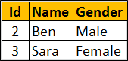  
  
**Creating the decrementing Sequence :** The following code create a Sequence object that starts with 100 and decrements by 1  
  
CREATE SEQUENCE [dbo].[SequenceObject]   
AS INT  
START WITH 100  
INCREMENT BY -1  
  
**Specifying MIN and MAX values for the sequence :** Use the MINVALUE and MAXVALUE arguments to specify the MIN and MAX values respectively.  
  
**Step 1 :** Create the Sequence object  
CREATE SEQUENCE [dbo].[SequenceObject]  
 START WITH 100  
 INCREMENT BY 10  
 MINVALUE 100  
 MAXVALUE 150  
  
**Step 2 :**Retrieve the next sequence value. The sequence value starts at 100. Every time we call NEXT VALUE, the value will be incremented by 10.   
  
SELECT NEXT VALUE FOR [dbo].[SequenceObject]  
  
If you call NEXT VALUE, when the value reaches 150 (MAXVALUE), you will get the following error  
The sequence object 'SequenceObject' has reached its minimum or maximum value. Restart the sequence object to allow new values to be generated.  
  
**Recycling Sequence values :** When the sequence object has reached it's maximum value, and if you want to restart from the minimum value, set CYCLE option  
  
ALTER SEQUENCE [dbo].[SequenceObject]  
 INCREMENT BY 10  
 MINVALUE 100  
 MAXVALUE 150  
 CYCLE  
  
At this point, whe the sequence object has reached it's maximum value, and if you ask for the NEXT VALUE, sequence object starts from the minimum value again which in this case is 100.  
  
**To improve performance**, the Sequence object values can be cached using the CACHE option. When the values are cached they are read from the memory instead of from the disk, which improves the performance. When the cache option is specified you can also specify the size of th cache , that is the number of values to cache.  
  
The following example, creates the sequence object with 10 values cached. When the 11th value is requested, the next 10 values will be cached again.  
  
CREATE SEQUENCE [dbo].[SequenceObject]  
 START WITH 1  
 INCREMENT BY 1  
 CACHE 10  
  
**Using SQL Server Graphical User Interface (GUI) to create the sequence object :**  
1. Expand the database folder  
2. Expand Programmability folder  
3. Right click on Sequences folder  
4. Select New Sequence  
  
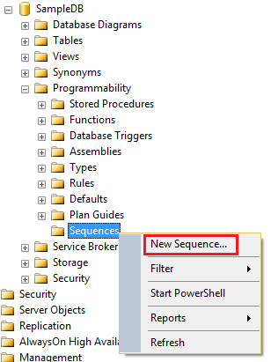  
  
**Next video :** Difference between SEQUENCE and IDENTITY in SQL Server

### **PART 135 : Difference between sequence and identity in SQL Server**

**Suggested Videos**  
[Part 132 - sys.dm\_sql\_referencing\_entities in SQL Server](http://csharp-video-tutorials.blogspot.com/2015/10/sysdmsqlreferencingentities-in-sql.html)  
[Part 133 - sp\_depends in SQL Server](http://csharp-video-tutorials.blogspot.com/2015/10/spdepends-in-sql-server.html)  
[Part 134 - Sequence object in SQL Server 2012](http://csharp-video-tutorials.blogspot.com/2015/10/sequence-object-in-sql-server-2012.html)  
  
In this video we will discuss the **difference between SEQUENCE and IDENTITY in SQL Server**  
  
  
This is continuation to [Part 134](http://csharp-video-tutorials.blogspot.com/2015/10/sequence-object-in-sql-server-2012.html). Please watch [Part 134](http://csharp-video-tutorials.blogspot.com/2015/10/sequence-object-in-sql-server-2012.html) from [SQL Server tutorial](https://www.youtube.com/playlist?list=PL08903FB7ACA1C2FB) before proceeding.  
  
**Sequence object** is similar to the Identity property, in the sense that it generates sequence of numeric values in an ascending order just like the identity property. However there are several differences between the 2 which we will discuss in this video.  
  
Identity property is a table column property meaning it is tied to the table, where as the sequence is a user-defined database object and is not tied to any specific table meaning it's value can be shared by multiple tables.  
  
**Example :** Identity property tied to the Id column of the Employees table.

CREATE TABLE Employees

(

    Id INT PRIMARY KEY IDENTITY(1,1),

    Name NVARCHAR(50),

    Gender NVARCHAR(10)

)

**Example :** Sequence object not tied to any specific table

CREATE SEQUENCE [dbo].[SequenceObject]

AS INT

START WITH 1

INCREMENT BY 1

This means the above sequence object can be used with any table.  
  
**Example :** Sharing sequence object value with multiple tables.  
  
**Step 1 :** Create Customers and Users tables

CREATE TABLE Customers

(

    Id INT PRIMARY KEY,

    Name NVARCHAR(50),

    Gender NVARCHAR(10)

)

GO

CREATE TABLE Users

(

    Id INT PRIMARY KEY,

    Name NVARCHAR(50),

    Gender NVARCHAR(10)

)

GO

**Step 2 :** Insert 2 rows into Customers table and 3 rows into Users table. Notice the same sequence object is generating the ID values for both the tables.

INSERT INTO Customers VALUES

   (NEXT VALUE for [dbo].[SequenceObject], 'Ben', 'Male')

INSERT INTO Customers VALUES

   (NEXT VALUE for [dbo].[SequenceObject], 'Sara', 'Female')

INSERT INTO Users VALUES

   (NEXT VALUE for [dbo].[SequenceObject], 'Tom', 'Male')

INSERT INTO Users VALUES

   (NEXT VALUE for [dbo].[SequenceObject], 'Pam', 'Female')

INSERT INTO Users VALUES

   (NEXT VALUE for [dbo].[SequenceObject], 'David', 'Male')

GO

**Step 3 :** Query the tables

SELECT \* FROM Customers

SELECT \* FROM Users

GO

**Output :** Notice the same sequence object has generated the values for ID columns in both the tables  
  
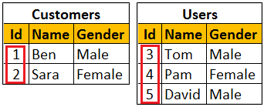  
  
To generate the next identity value, a row has to be inserted into the table, where as with sequence object there is no need to insert a row into the table to generate the next sequence value. You can use NEXT VALUE FOR clause to generate the next sequence value.  
  
**Example :** Generating Identity value by inserting a row into the table  
  
INSERT INTO Employees VALUES ('Todd', 'Male')  
  
**Example :** Generating the next sequence value using NEXT VALUE FOR clause.  
  
SELECT NEXT VALUE FOR [dbo].[SequenceObject]  
  
Maximum value for the identity property cannot be specified. The maximum value will be the maximum value of the correspoding column data type. With the sequence object you can use the MAXVALUE option to specify the maximum value. If the MAXVALUE option is not specified for the sequence object, then the maximum value will be the maximum value of it's data type.  
  
**Example :** Specifying maximum value for the sequence object using the MAXVALUE option

CREATE SEQUENCE [dbo].[SequenceObject]

START WITH 1

INCREMENT BY 1

MAXVALUE 5

CYCLE option of the Sequence object can be used to specify whether the sequence should restart automatically when the max value (for incrementing sequence object) or min value (for decrementing sequence object) is reached, where as with the Identity property we don't have any such option to automatically restart the identity values.  
  
**Example :** Specifying the CYCLE option of the Sequence object, so the sequence will restart automatically when the max value is exceeded

CREATE SEQUENCE [dbo].[SequenceObject]

START WITH 1

INCREMENT BY 1

MINVALUE 1

MAXVALUE 5

CYCLE

### **PART 136: Guid in SQL Server**

**Suggested Videos**  
[Part 133 - sp\_depends in SQL Server](http://csharp-video-tutorials.blogspot.com/2015/10/spdepends-in-sql-server.html)  
[Part 134 - Sequence object in SQL Server 2012](http://csharp-video-tutorials.blogspot.com/2015/10/sequence-object-in-sql-server-2012.html)  
[Part 135 - Difference between sequence and identity in SQL Server](http://csharp-video-tutorials.blogspot.com/2015/10/difference-between-sequence-and.html)  
  
In this video we will discuss  
1. What is a GUID in SQL Server  
2. When to use GUID  
3. Advantages and disadvantages of using a GUID  
  
**What is in SQL Server**  
The GUID data type is a 16 byte binary data type that is globally unique. GUID stands for Global Unique Identifier. The terms GUID and UNIQUEIDENTIFIER are used interchangeably.  
  
To declare a GUID variable, we use the keyword UNIQUEIDENTIFIER

Declare @ID UNIQUEIDENTIFIER

SELECT @ID = NEWID()

SELECT @ID as MYGUID

**How to create a GUID in sql server**  
To create a GUID in SQL Server use NEWID() function  
  
For example, SELECT NEWID(), creates a GUID that is guaranteed to be unique across tables, databases, and servers. Every time you execute SELECT NEWID() query, you get a GUID that is unique.  
  
**Example GUID :** 0BB83607-00D7-4B2C-8695-32AD3812B6F4  
  
When to use GUID data type : Let us understand when to use a GUID in SQL Server with an example.   
  
1. Let us say our company does business in 2 countries - USA and India.   
  
2. USA customers are stored in a table called USACustomers in a database called USADB.

Create Database USADB

Go

Use USADB

Go

Create Table USACustomers

(

     ID int primary key identity,

     Name nvarchar(50)

)

Go

Insert Into USACustomers Values ('Tom')

Insert Into USACustomers Values ('Mike')

Select \* From USADB.dbo.USACustomers

The above query produces the following data  
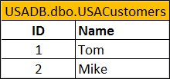  
  
3. India customers are stored in a table called IndiaCustomers in a database called IndiaDB.

Create Database USADB

Go

Use USADB

Go

Create Table USACustomers

(

     ID int primary key identity,

     Name nvarchar(50)

)

Go

Insert Into USACustomers Values ('Tom')

Insert Into USACustomers Values ('Mike')

Select \* From USADB.dbo.USACustomers

The above query produces the following data  
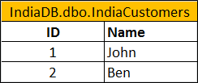  
  
In both the tables, the ID column data type is integer. It is also the primary key column which ensures the ID column across every row is unique in that table. We also have turned on the identity property,  
  
4. Now, we want to load the customers from both countries (India & USA) in to a single existing table **Customers**.  
  
First let's create the table. Use the following SQL script to create the table. ID column is the primary key of the table.

Create Table Customers

(

     ID int primary key,

     Name nvarchar(50)

)

Go

Now execute the following script which selects the data from IndiaCustomers and USACustomers tables and inserts into Customers table

Insert Into Customers

Select \* from IndiaDB.dbo.IndiaCustomers

Union All

Select \* from USADB.dbo.USACustomers

We get the following error. This is because in both the tables, Identity column data type is integer. Integer is great for identity as long as you only want to maintain the uniqueness across just that one table. However, between IndiaCustomers and USACustomers tables, the ID coulumn values are not unique. So when we load the data into Customers table, we get "Violation of PRIMARY KEY constraint" error.  
  
Msg 2627, Level 14, State 1, Line 1  
Violation of PRIMARY KEY constraint. Cannot insert duplicate key in object 'dbo.Customers'. The duplicate key value is (1).  
The statement has been terminated.  
  
A GUID on the other hand is unique across tables, databases, and servers. A GUID is guaranteed to be globally unique. Let us see if we can solve the above problem using a GUID.  
  
Create **USACustomers1**table and populate it with data. Notice ID column datatype is uniqueidentifier. To auto-generate the GUID values we are using a Default constraint.

Use USADB

Go

Create Table USACustomers1

(

     ID uniqueidentifier primary key default NEWID(),

     Name nvarchar(50)

)

Go

Insert Into USACustomers1 Values (Default, 'Tom')

Insert Into USACustomers1 Values (Default, 'Mike')

Next, create **IndiaCustomers1**table and populate it with data.

Use IndiaDB

Go

Create Table IndiaCustomers1

(

     ID uniqueidentifier primary key default NEWID(),

     Name nvarchar(50)

)

Go

Insert Into IndiaCustomers1 Values (Default, 'John')

Insert Into IndiaCustomers1 Values (Default, 'Ben')

Select data from both the tables (USACustomers1 & IndiaCustomers1). Notice the ID column values. They are unique across both the tables.

Select \* From IndiaDB.dbo.IndiaCustomers1

UNION ALL

Select \* From USADB.dbo.USACustomers1

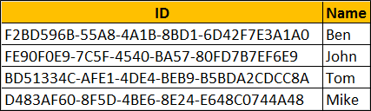  
  
Now, we want to load the customers from **USACustomers1**and **IndiaCustomers1**tables in to a single existing table called Customers1. Let us first create Customers1 table. The ID column in Customers1 table is uniqueidentifier.

Create Table Customers1

(

     ID uniqueidentifier primary key,

     Name nvarchar(50)

)

Go

Finally, execute the following insert script. Notice the script executes successfully without any errors and the data is loaded into Customers1 table.

Insert Into Customers1

Select \* from IndiaDB.dbo.IndiaCustomers1

Union All

Select \* from USADB.dbo.USACustomers1

The main advantage of using a GUID is that it is unique across tables, databases and servers. It is extremely useful if you're consolidating records from multiple SQL Servers into a single table.   
  
The main disadvantage of using a GUID as a key is that it is 16 bytes in size. It is one of the largest datatypes in SQL Server. An integer on the other hand is 4 bytes,  
  
An Index built on a GUID is larger and slower than an index built on integer column. In addition a GUID is hard to read compared to int.  
  
**So in summary**, use a GUID when you really need a globally unique identifier. In all other cases it is better to use an INT data type.

### **PART 137 : How to check GUID is null or empty in SQL Server**

**Suggested Videos**  
[Part 134 - Sequence object in SQL Server 2012](http://csharp-video-tutorials.blogspot.com/2015/10/sequence-object-in-sql-server-2012.html)  
[Part 135 - Difference between sequence and identity in SQL Server](http://csharp-video-tutorials.blogspot.com/2015/10/difference-between-sequence-and.html)  
[Part 136 - Guid in SQL Server](http://csharp-video-tutorials.blogspot.com/2017/03/guid-in-sql-server.html)  
  
In this video we will discuss **how to check if a GUID is null or empty**  
  
**How to check if a GUID is NULL :** Checking if a GUID is null is straight forward in SQL Server. Just use IS NULL keywords as shown below.  
  
Declare @MyGuid Uniqueidentifier

If(@MyGuid IS NULL)

Begin

     Print 'Guid is null'

End

Else

Begin

     Print 'Guid is not null'

End

In the above example, since @MyGuid is just declared and not initialised, it prints the message "Guid is null"  
  
Now let's say, if a GUID variable is NULL, then we want to initialise that GUID variable with a new GUID value. If it's not NULL, then we want to retain it's value. One way to do this is by using an IF condition as shown below.

Declare @MyGuid UniqueIdentifier

If(@MyGuid IS NULL)

Begin

     Set @MyGuid = NEWID()

End

Select @MyGuid

We can achieve exactly the same thing by using ISNULL() function. The advantage of using ISNULL() function is that, it reduces the amount of code we have to write.

Declare @MyGuid UniqueIdentifier

Select ISNULL(@MyGuid, NewID())

How to check if a GUID is EMPTY : Before understanding how to check if a GUID is empty, let's understand what is an empty GUID. An empty GUID is a GUID with all ZEROS as shown below.  
00000000-0000-0000-0000-000000000000  
  
How to create this empty GUID. Do we have to type all the ZERO's and Hyphens. The answe is NO. We do not have to type them manually. Instead use one of the following SELECT query's to create an empty GUID. I prefer to use the second SELECT statement as it has only one CAST

SELECT CAST(CAST(0 AS BINARY) AS UNIQUEIDENTIFIER)

OR

SELECT CAST(0x0 AS UNIQUEIDENTIFIER)

To check if a GUID is an empty GUID, you have 2 options  
**Option 1:** You can compare it to an Empty GUID value as shown below

Declare @MyGuid UniqueIdentifier

Set @MyGuid = '00000000-0000-0000-0000-000000000000'

If(@MyGuid = '00000000-0000-0000-0000-000000000000')

Begin

     Print 'Guid is Empty'

End

Else

Begin

     Print 'Guid is not Empty'

End

**Option 2:**You can also compare it to a return value of the CAST method

Declare @MyGuid UniqueIdentifier

Set @MyGuid = '00000000-0000-0000-0000-000000000000'

If(@MyGuid = Cast(0x0 as Uniqueidentifier))

Begin

     Print 'Guid is Empty'

End

Else

Begin

     Print 'Guid is not Empty'

End

### **PART 138 : Dynamic SQL in SQL Server**

**Suggested Videos**  
[Part 135 - Difference between sequence and identity in SQL Server](http://csharp-video-tutorials.blogspot.com/2015/10/difference-between-sequence-and.html)  
[Part 136 - Guid in SQL Server](http://csharp-video-tutorials.blogspot.com/2017/03/guid-in-sql-server.html)  
[Part 137 - How to check guid is null or empty in SQL Server](http://csharp-video-tutorials.blogspot.com/2017/03/how-to-check-guid-is-null-or-empty-in.html)  
  
**In this video we will discuss**  
1. What is Dynamic SQL  
2. Simple example of using Dynamic SQL  
  
**What is Dynamic SQL**  
Dynamic SQL is a SQL built from strings at runtime.  
  
**Simple example of using Dynamic SQL :** Let's say we want to implement **"Employee Search"** web page as shown below.   
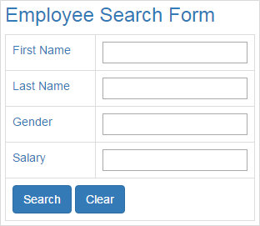  
  
  
  
Depending on the serach fields the end user provides, we want to search the following Employees table.  
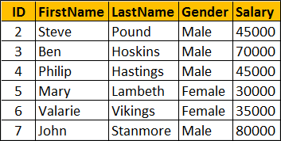  
  
Here is the SQL Script to create Employees table and populate it with data

Create table Employees

(

     ID int primary key identity,

     FirstName nvarchar(50),

     LastName nvarchar(50),

     Gender nvarchar(50),

     Salary int

)

Go

Insert into Employees values ('Mark', 'Hastings', 'Male', 60000)

Insert into Employees values ('Steve', 'Pound', 'Male', 45000)

Insert into Employees values ('Ben', 'Hoskins', 'Male', 70000)

Insert into Employees values ('Philip', 'Hastings', 'Male', 45000)

Insert into Employees values ('Mary', 'Lambeth', 'Female', 30000)

Insert into Employees values ('Valarie', 'Vikings', 'Female', 35000)

Insert into Employees values ('John', 'Stanmore', 'Male', 80000)

Go

One way to achieve this is by implementing a stored procedure as shown below that this page would call.

Create Procedure spSearchEmployees

@FirstName nvarchar(100),

@LastName nvarchar(100),

@Gender nvarchar(50),

@Salary int

As

Begin

     Select \* from Employees where

     (FirstName = @FirstName OR @FirstName IS NULL) AND

     (LastName  = @LastName  OR @LastName  IS NULL) AND

     (Gender      = @Gender    OR @Gender    IS NULL) AND

     (Salary      = @Salary    OR @Salary    IS NULL)

End

Go

The stored procedure in this case is not very complicated as we have only 4 search filters. What if there are 20 or more such filters. This stored procedure can get complex. To make things worse what if we want to specify conditions like AND, OR etc between these search filters. The stored procedure can get extremely large, complicated and difficult to maintain. One way to reduce the complexity is by using dynamic SQL as show below. Depending on for which search filters the user has provided the values on the "Search Page", we build the WHERE clause dynamically at runtime, which can reduce complexity.  
  
However, you might hear arguments that dynamic sql is bad both in-terms of security and performance. This is true if the dynamic sql is not properly implemented. From a security standpoint, it may open doors for SQL injection attack and from a performance standpoint, the cached query plans may not be reused. If properly implemented, we will not have these problems with dynamic sql. In our upcoming videos, we will discuss good and bad dynamic sql implementations.  
  
For now let's implement a simple example that makes use of dynamic sql. In the example below we are assuming the user has supplied values only for FirstName and LastName search fields. To execute the dynamicl sql we are using system stored procedure sp\_executesql.   
  
**sp\_executesql takes two pre-defined parameters and any number of user-defined parameters.**  
  
@statement - The is the first parameter which is mandatory, and contains the SQL statements to execute  
  
@params - This is the second parameter and is optional. This is used to declare parameters specified in @statement  
  
The rest of the parameters are the parameters that you declared in @params, and you pass them as you pass parameters to a stored procedure

Declare @sql nvarchar(1000)

Declare @params nvarchar(1000)

Set @sql = 'Select \* from Employees where FirstName=@FirstName and LastName=@LastName'

Set @params = '@FirstName nvarchar(100), @LastName nvarchar(100)'

Execute sp\_executesql @sql, @params, @FirstName='Ben',@LastName='Hoskins'

This is just the introduction to dynamic SQL. If a few things are unclear at the moment, don't worry. In our upcoming videos we will discuss the following

1. Implementing a real world "Search Web Page" with and without dynamic SQL
2. Performance and Security implications of dynamic sql. Along the way we will also discuss good and bad dynamic sql implementations.
3. Different options available for executing dynamic sql and their implications
4. Using dynamic sql in stored procedures and it's implications

**Once we discuss all the above, you will understand**  
1. The flexibility dynamic sql provides  
2. Advantages and disadvantages of dynamic sql  
3. When and when not to use dynamic sql

### PART 141 : Prevent sql injection with dynamic sql

**Suggested Videos**  
[Part 138 - Dynamic SQL in SQL Server](http://csharp-video-tutorials.blogspot.com/2017/03/dynamic-sql-in-sql-server.html)  
[Part 139 - Implement search web page using ASP.NET and Stored Procedure](http://csharp-video-tutorials.blogspot.com/2017/03/implement-search-web-page-using-aspnet.html)  
[Part 140 - Implement search web page using ASP.NET and Dynamic SQL](http://csharp-video-tutorials.blogspot.com/2017/04/implement-search-web-page-using-aspnet.html)  
  
In this video we will discuss, how to prevent SQL injection when using dynamic SQL. This is continuation to [Part 140](http://csharp-video-tutorials.blogspot.com/2017/04/implement-search-web-page-using-aspnet.html). Please watch [Part 140](http://csharp-video-tutorials.blogspot.com/2017/04/implement-search-web-page-using-aspnet.html) from [SQL Server Tutorial](https://www.youtube.com/playlist?list=PL08903FB7ACA1C2FB) before proceeding.  
  
In [Part 140](http://csharp-video-tutorials.blogspot.com/2017/04/implement-search-web-page-using-aspnet.html), we have implemented "Search Page" using dynamic SQL. Since we have used parameters to build our dynamic SQL statements, it is not prone to SQL Injection attack. This is an example of good dynamic SQL implementation.  
  
I have seen lot of software developers, not just the beginners but even experienced developers, buidling their dynamic sql queries by concatenating strings instead of using parameters without realizing that they are opening the doors for SQL Injection.  
  
  
Here is an example of bad dynamic SQL that is prone to SQL Injection

using System;

using System.Configuration;

using System.Data;

using System.Data.SqlClient;

using System.Text;

namespace DynamicSQLDemo

{

    public partial class SearchPageWithDynamicSQL : System.Web.UI.Page

    {

        protected void Page\_Load(object sender, EventArgs e)

        { }

        protected void btnSearch\_Click(object sender, EventArgs e)

        {

            string strConnection = ConfigurationManager

                .ConnectionStrings["connectionStr"].ConnectionString;

            using (SqlConnection con = new SqlConnection(strConnection))

            {

                SqlCommand cmd = new SqlCommand();

                cmd.Connection = con;

                StringBuilder sbCommand = new

                    StringBuilder("Select \* from Employees where 1 = 1");

                if (inputFirstname.Value.Trim() != "")

                {

                    sbCommand.Append(" AND FirstName = '" +

                        inputFirstname.Value + "'");

                }

                if (inputLastname.Value.Trim() != "")

                {

                    sbCommand.Append(" AND LastName = '" +

                        inputLastname.Value + "'");

                }

                if (inputGender.Value.Trim() != "")

                {

                    sbCommand.Append(" AND Gender = '" +

                        inputGender.Value + "'");

                }

                if (inputSalary.Value.Trim() != "")

                {

                    sbCommand.Append(" AND Salary = " + inputSalary.Value);

                }

                cmd.CommandText = sbCommand.ToString();

                cmd.CommandType = CommandType.Text;

                con.Open();

                SqlDataReader rdr = cmd.ExecuteReader();

                gvSearchResults.DataSource = rdr;

                gvSearchResults.DataBind();

            }

        }

    }

}

Since we are  concatenating the user input values to build the dynamic sql statement, the end user can very easily inject sql. Imagine, what happens for example, if the user enters the following in the "Firstname" textbox.  
  
' Drop database SalesDB --  
  
With the above SQL injected into the "Firstname" textbox, if you click the "Search" button, the following is the query which is sent to SQL server. This will drop SalesDB database.

Select \* from Employees where 1 = 1 AND FirstName = '' Drop database SalesDB --'

On the other hand, if you use parameters to build your dynamic SQL statements, SQL Injection is not an issue. The following input in the "Firstname" textbox, would not drop the SalesDB database.  
  
' Drop database SalesDB --  
  
The text the user has provided in the "Firstname" textbox is treated as the value for @Firstname parameter. The following is the query that is generated and executed.

exec sp\_executesql N'Select \* from Employees where 1 = 1 AND FirstName=@FirstName',N'@FirstName nvarchar(26)',@FirstName=N''' Drop database SalesDB --'

We don't have this problem of sql injection if we are using stored procedures. "SearchPageWithoutDynamicSQL.aspx" is using the stored procedure "spSearchEmployees" instead of dynamic SQL. The same input in the "Firstname" texbox on this page, would generate the following. Notice, whatever text we typed in the "Firstname" textbox is treated as the value for @FirstName parameter.

exec spSearchEmployees @FirstName=N''' Drop database SalesDB --'

An important point to keep in mind here is that if you have dynamic SQL in your stored procedure, and you are concatenating strings in that stored procedure to build your dynamic sql statements instead of using parameters, it is still prone to SQL injection. If this is not clear at the moment don't worry, we will discuss an example of this in out next video.  
  
So in summary, while dynamic sql provides great flexibility when implementing complicated logic with lot of permutations and combinations, if not properly implemented it may open doors for sql injection. Always use parameters to build dynamic sql statements, instead of concatenating user input values.  
  
Another benefit of using parameters to build dynamic sql statements is that it allows cached query plans to be reused, which greatly increases the performance. We will discuss an example of this in our upcoming videos.

### **PART 142 : Dynamic SQL in Stored Procedure**

**Suggested Videos**  
[Part 139 - Implement search web page using ASP.NET and Stored Procedure](http://csharp-video-tutorials.blogspot.com/2017/03/implement-search-web-page-using-aspnet.html)  
[Part 140 - Implement search web page using ASP.NET and Dynamic SQL](http://csharp-video-tutorials.blogspot.com/2017/04/implement-search-web-page-using-aspnet.html)  
[Part 141 - Prevent sql injection with dynamic sql](http://csharp-video-tutorials.blogspot.com/2017/04/prevent-sql-injection-with-dynamic-sql.html)  
  
In this video we will discuss, using dynamic sql in a stored procedure and it's implications from sql injection perspective. We will discuss performance implications of using dynamic sql in a stored procedure in a later video.  
  
  
Consider the following stored procedure "spSearchEmployees". We implemented this procedure in [Part 139](http://csharp-video-tutorials.blogspot.com/2017/03/implement-search-web-page-using-aspnet.html) of [SQL Server tutorial](https://www.youtube.com/playlist?list=PL08903FB7ACA1C2FB). This stored procedure does not have any dynamic sql in it. It is all static sql and is immune to sql injection.

Create Procedure spSearchEmployees

@FirstName nvarchar(100) = NULL,

@LastName nvarchar(100) = NULL,

@Gender nvarchar(50) = NULL,

@Salary int = NULL

As

Begin

     Select \* from Employees where

     (FirstName = @FirstName OR @FirstName IS NULL) AND

     (LastName  = @LastName  OR @LastName  IS NULL) AND

     (Gender      = @Gender    OR @Gender    IS NULL) AND

     (Salary      = @Salary    OR @Salary    IS NULL)

End

Go

Whether you are creating your dynamic sql queries in a client application like ASP.NET web application or in a stored procedure, you should never ever concatenate user input values. Instead you should be using parameters.  
  
Notice in the following example, we are creating dynamic sql queries by concatenating parameter values, instead of using parameterized queries. This stored procedure is prone to SQL injection. Let's prove this by creating a "Search Page" that calls this procedure.

Create Procedure spSearchEmployeesBadDynamicSQL

@FirstName nvarchar(100) = NULL,

@LastName nvarchar(100) = NULL,

@Gender nvarchar(50) = NULL,

@Salary int = NULL

As

Begin

     Declare @sql nvarchar(max)

     Set @sql = 'Select \* from Employees where 1 = 1'

     if(@FirstName is not null)

          Set @sql = @sql + ' and FirstName=''' + @FirstName + ''''

     if(@LastName is not null)

          Set @sql = @sql + ' and LastName=''' + @LastName + ''''

     if(@Gender is not null)

          Set @sql = @sql + ' and Gender=''' + @Gender + ''''

     if(@Salary is not null)

          Set @sql = @sql + ' and Salary=''' + @Salary + ''''

     Execute sp\_executesql @sql

End

Go

Add a Web Page to the project that we have been working with in our previous video. Name it "DynamicSQLInStoredProcedure.aspx". Copy and paste the following HTML on the page.

<html xmlns="http://www.w3.org/1999/xhtml">

<head runat="server">

    <title>Employee Search</title>

    <link rel="stylesheet"

        href="https://maxcdn.bootstrapcdn.com/bootstrap/3.3.7/css/bootstrap.min.css"

        type="text/css" />

</head>

<body style="padding-top: 10px">

    <div class="col-xs-8 col-xs-offset-2">

        <form id="form1" runat="server" class="form-horizontal">

            <div class="panel panel-primary">

                <div class="panel-heading">

                    <h3>Employee Search Form</h3>

                </div>

                <div class="panel-body">

                    <div class="form-group">

                        <label for="inputFirstname" class="control-label col-xs-2">

                            Firstname

                        </label>

                        <div class="col-xs-10">

                            <input type="text" runat="server" class="form-control"

                                id="inputFirstname" placeholder="Firstname" />

                        </div>

                    </div>

                    <div class="form-group">

                        <label for="inputLastname" class="control-label col-xs-2">

                            Lastname

                        </label>

                        <div class="col-xs-10">

                            <input type="text" runat="server" class="form-control"

                                id="inputLastname" placeholder="Lastname" />

                        </div>

                    </div>

                    <div class="form-group">

                        <label for="inputGender" class="control-label col-xs-2">

                            Gender

                        </label>

                        <div class="col-xs-10">

                            <input type="text" runat="server" class="form-control"

                                id="inputGender" placeholder="Gender" />

                        </div>

                    </div>

                    <div class="form-group">

                        <label for="inputSalary" class="control-label col-xs-2">

                            Salary

                        </label>

                        <div class="col-xs-10">

                            <input type="number" runat="server" class="form-control"

                                id="inputSalary" placeholder="Salary" />

                        </div>

                    </div>

                    <div class="form-group">

                        <div class="col-xs-10 col-xs-offset-2">

                            <asp:Button ID="btnSearch" runat="server" Text="Search"

                                CssClass="btn btn-primary" OnClick="btnSearch\_Click" />

                        </div>

                    </div>

                </div>

            </div>

            <div class="panel panel-primary">

                <div class="panel-heading">

                    <h3>Search Results</h3>

                </div>

                <div class="panel-body">

                    <div class="col-xs-10">

                        <asp:GridView CssClass="table table-bordered"

                            ID="gvSearchResults" runat="server">

                        </asp:GridView>

                    </div>

                </div>

            </div>

        </form>

    </div>

</body>

</html>

Copy and paste the following code in the code-behind page.

using System;

using System.Configuration;

using System.Data;

using System.Data.SqlClient;

namespace DynamicSQLDemo

{

    public partial class DynamicSQLInStoredProcedure : System.Web.UI.Page

    {

        protected void Page\_Load(object sender, EventArgs e)

        {}

        protected void btnSearch\_Click(object sender, EventArgs e)

        {

            string connectionStr = ConfigurationManager

                .ConnectionStrings["connectionStr"].ConnectionString;

            using (SqlConnection con = new SqlConnection(connectionStr))

            {

                SqlCommand cmd = new SqlCommand();

                cmd.Connection = con;

                cmd.CommandText = "spSearchEmployeesGoodDynamicSQL";

                cmd.CommandType = CommandType.StoredProcedure;

                if (inputFirstname.Value.Trim() != "")

                {

                    SqlParameter param = new SqlParameter("@FirstName",

                        inputFirstname.Value);

                    cmd.Parameters.Add(param);

                }

                if (inputLastname.Value.Trim() != "")

                {

                    SqlParameter param = new SqlParameter("@LastName",

                        inputLastname.Value);

                    cmd.Parameters.Add(param);

                }

                if (inputGender.Value.Trim() != "")

                {

                    SqlParameter param = new SqlParameter("@Gender",

                        inputGender.Value);

                    cmd.Parameters.Add(param);

                }

                if (inputSalary.Value.Trim() != "")

                {

                    SqlParameter param = new SqlParameter("@Salary",

                        inputSalary.Value);

                    cmd.Parameters.Add(param);

                }

                con.Open();

                SqlDataReader rdr = cmd.ExecuteReader();

                gvSearchResults.DataSource = rdr;

                gvSearchResults.DataBind();

            }

        }

    }

}

At this point, run the application and type the following text in the "Firsname" text and click "Search" button. Notice "SalesDB" database is dropped. Our application is prone to SQL injection as we have implemented dynamic sql in our stored procedure by concatenating strings instead of using parameters.  
' Drop database SalesDB --  
  
In the following stored procedure we have implemented dynamic sql by using parameters, so this is not prone to sql injecttion. This is an example for good dynamic sql implementation.

Create Procedure spSearchEmployeesGoodDynamicSQL

@FirstName nvarchar(100) = NULL,

@LastName nvarchar(100) = NULL,

@Gender nvarchar(50) = NULL,

@Salary int = NULL

As

Begin

     Declare @sql nvarchar(max)

     Declare @sqlParams nvarchar(max)

     Set @sql = 'Select \* from Employees where 1 = 1'

     if(@FirstName is not null)

          Set @sql = @sql + ' and FirstName=@FN'

     if(@LastName is not null)

          Set @sql = @sql + ' and LastName=@LN'

     if(@Gender is not null)

          Set @sql = @sql + ' and Gender=@Gen'

     if(@Salary is not null)

          Set @sql = @sql + ' and Salary=@Sal'

     Execute sp\_executesql @sql,

     N'@FN nvarchar(50), @LN nvarchar(50), @Gen nvarchar(50), @sal int',

     @FN=@FirstName, @LN=@LastName, @Gen=@Gender, @Sal=@Salary

End

Go

On the code-behind page, use stored procedure spSearchEmployeesGoodDynamicSQL instead of spSearchEmployeesBadDynamicSQL. We do not have to change any other code. At this point run the application one more time and type the following text in the "Firstname" textbox and click the "Search" button.  
' Drop database SalesDB --  
  
Notice "SalesDB" database is not dropped, So in this case our application is not susceptible to SQL injection attack.  
  
Summary : Whether you are creating dynamic sql in a client application (like a web application) or in a stored procedure always use parameters instead of concatenating strings. Using parameters to create dynamic sql statements prevents sql injection.

### **PART 143 : Sql server query plan cache**

**Suggested Videos**  
[Part 140 - Implement search web page using ASP.NET and Dynamic SQL](http://csharp-video-tutorials.blogspot.com/2017/04/implement-search-web-page-using-aspnet.html)  
[Part 141 - Prevent sql injection with dynamic sql](http://csharp-video-tutorials.blogspot.com/2017/04/prevent-sql-injection-with-dynamic-sql.html)  
[Part 142 - Dynamic SQL in Stored Procedure](http://csharp-video-tutorials.blogspot.com/2017/04/dynamic-sql-in-stored-procedure.html)  
  
**In this video we will discuss**  
1. What happens when a query is issued to SQL Server  
2. How to check what is in SQL Server plan cache  
3. Things to consider to promote query plan reusability  
  
  
**What happens when a query is issued to SQL Server**  
In SQl Server, every query requires a query plan before it is executed. When you run a query the first time, the query gets compiled and a query plan is generated. This query plan is then saved in sql server query plan cache.  
  
Next time when we run the same query, the cached query plan is reused. This means sql server does not have to create the plan again for that same query. So reusing a query plan can increase the performance.   
  
How long the query plan stays in the plan cache depends on how often the plan is reused besides other factors. The more often the plan is reused the longer it stays in the plan cache.  
  
**How to check what is in SQL Server plan cache**  
To see what is in SQL Server plan cache we will make use of the following 3 dynamic management views and functions provided by sql server  
1. sys.dm\_exec\_cached\_plans  
2. sys.dm\_exec\_sql\_text  
3. sys.dm\_exec\_query\_plan  
  
Please note we discussed CROSS APPLY in detail in [Part 91](https://www.youtube.com/watch?v=kVogo0AbatM&index=91&list=PL08903FB7ACA1C2FB) of [SQL Server tutorial](https://www.youtube.com/playlist?list=PL08903FB7ACA1C2FB).  
  
Use the following query to see what is in the plan cache

SELECT cp.usecounts, cp.cacheobjtype, cp.objtype, st.text, qp.query\_plan

FROM sys.dm\_exec\_cached\_plans AS cp

CROSS APPLY sys.dm\_exec\_sql\_text(plan\_handle) AS st

CROSS APPLY sys.dm\_exec\_query\_plan(plan\_handle) AS qp

ORDER BY cp.usecounts DESC

As you can see we have sorted the result set by **usecounts** column in descending order, so we can see the most frequently reused query plans on the top. The output of the above query from my computer is shown below.  
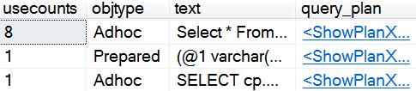  
  
The following table explains what each column in the resultset contains

|  |  |
| --- | --- |
| **Column** | **Description** |
| usecounts | Number of times the plan is reused |
| objtype | Specifies the type of object |
| text | Text of the SQL query |
| query\_plan | Query execution plan in XML format |

To remove all elements from the plan cache use the following command  
DBCC FREEPROCCACHE  
  
In older versions of SQL Server up to SQL Server 6.5 only stored procedure plans are cached. The query plans for Adhoc sql statements or dynamic sql statements are not cached, so they get compiled every time. With SQL Server 7, and later versions the query plans for Adhoc sql statements and dynamic sql statements are also cached.  
  
**Things to consider to promote query plan reusability**  
  
For example, when we execute the following query the first time. The query is compiled, a plan is created and put in the cache.  
Select \* From Employees Where FirstName = 'Mark'  
  
When we execute the same query again, it looks up the plan cache, and if a plan is available, it reuses the existing plan instead of creating the plan again which can improve the performance of the query. However, one important thing to keep in mind is that, the cache lookup is by a hash value computed from the query text. If the query text changes even slightly, sql server will not be able to reuse the existing plan.  
  
For example, even if you include an extra space somewhere in the query or you change the case, the query text hash will not match, and sql server will not be able find the plan in cache and ends up compiling the query again and creating a new plan.  
  
**Another example :** If you want the same query to find an employee whose FirstName is Steve instead of Mark. You would issue the following query  
Select \* From Employees Where FirstName = 'Steve'  
  
Even in this case, since the query text has changed the hash will not match, and sql server will not be able find the plan in cache and ends up compiling the query again and creating a new plan.  
  
This is why, it is very important to use parameterised queries for sql server to be able to reuse cached query plans. With parameterised queries, sql server will not treat parameter values as part of the query text. So when you change the parameters values, sql server can still reuse the cached query plan.  
  
The following query uses parameters. So even if you change parameter values, the same query plan is reused.

Declare @FirstName nvarchar(50)

Set @FirstName = 'Steve'

Execute sp\_executesql N'Select \* from Employees where FirstName=@FN', N'@FN nvarchar(50)', @FirstName

One important thing to keep in mind is that, when you have dynamic sql in a stored procedure, the query plan for the stored procedure does not include the dynamic SQL. The block of dynamic SQL has a query plan of its own.  
  
**Summary:** Never ever concatenate user input values with strings to build dynamic sql statements. Always use parameterised queries which not only promotes cached query plans reuse but also prevent sql injection attacks.

### **PART 144: exec vs sp\_executesql in sql server**

**Suggested Videos**  
[Part 141 - Prevent sql injection with dynamic sql](http://csharp-video-tutorials.blogspot.com/2017/04/prevent-sql-injection-with-dynamic-sql.html)  
[Part 142 - Dynamic SQL in Stored Procedure](http://csharp-video-tutorials.blogspot.com/2017/04/dynamic-sql-in-stored-procedure.html)  
[Part 143 - Sql server query plan cache](http://csharp-video-tutorials.blogspot.com/2017/04/sql-server-query-plan-cache.html)  
  
In this video we will discuss the **difference between exec and sp\_executesql**. This is continuation to [Part 143](http://csharp-video-tutorials.blogspot.com/2017/04/sql-server-query-plan-cache.html). Please watch [Part 143](http://csharp-video-tutorials.blogspot.com/2017/04/sql-server-query-plan-cache.html) from [SQL Server tutorial](https://www.youtube.com/playlist?list=PL08903FB7ACA1C2FB) before proceeding.  
  
In SQL Servere we have 2 options to execute dynamic sql  
1. Exec/Execute  
2. sp\_executesql  
  
  
We discussed sp\_executesql in detail in [Part 138](http://csharp-video-tutorials.blogspot.com/2017/03/dynamic-sql-in-sql-server.html) of [SQL Server tutorial](https://www.youtube.com/playlist?list=PL08903FB7ACA1C2FB). Please check out that video if you are new to sp\_executesql.  
  
  
If you do a quick search on the internet for the difference between exec and sp\_executesql, you will see that many articles on the web states using exec over sp\_executesql will have the following 2 problems  
1. It open doors for sql injection attacks  
2. Cached query plans may not be reused and leads to poor performance  
  
This is generally true, but if you use QUOTENAME() function you can avoid sql injection attacks and with sql server auto-parameterisation capability the cached query plans can be reused so performance is also not an issue. Let's understand these with examples.  
  
**What is exec() in SQL Server**  
Exec() or Execute() function is used to execute dynamic sql and has only one parameter i.e the dynamic sql statement you want to execute.   
  
As you can see in the example below, we are concatenating strings to build dynamic sql statements which open doors for sql injection.

Declare @FN nvarchar(50)

Set @FN = 'John'

Declare @sql nvarchar(max)

Set @sql = 'Select \* from Employees where FirstName = ''' +  @FN + ''''

Exec(@sql)

If we set @FN parameter to something like below, it drops SalesDB database

Declare @FN nvarchar(50)

Set @FN = ''' Drop Database SalesDB --'''

Declare @sql nvarchar(max)

Set @sql = 'Select \* from Employees where FirstName = ''' + @FN + ''''

Exec(@sql)

However, we can prevent SQL injection using the QUOTENAME() function as shown below.

Declare @FN nvarchar(50)

Set @FN = ''' Drop Database SalesDB --'''

Declare @sql nvarchar(max)

Set @sql = 'Select \* from Employees where FirstName = ' + QUOTENAME(@FN,'''')

--Print @sql

Exec(@sql)

Notice with the quotename function we are using a single quote as a delimiter. With the use of this function if there is a single quote in the user input it is doubled.  
  
For example, if we set @FN='John', notice the string 'John' is wrapped in single quotes

Declare @FN nvarchar(50)

Set @FN = 'John'

Declare @sql nvarchar(max)

Set @sql = 'Select \* from Employees where FirstName = ' + QUOTENAME(@FN,'''')

Print @sql

When the above query is executed the following is the query printed

Select \* from Employees where FirstName = 'John'

Along the same lines, if we try to inject sql, QUOTENAME() function wraps all that input in another pair of single quotes treating it as a value for the FirstName column and prevents SQL injection.  
  
With sql server auto-parameterisation capability the cached query plans can be reused. SQL Server can detect parameter values and create parameterised queries on its own, even if you don't explicitly declare them. However, there are exceptions to this. Auto-parameterisation comes in 2 flavours - Simple and Forced. We will discuss auto-parameterisation in detail in a later video.  
  
Execute the following DBCC command to remove all entries from the plan cache

DBCC FREEPROCCACHE

Execute the following query. Notice we have set @FN='Mary'

Declare @FN nvarchar(50)

Set @FN = 'Mary'

Declare @sql nvarchar(max)

Set @sql = 'Select \* from Employees where FirstName = ' + QUOTENAME(@FN,'''')

Exec(@sql)

Execute the following query to retrieve what we have in the query plan cache

SELECT cp.usecounts, cp.cacheobjtype, cp.objtype, st.text, qp.query\_plan

FROM sys.dm\_exec\_cached\_plans AS cp

CROSS APPLY sys.dm\_exec\_sql\_text(plan\_handle) AS st

CROSS APPLY sys.dm\_exec\_query\_plan(plan\_handle) AS qp

ORDER BY cp.usecounts DESC

Notice in the 3rd row, we have an auto-parameterised query and at the moment usecounts is 1.   
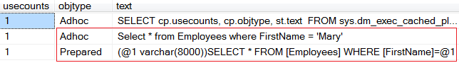  
  
Now set @FN='Mark' and execute the same query. After the query is completed, retrieve the entries from the plan cache. Notice the usecounts for the auto-parameterised query is 2, suggesting that the same query plan is reused.  
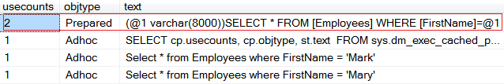  
  
Along the same lines, if you change @FN='John' and execute the query, you will see that the usecounts is now 3 for the auto-parameterised query.  
  
**Summary**

* If you use QUOTENAME() function, you can prevent sql injection while using Exec()
* Cached query plan reusability is also not an issue while using Exec(), as SQL server automatically parameterize queries.
* I personally prefer using sp\_executesql over exec() as we can explicitly parameterise queries instead of relying on sql server auto-parameterisation feature or QUOTENAME() function. I use Exec() only in throw away scripts rather than in production code.

### **PART 145 : Dynamic sql table name variable**

**Suggested Videos**  
[Part 142 - Dynamic SQL in Stored Procedure](http://csharp-video-tutorials.blogspot.com/2017/04/dynamic-sql-in-stored-procedure.html)  
[Part 143 - Sql server query plan cache](http://csharp-video-tutorials.blogspot.com/2017/04/sql-server-query-plan-cache.html)  
[Part 144 - exec vs sp\_executesql in sql server](http://csharp-video-tutorials.blogspot.com/2017/04/exec-vs-spexecutesql-in-sql-server.html)  
  
In this video we will discuss **how to pass table name dynamically for stored procedure in sql server**. This is one of the sql questions that is very commonly asked. Here is what we want to do.  
  
I have a web page with a textbox as shown below. When I enter a table name in the textbox and when I click "Load Data" button, we want to retrieve data from that respective table and display it on the page.  
  
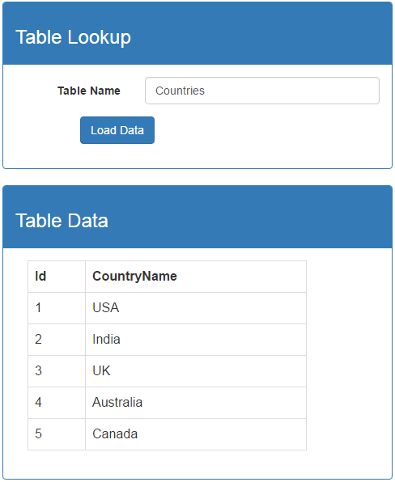  
  
  
  
For the purpose of this demo, we will use the following 2 tables.  
  
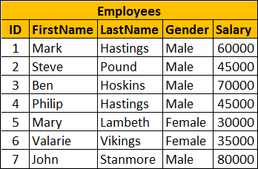  
  
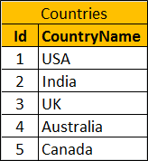  
  
**SQL Script to create the required tables**

Create table Countries

(

     Id int identity primary key,

     CountryName nvarchar(50)

)

Go

Insert into Countries values ('USA')

Insert into Countries values ('India')

Insert into Countries values ('UK')

Insert into Countries values ('Australia')

Insert into Countries values ('Canada')

Go

Create table Employees

(

     ID int primary key identity,

     FirstName nvarchar(50),

     LastName nvarchar(50),

     Gender nvarchar(50),

     Salary int

)

Go

Insert into Employees values ('Mark', 'Hastings', 'Male', 60000)

Insert into Employees values ('Steve', 'Pound', 'Male', 45000)

Insert into Employees values ('Ben', 'Hoskins', 'Male', 70000)

Insert into Employees values ('Philip', 'Hastings', 'Male', 45000)

Insert into Employees values ('Mary', 'Lambeth', 'Female', 30000)

Insert into Employees values ('Valarie', 'Vikings', 'Female', 35000)

Insert into Employees values ('John', 'Stanmore', 'Male', 80000)

Go

Create the following stored procedure. Notice we are passing table name as a parameter to the stored procedure. In the body of the stored procedure we are concatenating strings to build our dynamic sql statement. In our previous videos we discussed that this open doors for SQL injection.

Create procedure spDynamicTableName

@TableName nvarchar(100)

As

Begin

     Declare @sql nvarchar(max)

     Set @sql = 'Select \* from ' + @TableName

     Execute sp\_executesql @sql

End

So the obvious question that comes to our mind is, why are we not creating parameterised sql statement instead. The answers is we can't. SQL Server does not allow table names and column names to be passed as parameters. Notice in the example below, we are creating a parameterised query with @TabName as a parameter. When we execute the following code, the procedure gets created successfully.

Create procedure spDynamicTableName1

@TableName nvarchar(100)

As

Begin

     Declare @sql nvarchar(max)

     Set @sql = 'Select \* from @TabName'

     Execute sp\_executesql @sql, N'@TabName nvarchar(100)',

     @TabName = @TableName

End

But when we try to execute it we get an error - Must declare the table variable "@TabName"  
Execute spDynamicTableName1 N'Countries'  
  
Add a Web Page to the project that we have been working with in our previous video. Name it "DynamicTableName.aspx". Copy and paste the following HTML on the page.

<html xmlns="http://www.w3.org/1999/xhtml">

<head runat="server">

    <title>Employee Search</title>

    <link rel="stylesheet"

        href="https://maxcdn.bootstrapcdn.com/bootstrap/3.3.7/css/bootstrap.min.css"

        type="text/css" />

</head>

<body style="padding-top: 10px">

    <div class="col-xs-8 col-xs-offset-2">

        <form id="form1" runat="server" class="form-horizontal">

            <div class="panel panel-primary">

                <div class="panel-heading">

                    <h3>Table Lookup</h3>

                </div>

                <div class="panel-body">

                    <div class="form-group">

                        <label for="inputTableName" class="control-label col-xs-4">

                            Table Name

                        </label>

                        <div class="col-xs-8">

                            <input type="text" runat="server" class="form-control"

                                id="inputTableName" placeholder="Please enter table name" />

                        </div>

                    </div>

                    <div class="form-group">

                        <div class="col-xs-10 col-xs-offset-2">

                            <asp:Button ID="btnLoadData" runat="server" Text="Load Data"

                                CssClass="btn btn-primary" OnClick="btnLoadData\_Click" />

                            <asp:Label ID="lblError" runat="server" CssClass="text-danger">

                            </asp:Label>

                        </div>

                    </div>

                </div>

            </div>

            <div class="panel panel-primary">

                <div class="panel-heading">

                    <h3>Table Data</h3>

                </div>

                <div class="panel-body">

                    <div class="col-xs-10">

                        <asp:GridView CssClass="table table-bordered"

                            ID="gvTableData" runat="server">

                        </asp:GridView>

                    </div>

                </div>

            </div>

        </form>

    </div>

</body>

</html>

Copy and paste the following code in the code-behind page.

using System;

using System.Configuration;

using System.Data;

using System.Data.SqlClient;

namespace DynamicSQLDemo

{

    public partial class DynamicTableName : System.Web.UI.Page

    {

        protected void btnLoadData\_Click(object sender, EventArgs e)

        {

            try

            {

                if (inputTableName.Value.Trim() != "")

                {

                    string strConnection = ConfigurationManager

                   .ConnectionStrings["connectionStr"].ConnectionString;

                    using (SqlConnection con = new SqlConnection(strConnection))

                    {

                        SqlCommand cmd = new SqlCommand();

                        cmd.Connection = con;

                        cmd.CommandText = "spDynamicTableName";

                        cmd.CommandType = CommandType.StoredProcedure;

                        SqlParameter param = new

                            SqlParameter("@TableName", inputTableName.Value);

                        param.SqlDbType = SqlDbType.NVarChar;

                        param.Size = 100;

                        cmd.Parameters.Add(param);

                        con.Open();

                        SqlDataReader rdr = cmd.ExecuteReader();

                        gvTableData.DataSource = rdr;

                        gvTableData.DataBind();

                    }

                }

                lblError.Text = "";

            }

            catch (Exception ex)

            {

                lblError.Text = ex.Message;

            }

        }

    }

}

At this point, run the application and type the following text in the "Table Name" textbox and click "Load Data" button. Notice "SalesDB" database is dropped. Our application is prone to SQL injection as we have implemented dynamic sql in our stored procedure by concatenating strings instead of using parameters.  
Employees; Drop database SalesDB  
  
One way to prevent SQL injection in this case is by using SQL Server built-in function - QUOTENAME(). We will discuss QUOTENAME() function in detail in our next video. For now understand that by default, this function wraps that string that is passed to it in a pair of brackets.  
SELECT QUOTENAME('Employees') returns [Employees]  
  
Modify the stored procedure to use QUOTENAME() function as shown below.

Alter procedure spDynamicTableName

@TableName nvarchar(100)

As

Begin

     Declare @sql nvarchar(max)

     Set @sql = 'Select \* from ' + QUOTENAME(@TableName)

     Execute sp\_executesql @sql

End

At this point, type the following text in the "Table Name" textbox and click "Load Data" button. Notice you will see a message - Invalid object name 'Employees; Drop database SalesDB'. Also "SalesDB" database is not dropped.   
Employees; Drop database SalesDB  
  
The entire text in "Table Name" textbox is wrapped in a pair of brackets by the QUOTENAME function and is treated as table name. Since we do have a table with the specified name, we get the error - Invalid object name.

### **PART 146 : Quotename function in SQL Server**

**Suggested Videos**  
[Part 143 - Sql server query plan cache](http://csharp-video-tutorials.blogspot.com/2017/04/sql-server-query-plan-cache.html)  
[Part 144 - exec vs sp\_executesql in sql server](http://csharp-video-tutorials.blogspot.com/2017/04/exec-vs-spexecutesql-in-sql-server.html)  
[Part 145 - Dynamic sql table name variable](http://csharp-video-tutorials.blogspot.com/2017/04/dynamic-sql-table-name-variable.html)  
  
In this video we will discuss **Quotename function in SQL Server**. This is continuation to [Part 145](http://csharp-video-tutorials.blogspot.com/2017/04/dynamic-sql-table-name-variable.html). Please watch [Part 145](http://csharp-video-tutorials.blogspot.com/2017/04/dynamic-sql-table-name-variable.html) from [SQL tutorial](https://www.youtube.com/playlist?list=PL08903FB7ACA1C2FB) before proceeding.  
  
  
This function is very useful when you want to quote object names. Let us understand the use of this function with an example.  
  
We will use the following table for the examples in this demo  
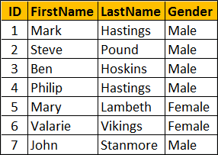  
  
  
  
SQL Script to create and populate the table with test data

Create table [USA Customers]

(

     ID int primary key identity,

     FirstName nvarchar(50),

     LastName nvarchar(50),

     Gender nvarchar(50)

)

Go

Insert into [USA Customers] values ('Mark', 'Hastings', 'Male')

Insert into [USA Customers] values ('Steve', 'Pound', 'Male')

Insert into [USA Customers] values ('Ben', 'Hoskins', 'Male')

Insert into [USA Customers] values ('Philip', 'Hastings', 'Male')

Insert into [USA Customers] values ('Mary', 'Lambeth', 'Female')

Insert into [USA Customers] values ('Valarie', 'Vikings', 'Female')

Insert into [USA Customers] values ('John', 'Stanmore', 'Male')

Go

Let us say, we are using dynamic SQL to build our SELECT query as shown below

Declare @sql nvarchar(max)

Declare @tableName nvarchar(50)

Set @tableName = 'USA Customers'

Set @sql = 'Select \* from ' + @tableName

Execute sp\_executesql @sql

When we execute the above script, we get the following error  
Msg 208, Level 16, State 1, Line 1  
Invalid object name 'USA'.  
  
The query that our dynamic sql generates and executes is as shown below. To see the generate SQL statement, use Print @sql.

Select \* from USA Customers

Since there is a space in the table name, it has to be wrapped in brackes as shown below

Select \* from [USA Customers]

One way to fix this is by including the brackets in @tableName variable as shown below

Set @tableName = '[USA Customers]'

The other way to fix this is by including the brackets in @sql variable as shown below

Set @sql = 'Select \* from [' + @tableName +']'

While both of the above methods give the result we want, it is extremely dangerous because it open doors for sql injection.  
  
If we set the brackets in @tableName variable, sql can be injected as shown below and SalesDB database is dropped

Declare @sql nvarchar(max)

Declare @tableName nvarchar(50)

Set @tableName = '[USA Customers] Drop Database SalesDB'

Set @sql = 'Select \* from ' + @tableName

Execute sp\_executesql @sql

If we set the brackets in @sql variable, sql can be injected as shown below and SalesDB database is dropped

Declare @sql nvarchar(max)

Declare @tableName nvarchar(50)

Set @tableName = 'USA Customers] Drop Database SalesDB --'

Set @sql = 'Select \* from [' + @tableName +']'

Execute sp\_executesql @sql

So, the right way to do this is by using QUOTENAME() function as shown below.

Declare @sql nvarchar(max)

Declare @tableName nvarchar(50)

Set @tableName = 'USA Customers Drop Database SalesDB --'

Set @sql = 'Select \* from ' + QUOTENAME(@tableName)

Execute sp\_executesql @sql

When we execute the above script we get the following error. SalesDB database is not dropped. The reason we get this error is because we do not have a table with name - [USA Customers Drop Database SalesDB --]. To see the sql statement use PRINT @sql.  
Invalid object name 'USA Customers Drop Database SalesDB --'.  
  
If we set @tableName = 'USA Customers', the query executes successfully, without the threat of SQL injection.

Declare @sql nvarchar(max)

Declare @tableName nvarchar(50)

Set @tableName = 'USA Customers'

Set @sql = 'Select \* from ' + QUOTENAME(@tableName)

Execute sp\_executesql @sql

If you want to use sql server schema name "dbo" along with the table name, then you should not use QUOTENAME function as shown below.

Declare @sql nvarchar(max)

Declare @tableName nvarchar(50)

Set @tableName = 'dbo.USA Customers'

Set @sql = 'Select \* from ' + QUOTENAME(@tableName)

Execute sp\_executesql @sql

The above query produces the following error  
Invalid object name 'dbo.USA Customers'  
  
Instead use QUOTENAME function as shown below

Declare @sql nvarchar(max)

Declare @tableName nvarchar(50)

Set @tableName = 'USA Customers'

Set @sql = 'Select \* from ' + QUOTENAME('dbo') + '.' + QUOTENAME(@tableName)

Execute sp\_executesql @sql

QUOTENAME() function

* Takes two parameters - the first is a string, and the second is a delimiter that you want SQL server to use to wrap the string in.
* The delimiter can be a left or right bracket ( [] ), a single quotation mark ( ' ), or a double quotation mark ( " )
* The default for the second parameter is []

QUOTENAME() function examples  
  
SELECT QUOTENAME('USA Customers','"') returns "USA Customers"  
  
SELECT QUOTENAME('USA Customers','''') returns 'USA Customers'  
  
All the following statements return [USA Customers]  
SELECT QUOTENAME('USA Customers')   
SELECT QUOTENAME('USA Customers','[')   
SELECT QUOTENAME('USA Customers',']')  
  
If you use a delimiter other than a single quotation mark, double quotation mark, left bracket or a right bracket, you get NULL. The following statement returns NULL.  
  
SELECT QUOTENAME('USA Customers','\*')  
  
For some reason if you have a bracket in the table name, QUOTENAME function will double it to indicate an escape character.  
SELECT QUOTENAME('USA ] Customers') returns [USA ]] Customers]  
  
To remove the QUOTENAME use, PARSENAME() function as shown below.

Declare @tableName nvarchar(50)

Set @tableName = 'USA ] Customers'

Set @tableName = QUOTENAME(@tableName)

Print @tableName

Set @tableName = PARSENAME(@tableName,1)

Print @tableName

**Result:**  
[USA ]] Customers]  
USA ] Customers  
  
PARSENAME() takes 2 parameters. The first is the object name and the second is the object piece. It is an int and can be  
1 = Object name  
2 = Schema name  
3 = Database name  
4 = Server name

### **PART 147 : Dynamic SQL vs Stored Procedure**

**Suggested Videos**  
[Part 144 - exec vs sp\_executesql in sql server](http://csharp-video-tutorials.blogspot.com/2017/04/exec-vs-spexecutesql-in-sql-server.html)  
[Part 145 - Dynamic sql table name variable](http://csharp-video-tutorials.blogspot.com/2017/04/dynamic-sql-table-name-variable.html)  
[Part 146 - Quotename function in SQL Server](http://csharp-video-tutorials.blogspot.com/2017/04/quotename-function-in-sql-server.html)  
  
In this video we will discuss the advantages and disadvantages of Dynamic SQL and Stored Procedures based on the following aspects  
  
1. Separating database logic from business logic  
2. Network traffic  
3. SQL Injection Attacks  
4. Cached query plans reuse  
5. Maintenance 6. Implementing flexible logic  
**Separating database logic from business logic :** Stored procedures allow us to keep database logic separate from business logic. The benefit of keeping database logic separate from the business logic is that, if there is an issue with the business logic you know you only have to check the application code. On the other hand if the issue is with the database logic, you will only have to check and modify the stored procedure.   
  
Another added benefit here is that, if you change the stored procedure there is no need to compile your application code and deploy it. Just modify the stored procedure and you are done. You will loose this benefit if you are composing your dynamic sql statements in client code, as you will have to change the application code if there is a bug. Changing the application code requires compilation, build and deployment.  
  
  
  
**Network traffic :**Stored procedures reduce network traffic as only the procedure name and a few parameters need to be sent over the network. With dynamic SQL, you will have to send your entire sql statement over the network. If the query is a complex one, with 50 to 60 lines, imagine the increased network traffic between the client application and the database server.  
  
**SQL Injection Attacks :**Stored procedures prevent SQL injection attacks. In general, dynamic SQL open doors for SQL injection attacks if not careful. However, even with dynamic SQL, we can prevent SQL injection attacks by using parameterised queries. In some cases where you need to pass a table name or a column name as a parameter, it is not possible to use parameterised queries with dynamic sql. In such cases use QUOTENAME() function to prevent SQL injection attacks.  
  
**Cached query plans reuse :**Stored procedures provide increased performance as cached query plans reusability increases. Even with dynamic SQL, if we use parameterised queries, cached query plan reusability increases, which in turn increases the performance. If you are not using parameterised queries, SQL Server auto-parameterisation feature can automatically detect parameter values and create parameterised queries which promotes query plan reusability and in turn performance.  
  
One important thing to keep in mind is that, from a performance standpoint OLTP queries benefit from cached query plan reuse. However, with OLAP systems as your data drifts and optimizer choices change, OLAP queries benefit from unique plans, so query plan reuse may not be desirable in this case for performance.  
  
**Maintenance :**With static SQL in a stored procedure, a syntax error is reported immediately so ease of writing is definitely one of the benefits of using a stored procedure. On the other hand if you have dynamic SQL in the stored procedure, and if there is a syntax error you wouldn't know it until you run it.   
  
Stored procedures with static SQL are also easy to maintain as you can use sp\_depends procedure to check the dependencies on other SQL objects. For example, let's say you have a database with lot of tables, and you want to know if a certain table is referenced, because you are considering changing or dropping it. In this case using sp\_depends TableName will let us know if it is referenced anywhere, so we can make changes without breaking anything. On the other hand if you are using dynamic sql in a stored procedure or sending it from a client, you loose this benefit.  
  
**Implementing flexible logic :** Sometimes, with stored procedures it is hard to implement flexible logic compared with dynamic SQL. For example, we want to implement a "Search" stored procedure with 20 or more filters. This stored procedure can get complex. To make things worse what if we want to specify conditions like AND, OR etc between these search filters. The stored procedure can get extremely large, complicated and difficult to maintain. One way to reduce the complexity is by using dynamic SQL. Depending on for which search filters the user has provided the values on the "Search Page", we build the WHERE clause dynamically at runtime, which can reduce complexity.

### **PART 148 : Dynamic sql output parameter**

**Suggested Videos**  
[Part 145 - Dynamic sql table name variable](http://csharp-video-tutorials.blogspot.com/2017/04/dynamic-sql-table-name-variable.html)  
[Part 146 - Quotename function in SQL Server](http://csharp-video-tutorials.blogspot.com/2017/04/quotename-function-in-sql-server.html)  
[Part 147 - Dynamic SQL vs Stored Procedure](http://csharp-video-tutorials.blogspot.com/2017/05/dynamic-sql-vs-stored-procedure.html)  
  
In this video we will discuss, **how to use output parameters with dynamic sql**. Let us understand this with an example.  
  
We will use the following **Employees**table in this demo.  
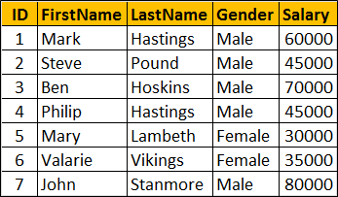  
  
  
  
SQL script to create Employees table

Create table Employees

(

     ID int primary key identity,

     FirstName nvarchar(50),

     LastName nvarchar(50),

     Gender nvarchar(50),

     Salary int

)

Go

Insert into Employees values ('Mark', 'Hastings', 'Male', 60000)

Insert into Employees values ('Steve', 'Pound', 'Male', 45000)

Insert into Employees values ('Ben', 'Hoskins', 'Male', 70000)

Insert into Employees values ('Philip', 'Hastings', 'Male', 45000)

Insert into Employees values ('Mary', 'Lambeth', 'Female', 30000)

Insert into Employees values ('Valarie', 'Vikings', 'Female', 35000)

Insert into Employees values ('John', 'Stanmore', 'Male', 80000)

Go

We want to write a dynamic sql statement that returns total number of male of female employees. If the gender value is specified as "Male", then the query should return total male employees. Along the same lines, if the the value for gender is "Female", then we should get total number of female employees.  
  
The following dynamic sql, will give us what we want. In this case, the query returns total number of "Male" employees. If you want the total number of female employees, simply set @gender='Female'.

Declare @sql nvarchar(max)

Declare @gender nvarchar(10)

Set @gender = 'Male'

Set @sql = 'Select Count(\*) from Employees where Gender=@gender'

Execute sp\_executesql @sql, N'@gender nvarchar(10)', @gender

At the moment we are not using output parameters. If you want the count of employees to be returned using an OUTPUT parameter, then we have to do a slight modification to the query as shown below. The key here is to use the OUTPUT keyword in your dynamic sql. This is very similar to using OUTPUT parameters with a stored procedure.

Declare @sql nvarchar(max)

Declare @gender nvarchar(10)

Declare @count int

Set @gender = 'Male'

Set @sql = 'Select @count = Count(\*) from Employees where Gender=@gender'

Execute sp\_executesql @sql, N'@gender nvarchar(10), @count int OUTPUT',   
                                      @gender, @count OUTPUT

Select @count

The OUTPUT parameter returns NULL, if you forget to use OUTPUT keyword.. The following query returns NULL, as we removed the OUTPUT keyword from @count parameter

Declare @sql nvarchar(max)

Declare @gender nvarchar(10)

Declare @count int

Set @gender = 'Male'

Set @sql = 'Select @count = Count(\*) from Employees where Gender=@gender'

Execute sp\_executesql @sql, N'@gender nvarchar(10), @count int OUTPUT',  
                                      @gender, @count

Select @count

### **PART 149 : Temp tables in dynamic sql**

**Suggested Videos**  
[Part 146 - Quotename function in SQL Server](http://csharp-video-tutorials.blogspot.com/2017/04/quotename-function-in-sql-server.html)  
[Part 147 - Dynamic SQL vs Stored Procedure](http://csharp-video-tutorials.blogspot.com/2017/05/dynamic-sql-vs-stored-procedure.html)  
[Part 148 - Dynamic sql output parameter](http://csharp-video-tutorials.blogspot.com/2017/05/dynamic-sql-output-parameter.html)  
  
In this video we will discuss the **implications of creating temp tables in dynamic sql**  
  
Temp tables created by dynamic SQL are not accessible from the calling procedure. They are dropped when the dynamic SQL block in the stored procedure completes execution.   
  
  
Let us understand this with an example. Notice in the example below, all the following 3 operations are in the block of dynamic sql code.   
1. Creating the Temp Table  
2. Populating the Temp Table  
3. Select query on the Temp Table 

Create procedure spTempTableInDynamicSQL

as

Begin

       Declare @sql nvarchar(max)

       Set @sql = 'Create Table #Test(Id int)

                           insert into #Test values (101)

                           Select \* from #Test'

       Execute sp\_executesql @sql

End

So when we execute the above procedure we are able to access data from the Temp Table.  
Execute spTempTableInDynamicSQL  
  
Now, let's move the SELECT statement outside of the dynamic sql code block as shown below and ALTER the stored procedure.

Alter procedure spTempTableInDynamicSQL

as

Begin

       Declare @sql nvarchar(max)

       Set @sql = 'Create Table #Test(Id int)

                           insert into #Test values (101)'

       Execute sp\_executesql @sql

       Select \* from #Test

End

At this point, execute the stored procedure. Notice, we get the error - Invalid object name '#Test'. This is because temp tables created by dynamic SQL are not accessible from the calling procedure. They are dropped when the dynamic SQL block in the stored procedure completes execution.  
Execute spTempTableInDynamicSQL  
  
On the other hand, dynamic SQL block can access temp tables created by the calling stored procedure. Let's prove this by modifying the stored procedure as shown below.

Alter procedure spTempTableInDynamicSQL

as

Begin

       Create Table #Test(Id int)

       insert into #Test values (101)

       Declare @sql nvarchar(max)

       Set @sql = 'Select \* from #Test'

       Execute sp\_executesql @sql

End

At this point, execute the stored procedure. Notice that we are able to access the temp table, which proves that dynamic SQL block can access temp tables created by the calling stored procedure.   
  
Execute spTempTableInDynamicSQL  
  
**Summary**

* Temp tables created by dynamic SQL are not accessible from the calling procedure.
* They are dropped when the dynamic SQL block in the stored procedure completes execution.
* On the other hand, dynamic SQL block can access temp tables created by the calling stored procedure